METHYL ESTER (BIODESEL) PRODUCTION FROM WASTE COOKING VEGETABLE OIL BY MICROWAVE IRRADIATION
(Penghasilan Metil Ester (Biodesel) Daripada Sisa Minyak Sayuran oleh Penyinaran Gelombang Mikro)
M.S.Khatun*, M.A. Khatun, M.Z.H. Khan, M. Debnath
Department of Chemical Engineering, Jessore University of Science & Technology, Jessore- 7408, Bangladesh.
*Corresponding Author- Email: sheauly.jstu@gmail.com

Abstract
In this study we tried to develop, test and optimize a batch microwave system using waste cooking vegetable oil (WCVO) that was used as biodiesel feedstock. Two catalysts, sodium hydroxide (NaOH) and potassium hydroxide (KOH) were tested in this study. Transesterification reactions between oil and methanol were carried out in presence of microwaves. It was observed that by using of microwaves, the reaction times were drastically reduced. As high as 99.5% conversions could be achieved for 0.5% KOH concentration. Moreover, quality analysis of biodiesels according to international standards was performed and the samples were found to meet the necessary specifications.

Keywords: Methyl ester biodiesel; waste cooking vegetable oil; microwave irradiation; biofuel.

Abstrak
Dalam kajian ini penulis cuba membangunkan, menguji dan mengoptimumkan suatu sistem penghasilan bahan mental biodesel secara gelombang mikro menggunakan sisa minyak sayuran memasak sisa (WCVO). Dua pemangkin, natrium hidroksida (NaOH) dan kalium hidroksida (KOH) telah diuji dalam kajian ini. Tindakbalas transesterifikasi antara minyak dan metanol telah dijalankan mengunakan gelombang mikro. Kajian mendapati bahawa dengan menggunakan gelombang mikro, masa tindakbalas berkurangan secara drastik. Penukaran boleh dicapai sehingga 95% bagi kepekatan KOH 0.5%. Selain itu, analisis kualiti biodiesel mengikut piawaian antarabangsa telah dilakukan dan sampel didapati memenuhi spesifikasi yang diperlukan.

Kata kunci: biodiesel metil ester; sisa minyak masak sayuran; penyinaran gelombang mikro; biofuel.

Introduction
There is increasing interest in developing alternative energy resources. An immediately applicable option is replacement of diesel fuel by biodiesel, which consists of the simple alkyl esters of fatty acid [1, 2]. Vegetable oil has been considered for a long time as an alternative energy source to produce biodiesel. The conversion of vegetable oils into biodiesel is a potential solution to the increasing demand for energy and environmental concerns [3]. But, using refined vegetable oil to produce biodiesel will reduce the edible oil. Thus, the use of waste vegetable oil instead of refined vegetable oil to produce biodiesel is an effective way to reduce the raw material cost and reduce food shortages. Additionally, using waste vegetable oil could also help solve the problem of waste oil disposal [4, 5].

The development of biodiesel is being driven by the need to reduce emissions from diesel engines without modifying them. Biodiesel can be produced from animal fats or vegetable oils with methanol or ethanol as the catalyst via a transesterification reaction. Biodiesel used as alternative fuel can reduce emissions of hydrocarbons, CO, SO, PAHs, and polychlorinated dibenzo-p-dioxin/ 2 dibenzofurans [6-12]. However, the major obstacle to biodiesel commercialization is its high cost, which is approximately 1.5 times higher than that of petroleum diesel fuel [13, 14]. Therefore, we need to increase biodiesel yield and reduce biodiesel cost. One of the best ways to reduce the cost of biodiesel is to decrease reaction time of transesterification and to increase biodiesel yields. Reaction temperature, reaction time, catalyst amount, and the alcohol-to-oil ratio are important parameters in biodiesel production. Catalytic reactions can use alkali catalysts, acid catalysts, or enzymatic transesterification to achieve the best results.

Biodiesel can be produced at a lower temperature and shorter reaction time with an alkali catalyst compared to those required for an acid catalyst [15-18]. The conventional heating of a sample has a few significant drawbacks, such as heterogenic heating of the surface, limitations dependent on the thermal conductivity of materials, specific heat, and density when compared to microwave irradiation [19,20], and thus many research groups have recently focused on the latter approach. In recent years, microwave irradiation has been used for the production of biodiesel [21] used single-step, base catalyst transesterification for the production of biodiesel from waste cooking oil. However, this method used an unmodified household microwave oven.

In this work, a feasibility study has therefore been carried out to produce biodiesel from waste cooking vegetable oil using a modified household microwave oven in presence of different catalysts. Another aim of this study was to determine the optimum conditions of fatty acid methyl ester (FAME) production from waste cooking vegetable oil.

Materials and Methods
Materials
Laboratory grade methanol (99.8%), sodium hydroxide (NaOH), potassium hydroxide (KOH), silica gel were used as purchased without any further purification. In this experiment, waste cooking vegetable oil (WCVO) was collected from restaurants, residences, hotels, etc. Residual food in the waste vegetable oil used in this study was removed by filtering.

Instrument
The used modified microwave was SHARP FTR-219, which could offer microwave power from 0-800W. The microwave oven consisted of a single neck glass reactor of 500 ml capacity with two neck adapter, one neck for condenser and other inlet for the reactants, to the set up.

Experimental procedure
In this experimental procedure, the WCVO was first filtered through silica-gel 60 mesh (10.00 g) to eliminate free fatty acids and water. The WCVO had an acid value of 0.40 mg KOH and 0.02% water content prior to base-catalyzed transesterification [22]. The transesterification reaction performed at different molar ratio of oil to methanol, varying from 1:3, 1:4, 1:5, 1:6 and 1:7 at different power level. The reaction time was varying 2-10 minutes for all experiments. Two types of catalysts have been used NaOH and KOH at a range 0.5% wt. of oil. After transesterification reaction the biodiesel was separated from glycerol using separating funnel and finally washed with 5% water followed by magnesium sulfate anhydrous to remove the water. Several basic variables, namely, catalyst type, methanol to oil ratio and reaction time of transesterification were investigated as they play a significant difference in biodiesel produced [23]. Reaction conditions are given in Table 1.

Table1. Reaction conditions
Use of the catalyst (wt%) | Time (min) | Oil: methanol molar ratio
NaOH | 2 | 1:3
KOH | 4 | 1:4
- | 6 | 1:5
- | 8 | 1:6
- | 10 | 1:7

Results and Discussion
Analysis of the result from the characterization of the Biodiesel produced.
The characterization of the produced biodiesel was carried out and the physical properties were presented in Table 2. The result is placed with the corresponding limit set for biodiesel standard [24]. One of the most important characteristics of any fuel is its flash point; this is defined as the lowest temperature at which it can vaporize to form an ignitable mixture in air. The biodiesel has a higher flash point of 100$℃$ as compared to that of the petro diesel (flash point of 80 $℃$ ). This makes the biodiesel sample safe for use and storage. Also, fuels with lower flash point tend to ignite at lower temperature making it highly dangerous if it is not stored and use properly. The viscosity of a fuel is important because it affects the atomization of the fuel being injected into the engine combustion chamber. A small fuel drop is desired so that complete combustion can occur. A high viscosity fuel will produce a larger drop of fuel in an engine combustion chamber which may not burn as clean as a fuel that produces a smaller drop. Unburned oxidized fuel will build up in the engine around valves, injector tips and on piston side walls and rings. The higher the viscosity the greater the tendency of the fuels to cause problems such as clogging of engine components. The specific gravity of a fuel is another important factor for good engine performance; the higher the specific gravity, the more difficult it becomes to pump the fuel.

Table2. Physical properties of waste cooking vegetable oil fuel and a comparison with diesel fuel
Physical properties | Produced biodiesel value | Biodiesel standard [24] | Diesel standard [25]
Specific gravity at 25 ⁰C | 0.85 | 0.88 at 15.5 $℃$ | 0.88 at 15.5 $℃$
Kinematic viscosity (mm²/s @ 40 ⁰C) | 4.96 | 1.9-6 | 1.3-4.1
Water content max. (wt%) | 0.05 | 0.05max. | 0.161
Cloud point | 4 | -3 to 12 | -15 to 5
Pour point ⁰C | 0 | -15 to 10 | -35 to -15
Flash point min ⁰C | 100 | 100 - 170 | 80 to 60

Effect of microwave power level
The transesterification reaction has been investigated at the same molar ratio of oil: methanol at the various powers of microwave irradiation and the different reaction times. The results are shown in Figure 1.The yield increases with the increase of power level. This may be due to the fact that the increase of power level increases the heating rate. In this case more molecules absorb microwave energy to interact with each other and this absorption rate enhances the ionic compound present in reaction through ionic conductance, the better results are obtained as microwave irradiation intensity increases. We have not been able to isolate the compound of biodiesel from glycerine when power levels are 800W. Probably the compound was decomposed at this level. As indicated, the temperature increased with power level. Since microwave heating significantly increases the reaction temperature [26], it is possible that microwave reaction temperature can exceed the temperature (activation energy) required for a new reaction that is not possible for a lower temperature. If this is the case, different products can be obtained in the microwave reactions. However, in these instances, the amount of the desired product should be small or decomposed. This observation confirmed that power level 400W showed the highest yield, that is, 99.5%. Therefore, it can be recommended that for transesterification of waste cooking oil with methanol to biodiesel production suitable power level is 400W.

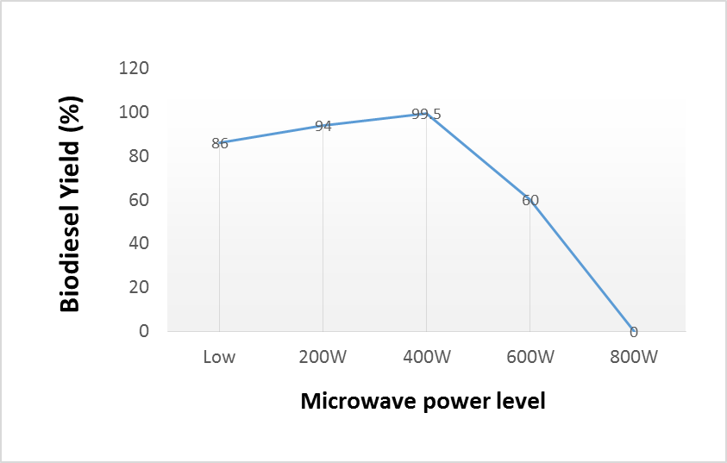
Figure 1. Effect of microwave power level on biodiesel production rate

Effect of oil/ methanol molar ratio
The oil to alcohol molar ratio is one of the important factors affecting the conversion of transesterification reaction of waste cooking vegetable oil to biodiesel. Methanolysis of WCVO was carried out with catalyst concentration 0.5 wt% of oil at microwave power level with different oil/ methanol molar ratio e.g. 1:3, 1:4, 1:5, 1:6, and 1:7 and the results exhibit that highest biodiesel yield is nearly 99.5% at 1:6 oil/methanol (Figure 2). From the Figure 2, it can be noticed that biodiesel yield continuously increases with the raise of molar ratio 1:3 to 1:6 but suddenly decreases for the molar ratio 1:7. Biodiesel yield observed in this study was higher than published data [27].

Figure 2. Effects of molar ratio on biodiesel conversion

Effect of different catalysts on biodiesel yield.
The further study, for example, impact of catalyst was performed using oil: methanol (1:6) has attained the most elevated rate. Past study demonstrates that production of biodiesel from waste cooking vegetable oil used catalyst sodium hydroxide with the reaction carried out at ambient pressure and temperature, the transformation rate of 98.4% were accomplished [28]. From Figure 3, it could be seen that highest biodiesel yield (99.5 %) has been achieved using KOH. Incomprehensibly throughout separating, washing of biodiesel the emulsification phenomena have been watched. In spite of the fact that the basic catalysts are the most well-known as the methodology using them is speedier and the reaction conditions are moderate these catalysts have some drawbacks[29]: they must be neutralized giving rise to waste waters and can't be reutilized, they make troubles to differentiate the methyl esters (biodiesel) by formation of stable emulsions, the by-product glycerol is gotten as a watery result of relatively low purity and the reaction gets to be extremely delicate to the vicinity of water and free fatty acids [30]. In this study it has been watched that this emulsification might be lightened lessening shaking power throughout washing and partition of biodiesel from glycerol. Notwithstanding higher yield, using NaOH causes more emulsion than KOH and makes muddled to separate biodiesel from glycerin.

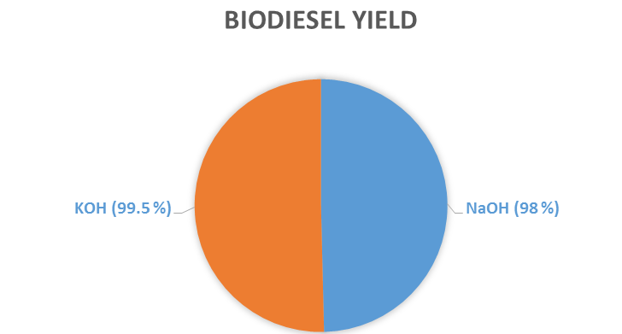

Figure 3. Different catalysts vs conversion rate

Effect of reaction time.
Figure 4 shows effects of the reaction time for the conversion rate. In order to ameliorate the mixing level between alcohol and oil, alkali catalysts were added to the reacting mixture. Results showed that after 4 minutes, the biodiesel conversion rate was more than 90%. The conversion rate reached to a noticeable value of 99.5% when the reaction time was 6 minutes. According to the normative standards of biodiesel, the required conversion rate must be 96.4%. In this work, microwave assists the catalyzing process of biodiesel production and the total reaction time required was 6 min. The total reaction time was less than previous studies [9, 15, 18, 19] which also trans- esterification of high FFA content oils with alcohol to biodiesel catalyzed by H₂SO₄ and NaOH.

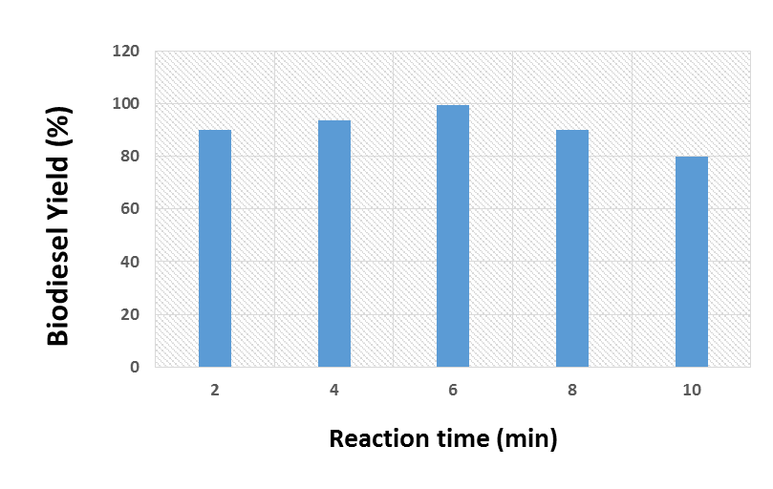

Figure 4: Effect of KOH reaction time on biodiesel yield.

The biodiesel samples produced under optimum condition of 1:6 oil-to-methanol molar ratio, 0.5% KOH catalyst and 6 minutes reaction time at 400W microwave power were analysed concerning some significant specifications as fuel in diesel engine.

There are two mechanisms by which microwave energy can interact with a sample. If a molecule possesses a dipole moment, then, when it is exposed to microwave irradiation, the dipole tries to align with the applied electric field. Because the electric field is oscillating, the dipoles constantly try to realign to follow this. At 2.45 GHz, molecules have time to align with the electric field but not to follow the oscillating field exactly. This continual reorientation of the molecules results in friction and thus heat. If a molecule is charged, then the electric field component of the microwave irradiation moves the ions back and forth through the sample while also colliding them into each other. This movement again generates heat. Because the mixture of vegetable oil, methanol, sodium hydroxide and potassium hydroxide contains both polar and ionic components, rapid heating is observed upon microwave irradiation, and because the energy interacts with the sample on a molecular level, very efficient heating can be obtained. In addition, because the energy is interacting with the molecules at a very fast rate, the molecules do not have time to relax and the heat generated can be, for short times, much greater than the overall recorded temperature of the bulk reaction mixture. In essence, there will be instantaneous localized superheating [31]. Thus, the bulk temperature may not be an accurate measure of the temperature at which the actual reaction is taking place. Microwave heating compares very favourably over conventional methods, where heating can be relatively slow and inefficient because transferring energy into a sample depends upon convection currents and the thermal conductivity of the reaction mixture.

Conclusion
The biodiesel from waste cooking vegetable oil was produced with microwave assistance by operating at various powers. The properties of oil, diesel, and biodiesel for waste cooking oil such as acid value, flash and fire point etc., were determined and compared. The properties of the biodiesel produced met all the required specifications as per standard limit. The most important observation was the reaction was completed within six minutes duration as compared to one hour reaction time with the conventional heating. Biodiesel from used cooking vegetable oils could be used as a diesel fuel which considered as renewable energy and environmental recycling process from waste oil after frying.

References
- Knoth, G., Gerpen, J. V., Krahl, J. (2005). The Biodisel Handbook. American oil chemists’ society, Urbana IL.
- Koonin, S.E. (2006). Properties on biofuel and biomaterials. Science, 311: 435.
- Lopez, D.E.,Goodwin, J. G., Bruce, D. A. and Lotero, E. (2005). Transesterification of triacetin with Alcohol on solid Acid and Base Catalysts. Applied Catalysis A: General, 295(2) : 97-105.
- Zhang, Y., Dube, D. A., McLean, D. D. and Kates, M. (2003). Biodiesel Production from Waste Cooking Oil: Proc-ess Design and Technological Assessment. Bioresource Technology, 89 (1): 1-16.
- Marchetti, J. M., Miguel, V. U. and Errazu, A. F. (2007). Hetero-geneous Esterification of Oil with High Amount of Free Fatty Acids. Fuel, 86(5): 906-910.
- Dorado, M.P., Ballesteros, E., López, F. J. and Mittelbach, M. (2004). Optimization of alkali-catalyzed transesterification of Brassica carinata oil for biodiesel production. Energ. Fuel, 18(1): 77-83.
- Lin, Y.C., Lee, W. J. and Hou, H.C. (2006). PAH emissions and energy efficiency of palm-biodiesel blends fueled on diesel generator. Atmos. Environ., V 40(21): 3930-3940.
- Lin, Y.C., Lee, W. J., Wu,T.S. and Wang, C. T. (2006). Comparison of PAH and regulated harmful matter emissions from biodiesel blends and paraffinic fuel blends on engine accumulated mileage test. Fuel, 85(17-18): 2516-2523.
- Lin, Y.C., Lee, W. J., Chao, H. R., Wang, S. L., Tsou, T. C., Chang-Chien, G.P. and Tsai, P. J. (2008). Approach for energy saving and pollution reducing by fueling diesel engines with emulsified biosolution/ biodiesel/diesel blends. Environ. Sci. Technol., 42(10): 3849-3855.
- Lin, Y.C., Tsai, C. H., Yang, C. R., Wu, C. H., Wuand, T. Y. and Chang-Chien, G. P. (2008). Effects on aerosol size distribution of polycyclic aromatic hydrocarbons from the heavy-duty diesel generator fueled with feedstock palm-biodiesel blends. Atmos. Environ., 42(27): 6679-6688.
- Lin, Y.C., Liu, S.H., Chen, Y. M. and Wu, T.Y. (2011). A new alternative paraffinic-palmbiodiesel fuel for reducing polychlorinated dibenzo-p-dioxin/ dibenzofuran emissions from heavy-duty diesel engines. J. Hazard. Mater, 185(1): 1-7.
- Lin, Y.C., Hsu, K.H. and Chen, C.B. (2011). Experimental investigation of the performance and emissions of a heavy-duty diesel engine fueled with waste cooking oil biodiesel/ultra-low sulfur diesel blends. Energy, 36(1): 241-248.
- Zhang, Y., Dube, M. A., McLean, D. D. and Kates, M. (2003). Biodiesel production from waste cooking oil: 2. Economic assessment and sensitivity analysis. Bioresource Technol., 90(3): 229-240.
- Haas, M.J., McAloon, A. J., Yee, W.C. and Foglia, T. A. (2006). A process model to estimate biodiesel production costs. Bioresource Technol., 97(4): 671-678.
- Fukuda, H., Kondo, A. and Noda, H. (2001). Biodiesel fuel production by transesterification of oils. J. Biosci. Bioeng., 92(5): 405-416.
- Dmytryshyn, S.L., Dalai, A. K., Chaudhari, S.T., Mishra, H. K. and Reaney, M. J. (2004). Synthesis and characterization of vegetable oil derived esters: Evaluation for their diesel additive properties. Bioresource Technol., 92(1): 55-64.
- Saifuddin, N. and Chua, K.H. (2004). Production of ethyl ester (biodiesel) from used frying oil: Optimization of transesterification process using microwave irradiation. Malaysian J. Chem., 6(1): 77-82.
- Vicente, G., Martinez, M. and Aracil, J. (2004). Integrated biodiesel production: A comparison of different homogeneous catalysts systems. Bioresource Technol., 92(3): 297-305.
- Carslaw, H.S. and Jaeger, J.C. (1959). Conduction of Heat in Solids. Oxford University Press, Oxford, UK.
- Metaxas, A.C. (1996). Foundations of Electro-heat. Wiley, New York.
- Leadbeater, N. E. and Stencel, L.M. (2006). Fast, easy preparation of biodiesel using microwave heating. Energ. Fuel., 20(5): 2281-2283.
- Sandro, L. B., Savio, E. O. M., Stanlei, I. K., Gabriela, R. H., Adriano, C. M. B. and Miguel, J. D. (2013). Microwave irradiation aiding ethanolysis of waste cooking oil. European International Journal of Science and Technology., 2(2): 211 – 222.
- Ma, F. and Hanna, M.A. (1999). Biodiesel production. A Review. Bioresour. Technol., 70 : 1-15.
- Morshed, M., Ferdous, K., Khan, M. and Mazumder, R. (2011). Rubber seed oil as a potential source for biodiesel production in Bangladesh. Fuel, 90 : 2981-2986.
- Joshi, R.M., Pegg, M. J. (2007). Flow properties of biodiesel fuel blends at low temperatures. Fuel, 86: 143-151.
- Gedye, R.N., Rank, W. and Westaway, K.C. (1991). The rapid synthesis of organic compounds in microwave ovens. Canadian Journal of Chemistry, 69(4): 706–711.
- Azcan, N. and Yilmaz, O. F. (2013). Microwave assisted transesterification of waste frying oil and concentrate methyl ester content of biodiesel by molecular distillation. Fuel, 104: 614–619.
- Hossain, A.B. and Boyce, A.N. (2009). Biodiesel production from waste sunflower cooking oil as an environmental recycling process and renewable energy. Bulgarian journal of agricultural science, 15(4): 312-317.
- Freedman, B., Prude, E. H. and Mounts, T. L. (1984). Variables affecting the yields of fatty esters from transesterified vegetable oils. J. Am Oil Chem. Soc., 61(10): 1638-1643.
- Arzamendia G., Campoa, I., Arguinarenaa, E., Sanchezb, M., Montesb, M. and Gandia, L. M. (2007). Synthesis of biodiesel with heterogeneous NaOH/alumina catalysts: Comparison with Homogeneous NaOH. Chemical Engineering Journal, 134: 123-130.
- Stuerga, D. (2006). For an introduction to the physical chemistry concepts of microwave heating. In Microwaves Organic Chemistry, Wiley-VCH: Weinheim, Germany.

