SYNTHESIS AND CHARACTERIZATION OF pH SENSITIVE HYDROGEL USING EXTRACTED PECTIN FROM DRAGON FRUIT PEEL

(Sintesis Dan Pencirian Hidrogel pH-Sensitif Berasaskan Ekstrak Pektin Kulit Buah Naga)

Azwan Mat Lazim¹, Farahain Mokhtar¹, Siti Fairus Mohd Yusof¹and Ishak Ahmad¹

¹School of Chemical Sciences and Food Technology, Faculty of Science and Technology, Universiti Kebangsaan Malaysia, Bangi, Selangor, Malaysia

*Corresponding author: azwani79@ukm.my

Abstract
The aim of this study is to synthesis pectin-based hydrogel from the dragon fruit peel. The pectin was extracted using acid extraction (pH 3.5) that carried out at 60 ºC for 30 minutes. The extracted compound conformation was analyzed by calculating the degree of esterification (DE) and the analysis was confirmed by the FTIR analysis spectrum. The dragon fruit peel pectin (PcDF) and acrylic acid (AA) hydrogel (AA-PcDF) was fabricated using a free radical polymerization in aqueous solution. Its uptaking efficiency was determined in different pH buffer solutions and their swelling percentage was calculated. Futher characterizations were made by using FTIR and SEM to examine the AA-PcDF hydrogel physicochemical properties. Results obtained showed that this new material has a high potential to be used as biomaterial in pharmaceutical and medical purposes.

Keyword: Pectin, dragon fruit peel, hydrogel, Hylocereus polyrhizus.

Abstrak

Tujuan kajian ini dijalankan adalah untuk mensintesis hidrogel beraaskan pektin daripada kulit buah naga. Pengastrakan ini dilakukan menggunakan kaedah pengestrakan asid dalam pH 3.5 pada suhu 60°C selama 30 minit. Perincian susunan kompaun yang telah diestrak telah ditentukan melalui darjah esterifikasi (DE) dan disahkan menggunakan spektrokopi FTIR. Penghasilan hidrogel berasakan pektin kulit buah naga (PcDF) dan akrilik asid (AA) (AA-PcDF) dilakukan melalui proses polimeran radikal bebas dalam larutan akues. Keberkesanan penyerapan dan pengembangan hidrogel ini ditentuksn menggunakan larutan penimbal pada pH yang berbeza iaitu pada pH 3, pH 7 dan pH 12. Pencirian lanjut telah dilakukan menggunakan analisis spektrokopi FTIR dan SEM bagi mengkaji sifat fiziokimia hidrogel AA-PcDF. Keputusan yang diperolehi telah menunjukkan matrial baru ini berpotensi tinggi untuk diaplikasikan dalam bidang farmasi dan perubatan.

Kata kunci: Pektin, kulitbuah naga, hydrogel, Hylocereus polyrhizus.

Introduction
Dragon fruit (Hylocereus polyrhizus) or red pitaya is an exotic tropical fruit which comes from the cactus family, Cactaceae. With leathery bright red skin and sweet, its kiwi-like flesh is highly in fiber and vitamins especially C and B. This fruit is widely used in food, jam and beverages. On contrary of the benefits, the dragon fruit waste during the peeling process is unmanageable and leads to environmental problems. Therefore, researches were conducted to utilize these waste materials as a source of pectin [1].

Generally, pectin (Figure 1) is a group of polysaccharides with an extremely diverse set of biopolymers present in all plant primary cell walls specifically, it is a methylated ester of polygalacturonic acid that contains 1,4-linked-α-D-galacturonic acid residues [1,2]. Pectin is characterized by its degree of esterification (DE) either high methoxyl pectin (DE >50 %) or low methoxyl pectin (DE<50 %). Interestingly, the amount of pectin from the dragon fruit is higher than apple pomace (12 %) however it is slightly lower than citrus peels (25%) [3, 4]. Pectin is widely used in food industry as gelling and thickening for jams, meat products, fruit juice and dairy products [5]. Pectin easily degrades by enzyme pectinase and microflora in the colon of the human body [6, 7].

Figure 1 Structure of pectin

In this research extracted pectin from dragon fruit (PcDF ) was grafted with acrylic acid (AA) by free radical polymerization. The swelling test of AA-PcDF hydrogel was conducted in three buffer solutions (pH 3, pH 7 and pH 12). Further characterizations and optimizations of AA-PcDF hydrogel were made by using fourier transform infrared (FTIR) spectroscopy, differential scanning calorimeter (DSC) and scanning electron microscopy (SEM) in order to examine the physicochemical properties of synthesized hydrogels. This grafted pectin hydrogel (AA-PcDF ) is expecting to produce a biocompatible hydrogel that suitable to be used as colonic drug carrier.

Experimental
Material
All chemicals such as hydrochloric acid (95%), ethanol (95%) and acrylic acid (AA), ammonium persulfate (APS), and N,N’-methylene-bis-acrylamide (MBA) were used as received and supplied by Merck. Dragon fruit was bought at a local store. For extraction hydrochloric acid at 0.1M has been used.

Pectin extraction from dragon fruit (PcDF)
Pectin from dragon fruit peels was extracted using a method modified from [4]. About 2 g dried dragon fruit peels was added to mixture of hydrochloric acid (0.1M) in 30 mL distilled water where the pH was adjusted to 3.5. The extraction process was carried out at 60 ºC for 30 minutes and the final product was filtered using cheesecloth. Ethanol (95%) was added to the extraction solution with a ratio of 0.5: 1.0 for 6 hours. The forming gel was filtered and washed using ethanol (45%) to separate mono-and disaccharides. Pectin was dried in an oven at 40 ºC for 24 hours.

Synthesis of AA-PcDF hydrogels
AA-PcDF hydrogels were synthesized by free radical polymerization using APS as the initiator and MBA as the crosslinker. In a round bottom flask, AA and solution of PcDF (1%) were prepared at different ratios (4:1, 3:2, 2:3 and 1:4). The mixture was purged with nitrogen gas for 10 minutes. Then about 1.6 % of MBA and 1 % of APS were added when the temperature reached at 70 ºC. The synthesis was left for 6 hours to complete the process of radical polymerization. The hydrogel produced was immersed in large amounts of distilled water for 24 hours before it was dried at room temperature for 72 hours.

Pectin characterization
Percentage of extracted pectin was calculated and recorded using this formula (Equation 1):

% Yield = P₁/P₀ x 100 (1)

P₀ is the weight of dry dragon fruit skin before extraction; P₁ is the weight of pectin extracted

Degree of esterification (DE) was calculated using a standard method proposed by [8]. In a 50 mL beaker, 50 mg pectin powder was dissolved in 65 % isopropanol and 10 mL of distilled water. Dropwise, 3 drops of phenolphthalein was added as color indicator. Pectin was titrated with 0.1N NaOH until the solution color changed to pink and the volume was recorded as A mL. After 30 minutes, 30 mL of 0.1N NaOH was added together with 30 mL 0.1N sulfuric acid. Using the same approached the second titration was made using 0.1N NaOH until the solution turned pink and recorded as B mL. Percentage of DE was calculated using a formula (Equation 2) proposed by [5]:

% DE = (B / AB) x 100 (2)

A is the first titration volume and B is the volume of the second titration.

Hydrogel AA-PcDF characterization
Percentage of gel fraction was calculated using formula (Equation 3) proposed by [7].

% Gel fraction = A₁/A₀ x 100 (3)

A₁ is the dry weight before extraction; A₀ is the dry weight after extracted.

The swelling percentage test of hydrogel was performed in buffer solution ie. pH 3, pH 7 and pH 12 to study the sensitivity of the hydrogel towards external stimuli under different pH factors. The swelling percentage was calculated using a formula (Equation 4 ) by [8].

% Swelling = G₁-G₀ x 100 (4)
G₀

G₁ is the dry weight of hydrogel before swelling. G₀ is the weight of hydrogel after swelling in 24h

FTIR spectroscopy analyzed was carried out using an Attenuated total reflectance (ATR) technique (Perkin Elmer, USA) while the hydrogel morphology was examined by using the scanning electron microscopy (SEM) technique.

Results and Discussions
Percentage of pectin
The pectin extraction yield obtained from the dragon fruit peel was 18.1%. This result is in significant as reported by [3]. It is also comparable with the commercially available pectin which extracted from citrus (25 %) and apple (12 %) [2-4]. Hence, this result indicates that dragon fruit peel is able to be an alternative source of pectin which is abundance and locally available

Degree of Esterification (DE)
It was found the degree of esterification (DE) for dragon fruit pectin that extracted at pH 3.5 was 36 %. According to Srisagul et. al. (2004) [9] DE is expressed as a percentage of the carboxyl group of the methyl ester on polysaccharides chain of pectic acid. If the DE > 50 % meaning it posess highly degrees of methoxy which is known as high methyl pectin (HM) while if DE < 50 % it is known as low methyl pectin (LM). For HM pectin, it easily forms gels at low pH levels whereas the LM pectin only forms gels in the presence of calcium or any cations. In this study low DE was obtained thus, dragon fruit pectin can be classified as low methoxy (LM) pectin. Therefore, this type of pectin is suitable to be used in colonic applications. As reported by [10], LM was fermented faster in-vivo and in-vitro rather than high methoxy (HM) pectin in colon.

FTIR Spectroscopy analysis
FTIR Spectroscopy analysis (Figure 2) shows that the structure of pectin extracted from dragon fruit is similar to the commercial pectin from citrus peel’s spectrum. In order to identify the structure of pectin, the absorbance at 1000-1600cm⁻¹ is being focused [2]. The peak at 1600cm⁻¹ indicates the presence of carbonyl groups, CO while the absorption 1740-1760 cm⁻¹ indicating the presence of a carboxyl group-COOH de-esterified. The peak at 3200-3600cm⁻¹ indicates the presence of hydroxyl-OH groups on galacturonic acid chain and the peak at 1100cm⁻¹ is regarding to the position of secondary alcohol.
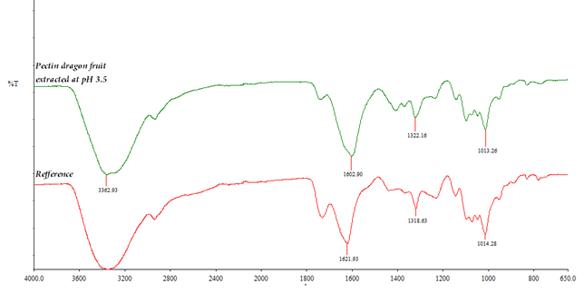

Figure 2 FTIR spectrum from dragon fruit extract pectin (green) at pH 3.5 and commercial pectin (red)

A soft hydrongel was obtained from the synthesis reaction. After being dried for 24 hours at 40 °C, these well-crosslinked gels produced a flexible swollen hydrogel when it immersed in water. The grafting reaction between monomers involved was suggested as shown in Figure 3.
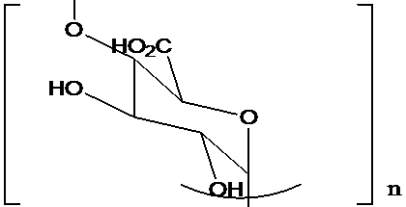
Acrylic acid Pectin
70ºC
+

Figure 3 Schematic grafting reaction between monomers AA and PcDF to produce AA-PcDF

Figure 4 shows the structure of AA-PcDF hydrogel in comparison with PcDF and Acrylic acid before polymerization of hydrogel. For PcDF spectra, peaks at 3200 –3260 cm^{–1} indicate the –OH stretching. It clearly shows that the peak of –OH at PcDF spectrum disappears after the polymerization. As be seen at acrylic acid spectrum, a strong peak at 900 cm⁻¹ indicated the C=CH₂ group disappeared after the polymerization where the absence of any peak at this area suggests pectin dragon fruit and acrylic acid were grafted (Figure 3).

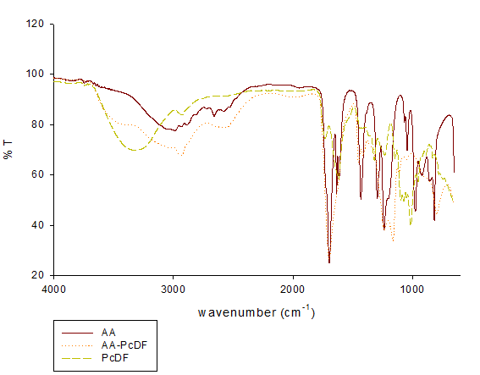

Loss of C=CH₂

Figure 4 FTIR spectra for AA, PcDF and AA-PcDF

Swelling test
The swelling effects on different weight ratio of AA to PcDF were investigated and the results were shown in Figure 5. It was demonstrated that the AA-PcDF hydrogels highly swelled in pH 7 compared to other pH. This condition occurred due to electrostatic repulsion between the ionized acid groups of poly-acrylic acid. It also being supported by the amount of solvent penetrated the networks. Of all the ratios tested, it was found that hydrogels with 1:4 ratios gave the highest swelling percentage with 3475%. The amount of pectin contributed to the increasing of the hydrogel’s expansion due to presence of carboxylic acid in pectin itself. Due to the increasing of charges it leads to electrostatic repulsion between the ionized acid groups and as the result the hydrogel swells [6-8].

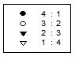

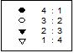

Figure 5 Graf Swelling percentages at a) pH 3, b) pH 7 and c) pH 12
Morphology
Morphology of hydrogel was observed by using the Field Emission Scanning Electron Spectroscopy (FESEM) Zeiss Supra 55VP in dry conditions to investigate the morphology and structure of the hydrogel. The surface image of the hydrogel was taken at 300x magnification. The different images were observed for various samples, AA without pectin, acrylic acid with pectin at ratio of 4:1, 3:2, 2:3, 1:4. A smooth surface was obtained for acrylic acid without pectin as shown in Figure 6a. However, due to the increasing of dragon fruit pectin pores were detected (Figure 6b-6e). Besides elongation of the pectin structure, it also reduces the crosslinking ability between the networks thus porosity sizes increased [9, 10]. This process is simplified as shown in Figure 7.
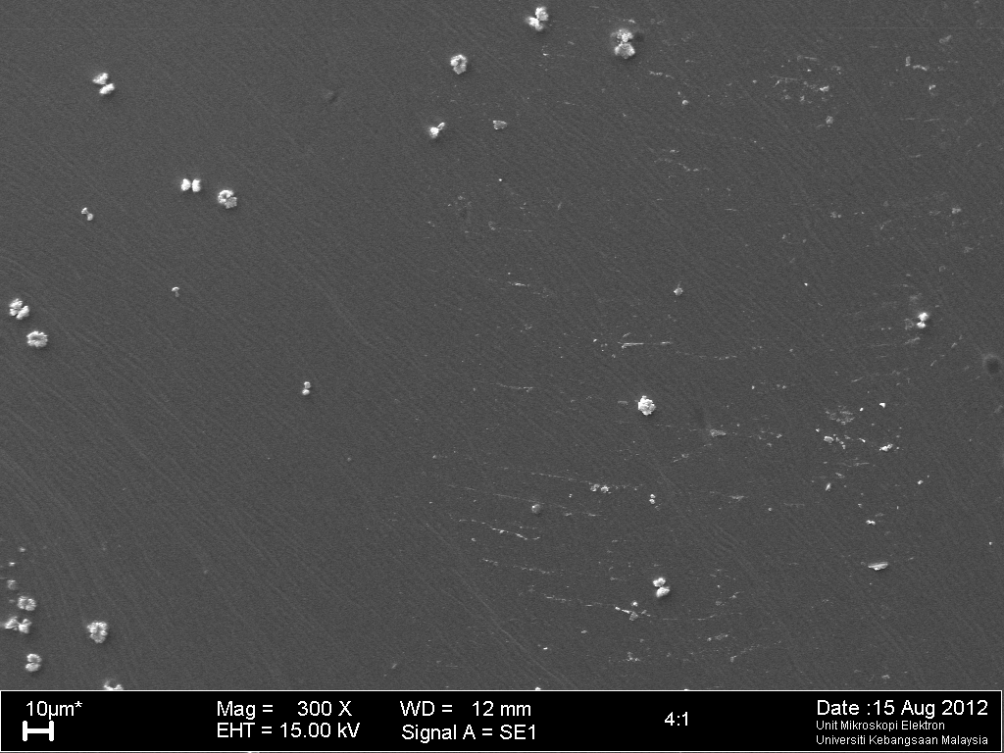
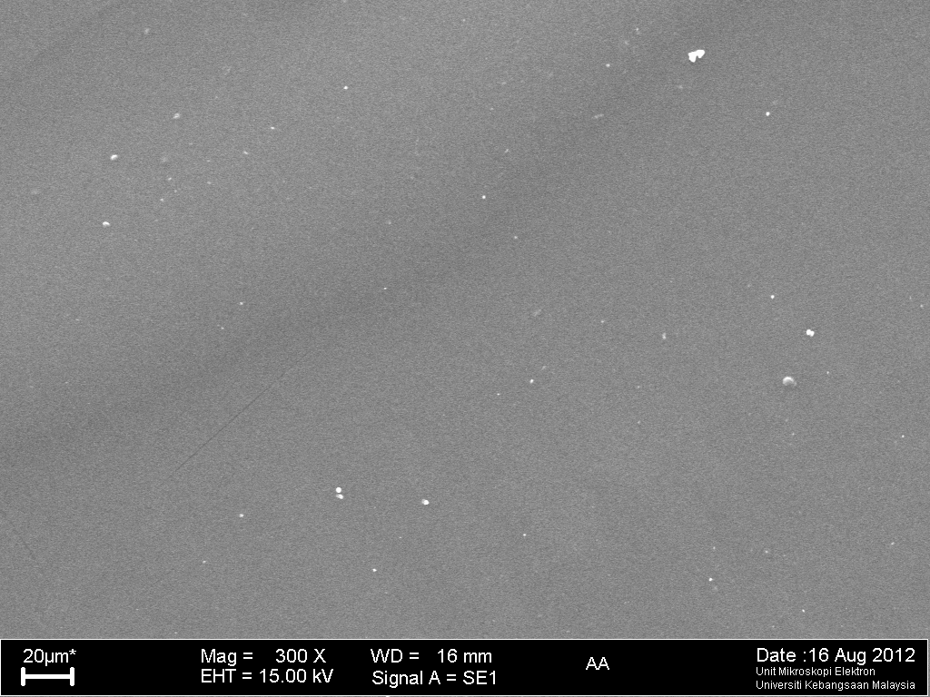
a
b
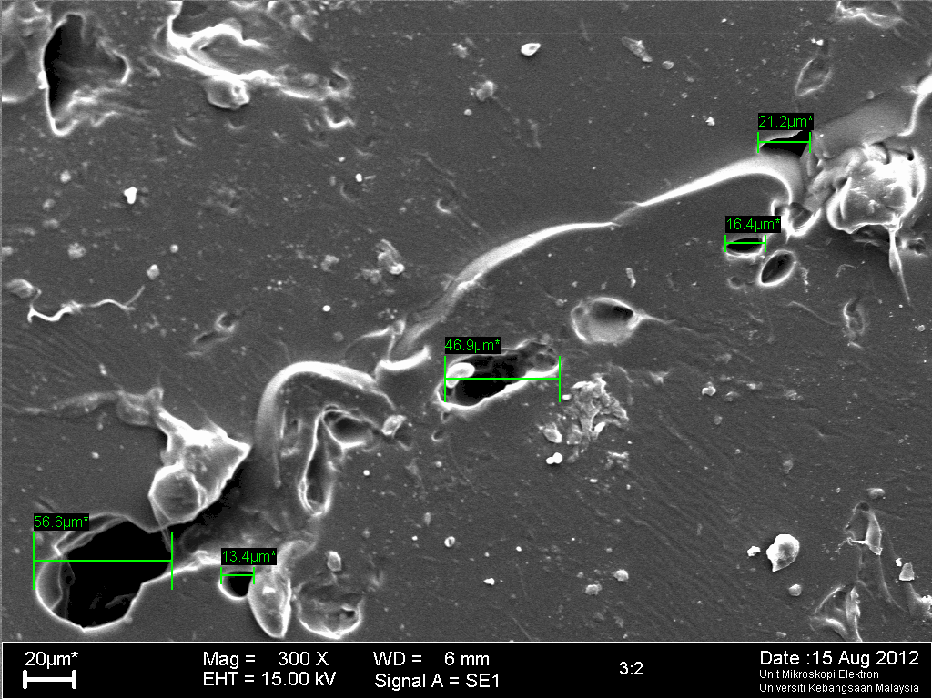
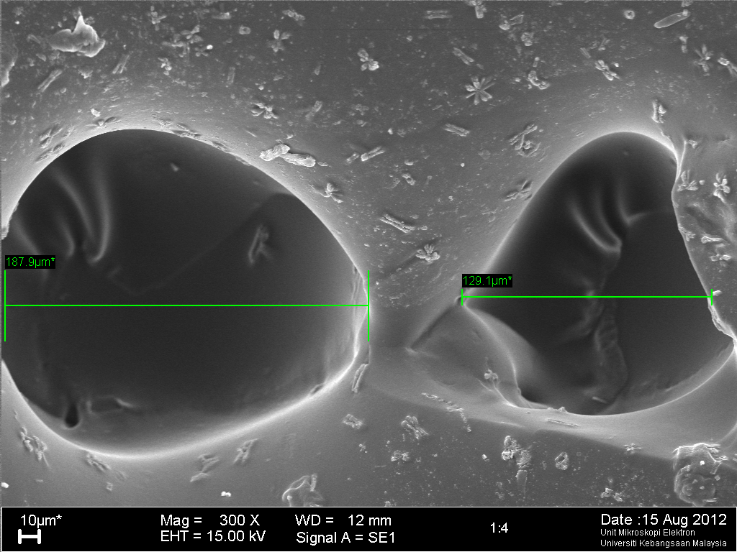
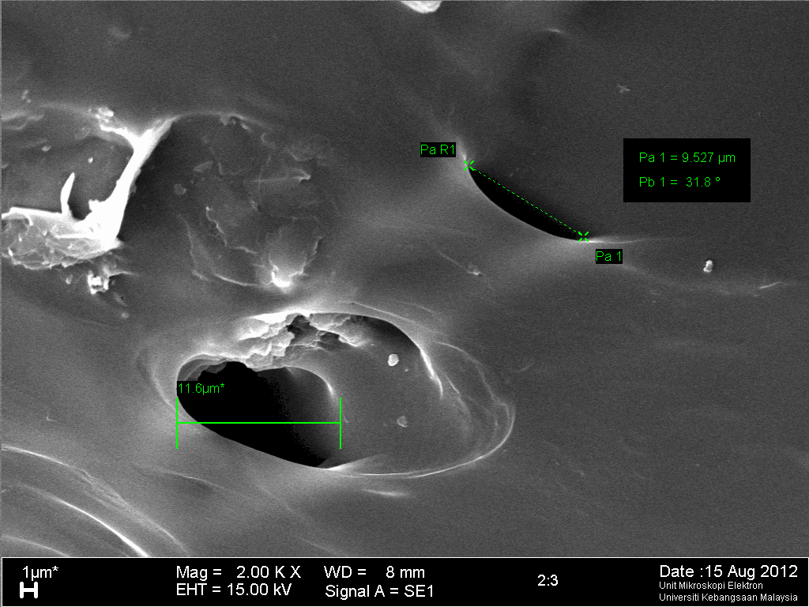
e
c
d

Figure 6 Morphology hydrogel surface in dry conditions. a) Acrylic acid without pectin, while the hydrogel produced with pectin in a ratio of b) 4:1,c) 3:2, d) 2:3 and e)1:4

Pectin
Pore

AA: PcDF AA: PcDF
4: 1 1:4

Figure 7 Diagram represent pore size and number of pores of hydrogel with increasing of pectin ratio

Conclusion
A low methoxy (LM) pectin exctracted from dragon fruit peel with 36 % degree esterification of galacturonic acid was able to be grafted with acrylic acid in order to produce a hydrogel. The percentage of swelling capacity was totally depended ratio of hydrogel acrylic acid and pectin being used. It was found that the hydrogels swelled effectively with 3475 % occurred at pH 7 at a ratio of 1:4. These promising results suggest that AA-PcDF hydrogel is a pH sensitive which possibly used as a drug carrier specifically targeted colon area.

Acknowledgment
This work was financially supported in part by research grants FRGS/1/2011/SG/UKM/02/25 and GGPM-2011-054 given by Universiti Kebangsaan Malaysia and Ministry of Higher Education.

References

- Levigne, S., Ralet, M.C. & Thibault, J.F. (2002). Characterization of pectin extracted from fresh sugar beet under

different conditions using an experimental design. Carbohydrate Polymers 49 : 145-153.
- Kalapathy, U & Proctor, A. (2001). Effect of acid extraction and alcohol precipitation conditions on the yield and purity of soy hull pectin. Food Chemistry 73 : 393 – 396.
- Nazaruddin. R, Norazelina S.M.I, Norziah M.H, & zainuddin M. (2011). Pectin from dragon fruit (hylocereus polyrhius) peel. Malaysian Applied Biology, 40(1): 19 – 23.
- Tang P. Y. Wong C. J W. Woo & K. K (2011). Optimization of pectin extraction from peel of dragon fruit (hylocereus polyrhizus). Asian Journal of Biological Sciences, 4(2):189 – 195.
- Jiang C. M, Liu S. C, Wu M. C, Chang W. H. & Chang H.M. (2005). Determination of degree of esterification of alkaline de-esterified pectin by capillary one electrophoresis. Food Chemistry 91: 551 – 555.
- Mizote A, Odagir H, Toei K., & Tanaka K. (1975). Determination of residues of carboxylic acids (mainly galacturonic acid) and their degree of esterification in industrial pectins by colloid titration with Cat-Floc. Analyst 100: 822 – 827.
- Yoshii F., Zhao L., Wach R.A., Nagasawa N., Mitomo H. & Kume T. (2003). Hydrogel of polysaccharide derivatives crosslinked with irradiation at paste-like condition. Nuclear Instruments and Methods in Physics Research (B) Beam Interactions with Materials & Atoms, 208: 320-324
- Peppas N.A. (1985). Analysis of fickian and non-fickian drug release from polymers. Pharmceutical Acta Helv. 60 : 110 – 111.
- Srisagul S., Pornsak S., Tasana P., Atawit S. & Satit P. (2004). Effect of degree of esterification of pectin and calcium amount on drug release from pectin based matrix tablets. AAPS pharmSciTech, 5(1): Article 9
- May C.D. (1990). Industrial pectin: Sources, production and applications. Carbohydrates polymer 12: 79 – 99.

