GRAPHENE COLLOIDAL DISPERSION IN VARIOUS ORGANIC SOLVENTS

(Penyerakan Koloid Grafin dalam Pelbagai Pelarut Organik)

Ainee Fatimah Ahmad¹, Fatin Humaizah Abd Moin¹, Hur Munawar Kabir Mohd¹, Irman Abdul Rahman¹,
Faizal Mohamed¹, Chia Chin Hua¹, Suria Ramli² & Shahidan Radiman¹*

¹School of Applied Physics, Faculty of Science and Technology,
²School of Chemical Sciences and Food Technology,
Faculty of Science and Technology, Universiti Kebangsaan Malaysia, 43600 Bangi, Selangor, Malaysia.

*Corresponding author: shahidan@ukm.my

Abstract
Graphene is an atom thick carbon-based material that has many intriguing physical and chemicals properties. Since stacks of graphene form graphite, graphene can be produce by chemical exfoliation of graphite in surfactant solution. In this study, the colloidal dispersions of graphene in a variety of organic solvents such as isopropanol, tetrahydrofuran (THF), N-methylpyrrolidone (NMP) and gamma-butyrolactone (GBL) were prepared. Dispersion by bath sonication provides mechanical disruption that breaks apart the graphite flakes, which is then sterically stabilized in the solvent system. FTIR analysis has confirmed the presence of the C=C groups in the samples. By analyzing bright-field TEM images obtained from each dispersion, we have found that the graphene dispersed in isopropanol and THF are multilayered, wrinkled and overlapping graphene sheets; while samples in NMP and GBL are less thick with predominantly folded graphene sheets. The stronger solvents such as NMP and GBL are more effective than isopropanol and THF in obtaining stable graphene dispersions. This will be useful for self-assembly work by dip-coating or monolayer method in the future.

Key words: Graphene, tetrahydrofuran (THF), N-methylpyrrolidone (NMP), gamma-butyrolactone (GBL), Fourier transform infrared spectroscopy (FTIR)

Abstrak
Grafin adalah bahan berasaskan karbon setebal satu atom yang mempunyai ciri-ciri fizikal dan kimia yang menarik. Memandangkan grafit adalah himpunan grafin, ia boleh dihasilkan melalui pengelupasan kimia grafit dalam larutan surfaktan. Dalam kajian ini, serakan koloid grafin telah disediakan dalam pelbagai jenis pelarut organik seperti isopropanol, tetrahidrofuran (THF), N-metilpyrrolidon (NMP) dan butirolakton gama (GBL). Penyerakan oleh sonikasi rendaman memberi gangguan mekanikal yang memisahkan empingan grafit, yang kemudiannya stabil secara sterik dalam sistem pelarut. Analisis FTIR telah mengesahkan kehadiran kumpulan C=C dalam sampel tersebut. Dengan mengkaji imej TEM bagi setiap serakan, didapati sampel dalam larutan isopropanol dan THF merupakan berbilang lapis, berkedut dan helaian grafin yang bertindih; manakala sampel dalam larutan NMP dan GBL adalah kurang tebal dengan sebahagian besarnya dalam bentuk kepingan grafin yang berlipat. Dapat dilihat bahawa pelarut yang lebih kuat seperti NMP dan GBL lebih berkesan daripada isopropanol dan THF dalam menghasilkan penyerakan grafin yang stabil. Hal ini berguna untuk sua-aturan melalui kaedah penyalutan-celup atau kaedah monolapisan pada masa akan datang.

Kata kunci: Grafin, tetrahidrofuran (THF), N-Metilpyrrolidon (NMP), butirolakton gama (GBL), Spektoskopi Inframerah Jelmaan Fourier (FTIR).

Introduction
Graphene is a flat monolayer of carbon atoms tightly packed into a two-dimensional honeycomb lattice, and is the basic building block for all carbon nanostructure [1]. Graphene has shown many intriguing properties including high mobility of charge carriers (20000 cm²V⁻¹s⁻¹), high surface area (≈2600 m²/g), high mechanical strength (≈1 Tpa), and extremely high thermal conductivity (5000 W/mK) [2, 3].
In 2004, Novoselov and Geim developed a micromechanical exfoliation method that consist of repeated peeling of graphite flakes using adhesive tape until the thinnest flakes are obtained which were then transferred onto a clean substrate by gentle pressing of the tape [4]. This method relies on the balance between the inter-layer cohesion and long distance interactions between the tape or the substrate and graphene [1]. In the chemical exfoliation process, the insertion of reactants in the inter-layer space weakens the van der Waals cohesive force. The loosened layer stacking is disrupted when the intercalant decomposition produces a high gas pressure of CO₂ by a rapid annealing to 1050°C. As a result, the sp² lattice is partially degraded into sp²-sp³ sheet that possesses less π-π stacking stability [1].
Chemical exfoliation can be performed in a suspension known as graphite oxide. The most common method to produce graphite oxide was reported by Hummer [5], where graphite is dispersed into a mixture of concentrated sulfuric acid, sodium nitrate and potassium permanganate at 45°C for a couple of hours. In this compound, the graphite layers remain largely intact and the quest molecules or atoms are located in between. To obtain a few or even single sheet materials, the intercalated reactant is decomposed to produce large amounts of gas in the van der Waals space by chemical or thermal means [6]. Then, rapid annealing to 1050°C generates a CO₂ over pressure and splits the graphite oxide into individual sheets [7]. Graphene oxide solutions are yellow in colour or greenish-blue when non-oxidized graphene sheets are the major constituents [8].
Graphene oxide (GO) shows different electronic properties than individual semi-metallic graphene layer obtained by micromechanical exfoliation because this chemical approach converts a large fraction of the sp² carbon into sp³configuration [1]. Thus, a chemical reduction treatment is required for the recovery of the specific properties of graphene. One of the effective reducing agent for graphene oxide is hydrazine( NH₂-NH₂), which is unfortunately a highly toxic reagent [3,9]. GO could be regarded as graphene functionalized by carboxylic acid, hydroxyl and epoxide groups. Hence, these functionalized groups make GO easily dispersed into a few select polar solvents that form an intercalated composite with polar molecules [10, 11]. The intercalation of solvent causes the graphene sheet to swell and lose its mechanical integrity [12]. Nevertheless, large quantities of structural defects introduced by the oxidation process shifts the physical properties away from pristine graphene [13].
In this study, a more straight forward method based on solvation is used, where graphite is dispersed and sonicated in organic solvents to produce graphene sheets. This method is technically similar to the graphene oxide exfoliation method, minus the oxidation step [1]. Solvent or surfactant stabilised graphene is attractive due to its defect free nature for many applications. However, this method produces graphene with a relatively low single-layered content [3,13]. The dispersed materials remains a concentrated suspension of defect free, un-oxidized sp² graphene which can be further homogenized by centrifugation to yield a solutions with 1µm diameter single sheets of graphene [1]. According to Soldano et al. [1], NMP shows the best thermodynamic stabilization and most concentrated suspensions. Furthermore, this colloidal dispersion in solvents is not oxidized to yield genuine graphene.

In this study, graphene was prepared in different solvents under ultrasonic condition and analysed by FTIR and TEM. FTIR analysis of the graphene colloidal dispersion in the NMP solvent was carried out to confirm the presence of C=C bonds of graphene in the sample, while TEM was used to elucidate the morphology of the different graphene sheets.

Materials and Methods

Sample Preparation
In this study, 2mg of sieved graphite powder (Aldrich product 332461) was dispersed in 20ml of isopropanol by bath sonication. Sonication of the dispersion was carried out using a WiseClean WUC-DIOH 200W, 40 kHz, 30% amplitude) ultrasonic bath up to 49 hours. Dispersion by bath sonication provided the mechanical disruption that broke apart the graphite flakes, which was then stabilized by the solvent system [14]. After sonication, the dispersion was grey in color and left to stand for about 24 hours to allow any unstable aggregates to form. To remove these aggregates and stabilise the dispersion, the top 16ml of the dispersion was taken out and consequently centrifuged for 30 minutes at ~15,000 rpm. After this primary centrifugation, the top 13ml of the dispersion was decanted by pipette, forming a homogeneous black dispersion which was retained for use. This procedure was repeated for the three other organic solvents: Tetrahydrofuran (THF), N-Methylpyrrolidone (NMP) and γ-Butyrolactone (GBL). After the final decantation, a small level of sedimentation occurred within 1 week in the isopropanol and THF dispersions and within 2 weeks in NMP and GBL. This suggests that NMP and GBL produced more stable dispersions than isopropanol and THF. Isopropanol is inexpensive and easy to use but solvents like THF, NMP, and GBL are expensive and toxic materials, which require special care when handling.

Characterization
Transmission Electron Microscopy (TEM) images were taken in bright field mode on Tecnai Spirit BioTwin microscope using an accelerating voltage of 120kV. Samples were prepared by dropping a small amount of each dispersions onto Formvar grids. Attenuated total reflectance FTIR (Perkin Elmer BX Spectrophotometer) spectra for graphene dispersion in NMP was used as the representative sample to confirm the presence of the C=C bond in the samples. The solvent NMP has been reported to yield high quality graphene sheets because of the strong interaction between NMP and carbon nanotube sidewall that makes the energetic penalty of exfoliation and solvation become small. Hence, a similar effect is suggested to may be occur between this solvents and graphene [3,15].

Results and Discussion
Figure 1 shows the top-view of bright-field transmission electron microscopy (TEM) images of graphene dispersion in isopropanol, THF, NMP and GBL. By analyzing the TEM images of each dispersion, the morphology of graphene in isopropanol (a) and THF (b) are mostly multilayered, wrinkled and overlapping graphene sheets [10]; while graphene in the NMP (c) and GBL (d) dispersions are less thick, with predominantly folded graphene sheets. In all cases, all graphene sheets have lateral sizes between2- 4 µm [3] from high-magnification TEM image and the sheet edges tend to scroll and fold slightly. The lack of any individual monolayer graphene sheetssuggested thatthe graphite is not fully exfoliated.In order to achieve single or double layered graphene, graphite needs to be re-exfoliated, and consequently ultrasonicated up to 168 hours before finally centrifuged to get a uniform distribution [13,16]. Separation of graphene layers depends on the mechanical disruption of the graphene stacking by ultrasonication [1]. From these images, we can conclude that NMP and GBL are better solvents than isopropanol and THF to yield a stable layer dispersion of graphene.

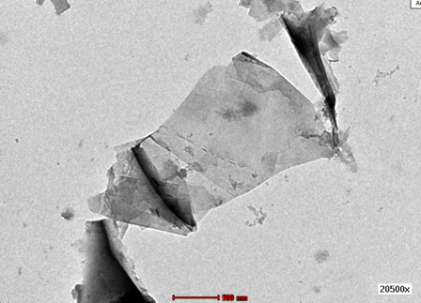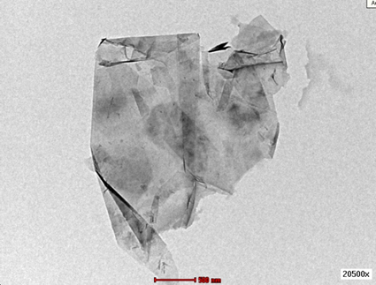
- (b)
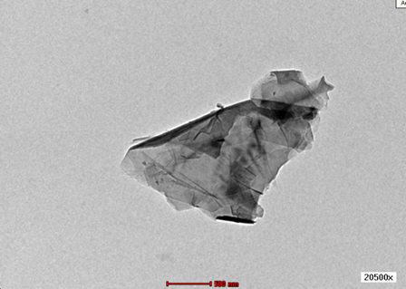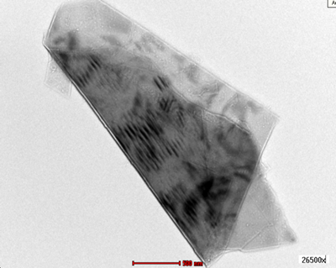
(c) (d)
Figure 1. Bright field TEM images of graphene sheet in (a) multi-layered/overlapping in isopropanol, (b) wrinkled/scrolled in THF, less thickness with folded layer in (c) NMP and (d) GBL.

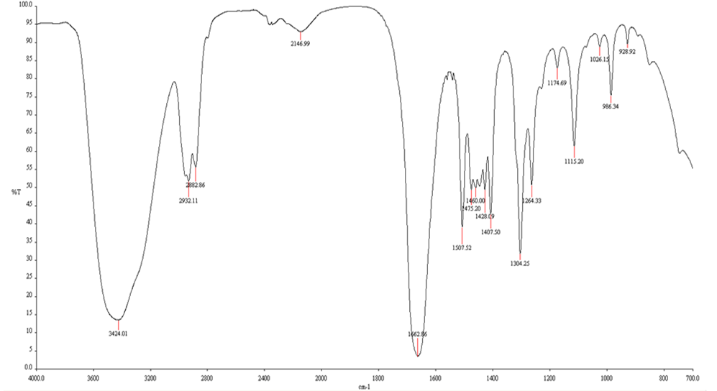
C=C
Figure 2. FTIR spectra of graphene dispersion in NMP shows peaks associated with C=C (~1662cm⁻¹) and N-H (~3424cm⁻¹).

FTIR spectra of graphene dispersed in NMP was obtained. The spectra in Figure 2 shows peaks associated with the C=C (~1662cm⁻¹) and N-H (~3424cm⁻¹) bands. The 2932 cm⁻¹, 2882cm⁻¹, 2146 cm⁻¹, 1460 cm⁻¹and 1174 cm⁻¹bands correspond to the C-H stretching vibrations of the hydrocarbon group. The C=C stretch band indicates the presence of graphene in the dispersion, where the C=C stretch band shows the remaining sp²character [17].
Successful dispersion of graphene monolayers was reported by Hernandez et al. [15], where graphite was almost completely exfoliated to multilayer structures with less than 5 layers in NMP, GBL and N,N’-Dimethylethyleneurea (DMEU), with significant quantities of individual monolayers. The authors estimate that the fraction of monolayer graphene in their NMP dispersion as 28%.
The dispersion in NMP can be improved by intercalating graphite with alkaline metals like potassium [18]. In this compound, electrons from the metallic potassium transfers to graphene and reduces the carbon atoms; forming negatively charged sp² graphene. When exposed to NMP, the satked sheets exfoliate and form a stable suspension, even without the ultrasonication process [18]. Polyvinylpyrrolidone, PVP can be used as a graphene dispersion stabilizer in a variety of solvents by preventing reaggregation by adsorbing on the graphene surface. By using PVP, graphene flakes forms a stable solution in comparison to without the PVP and can be easilly sedimented out through centrifugation [19]. Use of PVP as stabilizer will be explored in our future experiment.
Graphene dispersion is stabilized against re-aggregation by the presence of repulsive interactions between nearby surfactant-coated graphene. Surfactant consists of a hydrophilic head group and hydrophobic tail group. The structure of the head group controls the nature of the repulsive interactions [20]. Non-ionic surfactants have a polar head group, while ionic surfactants have an ionic head group. Thus, the repulsions are electrostatic in nature for ionic surfactants [20,21]. For non-ionic surfactants, the repulsions can be due to many sources such as steric interaction [22]. This method will be explored in our future work whilst preparing dispersions of graphene in a range of surfactants, in order to gain understanding the physico-chemistry of the surfactant-stabilization process [20].
Chemical exfoliation acts by weakening the van der Waals (VDW) cohesive forces upon insertion of reactants in the inter-layer space. Surface energy for graphite is defined as the energy per unit area required to overcome the VDW forces when peeling 2 sheets apart, with the literature suggested value of ~70-80 mJm⁻² [15]. Thus, an energy input of over 2eV/nm² of graphene surface is required to exfoliate pristine graphene into solution [1,14].

Conclusion
Colloidal dispersion in solventsunder ultrasonic condition was shown as a simple method to produce graphene of few layers without the need of oxidization with different solvents. The lack of single layered graphene sheets suggests that the graphite used as the feeder material was not fully exfoliated. NMP and GBL were found to be stronger solvents and more effective than isopropanol and THF in yielding stable graphene dispersions. The FTIR spectra obtained from the dispersion in NMP displayed the presence of the C=C bond, which confirmed the presence of graphene in the dispersion. TEM revealedthat the graphene-sheets obtained by sonication and centrifugationwere multilayered, wrinkled and overlapped in the isopropanol and THF solvents, while samples in NMP and GBL were less thick, with predominantly folded graphene sheets.This dispersion method offers a straight forward and low cost alternative to produce graphene for various technological applications like graphene based composites or solar cells [16].
Acknowledgements
The authors would like to acknowledge the financial support from UKM in this study, through grants UKM-GUP-2011-214, ERGS/1/2012/STG02/UKM/02/01, UKM-AP-NBT-15-2010 and UKM-PTS-011-2010.

References
- Soldano, C., Mahmood, A. & Dujardin, E. (2010). Production, Properties and Potential of Graphene. Carbon, 48:2127-2150.
- Geim, A.K. & Novoselov, K.S. (2007). The Rise of Grapehene. Nature Materials, 6:183-191.
- Park, S. & Ruoff, R.D. (2009). Chemical methods for the production of graphenes. Nature Nanotechnology 4:217-224.
- Novoselov, K.S., Geim, A.K., Morozov, S.V., Jiang, D., Zhang, Y., Dubonos S.V., Grigorieva, I.V. & Firsov, A.A., (2004). Electric Field Effect in Atomically Thin Carbon Films. Science, 306:666-669.
- Hummers, W.S. & Offeman, R.E. (1958). Preparation of Graphite Oxide. Journal of the American Chemical Society, 80(6):1339.
- Dressehaus, M.S. & Dressehaus, D. (2009). Intercalation Compounds of Graphite. Advance Physics, 51(1):1-186.
- Schniepp, H.C., Li, J.L., McAllister, M.J., Sai, H., Herrera-Alonso, M. & Adamson D.H. (2006). Functionalized Single Graphene Sheets Derived from Splitting Graphite Oxide. Journal of Physical Chemistry B, 110(17):8535-8539.
- McAllister, M.J., Li, J.L., Adamson, D.H., Schniepp, H.C., Abdala, A.A. & Liu, J. (2007). Single Sheet Functionalized Graphene by Oxidation and Thermal Expansion of Graphite. Chemistry of Material, 19(18):4396-4404.
- Li, D., Muller, M.B. Gilje, S., Kaner, R.B. & Wallace, G.G. (2008). Processable Aqueous Dispersions of Graphene Nanosheets. Nature Nanotechnology, 3(2):101-105.
- Chen, Y., Qi, Y., Tai, Z., Yan, X., Zhu, F., & Xue, Q. (2012). Preparation, mechanical properties and biocompatibility of graphene oxide/ultrahigh molecular weight polyethylene composites. European Polymer Journal, 48:1026-1033.
- Zhou, X.Z., Huang, X., Qi, X.Y., Wu, S.X., Xue, C., Boey F.Y.C., Yan, Q., Chen, P. & Zhang, H. In situ synthesis of metal nanoparticles on single-layer graphene oxide and reduced graphene oxide surfaces. Journal of Physical Chemistry C, 113:10842–6.
- Stankovich, S., Dikin, D.A., Compton, O.C., Dommett, G.H.B., Ruoff, R.S. & Nguyen S.T. (2010). Systematic Post-assembly Modification of Graphene Oxide Paper with Primary Alkylamines. Chemistry of Material, 22:4153-4157.
- Hernandez, Y., Nicolosi, V., Lotya, M., Blighe, F.M., Sun, Z. & De, S. (2008). High-yield Production of Graphene by Liquid-phase Exfoliation of Graphite. Nature Nanotechnology, 3(9):563-568.
- Khan, U., O’Neill, A., Porwal, H., May, P., Nawaz, K. & Coleman, N.J. (2012). Size of selection of dispersed, exfoliated graphene flakes by controlled centrifugation. Carbon, 50:470-475.
- Green, A.A.& Hersam, M.C. (2010). Emerging Methods for Producing Monodisperse Graphene Dispersions. The Journal of Physical Chemistry Letters, 1:544-549.
- Dhakate, S.R., Chauhan, N., Sharma, S., Tawale, J., Singh, S., Sahare, P.D. & Mathur. (2011). An approach to produce single and double layer graphene from re-exfoliation of expanded graphene. Carbon 49,1946-1954.
- Dato, A., Lee, Z., Jeon, K.J., Erni, R., Radmilovic, V., Richardson, T.J. & Frenklach, M. (2009). Clean and highly ordered graphene synthesized in the gas phase. Chemical Communications, 6095-6097.
- Valles, C., Drummond, C., Saadaoui, H., Furtado, C.A., He, M. & Roubeau, O. (2008). Solutions of Negatively Charged Graphene Sheets and Ribbons. Journal of the American Chemical Society, 130(47):15802-15804.
- Wajid, A.S., Das, S., Irin, F., Tanvir Ahmed H.S., Sherlburne, J.L., Parviz, D., Fullerton, R.J., Jankowski, A.F., Hedden, R.C. & Green M.J. (2012). Polymer-stabilized graphene dispersions at high concentrations in organic solvents for composite production. Carbon, 50:526-534.
- Smith, R.J., Loyta, M. & Coleman, J.N. (2010). The Importance of Repulsive Potential Barriers for the Dispersion of Graphene Using Surfactants. New Journal of Physics, 12: 125008.
- Hunter, R.J. (1993). Interaction to Modern Colloid Science. Oxford: Oxford University Press.
- Israelachvili, J. (1991). Intermolecular and Surface Forces. New York: Academic Press.

