DIFFERENTIATING AGARWOOD OIL QUALITY USING ARTIFICIAL NEURAL NETWORK

(Perbezaan Kualiti Minyak Gaharu Menggunakan Rangkaian Neural Tiruan)

Nurlaila Ismail^{1*}, Nor Azah Mohd Ali², Mailina Jamil², Mohd Hezri Fazalul Rahiman¹, Saiful Nizam Tajuddin³ and Mohd Nasir Taib¹

¹Faculty of Electrical Engineering,Universiti Teknologi MARA (UiTM), 40450 Shah Alam, Selangor

²Herbal Product Development Programme, Natural Products Division, Forest Research Institute Malaysia (FRIM), 52109 Kepong, Selangor

³Faculty of Industrial Science and Technology, Universiti Malaysia Pahang (UMP), Lebuhraya Tun Razak, 26300 Gambang, Pahang

*Corresponding author: nrk_my@yahoo.com

Abstract

Agarwood oil is well known as expensive oil extracted from the resinous of fragrant heartwood. The oil is getting high demand in the market especially from the Middle East countries, China and Japan because of its unique odor. As part of an on-going research in grading the agarwood oil quality, the application of Artificial Neural Network (ANN) is proposed in this study to analyze agarwood oil quality using its chemical profiles. The work involves of selected agarwood oil from low and high quality, the extraction of chemical compounds using GC-MS and Z-score to identify of the significant compounds as input to the network. The ANN programming algorithm was developed and computed automatically via Matlab software version R2010a. Back-propagation training algorithm and sigmoid transfer function were used to optimize the parameters in the training network. The result obtained showed the capability of ANN in analyzing the agarwood oil quality hence beneficial for the further application such as grading and classification for agarwood oil.

Keyword: agarwood oil, chemical compounds, quality, gas chromatography-mass spectrometry (GC-MS) and Artificial Neural Network (ANN)

Abstrak

Minyak gaharu dikenali sebagai minyak mahal yang diekstrak daripada resin kayu yang berbau wangi. Minyak ini mendapat permintaan yang tinggi di pasaran terutama dari negara-negara Timur Tengah, China dan Jepun kerana baunya yang unik. Sebagai sebahagian daripada penyelidikan untuk menentukan gred kualiti minyak gaharu, penggunaan rangkaian neural tiruan (ANN) dicadangkan dalam kajian ini untuk menganalisis kualiti minyak gaharu. Kerja ini melibatkan minyak gaharu yang terpilih dari kualiti rendah dan tinggi, pengekstrakan komponen kimia menggunakan GC-MS dan Z-skor untuk mengenalpasti sebatian penting sebagai input kepada rangkaian. Pengaturcaraan algoritma untuk ANN telah dihasilkan dan dilakukan secara automatik melalui perisian Matlab versi R2010a. Algoritma penyebaran undur untuk sesi latihan dan fungsi peralihan sigmoid telah digunakan untuk mengoptimumkan parameter dalam rangkaian latihan. Keputusan yang diperolehi menunjukkan keupayaan ANN dalam menganalisis kualiti minyak gaharu dan seterusnya bermanfaat untuk kegunaan selanjutnya seperti penggredan dan klasifikasi minyak gaharu.

Kata kunci: minyak gaharu, bahan kimia, kualiti, gas kromatografi-spektrometri jisim dan Rangkaian Neural Tiruan

Introduction

Agarwood oil is an expensive oil and is extracted from the resinous of fragrant heartwood of Aquilaria species [1]. This species is a genus and belongs taxonomically to the Thymelaeaceae family. The multiples usages of agarwood oil make this oil gets high demand in the market especially from the countries in The Middle East, China and Japan [1-3]. It can be used as incense, in perfume ingredient and medical preparation, during religion and wedding ceremony and also as a symbol of wealth in certain country [1, 4-6]. The agarwood oil has been sold in various qualities based on its physical appearance such as color and odor. Consumer perception and high fixative properties also give marks in qualifying the agarwood oil thus affect its price in the market [1, 7]. However this conventional technique makes the price of agarwood oil fluctuates and not standardize in the market. A standard is needed to ensure that the agarwood oil can be qualified according to its chemical properties so that accuracy can be trusted [4, 8]. Therefore, as part of an on-going research in grading the agarwood oil quality, the application of ANN is proposed to analyze agarwood oil quality using its chemical profiles. The chemical profiles refer to the complex mixtures of sesquiterpene and its chromone derivatives in agarwood oil [9-11].

Materials and Methods

Plant Material

Fifteen agarwood oil samples obtained at Forest Research Institute Malaysia (FRIM) and Universiti Malaysia Pahang (UMP) were used in this study. The oils are Aquilariamalaccensis species were sold as high and low qualities to the institutions by the agarwood traders certified by the Forestry Department, Malaysia [12]. The samples were labeled as LG, RG, HG, CM, MNS, EO3, EO2, EO4, MN, MS, M, MPE, T, MA1, LA, KB, JBD, MA2 and MA for high quality oils and CKE, R5 and HD for low quality oils.

GC-MS analysis

GC-MS analysis is carried out using Agilent Technologies 7890A/5975C Series MSD with HP-5MS column (30m x 0.25mm ID x 0.25µm film thickness). At first, the apparatus is set at 60˚C for 10min time duration, followed by 180˚C for 1min at 3˚C/min. The gas carrier helium is injected at a flowrate of 1.0mL/min and the ion-source temperature is programmed at 280˚C. The chemical compounds are identified by matching them to the mass spectral library (HPCH2205.L; Wiley7Nist05a.L; NIST05a.L). The chemical compounds are presented in terms of abundances (%) [4].

ANN structure and training

The ANN theory applied in this study has been adequately described before[13]. The ANN algorithms were computed by the Matlab software version R2010a for evaluation. It applied feed-forward neural network using back propagation training algorithm. This algorithm is used to adjust the network weights. The input is determined based on the number of input nodes. Therefore in this study the input nodes in number of significant chemical compounds as identified by Z-score. The Z-score application was briefly explained in the previous work [14].

There were ninety six of agarwood oil chemical compounds used as input-output data for ANN analysis. The data were divided into two datasets; training and testing using the ratio of 80%;20% [15]. Seven chemical compounds were used as input for the training data set. The output layer consists of only one node which corresponds to the quality of the agarwood oil, i.e. either high or low. The learning rate, momentum rate and hidden layer size were determined and optimized during the training of the network using the sigmoid transfer function. Mean square error (m.s.e.) was performed to evaluate the ANN performance. After that, the final parameters from ANN training were used for ANN validation.

Result and Discussion
Figure 1 shows the chemical composition or abundances (%) pattern of chemical compounds extracted by GC-MS. It can be seen that there is variation of abundances pattern belong to each of chemical compounds. The abundances for agarwood oil are different to each other. This finding proves that the agarwood oil chemical profile is a complex mixture of sesquiterpenes and its chromone derivatives [9-11] and the difference spotted confirms the finding by other researcher [16]. The pattern variation displays the behavior of the chemical compounds of agarwood oils. It is noticed that, four high peaks of abundances are recognized. They belong to compound no. 4 i.e. α-gurjunene, compound no.20 i.e. cis-β-guaiene, compounds no. 46. i.e. ɤ-eudesmol and compounds no. 71 i.e. β-costol. Different pattern and dissimilarity of abundances (%) amount exist in agarwood oils due to several factors such as ecological condition, environmental and genetic factors of each sample [6].

The chemical compounds and its abundances of agarwood oils as extracted by GC-MS were tabulated in Table 1 and Table 2 for high and low quality, respectively. Table 1 consists of LG, RG, HG, CM, MNS, EO3, EO2, EO4, MN, MS, M, MPE, T, MA1, LA, KB, JBD, MA2 and MA agarwood oils. These agarwood oils are traded as high quality in the market and some of them are published as supreme agarwood oil [17]. There were seven significant chemical compounds as identified by Z-score. They were β-agarofuran, α-agarofuran, 10-epi-ɤ-eudesmol, ɤ-eudesmol, longifolol, hexadecanol and eudesmol. It was observed that the chemical compounds such as longifolol, hexadecanol and eudesmol are not appear in almost the agarwood oil for this quality. 10-epi-ɤ-eudesmol is found in all samples. β-agarofuran as the most important compound in high quality agarwood oil [2] is found in all agarwood here except for EO4, MN, MS and M.

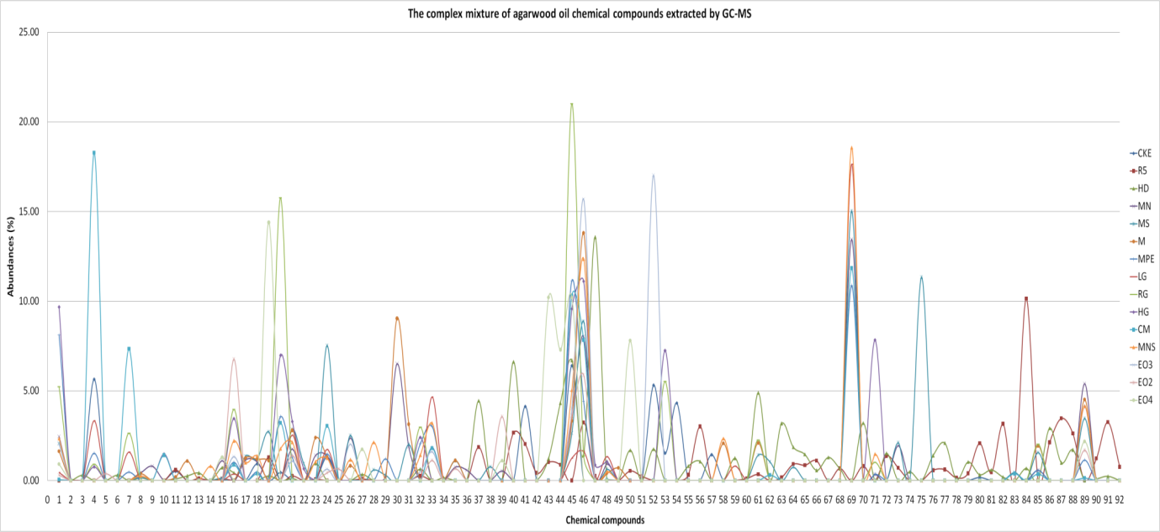
Notes: 1= 4-phenyl-2-butanone, 2= Nonanoic acid, 3= Decanoic acid, 4= α-gurjunene, 5= α-cedrene, 6= β-maaliene, 7= β-Gurjunene, 8= α-guaiene,9= β-humulene, 10= α-guaiene, 11= aromadendrane, 12= amorpha-4,11-diene, 13= Drima-7,9(11)-diene, 14= valencene, 15= ϒ-gurjunene, 16= β-agarofuran,17= ϒ-muurolene, 18=ar-curcumene, 19=β-selinene, 20=cis-β-guaiene, 21=α-muurolene,22= β-dihydroagarofuran, 23=α-bulnesene, 24=ϒ-cadinene, 25=δ-cadinene, 26=cis-calamenene, 27=α-elemol, 28=(Z)-nerolidol, 29=α-cadinene, 30=selina-3, 7(11)-diene, 31=hedycaryol, 32=α-agarofuran, 33=elemol, 34=nor-keto-agarofuran, 35=β-calacorene, 36=dodecanoic acid, 37=epoxy-bulnesene, 38=spathulenol, 39=viridiflorol, 40=tetradecanal, 41=β-gurjunene, 42=guaiol, 43=hinesol, 44=1,5-epoxy-nor-ketoguaiene, 45=10-epi-ɤ-eudesmol, 46=ɤ-eudesmol, 47=agarospirol, 48=allo aromadendrene epoxide, 49=selina 3,11-dien-6α-ol,50= jinkoh-eremol, 51=kusunol, 52=α-eudesmol, 53=valerianol, 54=selina 11-en-4α-ol, 55=bulnesol, 56=dehydrojinkoh-eremol, 57=β-bisabolol, 58=cadalene, 59=α-bisabolol, 60=selina-3,11-dien-9-one, 61=cyperotundone, 62=10-nor-calamenen-10-one,63= rotundone, 64=longifolol, 65=selina-4,11-dien-14-oic acid, 66=selina-3,11-dien-14-al, 67=9,11-eremophiladiene, 68=selina-3,11-dien-14-ol, 69=α-eudesmol, 70=selina-4,11-dien-14-al, 71=β-costol, 72=guaia-1(10),11-dien-15-ol, 73=selina-3,11-dien-14-oic acid, 74=sinenofuranol, 75=14-hydroxy-α-muurolene, 76=2-hexadecanone, 77=dihyrokaranone, 78=guaia-1(10),11-dien-15-al,79= karanone, 80=oxo-agarospirol, 81=pentadecanoic acid, 82=hexadecanol, 83=hexadecanoic acid, 84=eudesmol, 85=thujopsenal, 86=palmitic acid, 87=2-hydroxyquaia-1(10),11,15-oic acid, 88=9-hydroxyselina-4,11-dien-14-oic acid, 89=dihydrocollumellarin, 90=1,5-diphenyl-2-pentene, 91=guaia-1(10),11-dien-15,2-olide, 92=oleic acid

Figure 1. The abundances pattern for agarwood oil chemical compounds extracted by GC-MS

Table 2 tabulated the low quality of agarwood oils which is comprises of CKE, R5 and HD. As similar to the chemical compounds in high quality oil, there were seven significant chemical compounds as identified by Z-score; β-agarofuran, α-agarofuran, 10-epi-ɤ-eudesmol, ɤ-eudesmol, longifolol, hexadecanol and eudesmol. From this table, it is noticed that only 10-epi-ɤ-eudesmol appears in CKE. The rest of the compounds do not exist in this agarwood oil. As expected, longifolol, hexadecanol and eudesmol are detected as R5 and HD.

Table 1. The high quality of agarwood oils

No. | Chemical compounds | Abundances (%)
No. | Chemical compounds | LG | RG | HG | CM | MNS | EO3 | EO2 | EO4 | MN | MS | M | MPE
C1 | β-agarofuran | 0.36 | 3.96 | 3.47 | 0.88 | 2.21 | 1.33 | 6.77 | 0.00 | 0.00 | 0.00 | 0.00 | 1.02
C2 | α-agarofuran | 0.00 | 2.98 | 2.41 | 0.00 | 1.42 | 0.50 | 0.00 | 0.00 | 0.00 | 0.00 | 0.00 | 2.06
C3 | 10-epi-ɤ-eudesmol | 1.25 | 21.01 | 9.58 | 10.31 | 5.04 | 4.04 | 3.63 | 10.21 | 3.41 | 2.64 | 3.33 | 11.14
C4 | ɤ-eudesmol | 1.62 | 1.38 | 11.11 | 7.83 | 12.36 | 15.67 | 5.88 | 0.00 | 8.03 | 8.87 | 13.80 | 4.40
C5 | longifolol | 0.00 | 0.00 | 0.00 | 0.00 | 0.00 | 0.00 | 0.00 | 0.00 | 0.00 | 0.75 | 0.00 | 0.00
C6 | hexadecanol | 0.00 | 0.00 | 0.00 | 0.00 | 0.00 | 0.00 | 0.00 | 0.00 | 0.00 | 0.00 | 0.00 | 0.00
C7 | eudesmol | 0.00 | 0.00 | 0.00 | 0.00 | 0.00 | 0.00 | 0.00 | 0.00 | 0.00 | 0.00 | 0.00 | 0.00

Table 1 (continued): The high quality of agarwood oils
No. | Chemical compounds | Abundances (%)
No. | Chemical compounds | T | MA1 | LA | KB | JBD | MA2 | MA
C1 | β-agarofuran | 4.33 | 1.73 | 2.04 | 1.02 | 1.02 | 1.42 | 5.01
C2 | α-agarofuran | 3.53 | 1.72 | 1.37 | 1.47 | 1.76 | 1.48 | 2.73
C3 | 10-epi-ɤ-eudesmol | 9.76 | 10.91 | 7.65 | 7.07 | 8.14 | 8.28 | 20.6
C4 | ɤ-eudesmol | 0.00 | 8.16 | 0.00 | 30.36 | 14.85 | 12.93 | 3.11
C5 | longifolol | 0.00 | 0.00 | 0.00 | 0.00 | 0.00 | 0.00 | 0.00
C6 | hexadecanol | 0.00 | 0.00 | 0.00 | 0.00 | 0.00 | 0.00 | 0.00
C7 | eudesmol | 0.00 | 0.00 | 0.00 | 0.00 | 0.00 | 0.00 | 0.00

Table 2: The low quality of agarwood oils
No. | Chemical compounds | Abundances (%)
No. | Chemical compounds | CKE | R5 | HD
C1 | β-agarofuran | 0.00 | 0.00 | 0.43
C2 | α-agarofuran | 0.00 | 0.25 | 0.64
C3 | 10-epi-ɤ-eudesmol | 6.42 | 0.00 | 6.70
C4 | ɤ-eudesmol | 0.00 | 3.24 | 1.45
C5 | longifolol | 0.00 | 0.91 | 1.87
C6 | hexadecanol | 0.00 | 3.16 | 0.20
C7 | eudesmol | 0.00 | 10.15 | 0.68

Figure 2 shows the ANN final training errors with varying learning rate. The learning rate is varied from 0.1 to 1. Graphically, it can be seen that learning rate at 0.9 has minimum m.s.e. of 0.0038. The learning rate of 0.9 is used to adjust the next parameter in the training cycle.

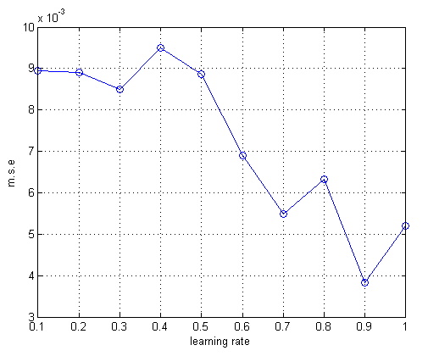

Figure 2. ANN final training errors with varying learning rate

Figure 3 shows the ANN final training errors with varying momentum rate. The momentum rate is varied from 0.1 to 1.0. It is observed that learning rate at 0.7 provides lowest m.s.e. (0.0028). The momentum rate of 0.7 is used to adjust the hidden layer for ANN training network.

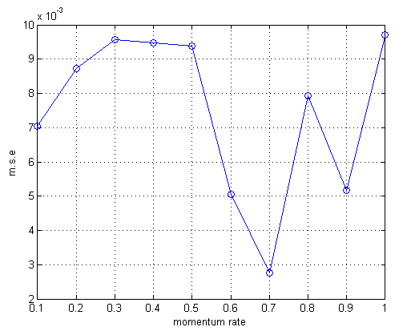

Figure 3. ANN final training errors with varying momentum rate

Figure 4 shows the ANN final training errors with varying hidden layer sizes. The hidden layer size is varied from 1 to 10. The hidden layer size at 2 nodes provides the lowest m.s.e. of 0.0011. The learning rate at 0.9, momentum rate at 0.7 and hidden layer size at 2 nodes were set as final parameters to train the ANN network.

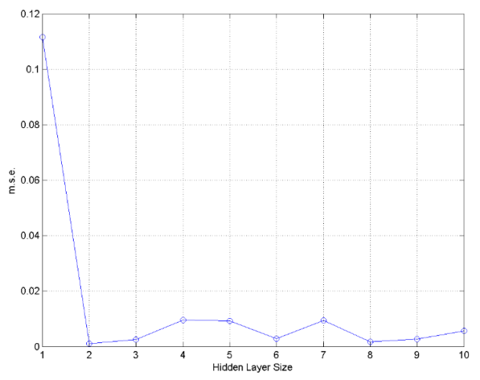

Figure 4. ANN final training errors with varying hidden layer size

Table 3 summarizes the ANN final design parameters for the ANN architecture and training parameters. The nodes in input layer is set as 7, represented by seven significant compounds in agarwood oils (C1 to C7) and the output layer is 1 which is the quality of agarwood oils either high (2) or low (1). The error goal used is 0.01 with the epochs is 100. The other adjusted parameters such as learning rate, momentum rate and nodes in hidden layer are optimum at 0.9, 0.7 and 2, respectively.

Table 3. ANN final design parameters
Parameters | Value
Nodes in input layer | 7
Nodes in hidden layer size | 2
Output layer size | 1
Learning rate | 0.9
Momentum rate | 0.7
Error goal | 0.01
Epochs | 100

Figure 5 shows the ANN prediction for the training network using the optimised parameters. The training network prediction shows two groups being predicted. Vividly, we can see that the first group, i.e. ‘1’ for low quality, the predicted target is less than 1.4 and for the second group, i.e. ‘2’ for high quality, the predicted target is between 1.8 to 2.0.

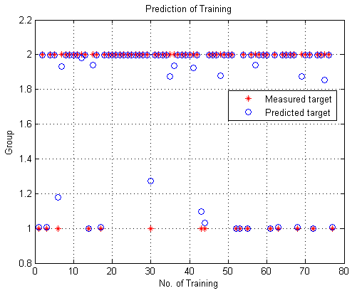

Figure 5. ANN prediction for the training network

Figure 6 shows the prediction of the ANN testing using the optimised training network. It is clear that the predicted targets fall under two groups such as 1 and 2.

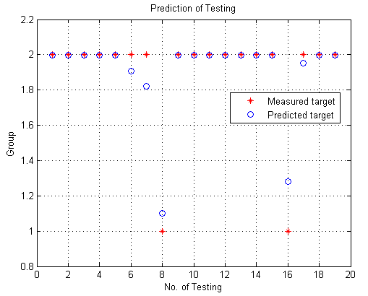

Figure 6. ANN Testing prediction

Figure 7 shows the prediction errors for ANN testing. It is observed that the errors are within -0.03 to 0.02, which is very small and acceptable for nineteen numbers of testing targets of agarwood oil quality.

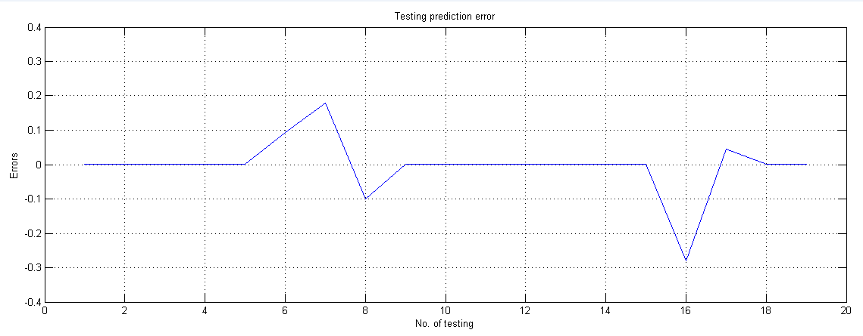

Figure 7. Prediction errors for ANN testing

From the above results, it is clear that the network with 2 nodes in hidden layer size provides one of the best structures for yielding highly accurate prediction of agarwood oil quality. The network successfully differentiated the quality high and low with the worst error of only 0.02 (see Figure 7) with a small error goal i.e. 0.01. The finding proved that the network managed to solve the difficulties in grading the agarwood oil quality using the conventional calibration method as stated before in Introduction. Finally, an application of the trained network with 2 hidden neurons was demonstrated by feeding it with seven new significant chemical compounds as identified by z-score technique i.e. β-agarofuran, α-agarofuran, 10-epi-ɤ-eudesmol, ɤ-eudesmol, longifolol, hexadecanol and eudesmol. This is as expected since these significant chemical compounds were identified for both quality of agarwood oil, high and low and they are belonging to the sesquiterpenes compounds.

Conclusion

The study showed that the application of ANN in analyzing the agarwood oil quality has been successful. The result obtained demonstrates the capability of ANN in predicting the quality of agarwood oil. The significant chemical compounds identified i.e. β-agarofuran, α-agarofuran, 10-epi-ɤ-eudesmol, ɤ-eudesmol, longifolol, hexadecanol and eudesmol are useful and beneficial for further analysis such as grading and classification system of agarwood oil.

Acknowledgement

The authors would like to acknowledge the financial support given to Nor Azah Mohamad Ali by the Malaysian Ministry of Agriculture and Agrobased Industry (Science fund 05-03-10-SF1017), Mohd Nasir Taib through the RIF Grant Code: 600-RMI/DANA 5/3/RIF (614/2012) and Nurlaila Ismail for MyPhD scholarship by The Ministry of Higher Education, Malaysia.

References

- R. Naef (2011). The volatile and semi-volatile constituents of agarwood, the infected heartwood of Aquilaria species: a review, Flavour and Fragrance Journal 26: 73-87.
- P. Tamuli, P. Boruah, S. C. Nath, & P. Leclercq (2005). Essential oil of eaglewood tree: a product of pathogenesis,Journal of Essential Oil Research 17: 601-604, 2005.
- S. N. Tajuddin & M. M. Yusoff (2010). Chemical Composition of Volatile Oils of Aquilaria malaccensis (Thymeleaceae) from Malaysia, Natural Product Communications 5: 1965-1968.
- N. A. B. Sidik (2008).Comparison of Gaharu (Aquilaria Malaccensis) Essential Oil Composition Between Each Country, Bachelor of Chemical Engineering, Faculty of Chemical Engineering and Natural Resources, University Malaysia Pahang.
- J. Pornpunyapat, P. Chetpattananondh, & C. Tongurai (2011). Mathematical modeling for extraction of essential oil from Aquilaria crassna by hydrodistillation and quality of agarwood oil, Bangladesh Journal of Pharmacology 6: 18 - 24.
- P. Pripdeevech, W. Khummueng, & S. K. Park, (2011). Identification of Odor-active Components of Agarwood Essential Oils from Thailand by Solid Phase Microextraction-GC/MS and GC-O, Journal of Essential Oil Research 23: 46-53.
- M. A. NorAzah, Y. S. Chang, J. Mailina, A. A. Said, J. A. Majid, S. S. Husni, H. N. Hasnida, & Y. N. Yasmin (2008). Comparison of Chemical Profiles of Selected Gaharu Oils from Peninsular Malaysia, The Malaysian Journal of Analytical Sciences 12: 338-340.
- N. A. Latif (2009). Analysis volatile compound of Gaharu oil composition via solid phase micro extraction (SPME), Bachelor of Chemical Engineering, Faculty of Chemical & Natural Resources Engineering, University Malaysia Pahang.
- M. Ishihara, T. Tsuneya, & K. Uneyama (1993), Fragrant sesquiterpenes from agarwood, Phytochemistry 33: 1147-1155.
- M. Ishihara, T. Tsuneya, & K. Uneyama, (1991). Guaiane sesquiterpenes from agarwood, Phytochemistry 30: 3343-3347.
- M. Ishihara, T. Tsuneya, M. Shiga, & K. Uneyama, (1991). Three sesquiterpenes from agarwood, Phytochemistry 30: 563-566.
- S. N. Tajuddin (2011). Resolution of complex sesquiterpene mixture in Aqualaria malaccensis (Gaharu) volatile oils using gas chromatography methods, PhD, Faculty of Industry and Science Technology (FIST), Universiti Malaysia Pahang (UMP).
- M. N. Taib, R. Andres, & R. Narayanaswamy (1996). Extending the response range of an optical fibre pH sensor using an artificial neural network, Analytica Chimica Acta 330: 31-40.
- N. Ismail, M. H. F. Rahiman, M. N. Taib, N. A. M. Ali, M. Jamil & S. N. Tajuddin, (2013). Analysis of Chemical Compounds of Agarwood Oil based on Headspace-Solid Phase Microextraction combined with Gas Chromatography Mass-Spectrometry, 2013 IEEE 9th International Colloquium on Signal Processing and its Applications (CSPA 2013): 215 - 218, 8-10 March 2013.
- T. Jayalakshmi & A. Santhakumaran, (2011). Statistical normalization and back propagation for classification, International Journal of Computer Theory and Engineering 3: 1793-8201.
- M. Ishihara, T. Tsuneya, & K. Uneyama (1993). Components of the volatile concentrate of agarwood, Journal of Essential Oil Research 5: 283-289.
- M. A. NorAzah, J. A. Majid, J. Mailina, A. A. Said, S. S. Husni, H. N. Hasnida, M. A. M. N. M. Arip, & Y. S. Chang (2009). Profiles of selected supreme Agarwood oils from Malaysia, Herbal Globalisation: A New Paradigm for Malaysian Herbal Industry (MAPS 2008): 393-398.

