ANALYSIS OF HIGH QUALITY AGARWOOD OIL CHEMICAL COMPOUNDS BY MEANS OF SPME/GC-MS AND Z-SCORE TECHNIQUE

(Analisa Bahan Minyak Gaharu Berkualiti Tinggi Dengan Cara Z-Score)

Nurlaila Ismail^{1*}, Mohd Ali Nor Azah², Mailina Jamil², Mohd Hezri Fazalul Rahiman¹, Saiful Nizam Tajuddin³ and Mohd Nasir Taib¹

¹Faculty of Electrical Engineering,Universiti Teknologi MARA (UiTM), 40450 Shah Alam, Selangor

²Herbal Product Development Programme, Natural Products Division, Forest Research Institute Malaysia (FRIM), 52109 Kepong, Selangor

³Faculty of Industrial Science and Technology, Universiti Malaysia Pahang (UMP), Lebuhraya Tun Razak, 26300 Gambang, Pahang

*Corresponding author: nrk_my@yahoo.com

Abstract

Currently, the grading of the agarwood oil to the high and low quality is done using manually such as human trained grader. It was performed based on the agarwood oil physical properties such as human experience and perception and the oil colour, odor and long lasting aroma. Several researchers found that chemical profiles of the oil should be utilized to overcome the problem facing by manual techniques i.e. human nose cannot tolerate with the many oils at the same time, so that accurate result can be obtained in grading the agarwood oil. The analysis involved of SPME/GC-MS and Z-score techniques have been proposed in this study to analyze the chemical compounds especially from the high quality samples of agarwood oil (Aquilariamalaccensis) from Malaysia. Two SPME fibers were used such as divinylbenzene-carboxen-polydimethylsiloxane (DVB-CAR-PDMS) and polydimethylsiloxane (PDMS) in extracting the oils’ compound under three different sampling temperature conditions such as 40˚C, 60˚C and 80˚C. The chemical compounds extracted by SPME/GC-MS were analyzed. The chemical compounds as identified by Z-score as significant compounds were discussed before the conclusion is made. It was found that 10-epi-ϒ-eudesmol, aromadendrane, β-agarofuran, α-agarofuran and ϒ-eudesmol were highlighted as significant for high quality agarwood oil and can be used as a marker compounds in classifying the agarwood oil.

Keyword: agarwood oil, chemical compounds, high quality, Z-score, solid phase micro-extraction (SPME) and gas chromatography-mass spectrometry (GC-MS)

Abstrak

Pada masa ini, penggredan minyak gaharu kepada kualiti tinggi dan rendah dilakukan secara manual seperti penggreder terlatih oleh manusia. Ia dilakukan berdasarkan ciri-ciri fizikal gaharu minyak seperti pengalaman dan persepsi manusia terhadap minyak tersebut, warna, bau dan ketahanan lama minyak gaharu. Beberapa penyelidik mendapati bahawa profil kimia minyak harus digunakan untuk mengatasi masalah yang dihadapi oleh kaedah manual di mana hidung manusia tidak boleh bertolak ansur dengan minyak yang banyak pada masa yang sama, supaya keputusan yang lebih jitu boleh diperolehi dalam penggredan minyak gaharu. Analisis melibatkan SPME/GC-MS dan teknik Z-skor telah dicadangkan dalam kajian ini untuk analisa bahan kimia minyak gaharu (Aquilariamalaccensis) dari Malaysia terutama dari sampel yang berkualiti tinggi. Dua gentian SPME telah digunakan seperti divinylbenzene-carboxen-polydimethylsiloxane (DVB-CAR-PDMS) dan polydimethylsiloxane (PDMS) untuk mengeluarkan kompaun minyak di bawah tiga keadaan suhu persampelan yang berbeza iaitu 40˚C, 60˚C dan 80˚C. Sebatian kimia yang dikeluarkan oleh SPME/GC-MS telah dianalisakan. Sebatian kimia seperti yang dikenalpasti oleh Z-skor sebagai bahan penting telah dibincangkan sebelum kesimpulan dibuat. Penemuan mendapati bahawa 10-epi-Υ-eudesmol, aromadendrane, β-agarofuran, α-agarofuran dan Υ-eudesmol telah diketengahkan sebagai sebatian kimia penting untuk minyak gaharu berkualiti tinggi dan boleh digunakan sebagai penanda aras dalam mengklasifikasikan minyak gaharu.

Kata kunci: minyak gaharu, bahan kimia, kualiti tinggi, Z-score, fasa pepejal mikro pengekstrakan dan gas kromatografi-spektrometri jisim

Introduction

Agarwood or gaharu is the resin impregnated heartwood of the Aquilaria species, a genus which belongs taxonomically to the Thymelaeaceae family. The agarwood oil highly demanded in the current world market due to its multiple usage such as an incense in religious ceremony (Buddhism, Hinduism and Islamic), in perfumery ingredient and traditional medicine preparations [1]. In another region, Middle East it is a symbol of wealth and presence in the wedding ceremony [2-7]. Usually, agarwood oil is traded into various qualities but there are countries use grades to classify the agarwood oil. In Malaysia, agarwood oil is classified according to the grade of A, B, C and D [7, 8]. In India, they have four grades too such as A, B, C and D based on color of agarwood oil [1]. In Japan, agarwood oil is categorized as high and low quality where Kanankoh is the highest quality and Jinkoh is low quality [9]. Malaysian labeled Kalambak for good quality and gaharu for the lower one [1]. This shows the classification of agarwood oil is different between countries and the grading system is not standardized. Agarwood oil can be classified according to their properties [10]. Analysis based on their chemical profiles is needed to ensure that agarwood oil can be classified according to their respective classes where the accurate results can be measured [9-12]. In this study, the chemical compounds of high quality agarwood oils were extracted by solid phase micro-extraction (SPME) and gas chromatography-mass spectrometry (GC-MS). The Z-score technique was proposed to identify the significant chemical compounds from the extraction. The findings obtained by all experiments were analyzed and discussed before the conclusion was made.

Materials and Methods

Plant Material

Two agarwood oils, species Aquilariamalaccensis known as MA2 and JBD are gathered from Forest Research Institute Malaysia (FRIM), Kepong, Selangor, Malaysia. The samples are regarded by the institution as high quality samples. Firstly, the samples ground is soaked with water for 7 to 21 days. Then, hydrodistillation process is took place for 3 to 5 days to extract the oil. After that, the essential oil is dried using anhydrous sodium sulphate and stored in amber vial for the analysis purposes.

Solid Phase Microextraction (SPME)

The agarwood oil samples, MA2 and JBD are placed into 20mL, tightly capped and screw-top clear vials. In order to extract the odor compound of agarwood oils, two types of SPME StableflexTM fibers are used. They are a 50/30 µm divinylbenzene-carboxen-polydimethylsiloxane (DVB-CAR-PDMS) and a 100 µm polydimethylsiloxane (PDMS). Both of them and together with the holder are purchased from Supelco (Bellefonte, PA, USA). The DB-CAR-PDMS fiber is placed in an agitator about 10min at incubation temperature of 40˚C, 60˚C and 80˚C. The extraction time is set to 10min to trap the volatile compounds. After that, the fiber is injected immediately into GC port for 10min. The same method is repeated for the PDMS fiber.

GC-MS analysis

GC-MS analysis is carried out using Agilent Technologies 7890A/5975C Series MSD with HP-5MS column (30m x 0.25mm ID x 0.25µm film thickness). At first, the apparatus is set at 60˚C for 10min time duration, followed by 180˚C for 1min at 3˚C/min. The gas carrier helium is injected at a flowrate of 1.0mL/min and the ion-source temperature is programmed at 280˚C. The chemical compounds are identified by matching them to the mass spectral library (HPCH2205.L; Wiley7Nist05a.L; NIST05a.L). The chemical compounds are presented in terms of abundances (%).

Z-score technique

The Z-score is based on the calculation of mean and standard deviation of an attribute. It is a measurement of difference between individual value and the mean population, and then divided by standard deviation of population. The computed, Z-score (Z) provides each feature with a zero mean and a unit variance. The foundation of Z-score is where the mathematical Gaussian curve or ‘Bell Shaped’ curve is applied to the data under study [13].

The Z-score, Z as in [14] is expressed as follow:

$$Z=\frac{x_{i}-\overline{X}}{SD}$$

where $x_{i}$ is an individual value, $\overline{X}$ is mean of population and $SD$ is standard deviation of population.

Result and Discussion

Table 1 tabulated the chemical compounds extracted by SPME/GC-MS for MA2 and JBD agarwood oils using PDMS fiber at temperatures 40˚C, 60˚C and 80˚C. At least thirty eight chemical compounds were extracted at all temperatures for both samples. Individually, for MA2, twenty seven, twenty four and twenty one chemical compounds were extracted at temperature 40˚C, 60˚C and 80˚C, respectively. It was followed by JBD oil, where twenty eight, twenty six and twenty two chemical compounds were extracted at temperature 40˚C, 60˚C and 80˚C, respectively. It was noticed that the temperature gave effect to the number of chemical compounds extracted in which at high temperature, less chemical compounds was extracted. For MA2 oil, 4-phenyl-2-butanone gave the highest abundances with the percentage of 14.18% at temperature 40˚C, α-bulnesene at temperature 60˚C with the highest abundances of 9.43% and ϒ-eudesmol at temperature 80˚C with the abundances highest of 9.43%. The result was followed by JBD oil where 4-phenyl-2-butanone gave the highest abundances with the percentage of 11.80% at temperature 40˚C, ϒ-eudesmol at temperature 60˚C with the highest abundances of 9.76% and 10-epi-ϒ-eudesmol at temperature 80˚C with the abundances highest of 10.67%. In other observation, there were eighteen and sixteen compounds exist in MA2 and JBD oils, detected by SPME using PDMS fiber in all temperatures. They were 4-phenyl-2-butanone, α-copaene, β-elemene, α-cedrene, α-guaiene, aromadendrane, α-humulene, β-agarofuran, ar-curcumene, cis-β-guaiene, α-selinene, β-dihydroagarofuran, α-bulnesene, α-agarofuran, elemol, β-gurjunene, 10-epi-ϒ-eudesmol and ϒ-eudesmol for MA2 oil. For JBD oil, the responsible compounds were 4-phenyl-2-butanone, α-copaene, β-elemene, α-funebrene, α-cedrene, α-guaiene, α-humulene, β-agarofuran, ar-curcumene, α-bulnesene, δ-cadinene, elemol, β-vetivenene, 10-epi-ϒ-eudesmol, ϒ-eudesmol and alloaromadendrane epoxide. The chemical compounds and its abundances (%) for MA2 and JBD agarwood oils using PDMS fiber is shown in Figure 1.

Table 1. The chemical compositions extracted by SPME for MA2 and JBD using PDMS fiber
No. | Chemical compounds | RI | Abundances (%)
No. | Chemical compounds | RI | MA2 40˚C | MA2 60˚C | MA2 80˚C | JBD 40˚C | JBD 60˚C | JBD 80˚C
1 | 4-phenyl-2-butanone | 1241 | 14.18 | 7.28 | 2.54 | 11.80 | 4.26 | 2.22
2 | α-copaene | 1374 | 10.20 | 2.25 | 1.47 | 1.11 | 0.41 | 0.34
3 | β-elemene | 1389 | 2.63 | 1.85 | 0.89 | 1.16 | 0.72 | 0.42
4 | α-funebrene | 1402 | 0.60 | - | - | 1.72 | 0.58 | 0.71
5 | α-gurjunene | 1403 | 1.31 | 2.85 | - | 1.81 | - | -
6 | α-cedrene | 1411 | 1.92 | 1.75 | 0.90 | 1.81 | 2.24 | 1.36
7 | α-Guaiene | 1433 | 5.98 | 6.23 | 2.50 | 4.13 | 1.56 | 1.82
8 | aromadendrane | 1443 | 1.08 | 1.30 | 0.67 | 0.97 | 0.52 | -
9 | α-humulene | 1452 | 0.82 | 1.73 | 1.54 | 2.45 | 0.63 | 0.88
10 | valencene | 1469 | - | - | - | 0.87 | - | -
11 | ϒ-gurjunene | 1472 | 0.32 | - | - | 7.63 | - | -
12 | β-agarofuran | 1474 | 5.28 | 6.77 | 5.14 | 9.63 | 6.67 | 5.73
13 | ϒ-muurolene | 1478 | 1.73 | 1.28 | - | 1.33 | 1.86 | -
14 | ar-curcumene | 1479 | 5.80 | 4.30 | 3.69 | 8.57 | 6.64 | 5.51
15 | cis-β-guaiene | 1492 | 0.96 | 1.99 | 1.33 | - | - | -
16 | α-selinene | 1498 | 1.90 | 1.20 | 0.27 | - | - | -
17 | α-Muurolene | 1500 | - | - | - | 1.73 | 3.80 | -
18 | β-dihydro agarofuran | 1502 | 2.17 | 2.73 | 1.62 | 3.91 | 3.61 | -
19 | α-bulnesene | 1509 | 10.76 | 9.43 | 6.64 | 6.16 | 4.43 | 2.89
20 | ϒ-cadinene | 1513 | 1.88 | 1.63 | - | - | - | -
21 | δ-cadinene | 1522 | - | - | - | 1.66 | 2.91 | 2.22
22 | selina-3,7(11)-diene | 1545 | - | - | - | - | 6.13 | -
23 | α-agarofuran | 1547 | 2.96 | 4.07 | 2.21 | 3.67 | 4.21 | -
24 | elemol | 1550 | 0.41 | 1.92 | 2.68 | 1.77 | 2.66 | 3.36
25 | β-vetivenene | 1554 | 0.42 | 0.99 | - | 0.71 | 1.17 | 1.35
26 | viridiflorol | 1592 | 1.42 | - | - | - | 1.20 | -
27 | β-gurjunene | 1600 | 4.35 | 3.40 | 0.69 | 0.51 | 0.74 | -
28 | 10-epi-ϒ-eudesmol | 1621 | 3.12 | 8.31 | 8.71 | 3.63 | 9.09 | 10.67
29 | ϒ-Eudesmol | 1635 | 1.40 | 6.96 | 9.43 | 4.45 | 9.76 | 10.30
30 | allo aromadendrene epoxide | 1639 | 0.17 | 0.24 | 0.87 | 0.86 | 0.50 | 0.45
31 | selina-3,11-dien-6-α-ol | 1642 | - | - | - | - | - | 1.12
32 | β-eudesmol | 1649 | - | - | - | 6.42 | - | -
33 | α-eudesmol | 1652 | 1.48 | 5.96 | - | - | 8.49 | -
34 | α-Bisabolol | 1683 | - | - | - | - | 0.18 | 0.85
35 | cyperotundone | 1695 | - | - | - | 0.89 | - | -
36 | 10-nor-calamenen | 1702 | - | - | - | 0.42 | - | -
37 | aristolone | 1762 | - | - | - | - | - | 0.53
38 | thujopsenal | 1887 | - | - | 1.25 | - | - | 1.24

Figure 1 shows the abundances pattern chemical compounds of MA2 and JBD agarwood oils extracted by SPME using PDMS fiber at temperature 40˚C, 60˚C and 80˚C. The chemical compounds of MA2 and JBD agarwood oils showed a complex mixture of monoterpenes, sesquiterpenes and its chromones derivatives. This finding was in agreement with the finding by Ishihara et.al [15]. The behavior of the compounds was showed by variation of the abundances pattern belong to the every compound. From this plot, 4-phenyl-2-butanone has the highest peak of abundances at temperature 40˚C.

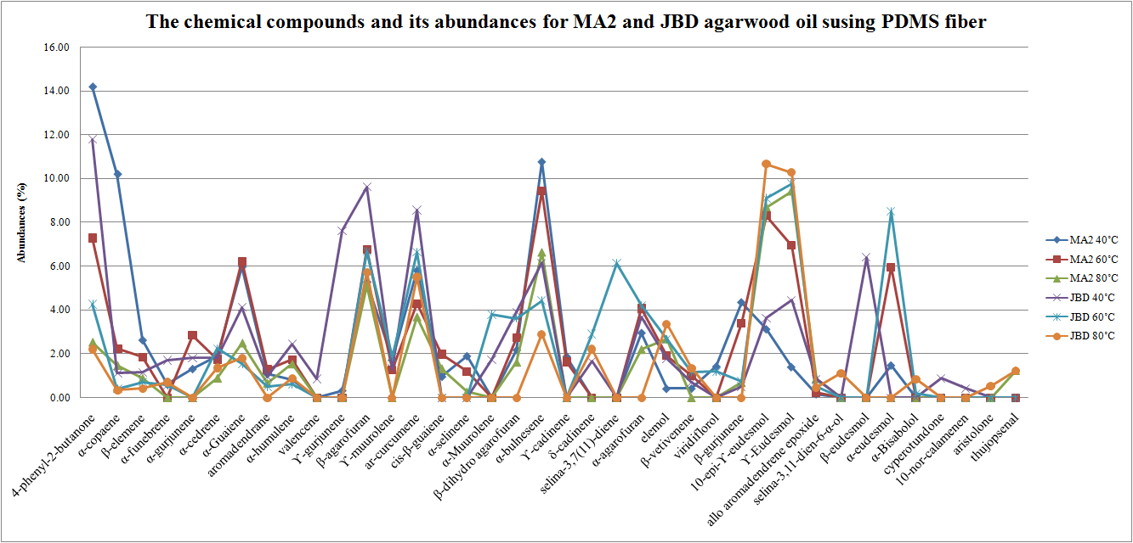

Figure 1. The chemical compounds and its abundances (%) for MA2 and JBD agarwood oils using PDMS fiber

Table 2 tabulates the chemical compositions extracted by SPME for MA2 and JBD agarwood oils using DVB-CAR-PDMS fiber at temperatures 40˚C, 60˚C and 80˚C. At least forty seven chemical compounds were extracted at all temperatures for both samples. It can be seen that, for MA2 oil, thirty seven, thirty six and thirty three chemical compounds were extracted at temperature 40˚C, 60˚C and 80˚C, respectively. The result was followed by JBD oil, where forty two, thirty six and thirty five chemical compounds were extracted at temperature 40˚C, 60˚C and 80˚C, respectively. Similarly from the finding in PDMS fiber, in DVB-CAR-PDMS, we can observed that the temperature also give effect to the number of chemical compounds extracted where at high temperature, less chemical compounds was extracted. For MA2 at temperature 40˚C and 60˚C, 4-phenyl-2-butanone gave the highest abundances with the percentage of 14.17% and 11.94%, respectively. At temperature 80˚C, the highest abundances belong to α-eudesmol with the value of 10.23%. The finding was followed by JBD oil where at temperature 40˚C and 60˚C, 4-phenyl-2-butanone gave the highest abundances with the percentage of 11.47% and 8.86%, respectively. At temperature 80˚C, the highest abundances belong to α-eudesmol with the value of 13.00%. We can see here that both agarwood oils have similarity for extracting similar chemical compounds that own the highest abundances at temperature 40˚C, 60˚C and 80˚C. i.e. 4-phenyl-2-butanone at temperature 40˚C and 60˚C and α-eudesmol at temperature 80˚C. In other observation, there were twenty six and twenty seven chemical compounds exist in MA2 and JBD oils, detected by SPME using DVB-CAR-PDMS fiber in all temperatures. For MA2 oil, the compounds were 4-phenyl-2-butanone, α-copaene, β-elemene, α-funebrene, α-cedrene, α-guaiene, α-humulene, E-β-farnesene, ɤ-gurjunene, β-agarofuran, ɤ-muurolene, ar-curcumene, β-selinene, cis-β-guaiene, α-bulnesene, ɤ-cadinene, δ-cadinene, elemol, β-vetivenene, spathulenol, β-gurjunene, 10-epi-ϒ-eudesmol, ϒ-eudesmol, alloaromadendrane epoxide, cyperotundone and thujopsenal. For JBD oil, the responsible compounds were 4-phenyl-2-butanone, methyl decanoate, α-copaene, β-elemene, α-funebrene, α-cedrene, α-guaiene, α-humulene, E-β-farnesene, ɤ-gurjunene, β-agarofuran, ɤ-muurolene, ar-curcumene, α-muurolene, trans-β-guaiene, α-bulnesene, ɤ-cadinene, δ-cadinene, elemol, β-vetivenene, spathulenol, β-gurjunene, guaia-3,10(14)-diene, 9, 11 epoxy, 10-epi-ϒ-eudesmol, ϒ-eudesmol, alloaromadendrane epoxide and α-eudesmol. The chemical compounds and its abundances (%) for MA2 and JBD agarwood oils using DVB-CAR-PDMS fiber is shown in Figure 2.

Table 2. The chemical compositions extracted by SPME for MA2 and JBD using DVB-CAR-PDMS fiber
No. | Chemical compounds | RI | Abundances (%)
No. | Chemical compounds | RI | MA2 40˚C | MA2 60˚C | MA2 80˚C | JBD 40˚C | JBD 60˚C | JBD 80˚C
1 | benzaldehyde | 952 | 0.07 | - | 0.04 | - | - | -
2 | 4-phenyl-2-butanone | 1241 | 14.17 | 11.94 | 5.16 | 11.47 | 8.86 | 4.74
3 | methyl decanoate | 1323 | - | - | - | 0.04 | 0.04 | 0.05
4 | α-copaene | 1374 | 3.12 | 3.20 | 1.74 | 0.84 | 0.73 | 0.36
5 | 2-epi-α-funebrene | 1380 | - | - | - | 0.07 | 0.10 | -
6 | β-elemene | 1389 | 2.47 | 1.89 | 1.04 | 1.09 | 0.80 | 0.41
7 | α-funebrene | 1402 | 0.83 | 0.55 | 0.37 | 0.47 | 0.67 | 0.68
8 | α-gurjunene | 1403 | 1.19 | 0.31 | - | 0.45 | 0.34 | -
9 | α-cedrene | 1411 | 2.09 | 2.00 | 0.97 | 0.19 | 2.54 | 1.20
10 | α-guaiene | 1433 | 3.97 | 5.54 | 3.14 | 2.43 | 2.79 | 1.19
11 | aromadendrane | 1443 | 0.88 | 1.08 | 0.21 | 0.05 | - | 0.03
12 | α-humulene | 1452 | 1.24 | 2.37 | 1.68 | 1.17 | 1.23 | 0.79
13 | E-β-farnesene | 1454 | 3.35 | 0.97 | 0.24 | 0.38 | 0.27 | 0.15
14 | valencene | 1469 | 0.10 | - | 5.03 | 0.45 | - | -
15 | ϒ-Gurjunene | 1472 | 0.51 | 0.24 | 0.19 | 0.48 | 0.13 | 0.28
16 | β-Agarofuran | 1474 | 4.87 | 7.48 | 3.20 | 8.41 | 8.05 | 3.32
17 | ϒ-muurolene | 1478 | 1.83 | 0.99 | 0.11 | 0.68 | 0.53 | 0.23
18 | ar-curcumene | 1479 | 4.87 | 5.51 | 4.06 | 7.32 | 7.31 | 5.36
19 | β-selinene | 1489 | 0.00 | 2.50 | 0.23 | 0.11 | - | 0.33
20 | cis-β-guaiene | 1491 | 0.87 | 1.36 | 0.51 | 0.93 | 0.88 | -
21 | δ-selinene | 1492 | - | - | - | 0.52 | - | -
22 | α-Muurolene | 1496 | 2.23 | 0.15 | - | 3.54 | 6.92 | 1.78
23 | α-selinene | 1498 | - | 0.61 | - | - | - | 0.10
24 | β-dihydro agarofuran | 1502 | 3.04 | - | - | 3.66 | - | -
25 | trans-β-guaiene | 1502 | - | 0.56 | 0.33 | 0.03 | 0.69 | 0.05
26 | α-bulnesene | 1509 | 5.89 | 4.36 | 2.70 | 4.36 | 3.56 | 2.61
27 | ϒ-cadinene | 1513 | 2.47 | 2.49 | 2.03 | 2.14 | 3.55 | 2.67
28 | trans-calamenen | 1521 | - | - | - | 0.16 | 0.15 | -
29 | δ-cadinene | 1522 | 2.11 | 2.32 | 0.68 | 2.47 | 2.60 | 2.21
30 | α-cadinene | 1537 | 0.08 | - | - | 0.37 | 1.37 | -
31 | selina-3,7(11)-diene | 1545 | - | 1.06 | - | 0.98 | 2.86 | -
32 | α-agarofuran | 1547 | 2.91 | 3.29 | - | 3.71 | 1.26 | -
33 | elemol | 1550 | 0.92 | 1.69 | 3.83 | 1.86 | 2.47 | 4.53
34 | β-vetivenene | 1554 | 0.83 | 1.56 | 1.52 | 0.76 | 1.48 | 1.30
35 | spathulenol | 1577 | 0.63 | 0.76 | 1.62 | 0.22 | 0.67 | 2.54
36 | viridiflorol | 1592 | 0.62 | - | 0.06 | - | 0.71 | 1.46
37 | β-gurjunene | 1600 | 0.11 | 2.40 | 1.64 | 1.64 | 0.92 | 3.97
38 | guaia-3,10(14)-diene, 9, 11 epoxy | 1601 | 0.05 | 0.13 | - | 0.11 | 0.11 | 0.06
39 | 10-epi-ϒ-eudesmol | 1621 | 3.49 | 5.11 | 8.42 | 5.41 | 6.25 | 9.02
40 | ϒ-eudesmol | 1635 | 2.26 | 4.74 | 7.60 | 4.78 | 6.73 | 10.01
41 | allo aromadendrene epoxide | 1639 | 0.09 | 0.69 | 1.35 | 0.13 | 0.55 | 0.40
42 | selina-3,11-dien-6α-ol | 1642 | - | - | 0.84 | 0.03 | - | 0.43
43 | β-eudesmol | 1649 | 2.71 | - | - | 6.02 | - | -
44 | α-eudesmol | 1652 | - | 6.93 | 10.23 | 1.70 | 6.48 | 13.00
45 | cyperotundone | 1695 | 0.17 | 0.34 | 0.27 | - | - | 0.24
46 | 10-nor-calamenen | 1702 | - | 0.11 | - | 0.20 | - | 0.06
47 | thujopsenal | 1887 | 0.49 | 0.66 | 0.26 | - | 0.35 | 0.04

Figure 2 shows the abundances pattern chemical compounds of MA2 and JBD agarwood oils extracted by SPME using DVB-CAR-PDMS fiber at temperature 40˚C, 60˚C and 80˚C. Similar to the result as obtained by PDMS fiber, the chemical compounds of MA2 and JBD oils show a complex mixture of monoterpenes, sesquiterpenes and its chromones derivatives. The behavior of the compounds is showed by variation of the abundances pattern belong to the every compound. From this plot, 4-phenyl-2-butanone has the highest peak of abundances at temperature 40˚C.

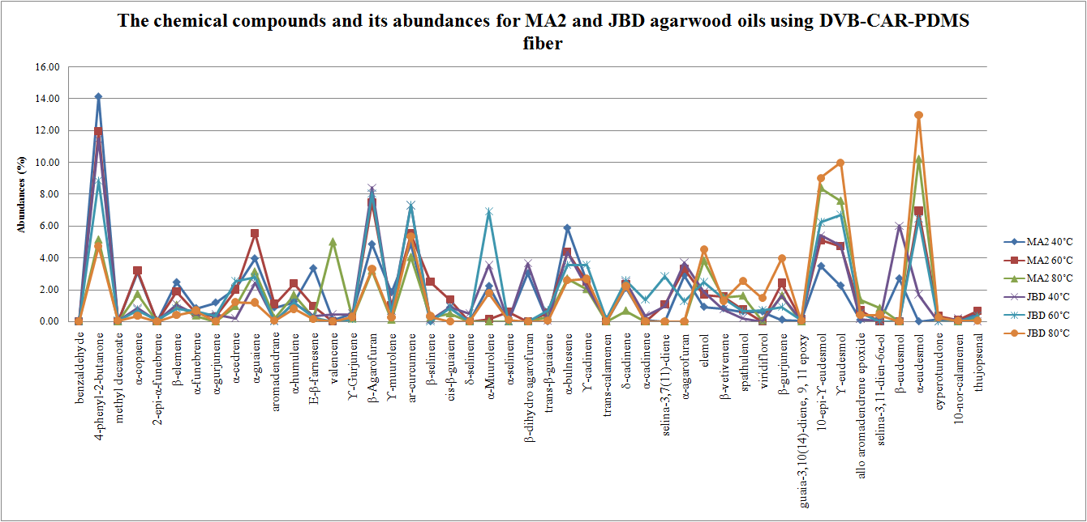

Figure 2. The chemical compounds and its abundances (%) for MA2 and JBD agarwood oils using DVB-CAR-PDMS fiber

It can be noticed from Figure 1 and Figure 2 , 4-phenyl-2-butanone exist as the dominant compound since this compound has the highest average of abundances in two samples i.e. MA2 and JBD using two fibers i.e. DVB-CAR-PDMS and PDMS at temperature 40˚C. This finding shows that SPME is a reliable technique for discriminating high-volatile monoterpenes (4-phenyl-2-butanone as one of the monoterpenes). This finding is supported by the previous researcher, J. Rohloff (1999) [16]. The result also is in agreement with Pripdeevech et. al. (2011) where 4-phenyl-2-butanone was recognized as one of the major compounds contributed to the odor of agarwood oil especially species Aquilariamalaccensis in their study [17].

As an essential oil, agarwood oil is a complex mixture of multi-component compounds which refer to polar and non polar compounds [18, 19]. Therefore, some of the chemical compounds in this study are lost at high temperature [20]. It is observed that the SPME with the lowest sampling temperature at 40˚C extracted the most compounds among all extraction. This is probably due to more volatile compounds are captured by SPME and are not lost during heating. However, with higher sampling temperature, compounds usually occurred in agarwood oils and are considered as heavy volatile odor-active components were found in higher yields. The relationship between temperature and number of compounds in SPME can be described by as the temperature is increased, the number of compounds extracted by SPME is decreased.

The different number of extraction using different fiber is due to polarity of the fiber. The PDMS (red) fiber is a polar fiber. Thus, it is expecting to be more effective in extracting polar compounds. The DVB-CAR-PDMS (grey) is a non-polar fiber and it is expecting to extract more non-polar compounds. Other factor may influence the difference in chemical compound extraction is the thickness of the fiber used. Thus, the SPME study shows that DVB-CAR-PDMS is more efficient than PDMS fiber since it can extract higher number of compounds. The result is supported by the review in [17] in which DVB-CAR-PDMS extracted higher number of volatile compounds as compared to PDMS.

Table 3 tabulates the significant compounds identified by Z-score from the many compounds extracted by SPME/GC-MS for MA2 and JBD oils using PDMS fiber. There are five significant chemical compounds identified by Z-score such as aromadendrane, β-agarofuran, α-agarofuran, 10-epi-ɤ-eudesmol and ɤ-eudesmol. At temperature 40˚C, β-agarofuran has the highest abundances with the value of 5.28% for MA2 and 9.63% for JBD. At temperature 60˚C, 10-epi-ɤ-eudesmol has the highest abundances with the percentage of 8.31% for MA2 and ɤ-eudesmol provides the highest abundances for JBD with the value of 9.76%. At temperature 80˚C, ɤ-eudesmol shows the highest percentage of abundances for MA2 with the values of 9.43% and for JBD, the highest abundances belong to 10-epi-ɤ-eudesmol with the value of 10.67%.

Table 3: The significant compounds identified by Z-score for MA2 and JBD using PDMS fiber
No | Chemical compounds | Abundances (%)
No | Chemical compounds | MA2 40˚C | MA2 60˚C | MA2 80˚C | JBD 40˚C | JBD 60˚C | JBD 80˚C
1 | aromadendrane | 1.08 | 0.86 | 0.67 | 0.97 | 0.52 | 0.00
2 | β-agarofuran | 5.28 | 6.77 | 5.14 | 9.63 | 6.67 | 5.73
3 | α-agarofuran | 2.96 | 4.07 | 2.21 | 3.67 | 4.21 | 0.00
4 | 10-epi-ϒ-eudesmol | 3.12 | 8.31 | 8.71 | 3.63 | 9.09 | 10.67
5 | ϒ-Eudesmol | 1.40 | 6.96 | 9.43 | 4.45 | 9.76 | 10.30

Table 4 tabulates the significant compounds identified by Z-score from the many compounds extracted by SPME/GC-MS for MA2 and JBD agarwood oils using DVB-CAR-PDMS fiber. Similar to the Table 3, five chemical compounds were identified as significant. They are aromadendrane, β-agarofuran, α-agarofuran, 10-epi-ɤ-eudesmol and ɤ-eudesmol. At temperature 40˚C, and 60˚C, for both oils, β-agarofuran has the highestabundances with the value of 4.87% and 7.48%, respectively for MA2 and 8.41% and 8.05%, respectively for JBD. At temperature 80˚C, 10-epi-ɤ-eudesmol has the highest abundances i.e. 8.42% for MA2 and ɤ-eudesmol has the highest percentage of abundances for JBD, i.e. 10.01%.

Table 4. The significant compounds identified by Z-score for MA2 and JBD using DVB-CAR-PDMS fiber

No | Chemical compounds | Abundances (%)
No | Chemical compounds | MA2 40˚C | MA2 60˚C | MA2 80˚C | JBD 40˚C | JBD 60˚C | JBD 80˚C
1 | aromadendrane | 0.88 | 1.08 | 0.21 | 0.05 | 0.00 | 0.03
2 | β-agarofuran | 4.87 | 7.48 | 3.20 | 8.41 | 8.05 | 3.32
3 | α-agarofuran | 2.91 | 3.29 | 0.00 | 3.71 | 1.26 | 0.00
4 | 10-epi-ϒ-eudesmol | 3.49 | 5.11 | 8.42 | 5.41 | 6.25 | 9.02
5 | ϒ-Eudesmol | 2.26 | 4.74 | 7.60 | 4.78 | 6.73 | 10.01

Figure 3 (a) and (b) show the abundances pattern from SPME/GC-MS analysis for MA2 and JBD agarwood oils using different fibers at three different sampling temperatures such as 40˚C, 60˚C and 80˚C. Obviously, it can be seen that there is a consistent abundances pattern provided by five significant chemical compounds as identified by Z-score. It is found that three compounds have high peak of abundances in all plots and it applicable for all temperature conditions. These three compounds are 10-epi-ϒ-eudesmol, β-agarofuran and ϒ-eudesmol. Meanwhile, the other two compounds such as aromadendrane and α-agarofuran provide low peak of abundances. The observation then is followed by the similarity trend provides by abundances pattern even different fibers are used to extract the agarwood oils. The Z-score has highlighted similar chemical compounds but different in their chemical compositions (abundances). These abundances pattern acquired by the significant chemical compounds in SPME/GC-MS contributed to the odor of high quality agarwood oil. They can be used as a benchmark to identify high quality agarwood oil. The chemical compounds such as 10-epi-ϒ-eudesmol, aromadendrane, β-agarofuran, α-agarofuran and ϒ-eudesmol can be used as the marker compounds in high quality agarwood oils.

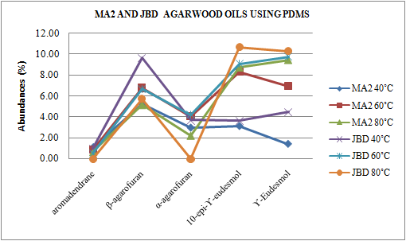

Figure 3 (a). The significant compounds as identified by Z-score at temperature 40˚C, 60˚C and 80˚C for MA2 and JBD using PDMS fiber

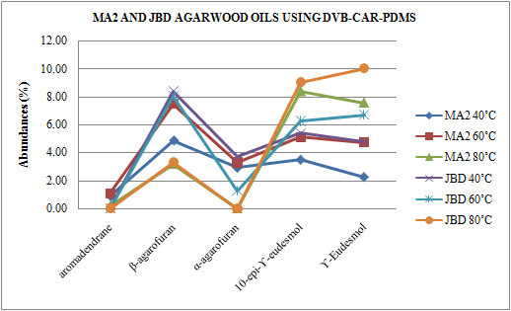

(b)

Figure 3 (b). The significant compounds as identified by Z-score at temperature 40˚C, 60˚C and 80˚C for MA2 and JBD using DVB-CAR-PDMS fiber

Conclusion

The study showed that SPME/GC-MS is a reliable technique in extracting the chemical compounds of agarwood oils especially from the high quality. The finding given by proposed Z-score gave a promising result in identifying the significant compounds from many compounds extracted by SPME/GC-MS. The chemical compounds such as 10-epi-ϒ-eudesmol, aromadendrane, β-agarofuran, α-agarofuran and ϒ-eudesmol were highlighted as significant and can be used as a marker compounds in classifying the agarwood oil especially for high quality of oils.

Acknowledgement

The authors would like to acknowledge the financial support given to Nor Azah Mohamad Ali by the Malaysian Ministry of Agriculture and Agrobased Industry (Science fund 05-03-10-SF1017), Mohd Nasir Taib through the RIF Grant Code: 600-RMI/DANA 5/3/RIF (614/2012) and Nurlaila Ismail for MyPhD scholarship by The Ministry of Higher Education, Malaysia.

References
- R. Naef. (2011). The volatile and semi-volatile constituents of agarwood, the infected heartwood of Aquilaria species: a review, Flavour and Fragrance Journal 26: 73-87.
- M. A. NorAzah, J. A. Majid, J. Mailina, A. A. Said, S. S. Husni, H. N. Hasnida, M. A. M. N. M. Arip, & Y. S. Chang (2009), Profiles of selected supreme Agarwood oils from Malaysia," Herbal Globalisation: A New Paradigm for Malaysian Herbal Industry (MAPS 2008) 393-398.
- W. Hidayat, A. Y. M. Shakaff, M. N. Ahmad, & A. H. Adom, (2010). Classification of Agarwood Oil Using an Electronic Nose, Sensors, 10: 4675-468.
- M. S. Najib, N. A. M. Ali, M. N. M. Arip, A. M. Jalil, & M. N. Taib, (2010). Classification of Agarwood region using ANN," IEEE Control and System Graduate Research Colloquium (ICSGRC 2011): 7-13.
- M. S. Najib, N. A. M. Ali, M. N. M. Arip, A. M. Jalil, M. N. Taib, & N. Kasuan. Classification of Malaysian and Indonesian Agarwood using k-NN, IEEE Control and System Graduate Research Colloquium (ICSGRC 2011).
- M. S. Najib, M. N. Taib, N. A. M. Ali, M. N. M. Arip, & A. M. Jalil, (2011). Classification of Agarwood Grades using ANN, International Conference on Electrical, Control and Computer Engineering 2011.
- N. A. B. Sidik, (2008). Comparison of Gaharu (Aquilaria Malaccensis) Essential Oil Composition Between Each Country, Bachelor of Chemical Engineering, Faculty of Chemical Engineering and Natural Resources, University Malaysia Pahang.
- Nor Azah M.A, Chang Y.S., Mailina J., Abu Said A , Abd. Majid J. Saidatul Husni S., Nor Hasnida H. and Nik Yasmin Y. (2008). Comparison of Chemical Profiles of Selected Gaharu Oils from Peninsular Malaysia, The Malaysian Journal of Analytical Sciences 12: 338 - 340.
- M. Ishihara, T. Tsuneya, & K. Uneyama (1993). Components of the agarwood smoke on heating, Journal of Essential Oil Research 5: 419-423.
- A. K. Pravina, (2008). Application of solid phase microextraction in gaharu essential oil analysis, Bachelor of Chemical Engineering, Faculty of Chemical Engineering and Natural Resources, Univerisiti Malaysia Pahang (UMP), Pahang.
- M. Ishihara, T. Tsuneya, & K. Uneyama, (1993). Fragrant sesquiterpenes from agarwood, Phytochemistry 33: 1147-1155.
- T. Nakanishi, E. Yamagata, K. Yoneda, & T. Nagashima, (1984). Three fragrant sesquiterpenes of agarwood, Phytochemistry 23: 2066-2067.
- R. W. Thatcher, C. J. Biver, & D. M. North, (2004). Z-Score EEG Biofeedback: Technical Foundations, Applied Neurosciences Inc.
- T. C. Brown, T. C. Daniel, & R. M. Forest, (1990). Scaling of ratings: concepts and methods 293: USDA Forest Service, Rocky Mountain Forest and Range Experiment Station.
- M. Ishihara, T. Tsuneya, & K. Uneyama, (1991). Guaiane sesquiterpenes from agarwood, Phytochemistry, 30 3343-3347.
- J. Rohloff, (1999), Monoterpene composition of essential oil from peppermint (Mentha× piperita L.) with regard to leaf position using solid-phase microextraction and gas chromatography/mass spectrometry analysis, Journal of Agricultural and Food Chemistry 47: 3782-3786.
- P. Pripdeevech, W. Khummueng, & S. K. Park, (2011). Identification of Odor-active Components of Agarwood Essential Oils from Thailand by Solid Phase Microextraction-GC/MS and GC-O, Journal of Essential Oil Research, 23: 46-53.
- S. N. Tajuddin & M. M. Yusoff, (2010), Chemical Composition of Volatile Oils of Aquilaria malaccensis (Thymeleaceae) from Malaysia, Natural Product Communications 5: 1965-1968.
- S. N. Tajuddin, (2011). Resolution of complex sesquiterpene mixture in Aqualaria malaccensis (Gaharu) volatile oils using gas chromatography methods," PhD, Faculty of Industry and Science Technology (FIST), Universiti Malaysia Pahang.
- P. Masango, (2005). Cleaner production of essential oils by steam distillation, Journal of Cleaner Production 13: 833-839.

