Extraction of Citrus hystrix D.C. (Kaffir lime) ESSENTIAL OIL using automated steam distillation process: analysis of volatile compounds

(Pengekstrakan Minyak Citrus Hystrix D.C. (Limau Purut) Menggunakan Kaedah Penyulingan Wap Automatik: Analisa Komposisi Hasil Minyak)

Nurhani Kasuan¹, Zuraida Muhammad¹, Zakiah Yusoff¹, Mohd Hezri Fazalul Rahiman¹,
Mohd Nasir Taib¹, Zaibunnisa A. Haiyee².

¹Faculty of Electrical Engineering, Universiti Teknologi MARA, 40450 Shah Alam, Malaysia.

²Faculty of Applied Science, Universiti Teknologi MARA, 40450 Shah Alam, Malaysia.

*Corresponding author: nurhani.kasuan@ieee.org

Abstract
An automated steam distillation was successfully used to extract volatiles from Citrus hystrix D.C (Kaffir lime) peels. The automated steam distillation integrated with robust temperature control can commercially produce large amount of essential oil with efficient heating system. Objective of this study is to quantify the oil production rate using automated steam distillation and analyze the composition of volatiles in Kaffir lime peels oil at different controlled and uncontrolled temperature conditions. From the experimentation, oil extraction from Kaffir lime peels only took approximately less than 3 hours with amount of oil yield was 13.4% more than uncontrolled temperature. The identified major compounds from Kaffir lime peels oil were sabinene, β-pinene, limonene, α-pinene, camphene, myrcene, terpinen-4-ol, α-terpineol, linalool, terpinolene and citronellal which are considered to have good organoleptic quality. In contrast with uncontrolled temperature, oil analysis revealed that some important volatile compounds were absent such as terpinolene, linalool, terpinen-4-ol due to thermal degradation effect from fast heating of extracted material.

Keyword: Automated steam distillation, Citrus hystrix D.C., Kaffir lime, volatile compounds, quality.

Abstrak

Satu penyulingan wap automatik telah berjaya digunakan untuk pengekstrakan minyak pati dari kulit Citrus hystrix D.C. (Limau purut). Penyulingan wap automatik bersepadu dengan kawalan suhu membolehkan penghasilan minyak pati lebih efisien dengan sistem pemanasan yang cekap. Objektif kajian ini adalah untuk mengukur kadar pengeluaran minyak menggunakan penyulingan wap automatik dan menganalisis komposisi minyak pati kulit limau purut pada keadaan suhu yang berbeza secara terkawal dan tidak terkawal. Melalui eksperimen ini, pengekstrakan minyak dari kulit limau purut hanya mengambil masa 3 jam dengan jumlah hasil minyak adalah 13.4 % lebih daripada suhu yang tidak terkawal. Komposisi bahan utama dari minyak pati kulit limau purut minyak adalah sabinena , β-pinene, limonene, α-pinene, camphene , myrcene , terpinen-4-ol, α-terpineol , linalool , terpinolene dan citronellal. Analisis komposisi minyak dari eksperimen suhu tidak terkawal menunjukkan bahawa beberapa komponen penting tidak hadir seperti terpinolene, linalool, terpinen-4-ol disebabkan oleh kesan kemusnahan haba daripada pemanasan proses berkadar cepat.

Kata kunci: Pengulingan wap automatik, Citrus hystrix D.C., Limau purut, komposisi kandungan minyak, kualiti.

Introduction
In many developing countries, one of valuable natural resources is aromatic plant. The benefit of plant resources to humanity, besides basic needs, contributes to economic advantages in food industries, flavors, fragrances, health care product and so forth. Essential oil from aromatic plants is valuable and high in demand. The feasibility to produce essential oil in mass quantity can be achieved by designing an automated process that enable to attain high production in efficient way and easy to operate. In this research, an automated steam distillation was designed to serve public users even in rural area where most of aromatic plant located. The steam distillation process is still preferred because of its low system cost, cleanliness, high production and low operational cost [1] compared to other advance extraction methods. In assessing reliability of automated steam distillation system, Kaffir lime peels is used as extraction material to quantify oil production rate at different operated temperature and also identifying major compounds of extracted oil in justifying oil quality. This study is important to obtain abundant of production oil yield and at the same time ensuring the oil quality yield is in good grade. The botanical material being analyzed in this study is Kaffir Lime or its scientific name Citrus hystrix D.C. from Rutaceae family. Kaffir lime has great potential in research and commercialization for aromatherapy and spa practices, solution for insect repellent, making shampoo, antioxidants compound and beauty product [2-6]. The quality of Kaffir lime peel essential oil is assessed based on the chromatographic profile of presence compound using Gas Chromatography (GC) and Gas Chromatography-Mass Spectrometry (GC-MS) [7-8]. The right compounds with standard concentration should present to ensure that the quality of essential oil is pure and good in organoleptic profile.
Steam distillation extraction process is a popular extraction method and suitable for most plant materials [1,9]. The duration of common steam distillation process is within 3 to 8 hours [10-12] on quantity and particle size of raw materials to be extracted. The steam distillation process is considerably cheap compared to other methods [9] and has potential for commercialization [13] due to its reliability in producing mass oil production. Several studies were carried out to compare the essential oil quality profiles and its production rate gained by steam distillation with several other extraction methods. Based on [14, 22], the relative chemical composition of volatile compound obtained by steam distillation and superheated water extraction (SWE) were proven similar. In fact, steam distillation itself can produce 0.24% more oil production in contrast with superheated water extraction. Moreover, Scalia et al. [15] proved that qualitative profile of essential oils obtained by the supercritical fluid extraction (SFE) was comparable with those produced by steam distillation process. Indeed, Ammann et al. [13] was concluded that steam distillation was the most effective technique as compared to SFE and SWE. While, comparing with supercritical carbon dioxides methods, steam distillation had produced more yields and in fact the quality of oil extracted by both methods is similar. Additionally, by taking advantage of operational and system cost-effective, automated steam distillation may execute desired outcome. This paper focused on how steam temperature, as controlled parameter, influence oil quality and productivity. In previous study by Li et al. [16], temperature exhibited the most significant effect on yield production followed by extraction time and particle size. Moreover, Silou et al. [17] revealed that the extraction rate in steam distillation had been decreased as the temperature and extraction time increased. If the extracted botanical plant is exposed to high temperature or prolong heating during extraction process, the essential oil may experience thermal degradation [14-15]. As a result, quality of oil will reduce and degrade the oil aromatic profiles and its physical color.

Materials and Methods

Kaffir lime Sample Preparation
Fresh Kaffir lime fruits ware obtained from Dengkil, Selangor. Peels of fresh Kaffir lime were used for all the experimental extraction. Prior to extraction, the Kaffir lime peels were weighted at 350 grams and then roughly ground to 2-4 mm mesh particles. After extraction took place, the essential oil samples is stored at chilled temperature before undergo further quality analysis.

Extraction Method
Kaffir lime essential oil extraction was carried out using automated steam distillation process. Basically, automated steam distillation processing plant is made up of three main modules i.e. distillation column, a condenser and heating system that illustrated in Figure 1. In the schematic diagram, 10 litre of filtered water is filled inside distillation column and a packed bed contained of Kaffir lime peels is located at the upper compartment of the column. For heating system, an embedded immersion type of heater is used to boil the water and level of water tank is kept at constant i.e. above the heating element. Water coolant for condenser is reused to substitute loss of water tank and sustain desired water level. By doing this, it will reduce wasted water and also minimize the temperature difference between water tank and water flow-in.
Steam passes through plant material and transporting tiny particles of essential oil to the condenser which then transform back to liquid mixture contained essential oil and water. The mixture is deposited in oil separator and undergone further water separation procedure. The advantage of this automated steam distillation process is to provide proper temperature control to meet user requirement and selection of suitable temperature profiles for associated plant during extraction process with reasonable cost operation. Additionally, this operation can extract essential oil in large volume with less human intervention or labor supervision due to computer monitoring module.
In the experiment, steam temperature inside the distillation column was controlled with pre-condition setting correspond to desired temperature profile. There were four temperature profiles under test i.e. 80ºC, 85ºC, 90ºC and uncontrolled temperature. In the case of controlled temperature (i.e. 80ºC, 85ºC, 90ºC), the trajectory of temperature response is well monitored and the response are allowed to fluctuate within ± <1ºC with respect to the set point. However, in uncontrolled condition, the heater is undergone fast heating response until saturated temperature. Without control strategy, the process response suffers from non-uniform temperature trajectory and experienced temperature fluctuation due to disturbances and process variations. The study will be assessed on the influence of all mentioned conditions towards extracted oil compositions and their productivity.

Figure 1 Steam Distillation Process for Essential Oil Extraction

Kaffir lime Essential Oil
The production yield was obtained approximately 50 minutes after process started. Two layers where formed, the top layer corresponds to oil while bottom layer is water. The oil sample was transferred into separating funnel. Dichloromethane was added into the funnel to form immiscible solvent where the oil and dichloromethane solvent at the bottom layer and water at the upper layer. The oil at lower layer was taken and the liquid at the upper layer was discarded. The evaporating process was continued to dry up remaining water contained in oil layer. Sodium anhydrous acid and dichloromethane acted as catalyze to accelerate the evaporating process using Vacuum Rotavap. Finally, the genuine extracted oil sample was ready for Gas Chromatography (GC) and Gas Chromatography – Mass Spectrophotometry (GC-MS) analysis.

Analysis of Volatile Compound.

The volatile compounds of Kaffir lime peel were analyzed using Shimadzu GC-2010 Gas Chromatography system for source identification. Then, the chemical compound was further analyzed using Agilent GCMS 7890A equipped with Agilent 5975C Mass Selective Detector and using HP-5MS column (30m x0.25mm x 0.25µm film thickness). The carrier gas for GC was Helium with flow rate of 1.0mL/min and the apparatus was programmed as tabulated in Table 1.

Table 1. GC-MS conditions for Kaffir lime oil analysis

Injector Temperature | 250ºC
Detector Temperature | 280ºC, with mass range recorded from 45-450 mass- to ratios, with electron energy of 70eV
Oven Temperature | The oven was set to 60ºC for ten minutes, and then the temperature was gradually increased up to 230ºC at a rate of 3ºC/min. For post run temperature is 50ºC.

The identification of oil chemical compounds was referred to mass spectral library HPCH2205.L, Wiley 7 NIST 05.L and NIST 05a.L database. The chromatograms from GC and GC-MS captured of existence sample oil constituents in terms of peak area count. For quantitative measurement, the percentage yield of extracted oil in wet weight basis can be calculated using Equation (1).

Yield (%) = Weight of essential oil recovered x 100%  Weight of fresh citrus peels | (1)

The weight of extracted material was based on fresh Kaffir lime peels. The density of Kaffir lime oil is in range of 0.871g/mL [21]. Therefore, the mass (in grams) of Kaffir lime oil can be derived from known volume (mL) x density of Kaffir lime oil (0.871g/mL).

Result and Discussion

Analysis on Production Rate of Kaffir lime Oil Based on Different Distillation Temperature Using Automated Steam Distillation Process.
Based on previous study [18], production yield of Kaffir lime peels contained richer oil compared to oil from Kaffir lime leaves. The essential oil extorted from Kaffir lime peels was quite lucrative even though the duration of distillation only took approximately 2 hours (120 minutes). The amount of percentage oil yield was calculated based on wet weight basis. Wet basis define that the raw material contained high moisture where no drying process was involved during pre-processing stage. The accumulated amount of percentage yield is summarized in Table 2 below for different controller temperature.

Table 2. Percentage yield of Kaffir lime essential oil extracted

 | Controller Steam Temperature (ºC)
 | 80 | 85 | 90 | Uncontrolled
%Yield (w/w) | 1.87 | 2.19 | 4.26 | 3.36

Refer to Table 2, when the temperature increased, more extracted oil was produced. At controlled temperature (90ºC), oil percentage yield is 4.26 (w/w). At lower temperature i.e. 80ºC, percentage oil yield is only 1.87 (w/w). When steam temperature regulated at 85ºC, the extracted oil yield get 2.19 (w/w). Interestingly, the increased in temperature to 90ºC really boost the oil yield almost up to 94.52% compared to yield during 85ºC (2.19 (w/w)). Even though the yield for uncontrolled steam temperature condition was greater than yield at 80ºC and 85ºC, but the extraction unable to drive system to produced maximum oil as much as yield at 90ºC.
Figure 3. Cumulative quantity of Kaffir lime extracted essential oil based on different temperature control.

Figure 3 presents production curves for extracted Kaffir lime oil for four different temperature profiles. The accumulated amount of oil was plotted for every 15 minutes. The overall oil production curve signifies that the Kaffir lime oil was aggressively extracted during first 30 minutes. Specifically, the production rates during this interval are approximately: 0.16ml/min, 0.3ml/min, 0.6ml/min, 0.56ml/min for 80ºC, 85ºC, 90ºC and uncontrolled temperature conditions respectively. The higher the steam temperature, the richer the oil extracted. After 75 minutes, the production curves converged to a steady value. The uncontrolled temperature, which the yield still cannot achieve to maximum production compared to 90ºC, might be due to temperature fluctuation and instable during extraction.

Analysis on the Quality of Kaffir lime Oil Based on Different Distillation Temperature Using Automated Steam Distillation Process.
This section is to investigate on how steam temperature influenced the quality of Kaffir lime peels oil based on different controlled temperature conditions. The concentration amount of compounds in Kaffir lime oil was identified using Gas Chromatography (GC) and Gas Chromatography – Mass Spectrometry (GC-MS) for each experimental sample. The chromatograms executed the peak ratio and each of peaks corresponds to particular compound at their respective retention time. Table 3 shows list of major volatile compounds derived in this experiment starting with α-Thujene occurred at lowest retention index 924 until Citronellol at 1223 of retention index. In the case of uncontrolled temperature, some important compounds were not found. The discrepancy may due to incomplete extraction process or the oil experienced thermal degradation that consequently losing some significant volatile compounds such as linalool and terpinen-4-ol.

Table 3. Major compounds of Kaffir lime oil collected from Selangor, Malaysia.
No | Retention time (RT) | Compounds | Retention Index (RI)* | Relative Peak Area (%)
 |  |  |  | 80ºC | 85 ºC | 90 ºC | Uncontrolled temperature
1 | 7.27+0.02 | α-Thujene | 0924 | 0.238 | 0.227 | 0.233 | 0.194
2 | 7.65+0.04 | α-Pinene | 0932 | 3.546 | 3.047 | 3.262 | 3.338
3 | 8.40+0.03 | Camphene | 0946 | 0.180 | 0.151 | 0.155 | 0.135
4 | 10.62+0.22 | Sabinene | 0969 | 45.590 | 35.203 | 46.573 | 31.224
5 | 10.80+0.22 | β-Pinene | 0974 | 16.835 | 19.601 | 13.509 | 32.967
6 | 11.50+0.13 | Myrcene | 0988 | 1.985 | 1.807 | 1.804 | 1.735
7 | 13.02+0.05 | δ-2-carene | 1001 | 0.578 | 1.123 | 0.758 | 0.263
8 | 14.21+0.18 | Limonene | 1024 | 17.733 | 19.831 | 17.232 | 20.687
9 | 15.86+0.06 | γ-terpinene | 1054 | 1.045 | 1.775 | 1.354 | 0.735
10 | 17.60+0.04 | Terpinolene | 1086 | 0.318 | 0.497 | 0.383 | -
11 | 18.95+0.06 | Linalool | 1095 | 0.633 | 1.044 | 1.156 | -
12 | 21.92+0.16 | Citronellal | 1148 | 4.616 | 7.829 | 7.809 | 7.531
13 | 23.18+0.06 | Terpinen-4-ol | 1174 | 1.823 | 2.822 | 2.418 | -
14 | 24.12+0.05 | α-terpineol | 1186 | 0.438 | 0.702 | 0.907 | 0.938
15 | 26.13+0.03 | Citronellol | 1223 | - | 0.118 | - | -

* refer to [23]

The results obtained from the GCMS analysis are illustrates in Figure 4 – Figure 7. The figures of chromatograms correspond to four different controlled temperature conditions i.e. 80ºC, 85ºC, 90ºC and uncontrolled temperature respectively. The peaks for each compound executed in chromatograms of four experimental samples occurred almost near to each retention time within certain range. The retention time is the time at which the compound elutes from the column in GC. As can be seen, altogether, there were 27 compounds identified. From the findings, the major compounds found from the oil samples are sabinene, α- pinene, limonene, myrcene, citronellal and terpinen-4-ol. The highest peak of GC-MS chromatogram is β-pinene and followed by sabinene. However, sabinene contributes highest concentration in extracted oil samples and the presence of sabinene indicates spiciness taste in the oil. The next important compounds are limonene and β- pinene. Both compounds provide distinctive aroma where limonene gives strong smells of oranges while β- pinene gives woody-green odor to the oil sample. Meanwhile, presence of citronellal indicates that the oil possesses antifungal quality and can be agent for insect repellent.

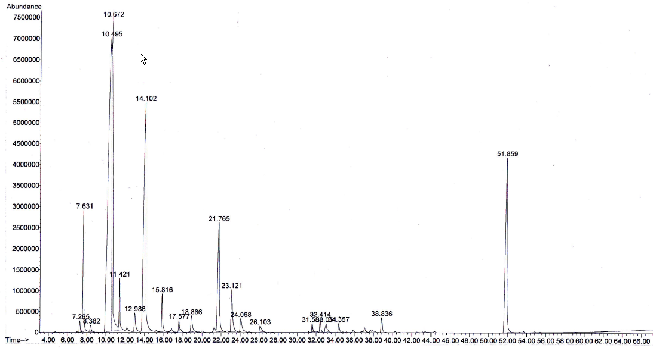
3
2
1
5
4
Figure 4 GCMS chromatogram of volatiles compounds from Kaffir lime peels oil (80ºC). Major
compounds peaks marked: α-Pinene(1), Sabinene(2), β-pinene(3), Limonene(4), Citronellal(5).

3

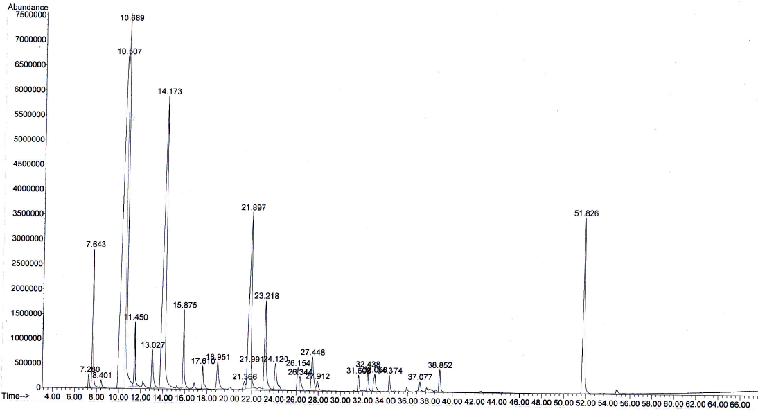
5
4
2
1
Figure 5 GCMS chromatogram of volatiles compounds from Kaffir lime peels oil (85ºC). Major compounds peaks marked: α-Pinene(1), Sabinene(2), β-pinene(3), Limonene(4), Citronellal(5).

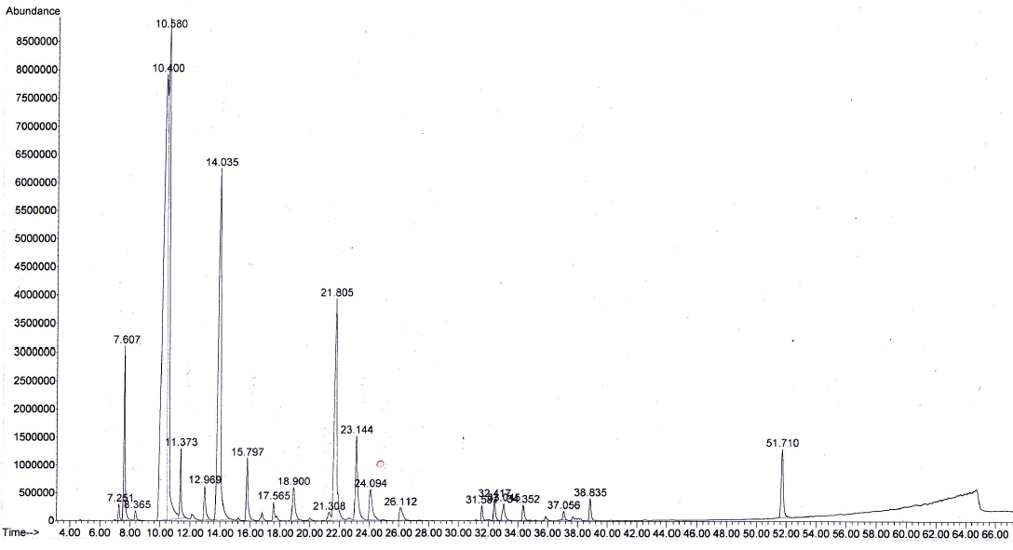
3
1
5
4
2

Figure 6 GCMS chromatogram of volatiles compounds from Kaffir lime peels oil (90ºC). Major
compounds peaks marked: α-Pinene(1), Sabinene(2), β-pinene(3), Limonene(4), Citronellal(5).

3

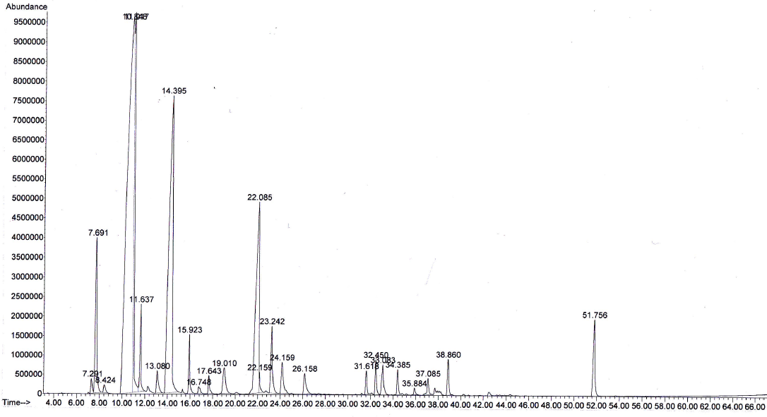
5
4
1
2
Figure 7 GCMS chromatogram of volatiles compounds from Kaffir lime peels oil (uncontrolled temperature).
Major compounds peaks marked: α-Pinene(1), Sabinene(2), β-pinene(3), Limonene(4), Citronellal(5)

The major constituents of Kaffir lime originated from Thailand and Madagascar are listed based on published papers [19-20] respectively and eight major constituents were highlighted. In comparing the quality of Kaffir lime peel with these continents, Table 4 summarized the outcomes. All three regions agreed that three abundance compounds in Kaffir lime peel oil are Limonene, Sabinene and β-pinene. Another study by Abd Majid et. al. [7], also agreed that the main compounds of the oil found were sabinene, limonene, β-pinene, terpinen-4-ol and α-terpineol. Generally, quality of Kaffir lime peel oil is comparable to other regions where major compounds were detected, only slight different in percentage of its concentrations. Therefore, the quality of essential oil in this experiment can be acceptable.
Table 4. Comparison of major compounds of Kaffir lime peel oil with other regions.

Major  Constituent | Relative Peak Area (%)
Major  Constituent | Malaysia  [Current study] | Thailand  [19] | Madagascar  [20]
Sabinene | 35.2 | 22.6 | 11.9
Limonene | 19.8 | 29.2 | 17.3
β-pinene | 16.8 | 30.6 | 22.7
Citronellal | 7.8 | 4.2 | 7.8
α-pinene | 3.1 | 2.5 | nm
Terpinen-4-ol | 2.8 | 0.2 | 7.2
Myrcene | 1.8 | 1.4 | nm
Linalool | 1.0 | 0.5 | 2.6

*nm = not mentioned

Conclusions
Returning to the hypothesis posed at the beginning of study, temperature will directly affect the production of essential oil. The analysis on qualitative and quantitative of Kaffir lime peel oil extracted using automated steam distillation had been accomplished successfully. In quantifying oil production rate, the relevance of different temperature response is clearly affects the amount of oil yield. Increase in temperature will speed up oil production rate. In assessing the Kaffir lime peel oil quality; it suggests that temperature regulation from 80ºC, 85ºC and 90ºC, a significant result where most of major constituents are present in the analyzed oil samples. It shown that 85ºC of controlled condition can be assumed as an optimal temperature condition, with respect to oil quality, where most of constituents appear at this temperature setting including Citronellol. However during uncontrolled temperature condition, some important compounds were not found in the oil sample. This signifies that extracted oil from uncontrolled temperature (which applied fast heating) can reduce quality of the oil. Further works is also considered to identify optimum conditions for extraction of Kaffir lime essential oil that can maximize the production within efficient means.
Acknowledgement
The authors would like to express most gratitude to Faculty Electrical Engineering, Research Management Institute, Universiti Teknologi MARA for their great contribution in supporting this project.

References
- Masango P. (2005). Cleaner production of essential oils by steam distillation, Journal of Cleaner Production.13: 833-839.
- Chan S. W., Lee, C. Y., Yap, C. F., Wan Aida, W. M. & Ho, C. W. (2009). Optimisation of extraction conditions for phenolic compounds from limau purut (Citrus hystrix) peels. International Food Research Journal. 16: 203-213.
- Tawatsin A., S. Wratten, R. Scott, U. Thavara, & Y. Techadamrongsin. (2001). Repellency of volatile oils from plants against three mosquito vectors. Journal of Vector Ecology. 26: 76-82.
- Chaisawadi S., D. Thongbutr, & S. Kulamai. (2007). Clean production process of freeze dried Kaffir lime powder for medicinal herb and cosmetic use. ISHS Acta Horticulturae 786: International Workshop on Medicinal and Aromatic Plants. pp. 193-200.
- Hongratanaworakit T., P. Tapaneeyasin, J. Nuamlert, A. Chansiri, & N. Hongrattanavorakit. (2006). Development of skin whitening preparations from kaffir lime oil (Citrus hystrix). Planta med, p. 72.
- Prasart F. & Chonlada W. (2005). Development of anti-dandruff shampoo from kaffir lime which is the by product of food industry. Kasetsart Journal (Natural Science)(Thailand); Witthayasan Kasetsart (Sakha Witthayasat), 39(4). 725-729.
- Abd Majid J., Nor Azah M. A., Abu Said A., & Mohd Faridz Z. (2005). Teknologi penghasilan minyak pati limau purut (Citrus hystrix) menggunakan kaedah penyulingan hidro berskala besar. Proceedings on Medicinal and Aromatic Plants: Trends and perspectives, Institut Penyelidikan Perhutanan Malaysia (FRIM), Malaysia, 214-217.
- Zaibunnisa A. H., & Chutima W. (2012). Extraction of volatile oil from Kaffir lime leaves (citrus hystrix) using pressurised liquid extraction. International Journal of Food, Nutrition & Public Health. 5: 201-210.
- Catchpole O., J. Grey, K. Mitchell, & J. Lan. (2004). Supercritical antisolvent fractionation of propolis tincture. The Journal of Supercritical Fluids. 29: 97-106.
- Song G., C. Deng, D. Wu, & Y. Hu. (2003). Comparison of Headspace Solid-Phase Microextraction with Solvent Extraction for the Analysis of the Volatile Constituents of Leaf Twigs of Chinese Arborvitae. Chromatographia. 58: 769-774.
- Adegoke G. & B. Odesola. (1996). Storage of maize and cowpea and inhibition of microbial agents of biodeterioration using the powder and essential oil of lemon grass (Cymbopogon citratus). International Biodeterioration & Biodegradation. 37: 81-84.
- Deng C., X. Xu, N. Yao, N. Li, & X. Zhang. (2006). Rapid determination of essential oil compounds in Artemisia Selengensis Turcz by gas chromatography-mass spectrometry with microwave distillation and simultaneous solid-phase microextraction. Analytica Chimica Acta. 556: 289-294.
- Ammann A., D. Hinz, R. Addleman, C. Wai, & B. Wenclawiak. (1999). Superheated water extraction, steam distillation and SFE of peppermint oil. Fresenius' Journal of Analytical Chemistry. 364: 650-653.
- Özel M., F. Gö ü , J. Hamilton, & A. Lewis.2005. Analysis of volatile components from Ziziphora taurica subsp. taurica by steam distillation, superheated-water extraction, and direct thermal desorption with GC× GC–TOFMS. Analytical and bioanalytical chemistry. 382: 115-119.
- Scalia S., L. Giuffreda, & P. Pallado. (1999). Analytical and preparative supercritical fluid extraction of chamomile flowers and its comparison with conventional methods. Journal of pharmaceutical and biomedical analysis. 21: 549-558.
- Li X., S. Tian, Z. Pang, J. Shi, Z. Feng, & Y. Zhang. (2009). Extraction of Cuminum cyminum essential oil by combination technology of organic solvent with low boiling point and steam distillation. Food Chemistry. 115: 1114-1119.
- Silou T., G. Mapola, R. Makany, A. Loumouamou, M. Malanda, & J. Chalchat. (2009). Model of Steam and Water Extraction of Essential Oil of Eucalyptus Citriodora Using a Complete 2n Factorial Plan. International Journal of Food Engineering. 5: 9.
- Nurhani K., M. Yunus, M. Rahiman, S. Aris, & M. Taib. (2009). Essential oil composition of Kaffir lime: Comparative analysis between controlled steam distillation and hydrodistillation extraction process. IEEE Student Conference on Research and Development (SCOReD). 479-482.
- Brian M.L., James W.H. & Stuart J.T. (1971).Constituents of the Leaf and Peel Oils of Citrus Hystrix D.C. Phytochemistry Reports, England. 10: 1404-1405.
- Ishikawa M., S. Hayashi, & S. Hashimoto. (2005). Essential oil components of Combava (Citrus hystrix DC). Koryo, Terupen oyobi Seiyu Kagaku ni kansuru Toronkai Koen Yoshishu. 49: 27-29.
- Adamiec J., C. Borompichaichartkul, G. Srzednicki, W. Panket, S. Piriyapunsakul, & J. Zhao. (2012). Microencapsulation of kaffir lime oil and its functional properties. Drying Technology. 30: 914-920.
- Ozel M. and H. Kaymaz. (2004). Superheated water extraction, steam distillation and Soxhlet extraction of essential oils of Origanum onites. Analytical and Bioanalytical Chemistry. 379: 1127-1133
- Robert P. Adams. (2007). Identification of essential oil components by Gas Chromatography/ Mass Spectrometry. 4th Ed., Illinois, USA: Allured Publishing Corp.

