PREPARATION AND ACTIVATION OF SPIROPYRAN-MEROCYANINE SYSTEM

(Penyediaan dan Pengaktifan Sistem Spiropiran-Merosianin)

Rumaisa Nordin, Azwani Mat Lazim, Atisya Rohadi, Siti Aishah Hasbullah*

School of Chemical Sciences and Food Technology,

Faculty of Science and Technology

Universiti Kebangsaan Malaysia, 43600 Bangi

*Corresponding author: aishah80@ukm.my

Abstract

A benzospiropyran derivative has been prepared by the condensation of the precursor, methylene indoline derivative with 2,3-dihydroxylbenzaldehye in 1:1 mole ratio. The product, spiro [2H-1-benzopyran-2, 2’-(8’-hydroxy-1’, 3’, 3’-trimethylindoline)] was able to undergo molecular rearrangement when exposed to UV light, producing an open form merocyanine. Both opened (MC) and closed form (SP) of benzospiropyran were characterized and distinguished by NMR spectroscopy, ATR Infrared and UV-vis absorption. In addition, complexation of metal ions with benzospiropyran in ethanol solution gives rise to colour changes that are visible to the naked eye. Hence, hypsochromic shift in the absorption bands were observed due to the metal ion binding (MC-M).

Keyword: benzospiropyran, photochromic, merocyanine and hypsochromic shift

Abstrak

Terbitan baru benzospiropiran telah berjaya disediakan melalui kondensasi bahan-bahan pemula metilena indolin dan kumpulan aldehid dengan nisbah 1:1. Penghasilan produk, spiro[2H-1-benzopiran-2,2’-(8’-hidroksi-1’,3’,3’-trimetilindolin)] mampu mengalami perubahan kedudukan molekul apabila diradisi oleh cahaya UV dengan menghasilkan komponen terbuka iaitu merosianin. Pencirian benzospiropiran dalam keadaan tertutup (SP) dan terbuka (MC) dijalankan melalui spekstroskopi NMR, ATR IR dan spektroskopi cahaya nampak (UV). Tambahan pula, pengkompleksan ion logam dan benzospiropiran dalam larutan etanol dapat menghasilkan perubahan warna yang dapat dilihat dengan mata kasar. Oleh yang sedemikian, anjakan hipsokromik dalam jalur serapan juga dapat dilihat disebabkan tindak balas bersama ion logam (MC-M).

Kata kunci: benzospiropiran, fotokromik, merosianin dan anjakan hipsokromik

Introduction

Stimuli-responsive polymer is reported to be as the most studied field since decades ago. It has a tremendous demand in sensory [1] as well as biomedical field [2]. This ‘smart’ polymer is able to elicit responsive behaviour on changes in the environment [3]. Light is one of the stimuli that are capable in performing those conformational and chemical changes in particular system [4].

Light-responding polymer present a fine molecular switch as it is known to be non-destructive, non-contact mode [5], with controlled wavelength, intensity, illuminated specific area and direction [6]. All of these have been observed in nature and the same concept was applied for molecular design of synthetic photoresponsive system [7].

There are few photoreaction compounds that are extensively being investigated in photochromic system, such as azobenzene [8], spiropyran [9], fulgides [10], triphenylmethane [11] and their derivatives. Among the structurally diverse photochromic compounds, spiropyrans and spiroozanines have attracted much interest due to their potential application for optical devices and sensors [12].

Spiropyrans (SP) is one of the well-known groups of light-responsive compound, which their properties have been studied extensively. They are able to undergo photo-transformation from closed spiropyran to open- zwitterions merocyanine (MC) when exposed to the UV- light as shown in Scheme 1. The current concept of applying the SP as molecular switch is based on the overall consistency of reversibility [13], rapid response time [14] and reasonably stable [15]. The adherence to those properties therefore leads to a potential molecular devices, sensors and fluorescent switches. However, many suffer from the above characteristics that hinder their wider application [16].

Scheme 1: Photochromism of typical spiropyran

Identification of the above problems has led to the search of new spiropyran derivatives to improve light fatigue resistance for sensory devices system. Hence, this study report on the synthesis and activation in photochromic system by employing metal ions to overcome the problem of stability and selectivity issues. Finally, their photochromic behavior will be investigated with the aid of absorption of the spectral measurements

Experimental

All the chemicals were purchased from Sigma Aldrich and were used without further purification. NMR spectra were recorded on a Bruker Avance MHz instrument (¹H NMR MHz) in deuterated chloroform and tetramethylsilane was used as an internal reference. The observation of functional group for spiropyran was recorded by FT-IR/FT-NIR spectrometer (Perkin Elmer, UK) in nitrogen gas purged environment using the attenuated total reflection (ATR) method for sample preparation technique in the range of 400-4000 cm⁻¹. Purification was performed using flash column chromatography on grade silica gel (Merck, 70-230 mesh). Thin layer chromatography (Merck DC Kieselgel 60 F₂₅₄ plates) was used for detection of all compounds using appropriate solvent system.

Synthesis of benzospiropyran (SP)

Spiro [2H-1-benzopyran-2, 2’-(8’-hydroxy-1’, 3’, 3’-trimethylindoline)] (SP) was prepared following the procedure of [17]. 2,3-dihydroxybenzaldehyde (0.7 g, 5.0 mmol) and 1,3,3-trimethyl-2-methyleneindoline (0.87 g, 5.0 mmol) were mixed together and dissolved into 50ml anhydrous ethanol. The mixture was refluxed for 5 hours and monitored by TLC to confirm the formation of product. The resulting solution was filtered by vacuum filtration and a pure compound was obtained after purification using flash column chromatography with petroleum – ethyl acetate (4:1) as eluent. Pure SP product was afforded as purple powder with 70% yield.

¹H NMR (CDCl₃) : δ 7.19 (t, J₁= 6.6 Hz, J₂= 6.6 Hz, 1H), 7.08 (d, J=6.6 Hz, 1H), 6.8 (d, J= 10.2 Hz, 2H), 6.87 (d, J=6.6 Hz, 1H), 6.75 (t, J₁= 7.2 Hz, J₂=7.8 Hz, 1H), 6.64 (d, =6.0 Hz, 1H), 6.54 (d, J=7.8Hz, 1H), 5.69 (d, J=10.2 Hz, 1H), 5.59 (s, 1H), 2.76 (s, 3H), 1.31 (s, 3H), 1.19 (s, 3H). IR (ATR, cm⁻¹): 3571, 3206, 1605, 1463, 1246, 1075, 933.

Photochromic Study
The spectroscopic measurements were performed with a UV/Vis absorption spectrophotometer. The spiropyran was dissolved in dichloromethane (10µM) and irradiated by high-pressure mercury lamp for 10 minutes. UV-vis spectra were recorded with subsequent times until no change in the maximum absorption of irradiated SP was recorded.

Metal-induced activation of spiropyran

In metal ion activation, standard solution of Zn(II), Cu(II), Co(II), Sn(II) and Fe(II) were prepared in five different concentrations (1 x 10⁻² M, 1 x 10⁻³ M, 1 x 10⁻⁴ M, 1 x 10⁻⁵ M and 1 x 10⁻⁶ M), dissolved in ethanol and stored in the dark room temperature. The standard solution of SP was prepared in ethanol with fixed concentration of 1 x 10⁻⁴ M. Solution studies were followed by addition of 300 µl metal chlorides solution into 6 ml of standard solution of SP. The mixture was placed into a 1cm path length cuvette and the absorption spectra of SP activated in each metals ion were taken.

Result and Discussion

Synthesis of benzospiropyran (SP)
Preparation of common benzospiropyran usually dealt with bromination reaction [18] in two consecutive steps. However, the SP prepared in this study was synthesized from the condensation of precursor fisher base and 2,3-dihydroxylbenzaldehyde in 1:1 mole ratio in one pot reaction (Scheme 2). The reaction mechanism took place when the fisher base formed a carbanion through the mesomeric effect [19]. Thus, the nucleophilic species of fisher base attack to the carbonyl group on the 2,3-dihydroxylbenzaldehyde. This allowed the internal proton transfer of hydroxyl group in the ring [20]. Ring closure through intramolecular addition of the phenolic oxygen to the ammonium group to form the spiro-compound followed by an elimination of water (Scheme 3).

Scheme 2: Synthesis of spiropyran

Scheme 3: Proposed mechanism of SP compound

Spectroscopic studies of benzospiropyran
The chemical structure of both SP and MC were successfully elucidated by ¹H-NMR and IR spectroscopies. Infrared spectroscopy was employed to confirm the structural changes of spiropyran compound before and after the irradiation took place. The ring opening process of SP is believed to take place after the irradiation which will result in breaking down of C-O bond and appearing of C=O bond in the merocyanine state [21]. The IR spectrum from 4000 cm⁻¹ to 650 cm⁻¹ for both SP and MC were presented in Figure 1 and the overall bands observed were simplified in Table 1. The spectrum of SP shows bands around 3206 cm⁻¹ which assigned to an OH frequency of intramolecular H-band of the salicyladehydes [22]. Approximate stretching ranging from 3100 to 2800 cm⁻¹ correspond to the C-H stretching vibration and the C-O-C stretching vibration is assigned at 1246 cm⁻¹ and 1075 cm⁻¹ respectively [23]. Furthermore, the C-O_{spiro} stretching frequencies were noticed at 990 cm⁻¹ - 934 cm⁻¹ that signifies the indolinobenzospiropyrans compounds [24]. In despite, the C-O_{spiro} vibration were not visible and strong band exhibited at 1708 cm⁻¹ associated to the C=O bond that only appears in merocyanine state. These indicate a significant difference in both open and closed state.

Table 1: Infrared spectral data of both spiropyran and merocyanine
Sample | Frequency (cm⁻¹)
Sample | OH | C=C | C-O-C | C=O | Cspiro-O
Spiropyran | 3206 | 1605 and 1463 | 1246 and 1075 | - | 933
Merocyanine | - | 1491 | - | 1708 | -

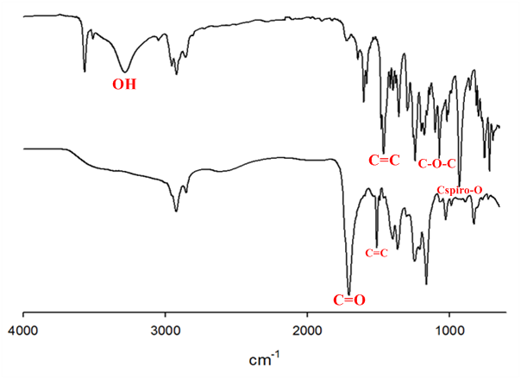

Figure 1: Infrared spectra of (a) spiropyran form (b) merocyanine form

Table 2 summarized the ¹H NMR of the SP before and after isomerization to the (coloured) MC form. The SP shows signals of the two geminal methyl groups at 1.19 ppm and 1.3 ppm and N-methyl peak at 2.97 ppm respectively due to the ring-closed form consisting of orthogonal nature of both indoline and benzopyran halves [25]. Olefinic protons appear at 5.77 and 6.9 ppm for H₃ and H₄ respectively with large coupling constants J=10 Hz indicates for the cis configuration. The J value within 7-10 Hz is described for cis double bond [26]. In contrast, after SP was irradiated under UV light, the corresponding peaks of germinal methyl groups had shifted downfield because of the effect of the positively charged nitrogen in the opened form [25]. This effect is attributed to the cleavage C-O bond and observed mainly at the peaks of NCH₃ which newly appeared at 3.41 ppm. Moreover, the conversion to the new species MC also collapsing the gem-dimethyl group signals into single peak at 2.08 ppm [25]. However, the rest of C-H aromatic peak assignment of merocyanine form was rather complex hence it has not been assigned.

Table 2: Significant ¹H NMR spectral data for both SP and MC

Sample | Assignment (ppm)
Sample | H-C aromatic^{(m)} | CH₃^{(s)} | N-CH₃^{(s)} | C-OH^{(s)}
Spiropyran | 5.69 – 7.19 | 1.31 and 1.19 | 2.76 | N.D
Merocyanine | 8.30 | 2.08 | 3.42 | N.D
s, singlet; m, multiplet; and N.D., Not Detected

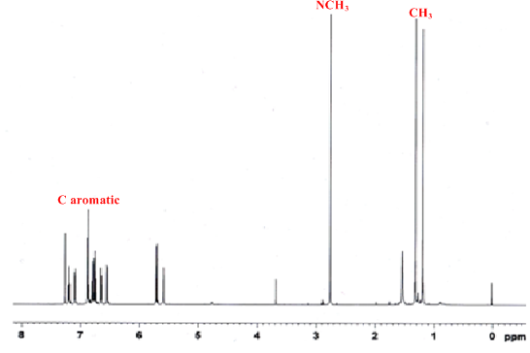

Figure 2: ¹H NMR spectrum of spiropyran in CDCl₃

Photochromic study

The SP appeared to be colourless after dissolution in dichloromethane and was able to exhibit a strong “positive photochromism” and lead to the formation of colored merocyanine. This result correspond to the irradiation of spiropyran under UV light for a certain time and triggered the isomerisation to merocyanine form via the photochemical cleavage of the C-O bond [9]. At times zero, there was almost no absorption appears at >430 nm, indicating the compound to be at closed form. By contrast, the increase time of UV exposure manifest a build-up of prominent band in the absorption spectrum at 430 nm due to hyperchromic effect (Figure 3). Hence, this proved that the conversion of SP MC in aqueous media can be accelerated in longer time [27].

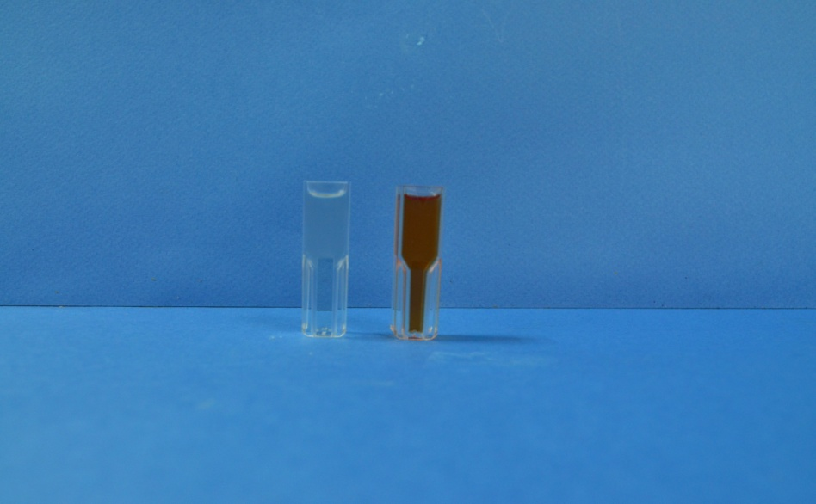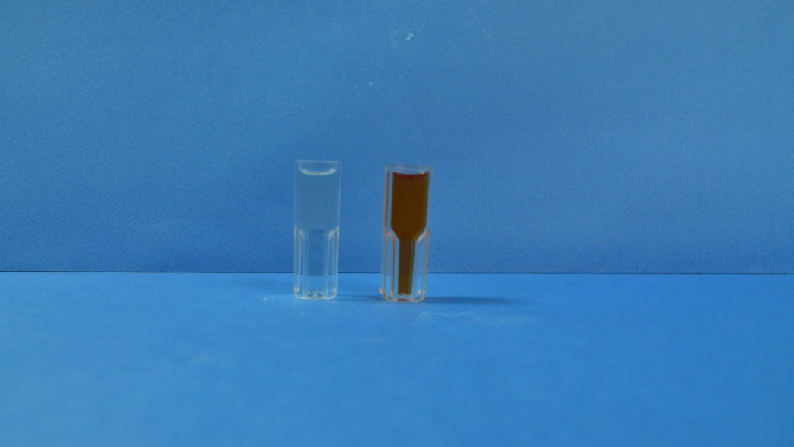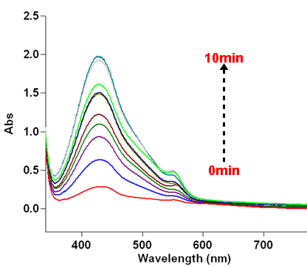

Figure 3: Absorption spectrum of spiropyran after irradiation leads to an increase in absorption at 430nm

Metal-induced activation of spiropyran

Upon the addition of various metal cations (Zn²⁺, Co²⁺, Cu²⁺, Fe²⁺ and Sn²⁺), the colourless spiropyran solution switched to coloured merocyanine metal complex. This binding interaction is in agreement with the previous report [26]. The new absorption peaks observed in the visible region in the presence of metal cations due to the formation of spiropyran-metal complexes where two different binding sites, a hydroxyl group (position 8’) and phenolate anion may be involved (Figure 4). The shifts of the absorption bands were observed in the visible region due to the formation of metal complexes (Figure 5). There is less variation in the response between different ions although the position of the maximum absorption depends on the nature of the metal ions [28]. For example, MC-Cu, MC-Co and MC-Fe complexes showed maximum absorption at 490 nm, 470 nm and 480 nm respectively. These absorption bands are hypsochromically shifted with respect to the free merocyanine absorption. For MC-Sn complex and MC, changes only occurred in their intensity not in their absorption suggesting the same kinetic energy in both compounds.

Figure 4: Metal-induced conversionof SP to MC

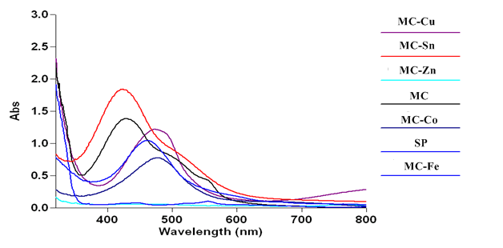

Figure 5: UV-vis absorbance spectra of SP in the presence of different divalent metal ions: Cu, Sn, Fe, Zn, and Co.

Conclusion
New photochromic spiropyran was synthesized containing a hydroxyl group and to undergo cleavage of the weak spiro carbon-oxygen bond to form a coloured photomerocyanine structure. The interaction between divalent ions Cu²⁺, Fe²⁺, Zn²⁺, Co²⁺ and Sn²⁺ also showed strong spectral and visual changes in all five divalent metal ions. Thus, it proved that the presence of external stimuli such as metal ions can also act as an important factor in heterolytic bond cleavage and ring opening of SP compound. The spectra of all forms are able to exhibit a strong absorption and stabilization with coordination to the metal ions. Furthermore, this ionochromic compound is necessary for the basic design of simple and cost-effective chemisensor.

Acknowledgement
This work was financially supported in part by research grants FRGS/1/2011/SG/UKM/02/25 and GGPM-2011-054 given by Universiti Kebangsaan Malaysia and Ministry of Higher Education.

References

[1] Jiang, G., Song, Y., Guo, X., Zhang, D.& Zhu, D. (2008). Organic Functional Molecules towards Information Processing and High-Density Information Storage. Journal of Advanced Materials, 20 (15):2888 – 2898.

[2] Young, D. D. & Deiters, A. (2003). Light-Regulated RNA–Small Molecule Interactions. Journal of ChemBioChem, 9(8): 1225–1228.

[3] Raymo, F. M. & Giodani, S. (2001). Signals Processing at the Molecular Level. Journal of the American Chemical Society, 123: 4651 – 4652.

[4] Zhu, M. Q., Zhu, L., Han, J. J., Wu, W., Hurst, J. K.& Li, A. D. Q. (2005). Spiropyran-based Photochromic Polymer Nanoparticles with Optically Switchable Luminescence. Journal of the American Chemical Society, 128: 4303 – 4309.

[5] Wang, S., Song, Y. & Jiang, L. (2007). Photoresponsive surfaces with controllable wettability. Journal of Photochemistry and Photobiology C: Photochemistry Reviews, 8: 18 – 29.

[6] Ercole, F., Davis, T. P.& Evans, R. A. (2009). Photo-responsive Systems and Biomaterials: Photochromic Polymers, light-triggered Self-assembly, Surface modification, fluorescence modulation and beyond. Polymer Chemistry, 1: 37 – 54.

[7] Maurer, M. K., Lednev, I. K.& Asher, S. A. (2005). Photoswitchable Spirobenzopyran- Based Photochemically Controlled Photonic Crystals. Journal of Advanced Functional Materials, 15 (9): 1401–1406.

[8] Anzai, J. I. & Osa, T. (2010). Photosensitive artificial membranes based on azobenzene and spirobenzopyran derivatives. Journal of Tetrahedron, 50 (14): 4039 – 4070.

[9] Berkovic, G., Krongauz, V. & Weiss, V. (2000). Spiropyran and Spirooxazines for Memories and Switches. Journal of Chemical Review, 100 (5): 1741 – 1754.

[10] Bowden, S. L., Harris, S. A., Heller, H. G. & Hewlins, M. J. E. (1992). Photochromic heterocyclic fulgides. Part 6. Base-catalysed cyclizations of 1-(2, 5-dimethyl-3-furyl and 2, 5-dimethyl-3-thienyl) ethylidene (isopropylidene) succinic anhydrides and related compounds. Journal of the Chemical Society, Perkin Transactions 1, 6: 725 – 728.

[11] Oda, H. (1991). Photostabilisation of colorants for imaging and data recording systems: Effects of metal carboxylates on the lightfastness of colour formers. Journal of Dyes and Pigments, 16:1 – 10.

[12] Shao, N., Zhang, Y., Cheung, S. M., Yang, R. H., Chan, W. H., Mo, T., Li, K. A. & Liu, F. (2005). Copper Ion-selective Fluorescent Sensor based on the inner filter effect using a spiropyran derivative. Journal of Analytical Chemistry, 77 (22): 7294 – 7303.

[13] Winkler, J. D., Bowen, C. M., and Michelet, V. (1998). Photodynamic Fluorescent metal ion sensors with parts per billion sensitivity. 1998. Journal of the American Chemical Society, 120:3237 – 3242.

[14] Ren, J. & Tian, H. (2007). Thermally Stable Merocyanine Form of Photochromic Spiropyran with Aluminium ions as a reversible photo-driven sensor in aqueous solution. Sensors, 7: 3166 – 3178.

[15] Oda, H. (1998). New Developments in the stabilization of Photochromic dyes: counter-ion effects on the light fatigue resistance of spiropyrans. Journal of Dyes and Pigments, 38 (4): 243 – 254.

[16] Yagi, S., Maeda, K. & Nakazumi, H. (1999). Photochromic properties of cationic merocyanine dyes. Thermal stability of the spiropyran form produced by irradiation with visible light. Journal of Materials Chemistry, 9: 2991 – 2997.

[17] Han, S. & Chen, Y. (2010). Mercury ion induced activation of the C-O bond in a photo-responsive spiropyran. Journal of Dyes and Pigments, 88: 235 – 239.

[18] Zakhs, E. R., Zvenigorodskaya, L. A., Leshenyuk, N. G. & Martynova, V. P. (1978). Bromination of spiropyrans and reduction of their nitro derivatives. Plenum Publishing Corporation, 10: 1320 – 1326.

[19] Scarmagnani, S. (2010). Development of New Adaptive Materials Based On Spiropyran Molecular Photoswitches. PhD Thesis. Dublin City University, 32 – 34.

[20] Hecht, S. (2011). Introduction to the Synthesis of Photochromes: Spiropyran and Diarylethenes. SFB Kolluquium. Humboldt-Universitat zu Berlin

[21] Macuil, R. D., Lopez, M. R., Martinez, M. B. & Pernas, V. C. (2008). ATR‐FTIR Spectroscopy and their Applications in the Ring‐Opening Reaction of Spiropyran Polymers. AIP Conference Proceedings, 992: 1237 – 1241.

[22] Keum, S. R., Choi, Y. K., Lee, M. J. & Kim, S. H. (2001). Synthesis and properties of thermo- and photochromic bisindolinobenzospiropyrans linked by thio- and carbonyl groups. Journal of Dyes and Pigments, 50: 171-176.

[23] Zou, W. X., Huang, H. M., Gao, Y., Matsuura, T. & Meng, J. B. (2004). Structures of Two Spiropyrans in the Open and Closed Form. Journal of Structural Chemistry, 15 (4): 317 – 321.

[24] Keum, S. R., Choi Y. K., Kim, S. H. & Yoon, C. M. (1999). Symmetric and unsymmetric indolinobenzospiropuran dimmers: synthesis and characterization. Journal of Dyes and Pigments, 41:41 – 47.

[25] Preigh, M. J., Stauffer, M. T., Lin, F. T. & Weber, S. G. (1996). Anodic oxidation mechanism of a Spiropyran. Journal of Chemical Society. Faraday Trans, 92 (20): 3991 – 3996.

[26] Natali, M., Aakeröy, C., Desper, J. & Giordani, S. (2010). The role of metal ions and counterions in the switching behavior of a carboxylic acid functionalized spiropyran. Dalton Trans, 39: 8269 – 8277.

[27] Shiraishi, Y., Itoh, M. & Hirai, T. (2010). Thermal isomerization of spiropyran to merocyanine in aqueous media and its application to colorimetric temperature indication. Physical Chemistry Chemical Physics, 12: 13731 – 13745.

[28] Nikolaeva, O. G., Tsukanov, A. V., Shepelenko, E. N., Lukyanov, B. S., Metelitsa, A. V., Kostyrina, O. Y., Dubonosov, A. D., Bren, V. A. & Minkin, V. I. (2009). Synthesis of Novel Iono- and Photochromic Spiropyrans Derived from 6, 7-Dihydroxy-8-Formyl-4-Methyl-2H-Chromene-2-One. International Journal of Photoenergy, 2009: 1 – 6.

