THE EFFECT OF GAMMA IRRADIATION ON THE CHEMICAL STRUCTURE AND SURFACE CHARACTERISTICS OF DIPALMITOYLPHOSPHATIDYLCHOLINE (DPPC)

(Kesan Sinaran Gama ke atas Struktur Kimia dan Ciri Permukaan Dipalmitoilfosfatidilkolina (DPPC))

Hur Munawar Kabir Mohd¹, Ainee Fatimah Ahmad¹, Faizal Mohamed¹, Nursaidatul Syafadillah Kamaruzaman¹, Ng Wei Ling¹, Poh Roe Jin¹, Muhamad Samudi Yasir¹, Mohd Hafez Mohd Isa³, Suria Ramli², Shahidan Radiman¹ and Irman Abdul Rahman¹*

¹School of Applied Physics,
²School of Chemical Sciences and Food Technology,
Faculty of Science & Technology, Universiti Kebangsaan Malaysia, 43600 Bangi, Selangor, Malaysia.
³Industrial Chemistry Technology Program,
Faculty of Science & Technology,
Universiti Sains Islam Malaysia, Bandar Baru Nilai, 71800 Nilai, Negeri Sembilan.

*Corresponding author: irman@ukm.my

Abstract
Dipalmitoylphosphatidylcholine (DPPC) is one of the most abundant lipids in the human body and carries out important physiological functions such as liver protection and fighting infections. This study was conducted to investigate the effect of ionising radiation on the chemical structure and surface characteristic of DPPC. Synthetic DPPC was dissolved in chloroform (1mg/ml) and irradiated with Cobalt-60 (dose range of 50 – 200 Gy). The change in surface characteristics due to gamma irradiation was determined by means of monolayer compression isotherms using a Langmuir trough. From the change in the isotherm features, the threshold dose that affected the surface characteristics of the DPPC monolayer was determined to be 60 Gy. With increasing dose value, the plateau feature in the DPPC isotherm became shorter and was shifted to higher surface pressures. Analysis using High Performance Liquid Chromatography (HPLC) and Mass Spectrometry (MS) suggested that gamma irradiation of DPPC destroyed the chemical structure of DPPC and produced two main radiolytic products, namely lisophosphatidylcholine, LPC (~495.3142 g/mol) and phosphatidic acid, PA (~718.916 g/mol) with an average percentage of LPC and PA of 23% and 74%, respectively.

Keywords: Dipalmitoylphosphatidylcholine (DPPC), Langmuir monolayer, High Performance Liquid-Chromatography (HPLC), Mass-Spectrometer (MS), Gamma radiation

Abstrak
Dipalmitoilfosfatidilkolina (DPPC) adalah antara lipid dengan kelimpahan yang tinggi dalam badan manusia dan terlibat dalam fungsi fisiologi penting seperti perlindungan hati dan penentangan jangkitan. Kajian ini dijalankan untuk menentukan kesan sinaran gama ke atas struktur kimia dan cirian permukaan monolapisan DPPC. DPPC sintetik dilarutkan dalam kloroform (1mg/ml) dan disinarkan dengan punca sinar gama Kobalt-60 (julat dos 50 – 200 Gy). Perubahan pada cirian permukaan isotherma pemampatan monolapisan DPPC akibat kesan sinaran gama ditentukan dengan menggunakan Palung Langmuir. Daripada perubahan ciri pada isoterma pemampatan yang diperolehi, dicadangkan dos ambang yang mula memberikan kesan ke atas kerosakan struktur DPPC bermula pada sekitar 60 Gy. Dengan peningkatan dos dedahan, ciri dataran pada lengkung isoterma DPPC menjadi semakin pendek dan berganjak kepada tekanan permukaan yang lebih tinggi. Analisis dengan menggunakan Kromatografi Cecair Prestasi Tinggi (HPLC) dan Spektrometri Jisim (MS) menentusahkan bahawa struktur kimia asal DPPC termusnah dan membentuk dua hasil radiolitik iaitu lisofosfatidilkolina, LPC (~495.3142 g/mol) dan asid fosfatidik, PA (~718.916 g/mol) dengan purata peratusan LPC dan PA masing-masing adalah 23% dan 74%.

Kata kunci: Dipalmitoilfosfatidilkolina (DPPC), monolapisan Langmuir, Kromatografi Cecair Prestasi Tinggi (HPLC), Spektrometri Jisim (MS), Sinar Gama

Introduction
Ionising radiation has been widely used in medical application as a tool in diagnostic imaging, nuclear medicine and radiotherapy. Living organisms exposed to radiation can undergo tissue deformity and suffer damages which is a major safety concern. However, there are few studies that investigate the effects of gamma radiation on biological system components, in particular phospholipids. In this study, the di-saturated and zwitterionic dipalmitoylphosphatidylcholine (DPPC) was used because it is the most abundant phospholipid and can be found almost everywhere in the body and functions to protect the liver, fight toxicity and infection in the body system. [1].

Gamma irradiation has been found to be effective in depolymerising and cleaving molecular chains ascribed to the decay processes. This is related to free radicals generated at the primary stage of gamma irradiation, which extends to changes in chemical composition as well as its physiological functions [2]. It has also been reported in previous studies that radiation, given to patients for the purpose of diagnosis and therapy, has caused an onset of joint pain and loss of joint fluidity. This is due to the unacceptably high radiation dose delivered to non-targeted organs because of the leakage from the treated joints [3].

In this study, there are three main objectives. The first objective is to study the effects of ionizing radiation on DPPC monolayer surface structure. A basic technique used to study the phase behavior of monolayers is the so-called Langmuir film balance. The effects are observed from the surface pressure-area isotherms obtained upon compression of lipid spread on an aqueous subphase. The second objective is to identify the chemical composition formed from the structural damage of irradiated DPPC at dose ranges of 0 Gy to 200 Gy. High Performance Liquid Chromatography (HPLC) and Mass Spectrometry (MS) were used to obtain and verify the chemical composition formed after irradiation. The third objective is to compare the DPPC irradiation results obtained from the HPLC method with the results obtained from the Langmuir monolayer compression method. This comparison allows us to determine the threshold dose of gamma radiation damage to DPPC.

Material and Methods
Research materials
Synthetic DPPC (1,2-dipalmitoyl-sn-glycerol-3-phosphocholine) was purchased from Avanti Polar Lipids Inc. (Alabaster, AL, USA). The samples were dissolved in chloroform to get a concentration of 1 mg/ml and all samples were irradiated with gamma irradiation. The samples irradiated at higher doses (60 Gy to 200 Gy) were supplemented with Fricke dosimetry to determine the exact absorbed dose. All samples were then analysed using Langmuir trough to observe the samples surface structure. HPLC and MS were used to obtain the chemical composition of the samples.

Sample preparation
DPPC monolayer surface structure was studied using the surface pressure-area isotherms obtained from spreading of lipid on an aqueous subphase in the Langmuir trough. All surface pressure-area measurements were performed on deionised water which had a resistivity greater than 18 MΩ m [4]. The chemical composition percentage of irradiated DPPC were analysed with HPLC and MS.

Irradiation Setup
The DPPC was irradiated in 4 ml glass vials with a ⁶⁰Co source at ambient temperature using a GammaCell 220 Excel irradiator at a dose rate of 4.20kGy/h. Vials containing DPPC were irradiated with 5, 10, 20, 30, 40, 50, 60, 90, 130, 170 and 200 Gy gamma radiation, with 0 Gy as a control. Time required to irradiate each samples were determined with the following equation (1);
A = A₀e^{-λt} (1)

Sample Analysis
The DPPC monolayer surface structure damage was determined through the surface pressure-area isotherms and comparisons between the plateau region slopes of the curve. Analysis of HPLC and MS confirms the chemical composition formed after irradiation.

Results and Discussion
Patterns formed from compression of DPPC monolayer
The obtained results for control and irradiated DPPC (Figure 1) exhibits a clear phase transition from liquid expanded to the liquid condensed state. The difference of slope of plateau region between each dose is observed. Each of the DPPC monolayers irradiated from 0 to 50 Gy seems to shift from an expanded to a condensed phase without any significant change in the isotherm slope. Increasing the dose from 60 Gy to 200 Gy gamma radiation exhibits a significant pattern of isotherms curve shifting to larger molecular areas.

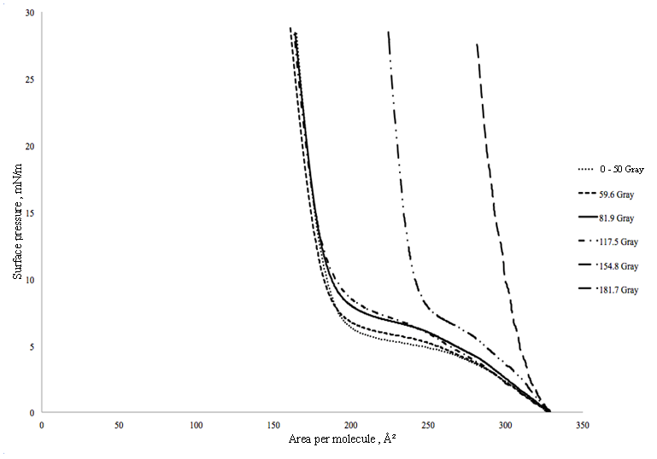
Figure 1. Surface pressure-area isotherms of DPPC monolayer at different radiation dose

As the radiation dose was increased, the slope of the plateau region also eventually increased, as observed in Figure 2. According to Hsu et al. (2009), the characteristics of the plateau’s slope are a contribution of several second phase inclusion, impurities and segregation. Charge difference or ion formation on the surface of DPPC also influences the electrostatic interaction characteristic of the air-water interface of DPPC [5,6].

High Performance Liquid Chromatography studies
HPLC analysis was performed to obtain the chemical composition of irradiated DPPC. Figure 3 displays the two linear lines that represents the radiolytic products formed i.e lysophosphatidylcholine, LPC and phosphatidic acid, PA [4]. Identification of the chemical compound formed was based on the reversed-phase HPLC work principal, where more polar compounds are eluted first [1,7]. It is known that LPC is a polar compound and PA is a non-polar compound. From the absorption unit versus operation time graph obtained from HPLC analysis, it was found that gamma radiation formed two radiolytic products due to DPPC structural damage with different chemical composition percentage for each dose.

Upon gamma irradiation, phospholipid tends to experience oxidation process and hydrolysis degradation reaction [8]. Oxidation occurs between cells that involve alternative mechanism after phospholipid has been irradiated which will form free radicals and cause damage to cells structure. Hydroxyl radical, •OH are one of the formed radical which reacts actively with irradiated cell and causes lipid oxidation [9].

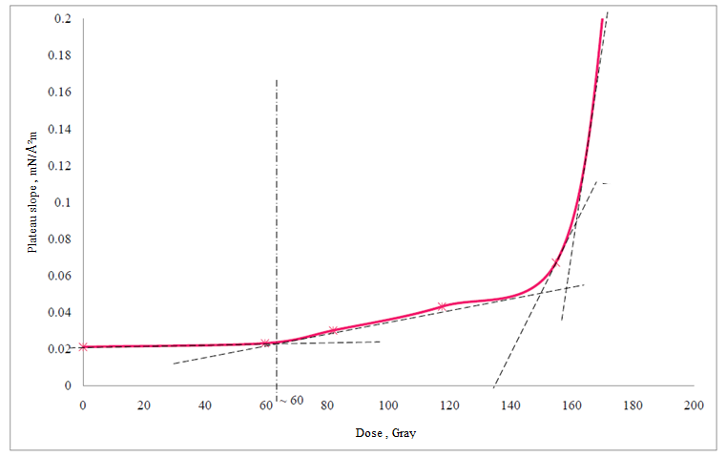
Figure 2. Plateau slope difference between each irradiated doses

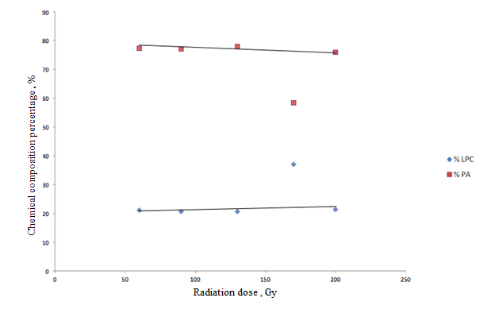
Figure 3 Percentage of chemical compound formed from HPLC separation

Mass Spectrometry studies
MS analysis provides mass spectrum information that can be used to identify molecules. In MS analysis, spectrum peak represents ions that are formed. The peak height depends on the intensity, whilst ions have their own specific abundance [10]. For this analysis, positive ion mode was used. The positive ions used were H⁺ and Na⁺ and these ions interact with samples to produce mass spectrum information.

Figure 4 shows the spectrum formed together with each individual molecular mass. Each peak represents the chemical compound formed after DPPC was irradiated with gamma radiation. It has been identified that the compounds were combined with Na to form [M+Na⁺] at an average peak of 518.31 g/mol (Figure 4(a)-(e)). Hence, the molecules formed at this peak have an average molecular mass of 495.31 g/mol, which is approximate to the LPC molecular mass of 495.63 g/mol. At the average peak of 756.54 g/mol (Figure 4(a)-(e)), it was identified that the molecule formed was [M+2Na⁺]. With a 46 unit molecular mass difference (molecular mass for every Na is 23 unit), it was identified that the compounds formed at this peak were phosphatidic acid, which has an average molecular mass value of 711.54 g/mol (~718.916 g/mol).

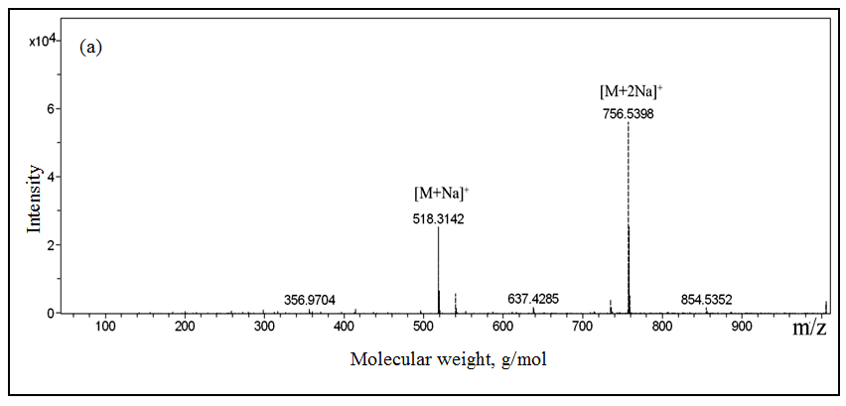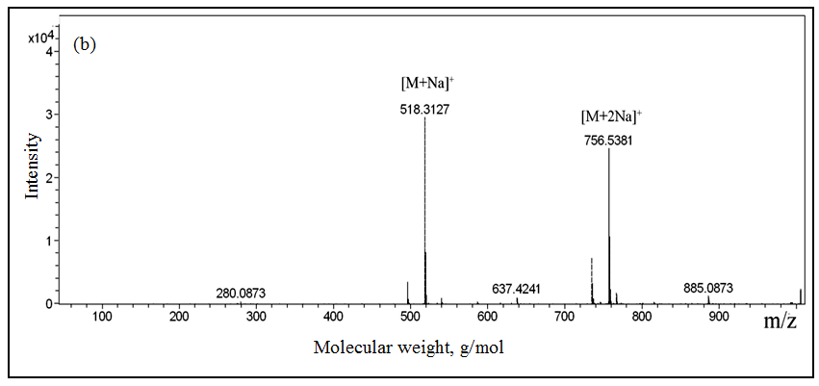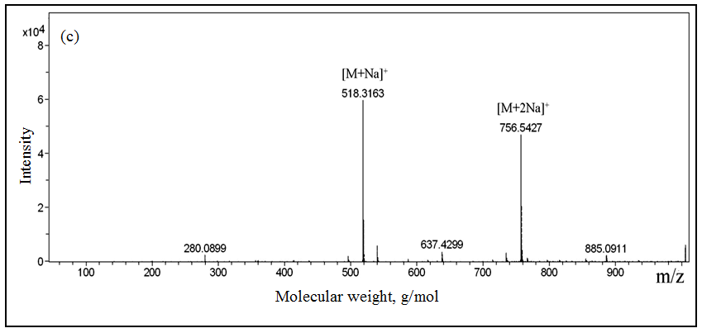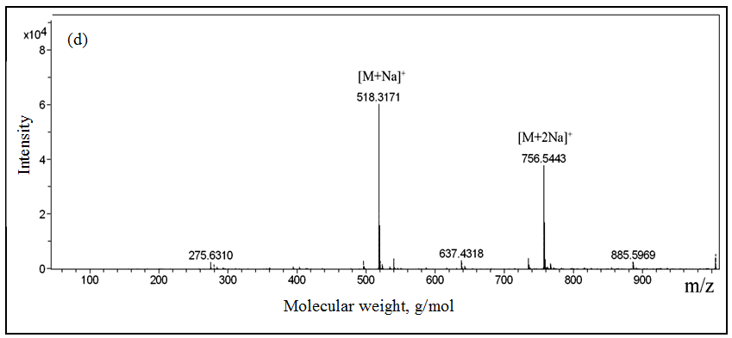
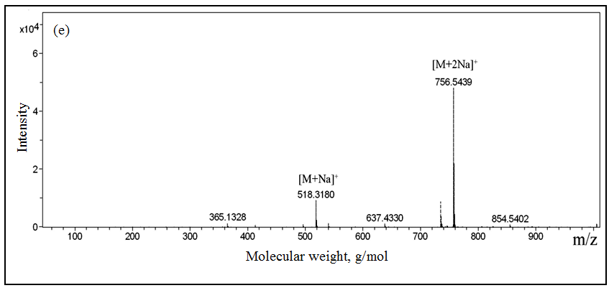
Figure 4 Mass spectrum of samples irradiated with (a) 56.5 Gy, (b) 84.8 Gy, (c) 122.4 Gy, (d) 160.1 Gy
and (e) 188.4 Gy dose

Conclusion
Based on the surface pressure-area isotherms data, it was noted that gamma irradiation lower than 50 Gy does not significantly affect the DPPC monolayer surface structure. At higher doses (59.6, 81.9, 117.5, 154.8 and 181.7 Gy), the results show the existence of the effect of ionising radiation on the characteristics of the DPPC monolayer surface. Based on the plateau slope pattern, the dose effect on the surface characteristics of DPPC monolayer was seen to start at approximately 60 Gy. With increasing dose values, the plateau of the DPPC isotherm curve became shorter and shifted to higher surface pressures. Analysis of MS confirms that the radiolytic products formed were lysophosphatidylcholine, LPC and phosphatidic acid, PA with average percentage 22.94% and 74.38%, respectively. A previous study showed that only LPC and PA were formed as the major radiolytic products of gamma irradiation on phospholipids at dose of 9.66 kGy [11]. In summary, our experiments clearly showed that DPPC has suffered damage to its chemical compound even at the lower doses (< 50 Gy). However, the surface structure displayed via the Langmuir monolayer remained intact with a gradual shift that depicts structural change starting from the dose of 60 Gy. This suggests the ability of DPPC to sustain its surface structure and functions at higher dose, even though its chemical structures have been altered at the lower doses of 50 Gy.

Acknowledgements
The authors would like to acknowledge funding from UKM in this work through research grants UKM-ST-07-FRGS0023-2010, ERGS/1/2012/STG02/UKM/02/1, UKM-ST-07-FRGS0018-2010 and UKM-PTS-011-2010. We would also like to thank the School of Chemical Sciences and Food Technology for extending their facilities to us.

References
1. Singleton, J., A., Ruan, M., Sanford, J., H., Haney, C., A. & Stikeleather, L., F. 1999. Separation and Characterization of Peanut Phospholipid Molecular Species Using High-Performance Liquid Chromatography and Fast Atom Bombardment Mass Spectrometry. Journal of the American Oil Chemists’ Society. 76(1): 49-56.
2. Kim, J. K., Srinivasan, P., Kim, J. H., Choi, J., Park, H. J., Byun, M. W. & Lee, J. W. 2008. Structural and antioxidant properties of gamma irradiated hyaluronic acid. Journal of Food Chemistry. 109(2008): 763-770
3. Wang S.J. 2001. Histologic study of effects of radiation synovectomy with Rhenium-1888 microsphere. Journal of Nuclear Medicine and Biology. 28(2002): 727-732
4. Harishchandra, R. K., Saleem, M. & Galla, H. J. Nanoparticle interaction with model lung surfactant monolayers. Journal of Royal Society Interface. 7(2010): 15-26
5. Garidel, P. & Blume, A. 2005. 1,2-Dimyristoyl-sn-glycero-3-phosphoglycerol (DMPG) monolayers: influence of temperature, pH, ionic strength and binding of alkaline earth cations. Chemistry and Physics of Lipids. 138(2005): 50-59
6. Hsu, S. E., Beibutian, V. M. & Yeh, M. T. 2002. Preparation of hydrogen storage alloys for applications of hydrogen storage and transportation. Journal of Alloys and Compounds. 330-332(2002): 882-885
7. Sanagi, M. M. 1998. Kaedah pemisahan dalam analisis kimia. Skudai: Percetakan Surya Sdn. Bhd.
8. Mengesha, A. E. & Bummer, P. M. 2010. Simple chromatographic method for simultaneous analyses of phosphatidylcholine, lysophosphatidylcholine and free fatty acids. Journal of American Association of Pharmaceutical Scientists. 1-8.
9. Hallahan, D. E., Virudachalam, S., Sherman, M.L, Huberman, E., Kufe, D. W. & Weichselbaum. 1991. Tumor necrosis factor gene expression is mediated by protein kinase C following activation by ionizing radiation. Journal of American Association for Cancer Research. 51: 4565-4569
10. Watson, J. T. & Sparkman, O. D. 2002. Introduction to mass spectrometry. 4th edition. Chichester: John Wiley & Sons Ltd.
11. Tinsley, P.W. & Maerker, G. 1993. Effect of Low-Dose γ-Radiation on Individual Phospholipids in Aqueous Suspension. Journal of the American Oil Chemist’s Society. 70(2): 187-191.

