LIPID PEROXIDATION IN RAT LIVER USING DIFFERENT VEGETABLE OILS

(Peroksidaan Lipid Pada Hati Tikus Yang Menggunakan Minyak Sayuran Yang Berbeza)

Eqbal Dauqan^{1*}, Aminah Abdullah² and Halimah Abdullah Sani¹

¹School of Biosciences and Biotechnology, Faculty of Science and Technology
²School of Chemical Sciences and Food Technology, Faculty of Science and Technology
Universiti Kebangsaan Malaysia, 43600 Bangi Selangor, Malaysia

*corresponding author: edouqan@yahoo.com

Abstract
The objective of the study was to evaluate the effect of different vegetable oils (Red Palm Olien (RPO), Palm Olein (PO), Corn Oil (CO) and Coconut Oil on lipid peroxidation of rat liver. One hundred and thirty two Sprague Dawley male rats were randomly divided into two groups. The first group contains seventy two rats were divided into twelve groups of 6 rats per group and were treated with different concentrations of RPO (5%, 10% and 15%) for 2, 4 and 8 weeks. The second group contains sixty male rats were randomly divided into ten groups of 6 rats per group and were treated with 15% of RPO, PO, CO and COC for 4 and 8 weeks. The results shows that after 8 weeks of treatment the malondialdehyde (MDA) value in RPO group was significantly lower (P≤0.05) than control or vegetable oils studied. These experiments suggested that red palm olein antioxidants present in rat diets may better attenuate peroxyl radical than other vegetable oil studied.

Keywords: lipid peroxidation, malondialdehyde (MDA), vitamin E, β-carotene, vegetable oils, antioxidants

Abstrak
Satu siri kajian telah dijalankan untuk menilai kesan minyak sayuran yang berbeza pada peroksidaan lipid pada hati tikus Satu ratus tiga puluh dua ekor tikus Sprague Dawley jantan telah dibahagi kepada dua kumpulan. Kumpulan pertama mempunyai 72 ekor tikus dan dibahagi kepada dua belas kumpulan 6 ekor tikus setiap kumpulan. Tikus-tikus diberi makan ad libitum dengan pelet komersial yang mengandungi kepekatan olein sawit merah (RPO) yang berbeza selama 2, 4 dan 8 minggu. Kumpulan kedua mengandungi 60 ekor tikus jantan yang dibahagi secara rawak kepada 10 kumpulan 6 ekor yang masing masing telah diberi 15% RPO, olein sawit (PO), jagung minyak (CO) dan kelapa sawit (COC) dan kawalan selama 4 dan 8 minggu. Selepas 8 minggu perlakuan nilai malondialdehida (MDA) dalam kumpulan RPO adalah jauh lebih rendah (P≤0.05) daripada kawalan atau kumpulan minyak sayur-sayuran yang dikaji. Keputusan eksperimen ini menunjukkan minyak olein sawit merah yang mengandungi banyak antioksidan dalam diet tikus dapat mengurangkan pembentukan radikal peroksi dengan lebih baik berbanding minyak sayuran lain yang dikaji.

Kata kunci: Peroksidaan lipid peroxidation, malondialdehida (MDA), vitamin E, β-karotena, minyak sayuran, antioksidan
Introduction
Vegetable oils in particular are natural products of plant origin consisting of ester mixtures derived from glycerol with chains of fatty acid contain about 14 to 20 carbon atoms with different degrees of unsaturation [1]. Vegetable oil is very common, affordable and used by majority of people across the globe especially in the tropics. Its use as antidote to prevent some oxidative stress related diseases and a complication is advocated [2]. Palm oil contains approximately an equal amount of saturated and unsaturated fatty acids. Amongst the former, palmitic and stearic acid account for 45% and 5% of the total fatty acids, respectively. Palm oil has a wide range of applications and it is commonly fractionated into olein and stearin [3]. The different properties of palm oil and it’s fractions allow the products to be used for different purposes [4]. Palm olein oil, a liquid fraction obtained from the refining of palm oil, is rich in oleic acid (42.7– 43.9%), β-carotene and vitamin E (tocopherols and tocotrienols) [5]. It is rich in tocotrienol which has been reported to be natural inhibitors of cholesterol synthesis. Tocopherols are very important minor components of oils and fats because of their antioxidant properties [6].

Red Palm Oil (RPO) contains 50% saturated fatty acids, 40% monounsaturated fatty acids and 10% polyunsaturated fatty acids. The RPO is the only vegetable oil with a balanced composition of saturated and unsaturated fatty acids both in the processed and unprocessed forms [7]. It contains carotenoids, phosphatides, sterols, tocopherols and trace metals. They have shown to be effective against oxidative stress in vitro and in vivo [8]. Red palm oil (RPO) is the oil obtained before refining. The characteristic colour of RPO is due to the abundance of carotenoids (500 – 700 mg / L) in the crude oil [9]. Most of the β-carotene is destroyed during processing the oil in palm oil refineries [10]. The carotenoids, together with vitamin E, ascorbic acid, enzymes and proteins, are members of the biological antioxidant network converting highly reactive radicals and free fatty peroxyl radicals to less active species [11] thus, protecting against oxidative damage to cells. Besides providing high energy density in the diet, β-carotene is the most abundant carotenoids which can be converted to vitamin A; which is an important in the visual process. In addition, it is an antioxidant that destroys singlet oxygen and free radicals [12]. Red Palm Oil is also a rich source of vitamin E, which is about 559 to 1000 ppm. Vitamin E acts as a potent antioxidant serving to protect cellular membranes from free radical-catalyzed lipid peroxidation [12].

Coconut oil is commercially a major source of lauric acid [13]. Coconut oil contains approximately 90% saturated fats. [14]. Coconut oil contains medium chain fatty acids such as lauric, caprylic and myristic acids. Of these three, coconut oil contains 40% lauric acid, which has the greater antiviral activity of these three fatty acids [15]. Corn oil provides essential fatty acids, mostly linoleic acid. Linoleic acid is necessary for the integrity of the skin, cell membranes, and the immune system, and for synthesis of eicosanoids. [16]. Corn oil is a good source of essential fatty acids and its nutritional properties are excellent and the fatty acids found in corn oil are palmitic acid, stearic acid, oleic acid, linoleic acid, and linolenic acid [17].

Reactive oxygen species (ROS) are highly reactive and in the absence of any protective mechanism they can disrupt normal metabolism through oxidative damage to lipids, protein and nucleic acids [18]. Peroxidation of lipids is a binding process connected with the formation of aldehydes and one of them is malondialdehyde (MDA). Thibarbituric acid (TBA) assay is the most common method to be used to measure MDA activity [19]. It is known that the quantity of MDA is an intensity index of peroxidation process of polyunsaturated fatty acids (PUFAs) contained in food [20, 21]. MDA is one of the final products of polyunsaturated fatty acids peroxidation in the cells, increase in free radicals causes overproduction of MDA. Malondialdehyde level is commonly known as a marker of oxidative stress and the antioxidant status [20, 22, 23]. Mohammad et al. [24] reported that the level of lipid peroxidation can be determined by measuring the level of malondialdehyde (MDA) which is a stable lipid peroxidation product. Therefore the the main objective of this work was to compare the effect of different concentrations (5%, 10% and 15%) of RPO and four vegetable oils (red palm olein, palm oil, corn oil and coconut oil) added to commercial pallet on lipid peroxidation of rats fed until 8 weeks of growth.

Experimental
Instruments
The following instruments were used in this study: (i) High-speed homogenizer (DI18 basic, IKA, Germany) (ii) centrifuge ( Kubota 2010, Malaysia) (iii) UV-Visible spectrophotometer (Hitachj U-1800 single, Germany).

Chemicals
Potassium chloride (KCl), thiobarbituric acid (C₄H₄N₂O₂S), tetraeethoxypropane (TEP), acetic acid (C₂H₄O₂), butanol (C₄H₁₀O) were obtained from Sigma (USA) while sodium dodecyl sulfate (C₁₂H₂₅O₄S) was obtaind from sigma-aldrich, Japan. Pyridin (C₅H₅N) were from Hopkin and Williams chemicals campony.

Experimentals Diets

The evaluated RPO samples consist of carotino. It is provided by Carotino SDN BHD company Palm olein (Seri Murni), corn oil and coconut oil were obtained commercially. For first group the test diet was prepared by mixing vegetable oils with normal commercial rat pellet to contain 15% of the vegetable oils. The 15% diet was prepared by adding 15g RPO, PO, CO or COC to 85g rat pallet, and mixed manually and the diets were then left to absorb the vegetable oils at room temperature overnight and stored at 20º C before the feeding trial was conducted. For second group the test diet was prepared by mixing RPO with normal commercial rat pellet to contain 5%, 10% and 15% of the red palm olein (RPO). The 5% diet was prepared by adding 5g RPO to 95g rat pallet, and mixed manually and the diets were then left to absorb the RPO at room temperature overnight and stored at 20º C before the feeding trial was conducted. Similar process was conducted with 10%, and 15% RPO.

Animals
One hundred and thirty two Sprague Dawley male rats each weighing between 170-250g and approximately 80 days old were obtained from the animal house of the Faculty of Science and Technology, Universiti Kebangsaan Malaysia. They were randomly divided into two groups. The first group contains seventy two rats were divided into twelve groups of 6 rats per group. The rats were fed ad libitum with commercial rat’s food containing different concentrations of RPO (5%, 10% and 15%) for 4 and 8 weeks. The second group contains sixty Sprague Dawley male rats were randomly divided into ten groups of 6 rats per group and were treated with 15% of RPO, PO, CO and COC for 4 and 8 weeks. Rats in control group were given normal rat pellet only while in treated groups 5%, 10% and 15% of additional RPO for first group were given and 15% of additional different vegetable oils for second group were given.

MDA Standard
Depend on Oxford biomedical research [25] method the MDA standard was provided as tetraethoxypropane (TEP) because MDA is not stable. However, the TEP standard was provided as a 20 mM stock solution. For a standard curve, pipette the volumes shown in table 1 to give a total of 200 μL of standard. The concentrations of MDA were determined from standard curve, which was constructed as follows:

Malondialdehyde was calculated using the following equation:
[MDA (µmol/g)]= A₅₃₂xV_{T}/Vs],
Where: V= Total value, and Vs= Sample value

Table 1 Standard Curve Dilution Volumes
Target concentration  of standard (µM) | 0 | 0.25 | 0.5 | 1.0 | 2.0 | 4.0
Volume of 20µM standard (µL) | 0 | 25 | 50 | 100 | 150 | 200
Volume of water, μL | 200 | 175 | 150 | 100 | 50 | 0

The clear supernatant was transferred to a cuvette and was absorbent at 586 nm. A plot of A₅₈₆ nm vs. [MDA] for the standards was constructed Figure 1.

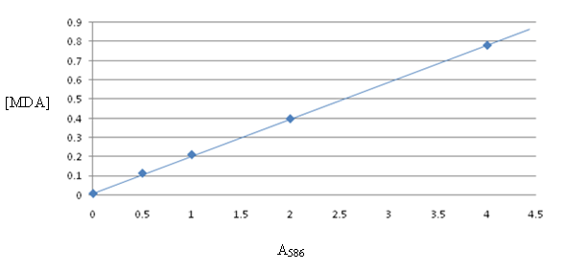

Figure 1 Malondialdehyde Standard curve

Statistical Analysis
Results were expressed as mean values ± SEM (n=6). Means of six samples were compared by analysis of variance (ANOVA). Significant differences between means were determined by Tukey’s least significant difference (p≤0.05). The software used was MINITAB® (14.20).

Determination of Lipid peroxidation (MDA)
Liver sample for malondialdehyde (MDA) was prepared by 1 g of liver cut to small pieces. Tissue was suspended in 9 ml of 1.15% KCl, and was homogenized using a mixer at top speed for 3 min. Thiobarbituric acid reactive substances (TBARS) will be measured by the modified spectrophotometric assay as Ohkawa at el. [26]. The reaction mixture contained 0.2ml of 8.1% sodium dodecyl sulfate (SDS), 1.5ml of 20% acetic acid solution, 1.5ml of 0.8% aqueous solution of thiobarituric acid (TBA), and homogenate (10%, 0.1ml). The mixture was finally made up to 4.0ml with distilled water, and heated at 95C⁰ for 60 min. After cooling with tap water, 1.0ml of distilled water was added and the red pigment produced was extracted with 5.0ml of the mixture of n-butanol and pyridine (15:1, v/v), and the mixture was shaken vigorously. After centrifugation at 4000 rpm for 10 min, the absorbance of the organic layer (upper layer) was measured at 532nm.

Results and Discussion
Malondialdehyde and other aldehydes are generally considered the end products of lipid peroxidation and are widely measured as the indexes of lipid peroxidation [21].

Effect of Different Concentrations of Red Palm Olein on Lipid Peroxidation of Rat Liver
The results of MDA level of rat liver with different concentrations (5%, 10% and 15%) of RPO for 2, 4 and 8 weeks of treatment are summarized in Figures 2, 3 and 4. After 2 weeks of treatment the results of MDA level was no significant different (P≥0.05) between control group and rat liver treated with 5%, 10% and 15% RPO groups. At 4 weeks the MDA level of treated rat increased in all concentrations compared to the control group but there was no significant different (P≥0.05) in MDA level of treated rat of RPO (5% and 10%) while there was significant increase (P≤0.05) in MDA level of treated rat of RPO (15%) compared to the control group. The mean ± SEM of lipid peroxidation as determined with MDA activity in the treated rat liver in control, 5%, 10% and 15% of RPO groups were 42.8µmol/g, 42.5µmol/g, 55.7µmol/g and 67.1µmol/g respectively.

At 8 weeks the MDA level was decreased with all concentrations compared to the control group. There was no significant different (P≥0.05) between control and 5% RPO but were significantly higher (P≤0.05) than 10% or 15% RPO treated liver samples. The mean ± SEM of lipid peroxidation as determined with MDA activity in the treated rat liver in control, 5%, 10% and 15% of RPO groups were 46.5µmol/g, 45.3µmol/g, 23.6µmol/g and 21.9µmol/g respectively. The results of the present study showed that after 2 weeks of treatment did not decrease MDA level. The two weeks of treatment was not suitable for investigation because the time of treatment too short to see the effect.

Lipid peroxidation is widely used as an indicator to reflect oxidative stress and cell membrane damage [27]. Free radicals like superoxide anion and hydroxyl radical exert their toxic effect by acting on lipids. Feeding dietary oils rich in unsaturated fatty acids makes target tissues more vulnerable to peroxidative damage [28]. This is reflected in higher lipid peroxidation production in livers of animals fed these diets. However, in this study suggested that the presence of high level of dietary vitamin E used may have protected the liver tissues from peroxidative damage.

There is increasing evidence that carotenoids are very effective quenchers of peroxyl radicals [29], but the mechanism of their action has not yet been defined. One might expect that the reaction of β-carotene with a peroxyl radical would form a carotenoid radical species shown in equation 1 [30, 31].
β-carotene + ROO. β-carotene + ROOH (1)
β-Carotene may react directly with a peroxyl radical to form a resonance-stabilized carbon-centered radical (equation 2).
β-carotene + ROO. ROO-β-carotene (2)
Thus, providing an explanation of the antioxidant effect of β-carotene on lipid peroxidation induced by peroxyl radicals, In the presence of oxygen, the β-carotene radical in the equation (1) would combine with oxygen to form a carotenoid-peroxyl radical (equation 3).
β-carotene + O2 β-carotene-OO. (3)
This reaction would be dependent on the oxygen tension in the system. If the oxygen tension is sufficiently low, the equilibrium of reaction (3) shifts to the left, reducing the amount of chain-carrying peroxyl radical. In addition, the β-carotene-peroxyl complex could react with another peroxyl radical, leading to a termination reaction, as shown in reaction (4).
β-carotene-OO. + ROO. inactive products (4)
On the other hand, if the oxygen tension is high, the equilibrium of reaction (3) would shift to the right and form a peroxyl radical capable of acting as a prooxidant. The last reaction is also referred to as autoxidation of β-carotene [31]. Eder et al. [32] showed that the relationship between the vitamin E intake and level lipid peroxidation can be explained by the fact that oils with highest content of antioxidant (vitamin E and β-carotene). Tamara et al. [33] suggested that the animals on the vitamin E diet had 40% lower hepatic malondialdehyde levels in liver male mice which treated with a diet high vitamin E. Peng and Stanley [34] reported that the effect of β-carotene, tocopherol in protecting membranes from oxidative damage relative to different oxygen tensions. Hence, current study found that during treatment with 15% RPO for 8 weeks the lipid peroxidation level was inhibited in the rat liver.

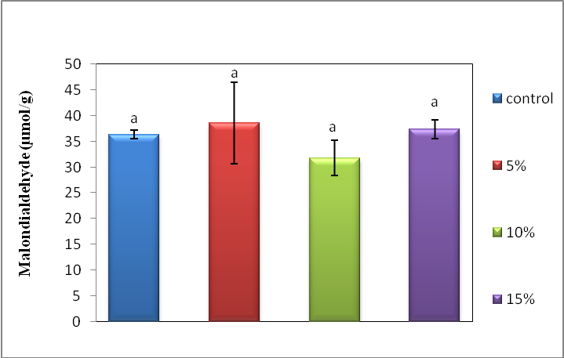

Figure 2 The malondialdehyde (MDA) in liver of rat fed with different concentrations of red palm olein for 2 weeks. Bars are mean ±SEM (n=6), no significantly different (P≥0.05)

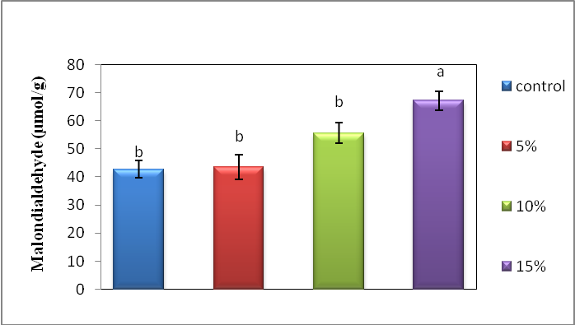

Figure 3 The malondialdehyde (MDA) in liver of rat fed with different concentrations of res palm oilein for 4 weeks. Bars are mean ±SEM (n=6), different alphabet an each bar indicate significant different (P≤0.05)

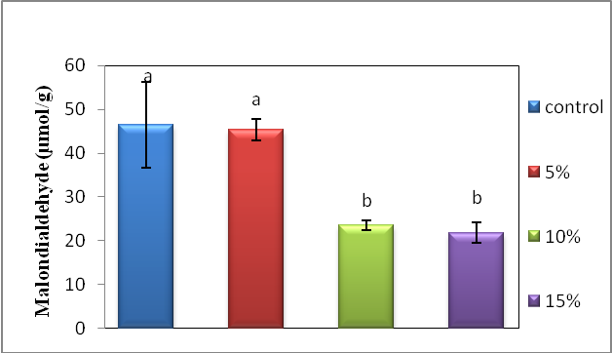

Figure 4 The malondialdehyde (MDA) in liver of rat fed with different concentrations of red palm oilein for 8 weeks. Bars are mean ±SEM (n=6), different alphabet an each bar indicate significant different (P≤0.05)

Effect of Four Different Vegetable Oils (RPO, PO, CO and COC) on Lipid Peroxidation of Rat Liver

The results of MDA level of rat liver with 15% of different vegetable oils for 4 and 8 weeks of treatment are summarized in Figures 5 and 6. At 4 weeks of treatment with different vegetable oils showed that MDA level of treated rat was increased in RPO, PO and CO groups whereas there was no significant difference (P≥0.05) in MDA level of rats treated in COC group compared to the control group. The mean ± SEM of lipid peroxidation as determined with MDA activity in the treated rat liver of control, RPO, PO, CO and COC groups were 27.3µmol/g, 92µmol/g, 54µmol/g, 47.4µmol/g and 72.6µmol/g respectively. The results at 8 weeks showed a decline in MDA level of treated rat in RPO group and there was significant increased at CO and COC groups but there was no significant different (P≥0.05) in MDA level of treated rat in PO group compared to control group. The mean ± SEM of lipid peroxidation as determined with MDA activity in the rat liver of control, RPO, PO, CO and COC groups were 31.5µmol/g, 25.2µmol/g, 43.4µmol/g, 50.1µmol/g and 48.3µmol/g respectively.

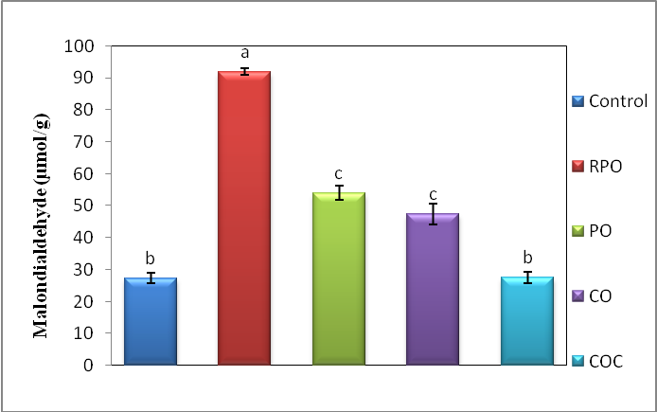

Figure 5 The malondialdehyde (MDA) in liver of rat fed with different vegetable oils for 4 weeks. Bars are mean ±SEM (n=6), different alphabet an each bar indicate significant different (P≤0.05)

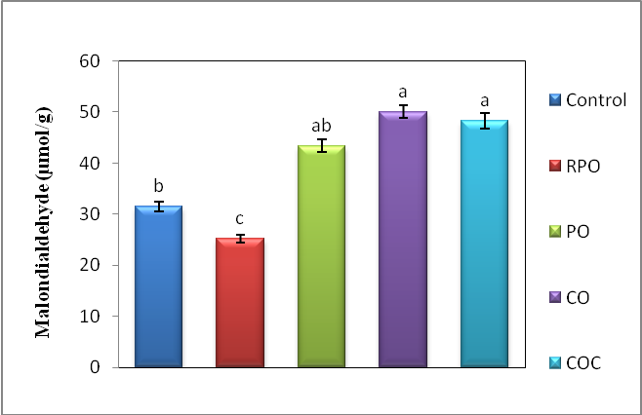

Figure 6 The malondialdehyde (MDA) in liver of rat fed with different vegetable oils for 8 weeks. Bars are mean ±SEM (n=6), different alphabet an each bar indicate significant different (P≤0.05)

The findings from present study that MDA level increased in RPO and PO groups compared to the control group after 4 weeks. This increase could be due to that it has been linked with oxidative stress and increased lipid peroxidation product expressed as level MDA. Thus, the present study could be explained on the basis of increased lipid peroxidation while the reduction in the level in RPO and PO groups after 8 weeks could be a result of the antioxidant property of palm oil. This property is conferred to palm oil by its possession of high level of α-tocopherol and other antioxidant vitamin [2].
Hence, in the second group there was significant decrease (P≤0.05) in MDA level of treated rats liver in RPO group while there was no significant decreased (P≥0.05) in MDA level of rat treated in PO group because RPO which used in this study contains vitamin E (0.10%) and PO (0.10%). Vitamin E is one of the most effective antioxidants in animals and it is composed of various subfamilies that include tocopherols and tocotrienols. These compounds have antioxidant properties [35]. Red palm olein contains β-carotene 542 ppm but PO does not contain β-carotene. Other suggests that generation of singlet oxygen during lipid peroxidation might be attributed to breakdown reactions of lipid hydroperoxy free radicals. Therefore, the β-carotene and α-tocopherol, act as potent antioxidants in protecting biological membranes or lipids against free radical damage [34].
Vitamin E as a lipid soluble, chain breaking antioxidant plays a major role against oxidative stress and prevents the production of lipid peroxides by scavenging free radicals in biological membranes [36]. Siti Khadijah et al. [19] showed that palm oil which contains high amount of monounsaturated fatty acids (MUFA) is less susceptible to oxidation. The results of MDA level of rat liver with 15% of CO for 4 and 8 weeks of treatment are increased. It seems probable that, the CO which uses in this study contains small amounts of vitamin E and β-carotene (0.03% and 0.913ppm) respectively compared to RPO and PO. Similar to the reported case of study that the increase in MDA levels observed could be due to increased oxidative stress from various sources or decrease in antioxidant defense mechanism [37]. Corn oil has a relatively high proportion of fatty acids, polyunsaturated (PUFA) [38].
Due to the high levels of unsaturation, these fats are highly susceptible to free radical oxidative reactions giving rise to the formation of lipid peroxide [39]. CO is the most unsaturated oils among widely consumed oils. It is rich in oleic, linoleic and linolenic acids. Therefore, they are easily affected by free radical reactions [40, 41]. The results of MDA level of rat liver with 15% of COC for 8 weeks of treatment are increased because the COC which uses in this study does not contain any antioxidants as vitamin E or β-carotene compared to other vegetable oils. Odutuga & Amballi [42] used male albino rat which treated with 5% of coconut oil for 14 weeks of treatment. They reported that the saturated fatty acids consumption and malondialdehyde formation in rat tissues has been studied. It is less vulnerable to lipid peroxidation than their unsaturated counterparts [43].
Conclusion
The results conclude that after 8 weeks of treatment with different vegetable oils (RPO, PO, C and COC) the malondialdehyde value in 15% red palm olein was lower than control or other oils studied. Thus, after eight weeks the lipid peroxidation was decreased in rat liver treated with 15% red palm olein. Therefore, the presence of vitamin E and beta carotene in the RPO could be the reasone of low lipid peroxidation compared to other vegetable oils studied.

Acknowledgment
This work was supported by the Organization for Women in Science for the Developing World (OWSDW) and the research was funded by UKM-GUP-NBT-27-103, UKM-HEJIM-Industri-16-2010 and UKM OUP-NBT-29-139/2011. We grateful thank to caroteno sdn bhd Malaysia for providing red palm olein sample.

References
- Emmanuel, O. A. & Mudiakeoghene O. 2008. The use of antioxidants in vegetable oils – A review. African Journal of Biotechnology, 7(29): 4836-4842
- Ogugua, V. N. & Ikejiaku, C. A. 2005. Effect of palm oil on some oxidative indices of alloxan induced diabetic rabbitic rabbits. Animal Research International 2: 227 – 230
- Pramod, K. 2006. Palm Oil: a nutritional overview. AgroFOOD industry hi-tech. Anno 17 - No. 3
- Flingoh, C. H. O. H., & Chong, Chiew Let, 1992. Surface tensions of palm oil, palm olein and palm stearin. Elasia, 4(1).
- Deepak, N., Subeena, S., Mathew, K. T., Amit, K. D. & Subir, K. M. 2004. Effect of dietary palm olein oil on oxidative stress associated with ischemic-reperfusion injury in isolated rat heart. BMC Pharmacology 4:29: 2210-2429
- Che Man, Y. B., Ammawath, W. & Mirghani, M. E. S. 2005. Determining α-tocopherol in refined bleached and deodorized palm olein by Fourier transform infrared spectroscopy. Food Chem. 90: 323-327
- Edem, D. O. & Akpanabiatu, M. I. 2006. Effects of palm oil-containing diets on enzyme activities of rats. Pak. J. Nutr. 5(4): 301-305
- Aboua, Y. G., Brooks, N., Awoniyi, D. O. &. Plessis, S. S. 2009. Red palm oil: A natural good Samaritan for sperm apoptosis. Medical Technology Sa. 23: 8-10
- Edem, D. O. 2009. Haematological and histological alterations induced in Rats by Palm Oil-Containing Diets. Eur. J. Sci. Res. 32: 405-418
- Edem, D. O. 2009. Haematological and histological alterations induced in Rats by Palm Oil-Containing Diets. Eur. J. Sci. Res. 32: 405-418
- Peng, Z. & Stanley, T. O. 2001. β-Carotene: interactions with α-tocopherol and ascorbic acid in microsomal lipid peroxidation. Journal of Nutritional Biochemistry 12: 38–45
- Edem, D.O. 2002. Palm oil: Biochemical, physiological, nutritional, hematological and toxicological aspects: A review. Plant Food for Human Neutrinos 57:319-343
- Gregorio C. Gervajio 2005 Fatty Acids and Derivatives from Coconut Oil, John Wiley & Sons, Inc. 1-56
- Sabitha, P., Vaidyanathan, K., Vasudevan, D. M. & Kamath, P. 2009. Comparison of lipid profile and antioxidant enzymes among South Indian men consuming coconut oil and sunflower oil. Indian J Clin Biochem. 24(1):76–81
- Lita, L. 2001. Coconut oil-why it is good for you, Raymond Peat. Chapter 29, page 175
- Cedomila, M., Robert, D., Marin, T., Jasminka, G., Mira, C., Biserka, R. E. & Zlatko, C. 2001. Effect of olive oil- and corn oil-enriched diets on the tissue mineral content in mice. Biological Trace Element Research 82: 201-210
- Michael, J. P. & David, F. W. 1975. Monosomic analysis of fatty acid composition in embryo lipids of zea maysl. Genetics 81: 277-286
- Hatice, G., C. Cem, K. Murat, K. Muge, C. Asuman, & E. Atilla 2008. Peroxidase activity and lipid peroxidation in strawberry (Fragaria X ananassa) plants under low temperature. J. Biol. Environ. Sci. 2: 95-100
- Siti Khadijah, A., Nik, A. S., Abdul, G. M. T. & Kamsiah, J. 2007. Heating reduces vitamin E content in palm and soy oils. Malaysian Journal of Biochemistry and Molecular Biology 15(2): 76-79
- Alan A. H. and Lester P. 1970 Interactions Between Malondialdehyde and Rat Liver Mitochondria, journal of Gerontology. 25(3):199-204
- Niedworok, E. & Bielaszka, A. 2007. Comparison of the effect of vitamins A and E on aging processes of edible vegetable oils. Polish J. of Environ. Stud. 16(6): 861-865
- Jarmila Z., Jiri S., Katerina K., Anna K., Tomas H., Vaclav Z. and Alena F. 2004 Effects of Oxidised Dietary Cod Liver Oil on the Reproductive Functions of Wistar Rat, Czech J. Food Sci. 22(3): 108–120
- Fakher S. H., Djalali M., Tabei S. M. B., Zeraati H., Javadi E., Sadeghi M. R., Mostafavi E., Fatehi F. 2007 Effect of Vitamins A, E, C and Omega-3 Fatty Acids on Lipid Peroxidation in Streptozotocin Induced Diabetic Rat, Iranian J Publ Healt. 36(2): 58-63.
- Muhammad, A. B. & Muhammad, T. 2008. Correlation of nigella sativa of and sunflower doet intake in albino rats. Professional Med. J. Dec. 2008 15(4): 500-507
- Oxford biomedical research, 2003. Colorimetric assay for lipid peroxidation. 1-7 (20/2/2011)
- Ohkawa, H., Nobuko, O. & Kunio, Y. 1979. Assay for lipid peroxides in animal tissues acid reaction. Anal. Biochem. 95: 351-358
- Halliwell, B. & Gutteridge, J. M. 1989. Free radicals in biology and medicine. 2nd ed. Oxford: Clarendon Press
- Jaya, T. V., Poomchai, A., Neera, S. & Gabriel, F. 1998. Effects of dietary n-6 and n-3 lipids on antioxidant defense system in livers of exercised rats. J. Am. Coll. Nutr. 17: 586-594
- Sophie, B., Bruno, F. & Gabriele, S. 2006. Do carotenoid-based sexual traits signal the availability of non-pigmentary antioxidants?. The Journal of Experimental Biology 209: 4414-4419
- Graham, W. B. 1989. Antioxidant Action of Carotenoids. J.Nutr 119:109-111.19
- Hussain, A. M. Z. I., Hydrie, B. & Claussen, S. A. 2010. Type 2 Diabetes and obesity: A review. Journal of Diabetology (1:2):1-7
- Eder, E., Wacker, M., Lutz, U., Nair, J., Fang, X., Bartsch, H., Beland, F.A., Schlatter, J. & Lutz, W. K. 2006. Oxidative stress related DNA adducts in the liver of female rats fed with sunflower-, rapeseed-, olive- or coconut oil supplemented diets. Chemico-Biological Interactions 159: 81–89
- Tamara, R. K., Marc, W., Anwar, F. & Hartmut, J. 2003. Role of lipid peroxidation as a mechanism of liver injury after acetaminophen overdose in mice. Toxicological Science 76: 229–236
- Peng, Z. & Stanley, T. O. 2001. β-Carotene: interactions with α-tocopherol and ascorbic acid in microsomal lipid peroxidation. Journal of Nutritional Biochemistry 12: 38–45
- Mazlan, M., Abd Halim, F., Mat Top, G. & Wan, Z. 2002. Effect of vitamin E on plasma malondialdehyde, antioxidant enzyme levels and the rates of wound closures during wound healing in normal and diabetic rats. Asia Pac. J. Clin. Nutr. 11: 448-451
- Saalu, L. C., Oluyemi, K. A. & Omotuyi, I. O. 2007. a-Tocopherol (vitamin E) attenuates the testicular toxicity associated with experimental cryptorchidism in rats. African Journal of Biotechnology 6 (12):1373-1377
- Kato J, Alice A. R., Sekharjit S. S., Bilasini D. S., Ibetombi D. Th. and Gyaneshwar S. W. 2007 Lipid Peroxidation and Antioxidant Vitamins in Urolithsis, Indian Journal of Clinical Biochemistry. 22 (1): 128-130.
- Jinah, H. 2009. Diets with corn oil and/or low protein increase acute acetaminophen hepatotoxicity compared to diets with beef tallow in a rat model. Nutrition Research and Practice 3(2): 95-101.
- Valls, M. G. V., Mun, P., Saez, G. T. & Cabo, J. R. Effect of corn oil and vitamin E on the oxidative status of adipose tissues and liver in rat. Food Chemistry 81(2): 281-286
- Nobuko I., Eiko F. and Yohko K. 1979 Effect of Corn Oil Feeding on Lipid Peroxidation in Rats , the journal of nutration,558: 924-930.
- Recep G. K. E, Udris A., Mustafa Y. N., Mahmut A. Y., Ahmet G. R., Osman A., Said, B. & Serdar E. 2000. Effects of dietary oils on lipoproteins, lipid peroxidation and thromboxane A2 production in chicks. Turk. J. Vet. Anim. Sci. 24: 473-478
- Odutuga A.A. and Amballi A.A. 2007 Lipodystrophic and Lipo-Peroxidative Effects of Hydrogenated Coconut Oil Diet in Rats, Pakistan Journal of Nutrition. 6 (6): 593-596.
- Leonard, T. R., Gregory, W. T., Michael, L. C., Gerald, C., Raphael, B. & David B. 2004. Lipid Peroxidation and the thiobarbituric acid assay: Standardization of the assay when using saturated and unsaturated fatty acids. Journal of Biochemistry and Molecular Biology 37(6): 749-752

