RAPID SYNTHESIS AND CHARACTERIZATION OF NANOSODALITE SYNTHESIZED USING RICE HUSK ASH

(Sintesis cepat dan pencirian nanosodalit yang disintesis
menggunakan abu sekam padi)

Siti Haslina Ahmad Rusmili¹, Leny Yuliati² and Zainab Ramli¹*

¹Department of Chemistry, Faculty of Science,

²Ibnu Sina Institute for Fundamental Science Studies,
Universiti Teknologi Malaysia,
81310 Johor Bahru, Johor, Malaysia.

*Corresponding author: zainab@kimia.fs.utm.my

Abstract

Rice husk ash (RHA) which contains more than 90 percent silica is proven to be an active silica source in zeolite synthesis. In this study, nanosodalite has been successfully synthesized hydrothermally at 60⁰C using RHA as silica source in alkaline medium at various crystallization times. Commercial fumed silica was used as comparison for the silica source. Analysis by XRD has shown that pure nanosodalite was formed in 3 hours and stable up to more than 24 hours when using RHA as silica source. On the other hand, fumed silica produced pure nanosodalite only at 4 hours while a mixture of zeolites was observed outside this time range. FESEM shows a worm-like morphology of nanosodalite in the size range of 50-100 nm while FTIR shows the formation of aluminosilicates bonds. Analysis on the dissolved silica in the gel reaction mixture demonstrates the decreasing mass of silica after prolong time of crystallization which indicates the consumption of the dissolved silica in crystal growth of nanosodalite. This study shows that RHA is a better silica source in stabilizing the nanosodalite phase in oxide gel reaction mixture as compared to fumed silica.

Keywords: Rice husk ash , Commercial fumed silica, Zeolite, Nanosodalite

Abstrak

Abu sekam padi (RHA) yang mengandungi lebih 90 peratus silika telah terbukti sebagai sumber silika yang aktif di dalam sintesis zeolit. Di dalam kajian ini, nanosodalit telah berjaya disintesis secara hidroterma pada suhu 60°C menggunakan RHA sebagai sumber silika di dalam larutan alkali pada masa penghabluran yang berbeza. Silika komersial yang telah diasapkan telah digunakan sebagai perbandingan bagi sumber silika. Analisis XRD menunjukkan nanosodalit tulen telah terbentuk dalam masa 3 jam dan stabil sehingga lebih daripada 24 jam apabila menggunakan RHA sebagai sumber silika. Manakala, silika yang telah diasapkan membentuk nanosodalit tulen hanya dalam 4 jam dan berbagai campuran zeolit dapat dilihat di luar tempoh ini. FESEM menunjukkan morfologi nanosodalit seperti ulat pada saiz 50-100 nm manakala FTIR menunjukkan pembentukan ikatan aluminosilikat. Analisis bagi silika terlarut di dalam campuran gel tindak balas menunjukkan penurunan jisim silika selepas pemanjangan tempoh masa pengkristalan menandakan penggunaan silika terlarut di dalam pertumbuhan hablur nanosodalit. Kajian ini menunjukkan RHA adalah sumber silika yang lebih baik dalam menstabilkan fasa nanosodalit dalam campuran tindak balas gel oksida berbanding silika komersial yang telah diasapkan yang biasa.

Kata kunci: Abu sekam padi, Silika komersial yang telah diasapkan, Zeolit, Nanosodalit

Introduction

Rice husk ash (RHA) is a byproduct which available in bulk amount in rice producing countries where paddy is produced. Rice husk ash was obtained from the combustion of rice husk at high temperature forming a black or grey coloured substance. This material has to be disposed in time to avoid it became a mojor problem towards the environment, since it will leads to water and air pollution [1]. However, due to the high silica (SiO₂) content in this material ( >90% ), carbon and other metal traces, the disposal of RHA has become a problem. Because of this reason, RHA had become an interesting material to study since it is abundance and cost free [2]. Therefore, appropriate methods to exploit and utilize this material need to be studied. Previous studies have found that RHA has widely used as construction industries, adsorbent for dye and metal ions such as Cd²⁺ and Zn²⁺ [3]. Previous studies also found that the alternative used of RHA in zeolite synthesis such as zeolite beta [3], zeolite X [4] and zeolite A [5] due to the high silica content which makes it a possible candidate as silica source.

Sodalite, a type of zeolite with the general composition of M₈[TT’O₄]₆(X)_{y}, where X is a monovalent guest anion such as chlorine in the mineral sodalite [6]. Sodalite is an ultra micropore zeolite, which aluminosilicate framework consists of a six-membered ring aperture with a pore size of 2.8 Å, known as to be the smallest pore size in zeolite family. Because of its small pore size and high ion exchange capacity, sodalite has been considered as a good candidate material for a wide range of applications such as hydrogen storage, optical materials and hydrogen separation [7]. So far, sodalite had becomes attraction due to its properties such as small pore size and high ion exchange capacity which suitable for hydrogen storage, adsorbent and base catalyst. Nanocrystals zeolites was highly demanding in the industries thus it lead the interest in the study as it usages has grown for many applications such as host of photochemially and an active material in catalysis study. Many nanosize zeolites has been successfully synthesized such as pure silica ZSM-5 [8], Zeolite Y [9], zeolite A [10] and zeolite X [11]. Recent studies have reported successfully synthesized sodalite in nanosize [7, 12]. However, these studies were carried out using commercial fumed silica as silica source. Nevertheless, synthesis of this type of zeolite using RHA is not widely known. Hence, the potential usage of RHA as silica source in nanosodalite formation was investigated. Here, rapid formation of pure nanosodalite by using RHA as silica source was reported.

Experimental

Materials

Chemicals used for the synthesis were sodium hydroxide, NaOH (Merck, EMSURE, >99%) as alkali source and sodium aluminate, NaAlO₂ (Riedel-de-Haёn) as alumina source. Rice husk ash (58.42 m²/g - as obtained by BET analysis) which was taken from Zeolite and Nanostructured Materials Laboratory, Universiti Teknologi Malaysia, Skudai were used in this study as silica source. Other silica sources used are fumed silica (Fluka) which were commercially purchased (~200 m²/g –as obtained from manufacturer).

Treatment of Rice Husk Ash

Rice husk ash was treated with HNO₃ (30%) several times to remove any contaminant present until the solution turn colourless. Then, the treated RHA was washed using distilled water until the filtrate solution becomes pH 7. The treated RHA was dried in oven at 100°C for 24 hours, followed by calcinations at 550°C for 12 hours to obtain greyish white substance.

Synthesis of Nanosodalite

The hydrothermal synthesis of nanosodalite was performed by preparing a sol containing oxide ratios of 19Na₂O : 1AlO₂ : 1SiO₂ : 190H₂O [12]. First, NaOH solution was prepared by dissolving NaOH pallet (8.04g) in distilled water (15g). The solution was divided into two portions equally. One portion of alkaline solution was mixed with RHA (1.05g) to form silicate mixture and the other portion was mixed with NaAlO₂ (0.72g) to form aluminate solution. Both solutions were heated at 100°C to dissolve the solid until clear solution formed. The solutions then cooled down to 5°C. Silicate solution was added dropwise into aluminate solution with vigourous stirring until a clear homogenous gel mixture was formed. The gel mixture was heated at 60°C at various times (2-48 hours). The solid product was recovered by centrifugation (3800 rpm). Then the solid product obtained was washed using distilled water until the filtrate solution reached pH 8. The recovered product was dried at 60°C for 48 hours. The amorphous phase which still sticked to the solid product was removed using 2M of NaOH.

The same procedure was repeated for commercial fumed silica as silica source.

Gravimetric Analysis of Unreacted Silica in Gel Reaction Liquor

Reaction liquor is the solution of the reaction mixture collected after separation from the solid part by centrifugation. The liquor still contained a certain amount of dissolved silica which was not converted to zeolite crystal. As such, analysis of unreacted silica was carried out in order to evaluate the actual silica being used in the formation of zeolite crystal. The liquor was collected after centrifugation by separating the solid zeolite phase. Concentrated H₂SO₄ solution (60%) was prepared for the analysis and slowly dropped into the liquor with continuous stirring until the pH of the reaction mixture reached neutral or slightly acidic (pH 6-7). At this stage, a viscous white layered product was formed. The white precipitate then was filtered and washed several times with distilled water and dried at 100°C for 24 hours. The resulted white powder was weighed and recorded as the unreacted silica in the formation of nanosodalite crystal [13].

Characterization

Chracterization of sodalite formed was carried out by X-Ray Diffractometer (Model Bruker D8) with radiation sources Cu K_{α} that has λ=1.542 Å at 40 kV and current of 10 mA. The diffractogram were scanned in the degree of 2θ at the range of 5 - 60⁰ with the step size of 0.05⁰. The crystallite size of the zeolite was calculated theoritically using Debye-Scherrer equation (Eq: 1) at angle 2θ, around 14.05° and 24.53° which are the major difraction peaks of sodalite crystals [10].

( Eq: 1 )

The presence of tetrahedral TO₄ ( T=Si or Al ) bonding is determined by using Fourier Transform Infrared Spectroscopy, FTIR (Perkin Elmer series 1600). The spectrum was elucidated for zeolite framework structure at wavelength between 400-1500 cm⁻¹. The Brunauer–Emmett–Teller (BET) method was used to determine the specific surface area of RHA. The morphology of nanosodalite was elucidated using Field Emission Scanning Electron Microscopy, FESEM (JEOL).

Results and Discussion

Characterization of Silica Sources

Characterization of silica sources was carried out to determine the physical properties of rice husk ash and commercial fumed silica in terms of phase and surface area. The XRD patterns of fumed silica and rice husk ash are shown in the Figure 1. Fumed silica is known to have amorphous silica phase which was corresponds with the XRD pattern taken for fumed silica used in this study. As shown in the XRD, a broad peak appears at 2θ, 15-30° indicating the presence of amorphous phase in both fumed silica and rice husk ash [14]. In terms of surface area, fumed silica has larger surface area (~200 m²/g) compared to rice husk ash (58.42 m²/g). It was observed that rice husk ash exhibits pattern as fumed silica indicating that RHA has potential to be used as silica source in the synthesis of nanosodalite.

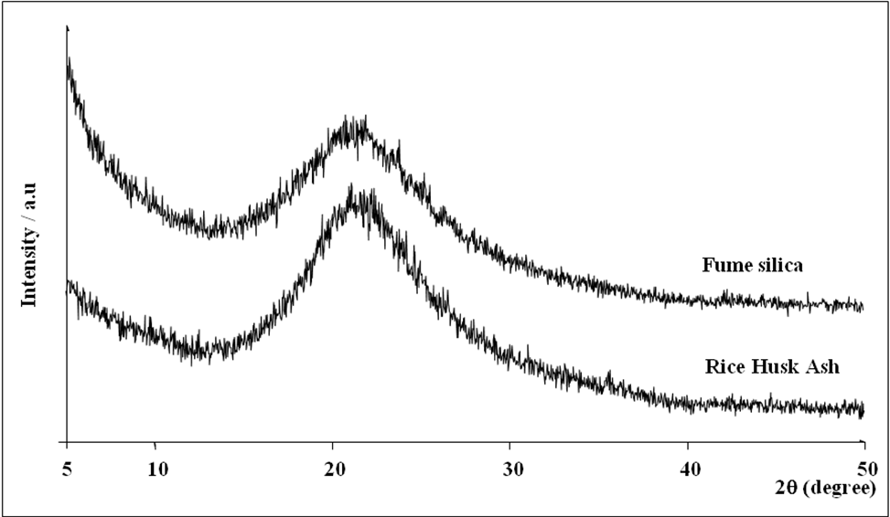

Figure 1: XRD pattern of silica sources used.

Formation of Nanosodalite from Various Silica Sources

The XRD of sodalite formation using fumed silica and rice husk ash was presented in Figure 2 and 3 respectively. The presence of sodalite phase was confirmed by comparing the diffraction peaks at 2θ, 14.097°, 24.438°, 31.752°, 34.765° and 42.888° with that of the reference for sodalite [JCPDS 81-0705]. These peaks corresponds to the plane d_{[110]}, d_{[211]}, d_{[310]}, d_{[222]} and d_{[330].} In Figure 2, which shows the samples synthesized using fumed silica as silica source, pure sodalite was observed to form within 4 hours of crystallization time. However, the presence of a mixture consisting of sodalite, zeolite A and other unidentified phases can be observed in samples at less and longer than 4 hours. Formation of zeolite A and other phases can be explained due to the stability of the zeolites in the high aluminium content in the gel mixture of Na₂O-SiO₂-Al₂O₃-H₂O system. The mixing of silicate and aluminate ions produce visible aluminosilicates gel in the solution suggesting the formation of random aluminosilicate framework. The mixture undergoes changes at elevated temperature due to the equilibrium reactions at this stage, the solid and solution approach an equilibrium and the formation of zeolite nucleus was established. Synthetic zeolite represent metastable structure where in the given conditions, it can be transformed into more stable types of zeolite. In gel oxide ratio used in the study, sodalite and Zeolite A have equal opportunity to form since both sodalite and zeolite A framework are built from the same secondary building unit (SBUs) of 4- and 6- membered ring; although both are not thermodinamically stable [15]. However, zeolite A which having more open structure than sodalite, reduced its stability and easily redissolve in reaction medium while sodalite formed having denser structure with the help of Na⁺ ions act as stabilizer for Al-O-Si linkage, sodalite was observed to become dominant zeolite. Therefore, as the time increased, sodalite become dominant zeolite while the dissolve zeolite A was used in the crystal growth of sodalite as shown in Figure 2 (b). Fan et al reported similar observation, however, they produced pure nanosodalite within 5 hours [12]. In this study, sample formed within 5 hours shown in Figure 2 (c) give similar diffractogram as sample formed within 3 hours as shown in Figure 2 (a). This might be due to the dissolution of sodalite framework bacause of high alkalinity of gel mixture [16].

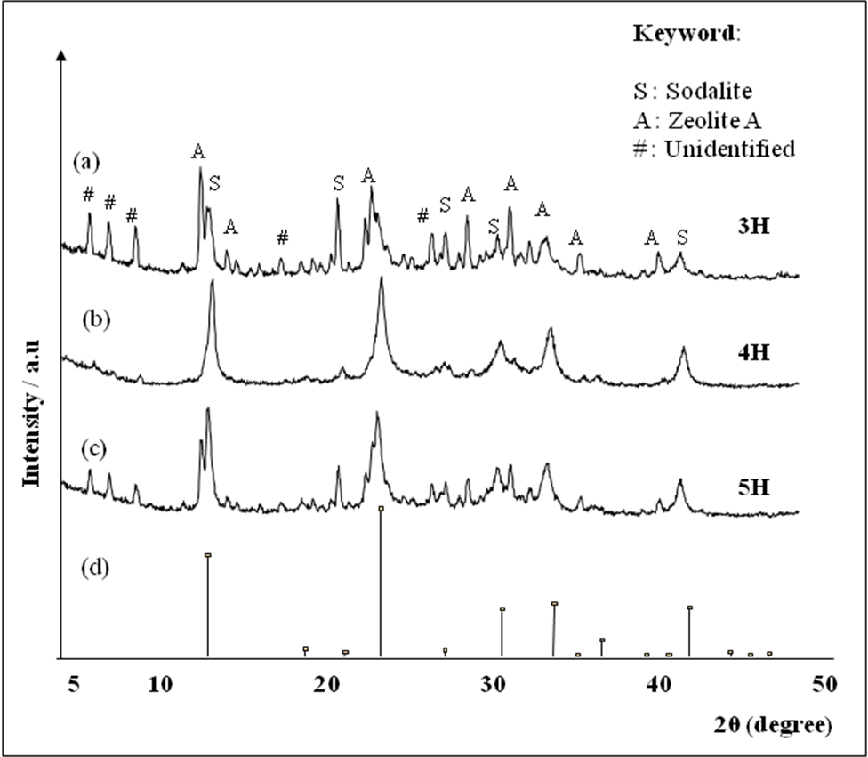

Figure 2 : XRD pattern of sodalite synthesized using fumed silica.
(a) 3 hours, (b) 4 hours and (c) 5 hours (d) standard

IR spectrum of sodalite sample in Figure 3 shows broad band of asymmetric stretching of T-O-T (T=Si or Al) bond was observed around ~990 cm⁻¹ which indicates the formation of Si-O-Al bond. A slightly broad peak around ~850 cm⁻¹ shows the presence of silanol group (Si-OH) bending mode which associated with silicon atom linked with hydroxyl group in the framework. The vibration of T-O-T symmetric stretching mode was observed around 714 cm⁻¹ to 660 cm⁻¹ and a small peak around 462 cm⁻¹ indicating the formation of T-O bending vibration in the sodalite framework.

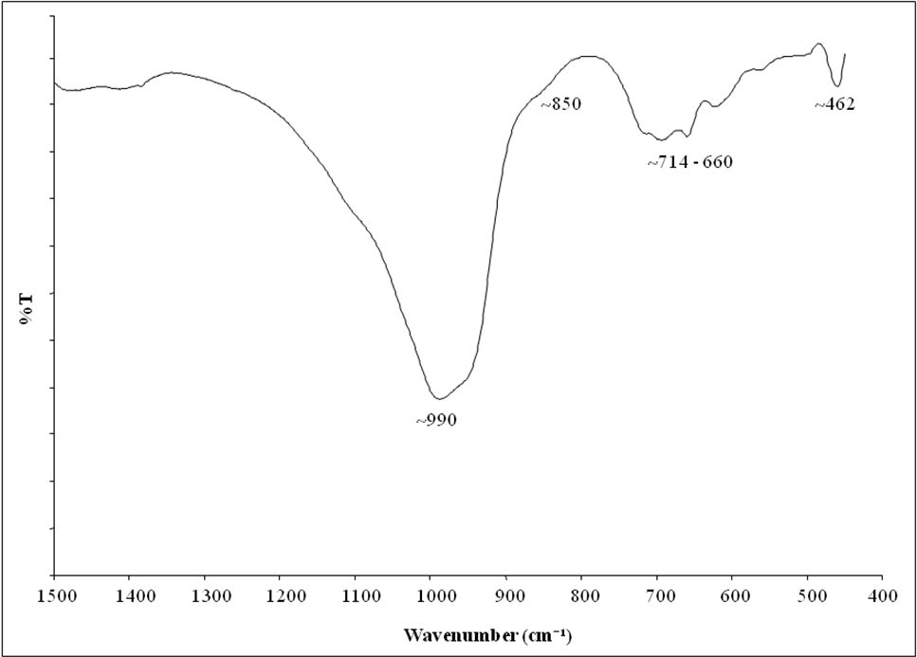

Figure 3: IR spectrum for sodalite synthesized from fumed silica

Diffractograms of samples produced by using RHA as silica source are shown in Figure 4. It is observed that pure sodalite was formed within 3 hours as compared to 4 hours for sample using fumed silica. In addition, no other zeolite phase is observed to form even at earlier crystallization time and sodalite phase is found to be stable up to more than 24 hours crystallization time. Even though, fumed silica and RHA are amorphous, the difference lies in their surface areas which normally related to the particle size. Fumed silica has large surface (~200 m²/g) as compared to RHA (58.42 m²/g). Therefore, fumed silica should have small particle size than RHA. Thus, the rate of dissolution of fumed silica in alkali solution increases, leading to rapid reaction between silicate and aluminate ions to form alminosilicate gel and SBUs, which facilitate simultaneous formation of all kind of zeolites of high aluminium content such as zeolite A, sodalite etc. Having lower surface area indicates that RHA has larger particle size than fumed silica, thus the dissolution of RHA into silicate solution occurred as slower pace such that giving it enough time to form one kind of zeolite which in this case is sodalite. Sodalite from RHA shows similar IR spectrum with sodalite synthesize using fumed silica as shown in Figure 3.

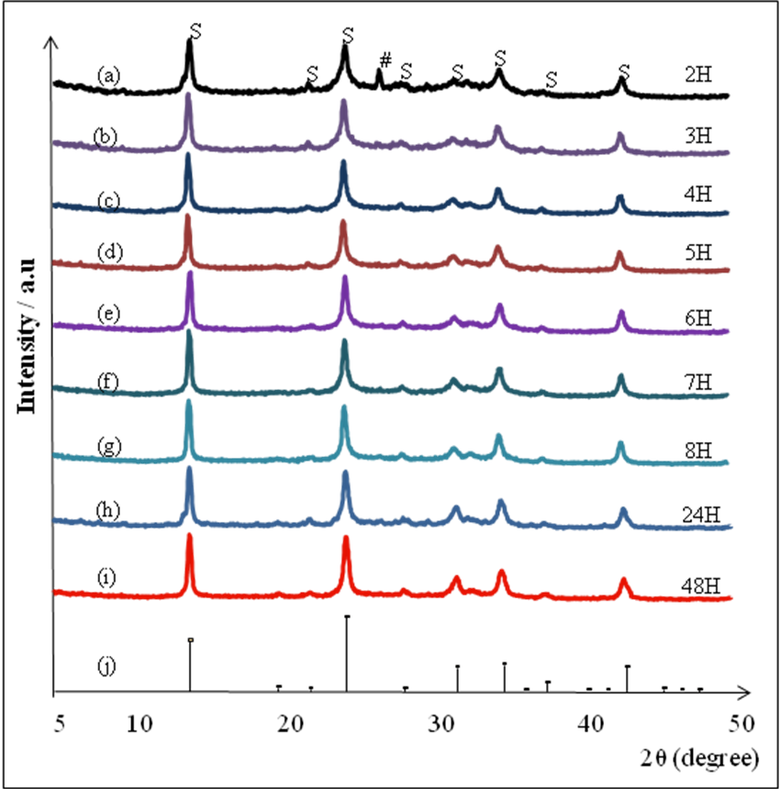

Figure 4 : XRD pattern zeolite synthesized by RHA at various time at 60°C. (a)2 hours, (b) 3 hours, (c) 4 hours,
(d) 5 hours, (e) 6 hours, (f) 7 hours, (g) 8 hours, (h) 24 hours, (i) 48 hours and (j) standard

Each sample of the synthesized sodalite have shown broad diffraction peaks showing the probability of the crystal to exist in nano size. The crystallize size of pure sodalite formed was calculated using Debye- Sherrer equation as shown in Table 1. The size of sodalite formed were in the range of 16-26 nm regardless the silica sources used, indicating that all sodalite samples obtained in the synthesis are in the nano-sized range. The formation of small size of zeolite was the result of the conditions that favors nucleation instead of growth [17]. In the case of sodalite formation, since the mixing of reactant was done at low temperature (~5°C), aided the formation of sodalite in nanosize. The synthesis was conducted at low temperature so as slowing down the reaction in order to stabilize the nucleation over growth of sodalite crystal. This stage is where the zeolite transformed via the dissolution of aluminosilicate solution in basic medium forming zeolite nucleus. This process continue until the zeolite structure becomes more ordered. This can be observed in the reaction mixture at the end of synthesis time whereby cloudy solution was observed instead of the solid settled down at the bottom of the reaction vessel.

Table 1: The crystallite size of pure nanosodalite formed calculated by Debye-Scherrer equation.

Silica Source | Crystallization Time (Hours) | Average crystallite size (nm)
FS | 4 | ~16
RHA | 2 | ~ 17
RHA | 3 | ~24
RHA | 4 | ~ 25
RHA | 5 | ~ 25
RHA | 6 | ~ 26
RHA | 7 | ~ 26
RHA | 8 | ~ 27
RHA | 24 | ~26
RHA | 48 | ~26
Note: FS - fumed silica, RHA - rice husk ash

Crystal Growth of Nanosodalite of Rice Husk Ash

As shown in Figure 4, nanosodalite formed by using RHA as silica source is stable in reaction mixture for more than 24 hours crystallization time. XRD pattern for the nanosodalite changes from broader to sharper peaks indicating the crystal growth process is on going. The result corresponds to the average crystallite size calculated by Debye-Scherrer equation as shown in Table 1. The size of nanosodalite increased gradually with time, up to 5 hours. Then, the size becomes constant with prolong crystallization time. Roughly, zeolite nucleus was generated in the aluminosilicate gel solution and had not yet reached the size necessary for crystal growth. In this study, the growth of zeolite nuclei depend on the crystallization condition (temperature) and Si/Al ratio in aluminosilicates gel mixture. Since the crystallization of zeolite synthesis was conducted at low temperature (60°C), the supply energy is not enough for the nucleus to overcome the activation energy of nucleus for crystal growth, thus the growth of zeolite was delayed [17-18]. In case of high Si/Al ratio, with prolong time, the aluminium in reaction mixture was used up in the zeolite formation, thus, leaving only the presence of silicate ion where these conditions ceased the crystal growth of nanosodalite. Analysis on the unreacted silica in the parent mixture in Table 2 supports the result from XRD of sodalite formed from RHA. The decreased of silica mass in time signify the increasing of silicate ions usage in the formation of nanosodalite. In the early stage of the crystallization process and up to 5 hours, almost 50 percent silicate ions is steadily being consumed in the formation of nanosodalite framework but found to be constant with prolong time.

Table 2: Analysis of unreacted dissolved silica in reactant mixture by time (60°C)

Time  (hours) | Mass of Unreacted  Silica (g) | Mass of Reacted Silica (g) |  | Percent of  Conversion (%)
0 | 0.95 |  | 0.10 | 10
2 | 0.88 |  | 0.17 | 16
3 | 0.68 |  | 0.37 | 35
4 | 0.56 |  | 0.49 | 47
5 | 0.52 |  | 0.53 | 50
6 | 0.51 |  | 0.54 | 51
7 | 0.49 |  | 0.56 | 53
8 | 0.47 |  | 0.58 | 55
24 | 0.44 |  | 0.61 | 58
48 | 0.42 |  | 0.63 | 60
Note: Initial mass of RHA used was 1.05g, therefore it was counted as 100 percent of silica.

Morphology of Nanosodalite From Rice Husk Ash

The morphology of the nanosodalite from RHA is shown in Figure 5 and 6. The RHA (Figure 5) shows granule-like morphology with the diameter ca. 4µm. The FESEM image clearly shows that the transformation of RHA to nanosodalite occurs at the surface of RHA particle with worm-like morphology (Figure 6) unlike coral-like structure morphology as reported by Naskar et al [19] when using RHA as silica source. When sample of nanosodalite formed within 3 hours was analyzed at higher magnification (x100,000), nanosodalite particles was observed with the average size of ca. 30-40 nm width and 50-100 nm length (Figure 7). The chain worm-like image started to diminish to the undefined structure after longer period of time such as shown by sample obtained at 24 hours (Figure 8).

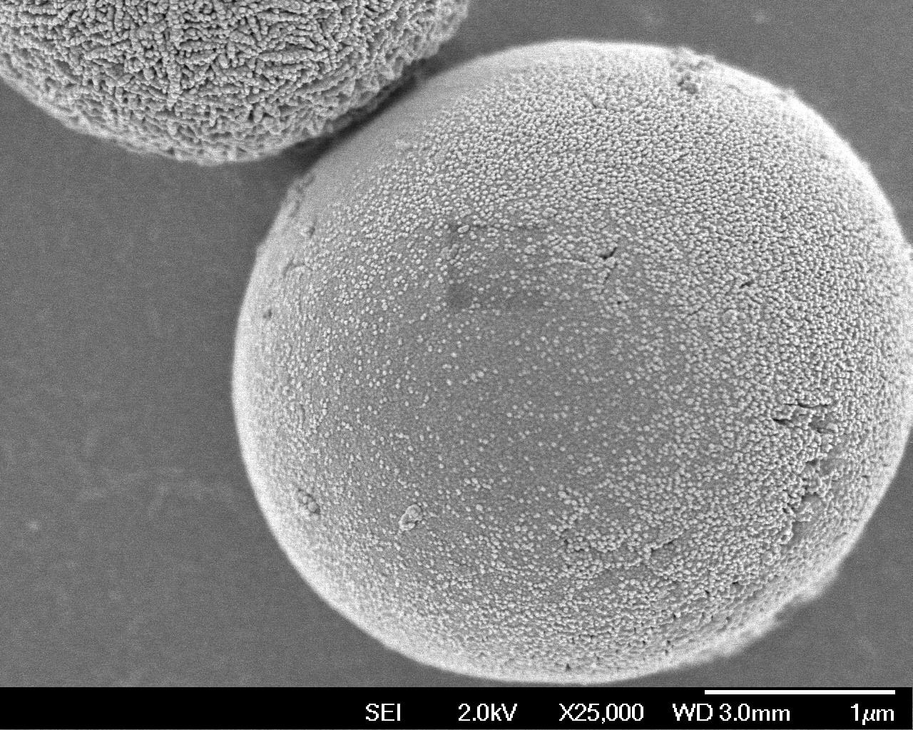  Figure 5 : Rice Husk Ash | 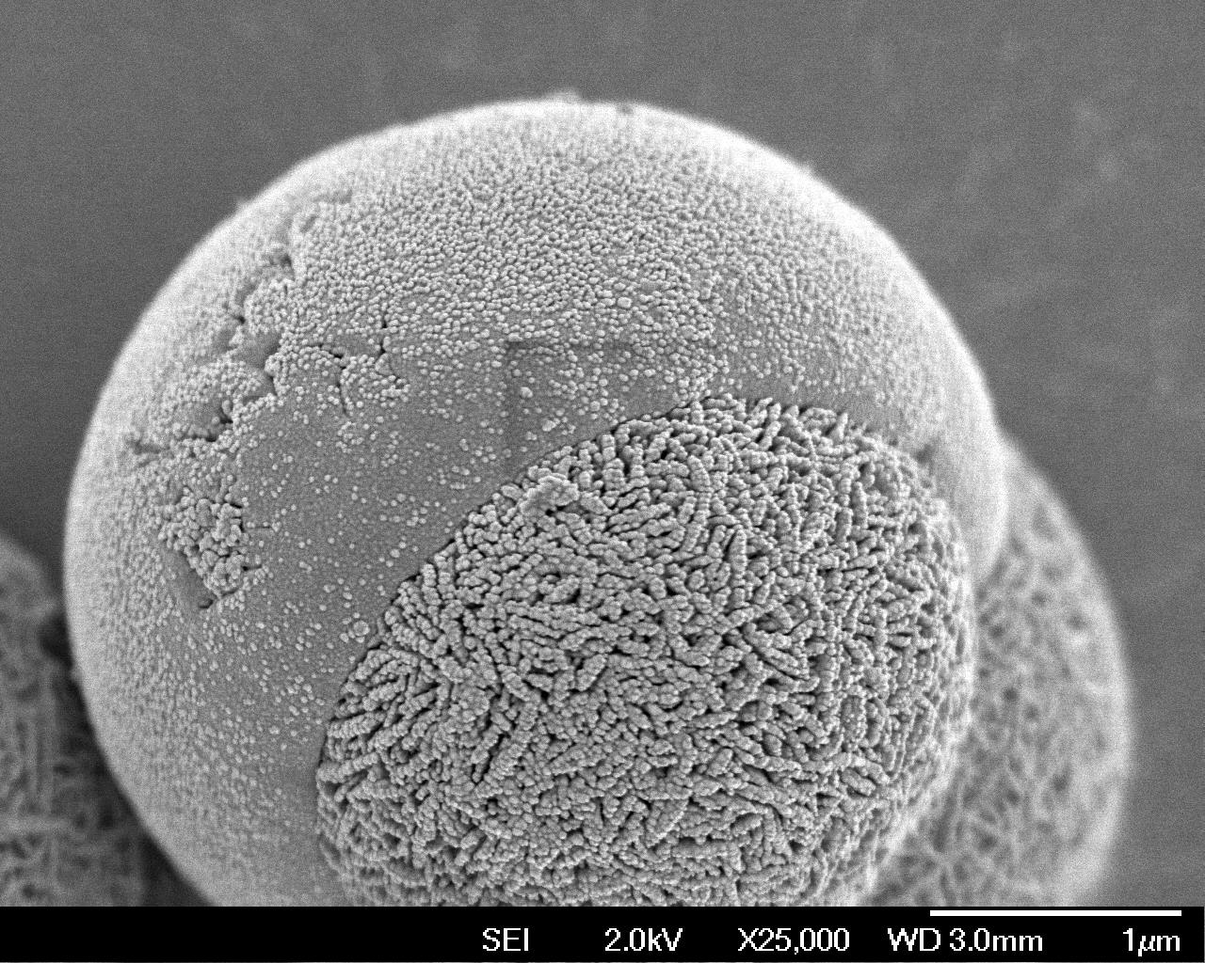  Figure 6 : Transformation of RHA into sodalite
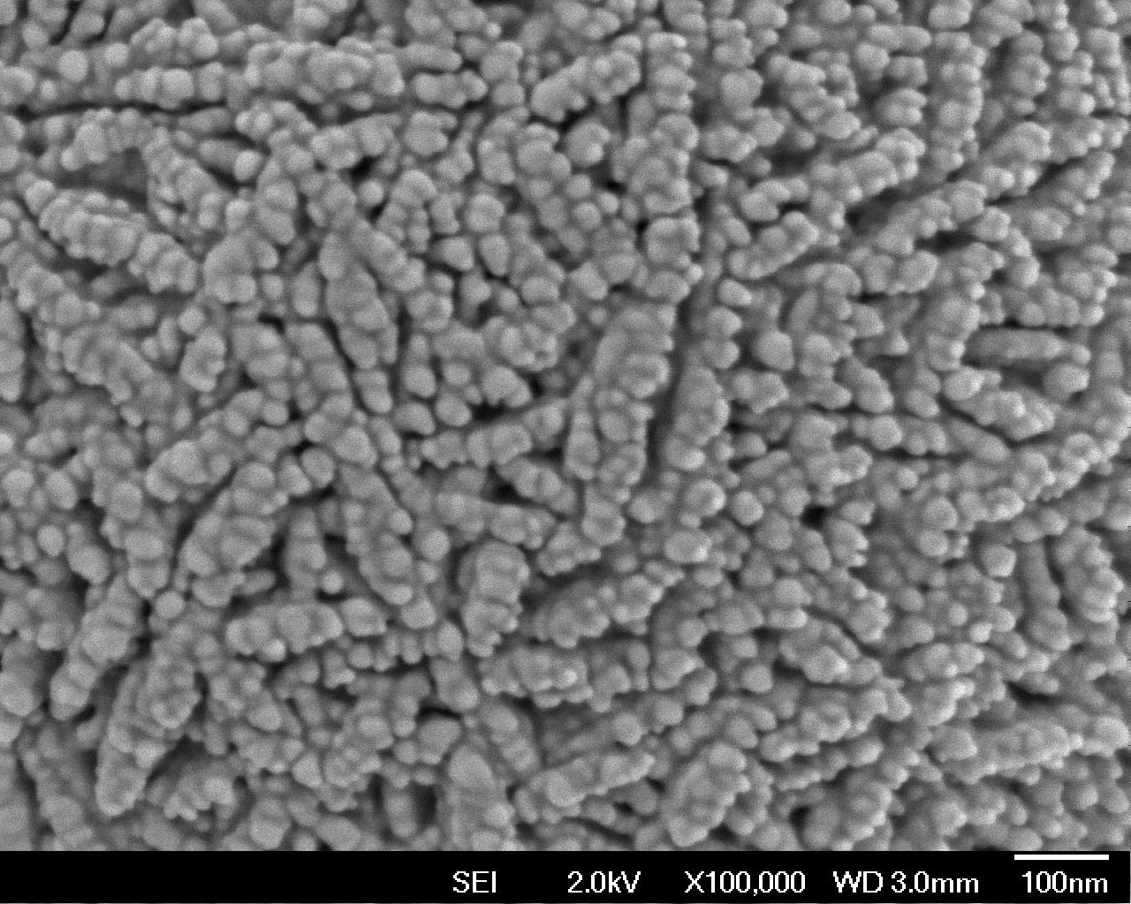  Figure 7 : Nanosodalite at 3 hours | 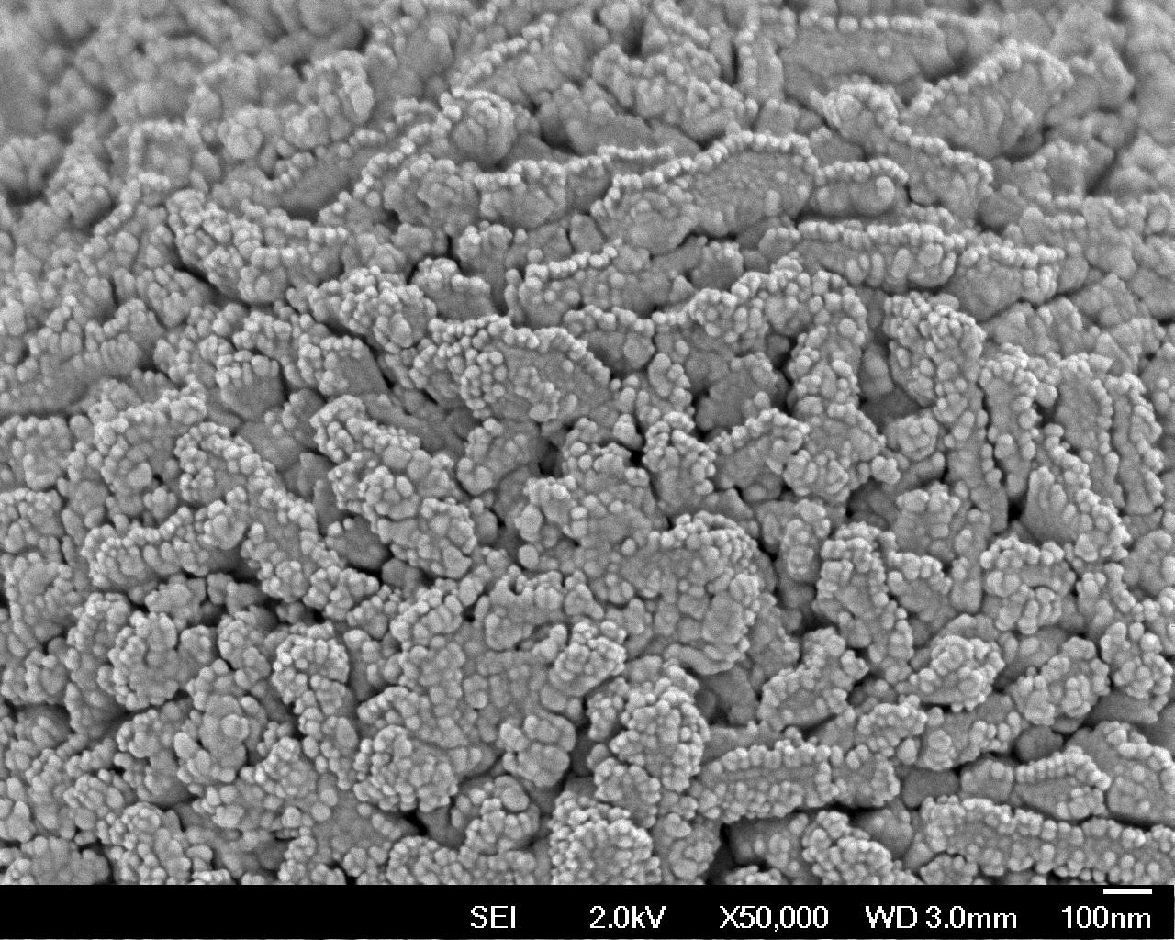  Figure 8 : Nanosodalite at 24 hours

Conclusion

The results obtained from this study demonstrated the reactivity of rice husk ash (RHA) as source of silica in synthesis of nanosodalite. It was observed that nanosodalite formed from RHA was in nanosized zeolite particles. Nanosized sodalite of RHA took shorter time to form compared to commercial fumed silica. In addition, nanosodalite formed from this material is more stable in reaction mixture up to more than 24 hours where calculated average size using Debye-Scherrer equation shows the size in the range of 26-27 nm. Image from FESEM analysis shows the formation of nanosodalite on RHA surface in the form of worm-like morphology with average size of around 30-40 nm width and 50-100 nm length. This study has successfully demonstrated the waste rice husk ash can be the source of siliica for formation of nanozeolite.

Acknowledgement

We hereby placed our gratitude to Universiti Teknologi Malaysia and Ministry of Higher Education of Malaysia (MOHE) for financial support under Geran Universiti Penyelidikan (GUP) Vote No: QJI30000.7126.03J85.

References

- An, D, Guo, Y, Zhu, Y and Wang, Z. (2010). A green route to preparation of silica powders with rice husk ash and waste gas. Chemical Engineering Journal. 162: 509-514.
- Tzong-Horng, L. and Chun-Chen, Y. (2011). Synthesis and surface characteristics of nanosilica produced from alkali-exracted rice husk ash. Materials Science and Engineering B. 176: 521-529.
- Prasetyoko, D., Ramli, Z., Endud, S., Hamdan, H. and Sulikowski, B. (2006). Conversion of rice husk ash into zeolite beta. Waste Management. 26: 1173-1179.
- Dalal, A. K. and Rao, M. S. (1985). Synthesis of NaX using silica from rice husk ash. Industrial and Engineering Chemistry Research and Development. 24: 465-468.
- Ghasemi, Z. and Younesi, H. (2011). Preparation and characterization of nanozeolite NaA from rice husk ash at room temperature with organic additives. Journal of Nanomaterials. ID 858961.
- King, R. S. P., Dann, S. E., Elsegood, M. R. J., Kelly, Mortimer, R. J. (2009). The synthesis, full characterization and utilization of template-free silica sodalite, a novel polymorph of silica. Chemistry – A European Journal. 15(22): 5441-5443.
- Li, D., Yao, J. F. , Wang, H., Hao, Na, Zhou, D., Ratinac, K. R. and Ringer, S. P. (2007). Organic-functionalized sodalite nanocrystals and their dispersion in solvents. Microporous and Mesoporous Material. 106: 262-267.
- Majano, G., Darwiche, A., Mintova, S. and Valtchev, V. (2009). Seed-induced crystallization of nanosized Na-ZSM-5 crystals. Industrial and Engineering Chemistry Research and Development. 48: 7084-7091.
- Fagihihian, H. and Godasandeha, N. (2008). Synthesis of nanocrystalline zeolite Y from bentonite. Journal of Porous Materials. 16. No. 3: 331-335.
- Pan, Y., Ju, M., Yao, J. F., Zhang, L. X. and Xu, N. P. (2009). Preparation of uniform nano-sized zeolite A crystals using manipulated organic-template free synthesis solutions. Chemical Communications. Issue 46: 7233-7235.
- Xhan, B. Z., White, M. A., Robertson, K. N., Cameron, T. S. and Gharghouri, M. (2001). A novel organic-additive free synthesis of nanometer-sized NaX crystals. Chemical Communications. 13: 1176-1177.
- Fan, W., Morozumi, K., Kimura, R., Yokoi, T. and Okubo, T. (2008). Synthesis of nanometer-sized sodalite without adding organic additives. Langmuir. 24: 6952-6958.
- Ramli, Z. (1995) “Rhenium-Impregnated Zeolites: Synthesis, Characterization and Modification as catalysts in the Metathesis of Alkanes,” Ph.D. Thesis, Universiti Teknologi Malaysia.
- Hamdan, H., Muhid, M. N. M., Endud, S., Listorini, E. and Ramli, Z. (1997). Journal of Non-Crystalline Solids. 211: 126-131.
- Ding, L. H., Yang, H., Rahimi, P., Omotoso, O,. Friesen, W., Fairbridge, C., Shi, Y. and Ng, S. (2010). Solid transformation of zeolite A to sodalite. Microporous and Mesoporous Materials. 130: 303-308
- Xu, R. et al. (2007). Chemistry of zeolites and related porous materials: synthesis and structure. Wiley, pg 285-286
- Charles M. Lukeheart and Robert A. Scott. (2008). Nanomaterials: Inorganic and Bioinorganic Perspectives. John and Wiley and Sons. pg 543-563
- Auerbach, S. E, Carrado, A. K. and Dutta, K. P. (2003). Handbook of Zeolite Science and Technology. 5th Edition, Marcel Dekker Inc. pg. 129-195
- Naskar, M. K., Kundu, D. and Chaterjee, M. (2011). Coral-like hydroxyl sodalite particles from rice husk ash as silica source. Materials Letter. 65: 3408-3410

