INCORPORATION OF CYCLOTRIPHOSPHAZENES AS PENDANT GROUPS TO THE SAGO NETWORK

(Percantuman siklofosfazena sebagai kumpulan terikat kepada rantaian sagu)

Zainab Ngaini*¹, Khairul Aidil Azlin Abd Rahman², Nazlina Shaari², Hasnain Hussain¹, Norhaizat Sundin², Teng Jingxin¹

¹Department of Chemistry, Faculty of Resource Science and Technology,
²Department of Design Technology, Faculty of Applied and Creative Arts,
Universiti Malaysia Sarawak, 94300, Kota Samarahan, Sarawak.
Corresponding author: nzainab@frst.unimas.my

Abstract
Cyclotriphosphazene-incorporated sago wastes as pendant groups have been prepared and structurally characterized using FT-IR and SEM. The chemically modified sago wastes composite was applied with binders and developed as sound absorbing panels. These panels are a class of organic-inorganic based materials that exhibit excellent fire retardant properties. Sound absorbance test has given a higher value at 250, 500 and 2000 Hz, which indicates the suitability of the panel for used in medium frequency. The panel was 51% lighter compared to fiberboard. The function and basic manufacturing of sound absorbers products was aligned with the present products in the market.

Keywords: sago waste, cyclotriphosphazene, fire retardant; sound absorber panel

Abstrak
Hampas sagu yang bergabung dengan kumpulan siklotrifosfazena telah disedia dan dicirikan dengan mengunakan FT-IR dan SEM. Komposit hampas sagu yang terubahsuai secara kimia telah campurkan dengan pelbagai bahan pengikat untuk dijadikan panel penjerap bunyi. Panel ini termasuk dalam kelas bahan organik-tak organik yang menunjukkan sifat kekalisan api yang baik. Ujian penjerapan bunyi memberi nilai tinggi pada 250, 500 dan 2000 Hz, yang merujuk kepada kesesuaian panel tersebut untuk digunakan dalam gelombang pertengahan. Panel yang terhasil adalah 51% lebih ringan daripada papan gentian. Fungsi dan pembuatan asas panel penjerap bunyi adalah setanding dengan produk terkini di pasaran.

Kata kunci: hampas sagu, siklotrifosfazen, kalis api, panel penjerap bunyi

Introduction
Sago palm is commonly found in tropical lowland forest and freshwater swamps. Sago palm is one of the main exports for Sarawak. Sarawak is currently the world largest exporter of sago products, exporting annually about 25,000 – 40,000 tons of sago products to various countries such as Singapore, Taiwan and Japan [1]. The mass production of sago produces residues during processing. It has been estimated approximately 7 t of sago pith waste was produced daily from a single sago starch processing mill [2].The residues were discharged into the river which eventually contributed to serious environmental problems. The fiber residue consists of lignin, cellulose and hemicelluloses which is vulnerable to form chemical bonding with electrophiles via hydroxyl groups.

Hexachlorocyclotriphosphazenes, on the other hands, is an inorganic compound with skeletal nitrogen and phosphorus atoms and susceptible to nucleophilic substitution reaction and exhibit unusual thermal properties such as fire retardancy. The incorporation of cyclotriphosphazenes as pendant groups to the backbone of synthetic organic polymers afforded a class of organic-inorganic polymers that exhibited useful thermal properties such as flame retardancy and self-extinguishability [3-6].

In this paper, we report on the chemical modification of sago waste by incorporating cyclotriphosphazenes as pendant groups onto the sago network via P-O-C bond. The end product was designed for sound absorbing panels with inherent fire retardant properties. This study promises to be one of the environmental solutions to balance the sago waste production by the industries.

Materials and Methods

Sago waste was obtained from sago processing mill in Mukah, Sarawak. Samples were sun-dried, ground using Retsch SM 100 grinder, sieved into 1 mm particles and dried in the oven (80 ºC). All chemicals were used as received and all reactions were performed under nitrogen atmosphere.

Characterization
The IR spectra were obtained on a Perkin Elmer Instruments Spectrum Gx1v5.0 using KBr. Scanning Electron Microscopic (SEM) analysis was conducted with Joel Model JSM6390LA to examine the surface morphology of the samples. Frequency rate testing for sound absorption were obtained with ASTM C423 -90a method at Standards Institutes and Industrial Research Malaysia (SIRIM), Shah Alam.

Modification of Sago Waste
Dried sago waste was reacted with cyclotriphosphazene in acetone in the present of catalyst. The mixture was stirred and refluxed for 2 h. The mixture was filtered and successively washed with ethanol and dried.

Preparation of Panels (PI)
Selected binder was dissolved in dichloromethane and mixed with the modified sago waste. The mixture was poured into metal mould and heated at 120 ºC for 3 h to form panels (PI). Comparison of the sound absorbance rate was carried out against the current available products such as fiberboard, plywood, carpet and solid wood. All samples were fabricated with same thickness (100 mm and 29 mm) and evaluated for sound absorbance rate from 250 Hz to 4000 Hz using ASTM C423 – 90a (Tube method) standard. Surface morphology of PI before and after ignition was characterized with SEM.

Results and Discussion
Cyclotriphosphazene-incorporated sago waste as pendant groups have been successfully prepared and characterized. The presence of cyclophosphazene via chemical modification has improved significantly on the fire retardant performance of the panels and widens its applications.

Infra Red Characterization
FT-IR spectra of the untreated sago waste and PI are shown in Figure 1. PI showed significant absorption bands at 1056 - 1209cm⁻¹ which corresponded to the formation of P-O-C bonds between sago network and cyclotriphosphazene. The appearance of peak at 1394 cm⁻¹ for PI was attributed to the presence of v_{P-N} delocalised bond in the sago network [7]. PI, however, showed strong absorption peak at 3446 cm⁻¹ which indicated that the OH groups were still available in the cellulosic materials and substantial for further substituted with cyclotriphosphazenes.
% T
cm⁻¹

1394

4000

3200
2400
1800
1400
1000
600

3428
1638
1051
650
(b)
1640
1056
606
(a)
3446

Fig. 1: FT-IR spectra of (a) sago waste and (b) modified sago waste (PI)

Flame Ignition Test
The cyclotriphosphazene-incorporated panel was tested for fire retardant properties. It was carried out via open burning by comparing untreated sago waste panel with PI (Figure 2). The panel of untreated sago waste was easily ignited and burned to completion into ashes (Figure 2a), whereas the ignition test onto PI, even after soaked with kerosene, was resisted to burning and readily self extinguished when the kerosene was consumed (Figure 2b). The force ignition of PI without kerosene was only resulted on the formation of chars onto the targeted area.

Flame Ignition Test | (a) Untreated Panel | (b) Panel PI
Panels | 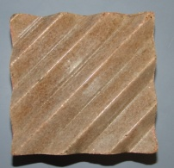 | 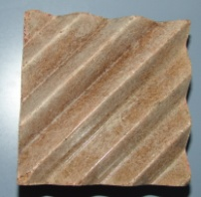
Ignition Process | 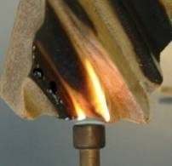 | 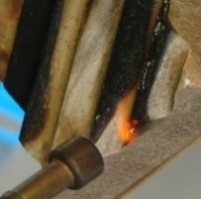
After Ignition | 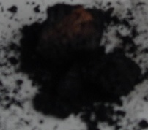 | 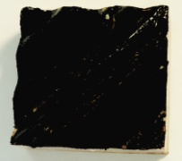

Fig. 2: Flame Ignition Test of (a) Untreated Panel without cyclotriphosphazenes (b) Panel PI

Scanning electron microscope (SEM) micrograph of PI after the flame ignition test showed the formation of chars at the outer layer while the inner layer was not burned (Figure 3). Analysis of the SEM for the cross-section of PI (Figure 3c) showed two layers of images with the upper layer (inner layer) was similar to Figure 3a and the bottom layer (outer layer) was similar to Figure 3b. This was due to the formation of phosphorus chars at the outer layer, which inhibited the oxygen from further burning [6]. The ignition caused the breakdown of the P-O-C bonds which yields high amount of phosphorus char that inhibit the contact of air with inner part of the panels for further ignition [6]. The incorporation of cyclotriphosphazenes onto chain structure of the cellulose and lignin of the sago waste via the hydroxyls groups has increased the thermal and flame resistance of the products.

(a) | 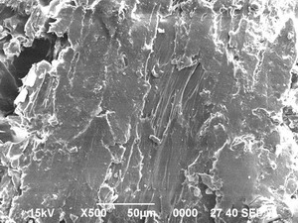 | 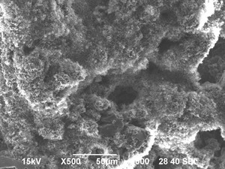  (b)
(c) | 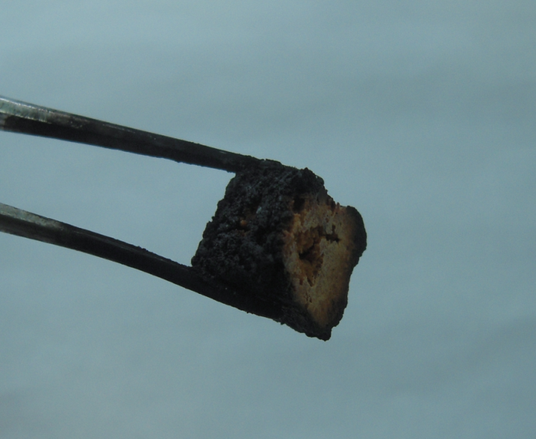  Outer layer  Inner layer | 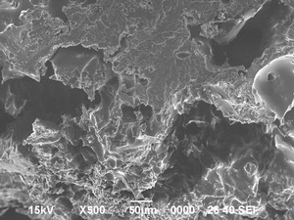

Fig. 3: SEM Morphology of (a) PI before ignition (b) PI after ignition and (c) cross-section of PI after flame ignition test

Frequency Test
The frequency rate testing for sound absorption was performed using ASTM C423-90a method at Standards Institutes and Industrial Research Malaysia (SIRIM). The panel has been designed with the organized pattern for aesthetic preferences as well as to meet the possible standard requirement for sound and frequency absorbance and weakening the sound reflection.

The comparison of the sound absorbance rate with the current available products showed that panel PI gave mean frequency value of 0.716, which is higher than other samples but equivalent to fiberboard (Table 1). However, in comparison to other samples, the absorbance rate of PI significantly showed higher value at the low frequency (250 Hz and 500Hz) and also at medium frequency (2000 Hz). These findings indicated that PI is suitable for used in the medium frequency. Moreover, thicker composite of PI (100 mm) has given better sound absorbance capacity and reduced sound intensity. Significantly, the panel of PI was 51% lighter compared to fiberboard.

Table 1: Comparison of the rate of sound absorbance with the rate of reduced sound (Intensity)
 |  |  | Frequency
Samples | 250 Hz | 500 Hz | 1000 Hz | 2000 Hz | 4000 Hz | Mean  (a )
Sago waste Panel (PI) | 0.564 | 0.718 | 0.710 | 0.873 | 0.715 | 0.716
Fiberboard | 0.525 | 0.612 | 0.702 | 0.804 | 0.937 | 0.716
Plywood | 0.203 | 0.510 | 0.794 | 0.832 | 0.895 | 0.647
Carpet | 0.249 | 0.346 | 0.509 | 0.808 | 0.922 | 0.566
Solid Wood | 0.202 | 0.322 | 0.733 | 0.684 | 0.625 | 0.513

Installation of Panels
The panel was designed for simple installation to the wall. Aluminum or wooden frame was used as a holder for the panels to be arranged accordingly (Figure 4a-b) based on the customers’ preferences. The panel has also been designed with an interchangeable casing made of thermosetting plastic with various modern and contemporary patterns that suit to the customers’ preferences (Figure 4c-d). The casing could function as a double layer silencer and sound filter. The installation method for the finished product with plastic wall casing is shown in Figure 4(a-d).
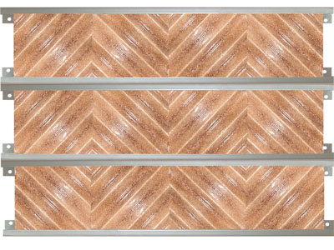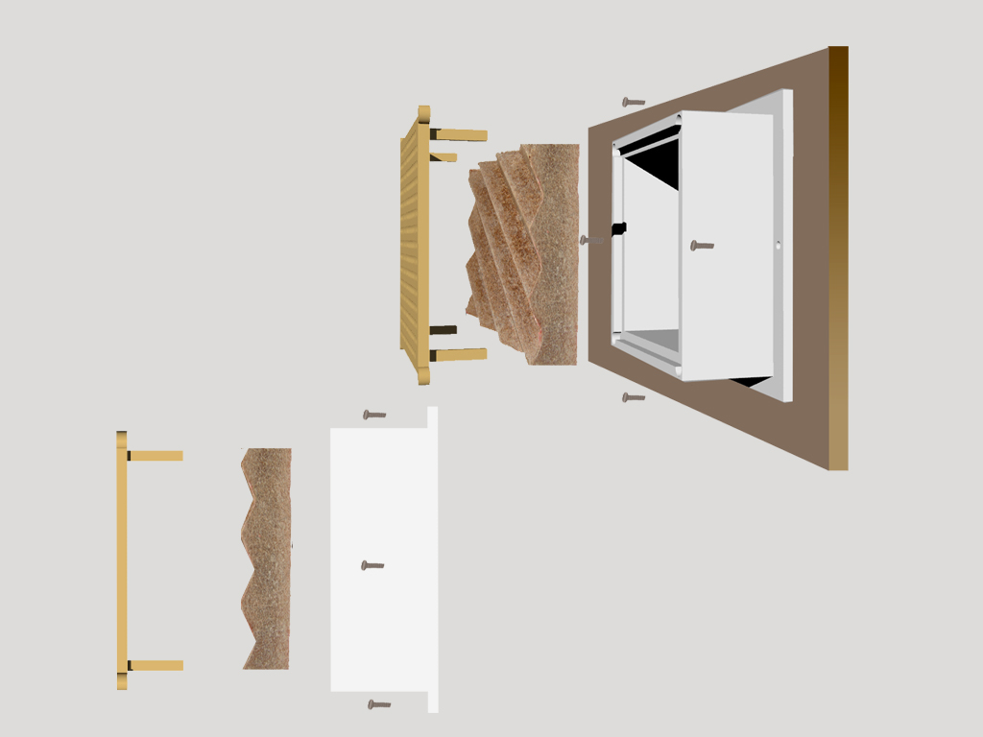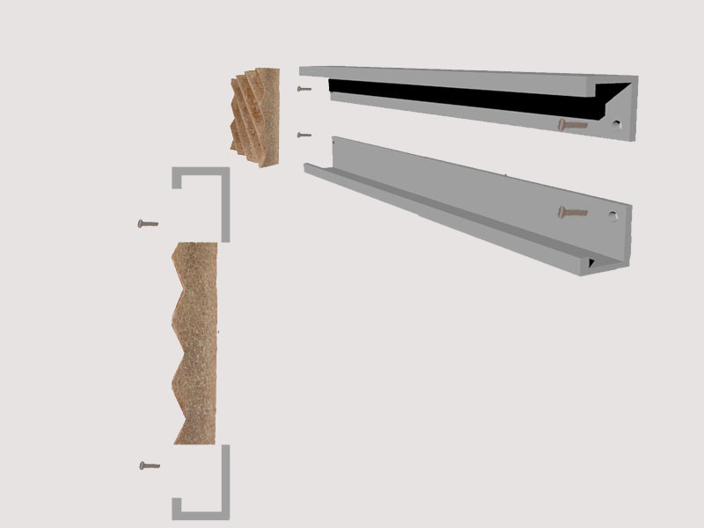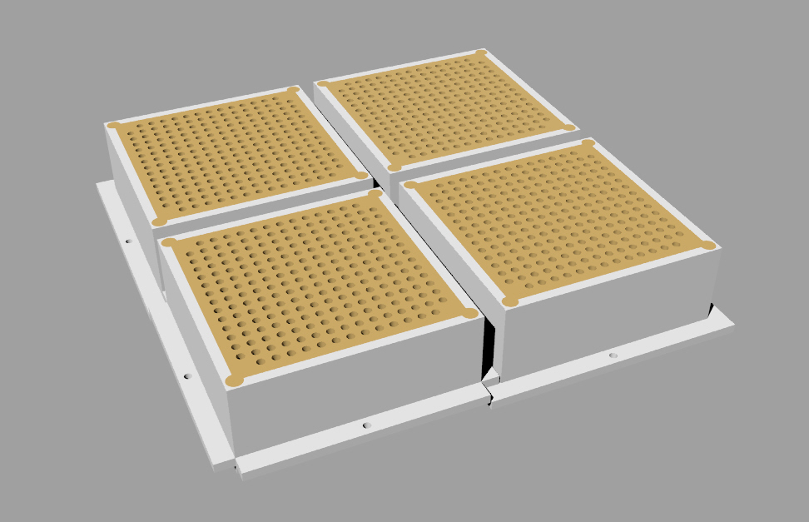

(a)
(b)
Frame
Screw
Casing
Screw
Panel
Aluminum Frames
(a)
(d)
(c)
Fig 4 (a-d): Mounting and installation of Panel PI

Conclusion
The sound absorber panels PI has been successfully developed using sago waste composite. The modification of sago waste via incorporation with hexachlorocyclotriphosphazene has successfully exhibited fire retardant property to the panel. These panels have high potential to be commercialized especially for music industries. Furthermore, the production of the panels does not require high technology and could be produced in large scale for mass production.
Acknowledgement
The authors thank Universiti Malaysia Sarawak and Ministry of Science, Technology and Innovation (MOSTI) for financial support through Dana Inovasi DI/02/2007(02) and FRGS/01(03)/608/2006(41).

References
- Singhal R. S., Kennedy, J. F., Gopalakrishnan, S. M., Kaczmarek, A., Knill, C. J. & Akmar P. F., 2008. Industrial production, processing and utilization of sago palm-derived products. Journal of Carbohydrate Polymers 72:1-20.
- Bujang, K, Apun, K. & Salleh, M. A. 1996. A Study in the Production and Bioconversion of Sago Waste. In Sago-The future Source of Food and Feed, edited by Jose C, Rasyad A, Riau University Press, Indonesia: 195-201.
- Inoue, K., Nakamura, H., Ariyoshi, S., Takagi, M. & Tanigaki, T. 1989. Heat Resistance Polymers Prepared from [(4′-(2-Vinyl)-4-Biphenylyl)Oxy] Pentachlorocyclo-triphosphazene. Macromolecules 22(12): 4466-4469.
- Selvaraja, I. I. & Chandrasekhar, V. 1997. Copolymerization of 2-(4-vinyl-4-biphenylyloxy)pentachlorocyclotriphosphazene with Acrylate and Methacrylate Monomers. Polymer 38(14): 3617-3623.
- Muraki, T., Ueta, M., Hara, E. & Inoue, K. 2004. Enhancement of thermal stability of polystyrene and poly(methyl methacrylate) by cyclotriphosphazene. Polymer Degradation and Stability 84: 87- 93
- Liu, R. & Wang, X. 2009. Synthesis, Characterization, Thermal Propereties and Flame Retardancy of a Novel Nonflammable Phosphazene-Based Epoxy Resin. Polymer Degradation and Stability 94(4): 617-624.
- Kruszynski, R., Siwy, M., Iwona, P.-C., & Trzesowska, A. 2006. A New Regioselective Method of Macrobicyclic Schiff Bases Synthesis. Inorganica Chimica Acta 359: 649-658.

