SYNTHESIS AND CHARACTERIZATION OF MESOPOROUS MATERIAL FUNCTIONALIZED WITH DIFFERENT SILYLATING AGENT AND THEIR CAPABILITY TO REMOVE CU²⁺
(Sintesis dan Pencirian Bahan Liang Meso yang difungsikan dengan Ejen Sililasi yang Berbeza dan Keupayaanya Menyingkir Cu²⁺)
Zaini Hamzah ¹ ,Norhidayu Narawi^{*1}, Hamizah Md Rasid¹ and Amira Nazirah Md Yusoff²
¹Fakulti Sains Gunaan,
Universiti Teknologi Mara, 40000 Shah Alam, Selangor, Malaysia.

*Coresponding author: areu_luv@yahoo.com

Abstract
Mesoporous material MCM-41 with uniform hexagonally ordered pores in range of 2-10 nm was synthesized through hydrothermal method. The synthesis started from highly pure silica source known as Ludox which act as an active source of silica in the presence of organic surfactant (CTABr) as structure-directing agent. MCM-41 has been functionalized with the organic group known as 3-aminopropyltriethoxysilane (APTES), 3-mercaptopropyltrimethoxysilane (MPTMS), and chloropropyltriethoxysilane (CPTES) by co-condensation method in order to enhance the surface hydrophobicity of MCM-41. The increasing hydrophobicity will lead to efficient reaction specifically for organic reaction in organic solvent. The resulting materials were characterized with various techniques which are PXRD, FTIR, NMR, Elemental Analysis and AAS. The formation of uniform hexagonal framework of synthesized materials was shown in PXRD result. The functionalized groups of modified MCM-41 can be characteried via FTIR and ¹³C-NMR results. The Elemental Analysis shows the percentage of nitrogen, carbon, hydrogen and sulphur in MCM-41 and functionalized MCM-41. From AAS, MCM-41 MPTMS has high capability for removal of Cu (II) in aqueous solution compared with others.

Keywords: 3-aminopropyltriethoxysilane, 3-mercaptopropyltrimethoxysilane and 3-chloropropyltriethoxysilane.

Abstrak
Bahan mesoporous MCM-41 mempunyai susunan liang-liang berbentuk heksagonal seragam di antara julat 2-10 nm yang telah disintesis melalui kaedah hidroterma. Sintesis bermula dari sumber silika yang sangat tulen dan aktif iaitu Ludox yang berfungsi sebagai sumber aktif silika untuk ejen pengstrukturan dalam kehadiran surfaktan organik (CTABr). MCM-41 telah difungsikan dengan pelbagai kumpulan organik yang dikenali sebagai 3-aminopropyltriethoxysilana(APTES), 3-mercaptopropyltrimethoxysilana (MPTMS) and 3-chloropropyltriethoxysilana (CPTES) melalui kaedah Ko-Pemeluapan dalam usaha untuk meningkatkan sifat hidrofobik yang akan membawa kepada tindak balas yang berkesan khususnya bagi tindak balas organik dalam pelarut organik. Bahan-bahan yang terhasil dicirikan dengan pelbagai teknik seperti PXRD, FTIR, NMR, Analisis Elemen dan AAS. Pembentukan rangka kerja bahan sintesis yang heksagonal dan seragam telah ditunjukkan dalam keputusan PXRD. Kumpulan yang difungsikan dengan MCM-41 boleh dibuktikan melalui keputusan FTIR dan ¹³C-NMR. Analisa Elemen menunjukkan peratusan Nitrogen, Karbon, Hidrogen dan Sulfur dalam MCM-41 dan MCM-41 yang difungsikan dengan kumpulan organik. Daripada keputusan AAS, MPTMS MCM-41 mempunyai kepupayaan sebagai penjerap dalam penyingkiran Cu(II) dalam larutan berair berbanding dengan kumpulan organik yang lain.

Kata kunci: 3-aminopropyltriethoxysilana, 3-mercaptopropyltrimethoxysilana and 3-chloropropyltriethoxysilana.

Introduction
MCM-41 is the most useful because it possesses linear channels constructed with a silica matrix uniform hexagonal array. Due to the high surface area, a well-defined pore size and pore volume of mesoporous material, MCM-41 have been believed to be used in many applications such as catalysis and adsorption process [1]. A lot of researchers have done functionalization of MCM-41 with organic groups. This modification does not only giving a new function to mesopores materials but also raising their hydrophobicity. This is because the surface hydrophobicity plays an important role in the catalytic reactions of organic compound which are conducted in the presence of water either as reactant and product. Besides, the functionalization also can avoid leaching occurs for the next stage of any applications such as epoxidation, oxidation and adsorption [2]. Nowadays, most modification of MCM-41 involved amine group as the functionalized group. Here, as an alternative approach, we have prepared functionalized MCM-41 via co-condensation method by using different functionalized groups which are 3-Mercaptopropryltrimethoxysilane (MPTMS), 3-Aminopropyltriethoxysilane (APTES) and Chloropropyltriethoxysilane (CPTES) in toluene. The functionalization introduces Sulphur, Nitrogen and Chlorine as donor atom onto silica particles respectively (Fig.1). The synthesized materials were characterized by using PXRD, FTIR, NMR, Elemental Analysis and AAS.

a) 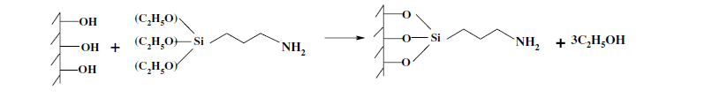
b)
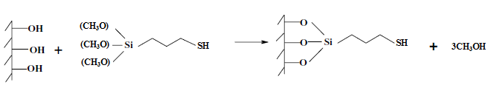
c)
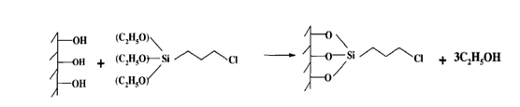

Fig 1: Possible mechanisms for modification of (a) MCM-41 APTES, (b) MCM-41 MPTMS and (c) MCM-41 CPTES

Experimental
All the chemicals used for this research were received from the commercial suppliers. The chemicals used for this experimental were Ludox (93% SiO₂), cetylammonium bromide, Sodium Hydroxide,ammonium hydroxide, 3-aminopropyltriethoxysilane, 3- chloropropyltriethoxysilane, 3-mercaptopropyltriethoxysilane, Diethyether, Dichloromethane, n-hexane and Toluene.

Synthesis of MCM-41

The synthesis of MCM-41 was carried out from the below equation:

6 SiO₂ : CTABr : 1.5 NaOH : 0.15 (NH₄)₂O : 250 H₂O
Synthesis of MCM-41 was started from the Part A by mixed Ludox (SiO2, 93%) with Sodium Hydroxide (NaOH) in distilled water and stirred. For the Part B, cetyltrimethylammonium bromide (CTABr) was dissolved in distilled water followed by the addition of ammonium hydroxide aqueous solution and followed by stirred. Then, Part A then was mixed with Part B and aged overnight in oven at 97 °C. The mixture was filtered, washed and dried in oven for 10 hours. Finally, the sample was calcined at 550 °C.
Functionalization of MCM-41 by MPTMS and APTES
Approximately, activated MCM-41 was pretreated at 140 °C and immersed into toluene and MPTMS or APTES. The mixture was refluxed for 4 hours and the powder was filtered, washed, and dried at 80 °C.

Functionalization of MCM-41 by CPTES
MCM-41 was dispersed in toluene followed by the addition of CPTES. The mixture was refluxed for 3 hours. The powder was filtered, washed and Soxhlet extracted with dichloromethane.

Characterization of functionalized MCM-41
The synthesized materials were characterized by using X-Ray diffraction (XRD) on a Bruker D8 Advanced powder diffractometer Cu Kα radiation source (λ= 1.5418 A, kV=40, mA=40). IR spectra of samples were obtained on a Perkin Elmer Spectrum One FTIR spectrophotometer by using method of Potassium Bromide (KBr) pellet.¹³C NMR spectra were recorded on Bruker 300 Ultrasheild. The carbon, hydrogen and nitrogen analysis of the samples was acquired by using Flash 2000 Organic Elemental Analyzer Thermo Finnigan.

Removal of Copper (II) testing
Stock solution of Cu (II) solution (1000 ppm) was diluted with deionised water to prepare the desired concentration of standard solution which is 100 ppm. Sorption experiments were performed at room temperature on an orbital shaker (200 rpm) using conical flasks. In all experiments, 100 mg of functionalized silica was thoroughly mixed into 100 ml of Cu (II) solutions with 60 minutes as contact time. After 60 minutes, the content of the flasks were filtered with filter paper to collect the final solutions. Each solution was stored in the refrigerator until Cu (II) concentration measurements by AAS using AAnalyst 400 (Perkin Elmer) were carried out.

Results and Discussion

PXRD
Figure 2 shows five different peaks of PXRD patterns of the as-synthesized MCM-41 that can be indexed to (100), (110) and (200) which corresponding to characteristics of hexagonal structure in MCM-41[3]. After the removal of templates, the XRD intensity at peak (100) of calcined MCM-41 was greater than as synthesized MCM-41.From the figure, the intensity as synthesized MCM-41(fig. 2(a)) was 20000 cps and after calcinations (fig. 2(b)) were increased to 60000 cps. The increasing intensity of the calcined MCM-41 is due to small and well defined pores obtained after the removal of surfactant. From figure 2(c) - (e), the intensity of (100) reflection decreased sharply with the addition of MPTMS, APTES and CPTES in MCM-41. From here, the loss of Bragg peaks and the decrease in (100) intensity could be due to contrast matching between the silica walls and the content of channels after functionalization and evidence that contraction of hexagonal unit cells mainly occurs inside the mesopore channels, since the attachment of organic functional groups in the mesopore channels that reducing the scattering power of the mesoporous silicate wall.[4] The lattice parameters, which were calculated using the d100 were 45.5 Å (d100 = 39.41 Å, 2θ = 2.24 °) and 43.9 Å (d100 = 38.05 Å, 2θ = 2.32) for MCM41 and functionalized MCM-41 respectively. However, XRD results still show that the mesopores structures still remained intact as hexagonal structure.

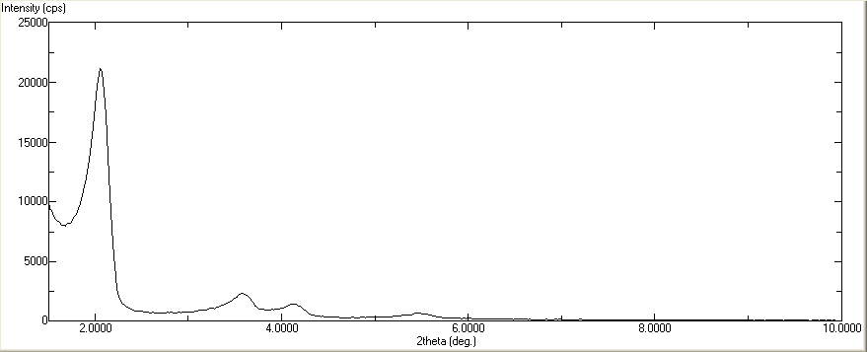
(100)

(a)

(110)
(200)

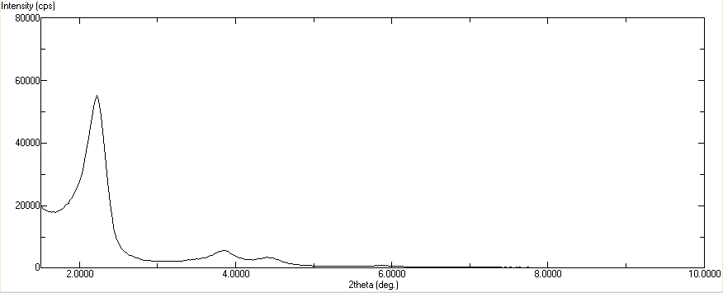
(b)

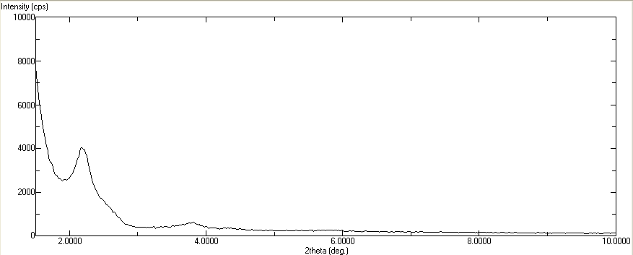
(c)

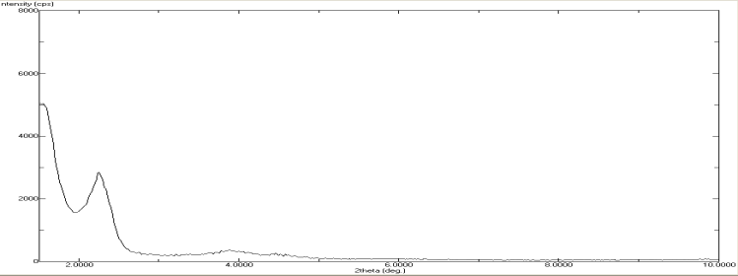
(d)

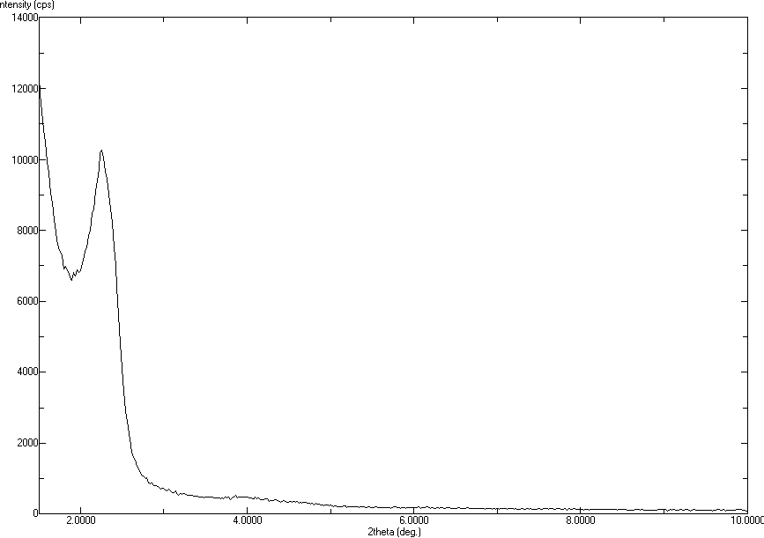
(e)

Fig 2: PXRD patterns of (a) MCM-41 before calcine, (b) MCM-41 after calcine, (c) MCM-41-APTES, (d) MCM-41 MPTMS and (e) MCM-41 CPTES.

FTIR
All four samples show similar features of FTIR spectra of organic containing silica material. The Si-O-Stretching band around 1240-1030 cm⁻¹ was assigned as the fingerprint region of MCM-41 [5, 6]. For MCM-41 APTES, the Si-OH vibration band decreased around 966 cm⁻¹, after pore expanding of synthesized materials due to the interaction between –NH₂ groups and silanol groups through hydrogen bonding. The presence of N-H bending vibration around 692 cm⁻¹ confirms the incorporation of amino groups into MCM-41 [7]. C-N stretching vibration absorbance is normally around 1200 – 1000 cm⁻¹ but this band cannot be resolved due to its overlapping with the absorbance of Si-O-Si stretch in 1000 – 1300 cm⁻¹ range and that of Si-CH₂-R stretch in 1200- 1250 cm⁻¹. The FTIR spectra of MCM-41 MPTMS shows band at 876.34 cm⁻¹ which indicate the S-H bending. For MCM-41 CPTES, the band at 699 cm⁻¹ indicates the presence C-Cl stretching in MCM-41 APTES.

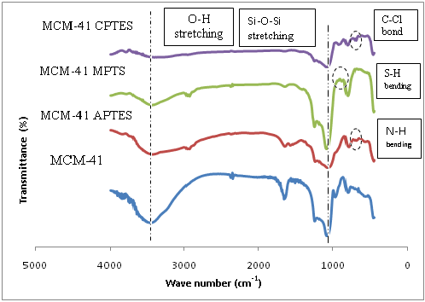

Fig 3: FTIR spectra MCM-41, MCM-41 APTES, MCM-41 MPTMS, and MCM-41 CPTES.

Elemental Analyzer
Table 1 shows the percentage of nitrogen, carbon, hydrogen and sulphur in MCM-41 and functionalized MCM-41. The results show that 0.41, 0.07 and 3.48 % of nitrogen, carbon and hydrogen are present respectively in MCM-41. In MCM-41 APTES, 4.97 % of nitrogen, 12.87 % of carbon and 4.13 % of hydrogen are present. The increasing percentage of nitrogen, carbon and hydrogen are due to presence of aminopropyl in MCM-41. The 12.24, 2.55 and 6.13 % of carbon, hydrogen and sulphur respectively consists in MCM-41 MPTMS. It shows the existence of sulphur which proves that the MPTMS was successfully anchored on MCM-41 mesoporous silica. MCM-41 CPTES consists of 11.62 % of carbon and 2.55 % of hydrogen.

Table 1: Elemental Analysis for MCM-41, MCM-41 APTES, MCM-41 MPTMS and MCM-41 CPTES.
Adsorbent | Nitrogen (%) | Carbon (%) | Hydrogen (%) | Sulphur (%)
MCM-41 | 0.4118 | 0.0714 | 3.4762 | 0
MCM-41 APTES | 4.9645 | 12.8657 | 4.1248 | 0
MCM-41 MPTMS | 0 | 12.2377 | 2.5515 | 9.4613
MCM-41 CPTES | 0 | 11.6174 | 2.5488 | 0

¹³C-NMR
The ¹³C-NMR results for functionalized MCM-41 are shown in Table 2. The absence peaks at 5 and 58 ppm assigned to SiO-CH₂-CH₂ species indicates that the surfactant is completely removed from MCM-41 pore channels [8]. Furthermore, MCM-41 APTES shows 2 peaks at 31.14 and 39.89 ppm attributed to –CH₂- and –CH₂-NH₂- carbons respectively. For MCM-41 MPTMS, 2 peaks are appeared at 31.14 and 39.87 ppm, corresponding to –CH₂ and –CH₂-Cl carbons respectively. MCM-41 CPTES shows 2 peaks of –CH₂- and CH₂-Cl carbons at 31.13 and 39.88 ppm. Peak of-CH₂-NH₂ is more downfield than peak of CH₂-Cl because nitrogen is more electronegative compared to chlorine. Thus, the higher electronegativity of the element, the more downfield the chemical shift.

Table 2: Peak and chemical shift determine by 13 C-NMR of functionalized MCM-41
Adsorbent | Peak | Chemical shift (ppm)
MCM-41 APTES | -CH₂  -CH₂-NH₂ | 31.14  39.89
MCM-41 MPTMS | -CH₂  -CH₂-SH | 31.14  39.87
MCM-41 CPTES | -CH₂  -CH₂-Cl | 31.13  39.88

Aqueous heavy metal (Cu²⁺) removal on functionalized MCM-41
Table 3 summarized the percentage removal of copper by functionalized MCM-41. MCM-41 MPTMS is the best adsorbent to remove Cu (II) compared to MCM-41 APTES with 18.14 % removal. MCM-41 CPTES does not have the adsorption capacity to remove the Cu (II) due to Cl has weak interaction between Cl and metal cations. MCM-41 MPTMS has higher tendency to remove the Cu (II) because thiol group has higher bonding ability with Cu²⁺ [9]. The NH₂ groups inside MCM-41 APTES are responsible for metal ions adsorption because amino chain in pores with larger dimension have more freedom and accessibility to metal ions.

Table 3: The percentage removal of Cu²⁺ on functionalized MCM-41
Adsorbent | Initial concentration (ppm) | Final concentration (ppm) | % removal
MCM-41 MPTMS | 100 | 9.30 | 90.70
MCM-41 APTES | 100 | 76.95 | 23.05
MCM-41 CPTES | 100 | 99.95 | No removal

Conclusion
It can be concluded that MCM-41 has been successfully functionalized with three different groups of silylating agents by co-condensation method. From the copper removal test, it shows that MPTMS-MCM41 has a high tendency to remove copper in aqueous solution after stirred for 60 minutes.

Acknowledgement
This work was supported by Universiti Teknologi Mara. The authors wish to thank Faculty of Pharmacy UiTM Puncak Alam for the use of XRD instrument in this research.

References
[1] C.T. Kerge, M.E. Leonowicz, W.J. Roth, J.C. Vartuli, and J.S. Beck. Ordered mesoporous molecular sieves synthesized by a liquid-crystal template mechanism. Journal of Nature, 359, (1992), 710-712.
[2] R.S. Robert, A. Rafael, A.D. James and W.R. Thatcher. Vapor-phase silylation of MCM-41 and Ti-MCM-41. Microporous and Mesoporous Materials, 66, (2003), 53-67.
[3] J.S. Beck, J.C. Vartuli, W.J. Roth, M.E. Leonowicz, C.T. Kresge, K.D. Schmitt, C.T. Chu, D.H. Olson, Z.W. Sheppard, S.B. Cullen, J.B. Higgins, and J.L. Schlenker, A new family of mesoporous molecular sieves prepared with liquid crystal template. Journal American Chemical Society, 114, (1992), 10834-10843.
[4] S.Zheng, L. Gao, and J. Guo, Synthesis and characterization of functionalised mcm-41 with copper and manganese phenathroline complexes, Journal of Solid State Chemistry 152, (2000), 447-452.
[5] S.Evangelista, E.DeOliveira, G. Castro, L.Zara, A.Prado ,Hexagonal mesoporous silica modified with 2-mercaptothiazoline for removing mercury from water solution, Surf. Sci.601 (2007) 2194-2202.
[6] G.Grigoropoulou, P. Stathi, M.A. Karakassides, M.Louloudi, Y.Deligiannakis, Functionalized SiO₂ with N-, S-containing ligannds for Pb(II) and Cd(II) adsorption,Colloids, Surf. A 320 (2008) 25-35
[7] A. Benhamou, M. Baudu, Z. Derriche, and J.P. Basly. Aqueous heavy metals removal on amine-functionalized Si-MCM-41 and Si-MCM-48. Hazardous Material, 171, (2009) 1001-1008.
[8] K.M. Parida, and D. Rath. Amine functionalized MCM-41: An active and reusable catalyst for Knoevenagel condensation reaction. Molecular Catalysis A: Chemical, 310, (2009), 93-100.
[9] X. Liang, Y. Xua, G. Sun, L. Wang, Y. Sun and X. Qin, X. Preparation, characterization of thiol- functionalized silica and application for sorption of Pb²⁺ and Cd²⁺. Colloids and Surfaces A: Physicochemical and Engineering Aspects, 349, (2009), 61-68.

