DETERMINATION OF ORGANIC AND INORGANIC MERCURY SPECIES IN SUNGAI KINTA, PERAK BY REVERSED-PHASE HIGH PERFORMANCE LIQUID CHROMATOGRAPHY (HPLC) ON-LINE COUPLED WITH ICP-MS

Norshidah Baharuddin ^{1*}, Norashikin Saim ², Rozita Osman ², Sharifuddin Md. Zain ³,
Hafizan Juahir ⁴, Siti Rafzah Saari ¹

¹Sirim Berhad, 40911 Shah Alam, Selangor, Malaysia
²Faculty of Applied Sciences, Universiti Teknologi MARA, 40450 Shah Alam, Selangor, Malaysia
³Department of Chemistry, Faculty of Science, UM 56000 Kuala Lumpur, Malaysia
⁴Department of Environmental Sciences, Faculty of Environmental Study, Universiti Putra Malaysia, 43400 Serdang, Selangor, Malaysia

Abstract
This paper describes a simple method for mercury speciation in river water samples of Sungai Kinta, Perak. Separation and measurement were done by high-performance liquid chromatography on-line with inductively coupled plasma mass spectrometry (HPLC/ICP-MS). Separation of mercury species was accomplished within 6 minutes on an AQ C18 4.6mm i.d x 150mm, 5µm reversed phase column with 0.1% (w/v) L-cysteine as mobile phase. Under the optimum instrumental conditions, recoveries of 101-104% for MeHg⁺ and 96 – 104% for Hg²⁺ were obtained with experimental detection limits of 1ngL⁻¹ for inorganic mercury and 1.5µgL⁻¹ for organic mercury.

Keywords: HPLC/ICP-MS, reversed phase, L-cysteine, mobile phase

Abstrak
Kajian ini bertujuan untuk membangunkan satu kaedah untuk analisa spesies raksa dalam air sungai di Sungai Kinta, Perak. Penganalisaan kandungan spesies raksa telah dijalankan dengan menggunakan high-performance liquid chromatography on-line with inductively coupled plasma mass spectrometry (HPLC/ICP-MS). Pemisahan spesies raksa dicapai dalam masa 6 minit dengan menggunakan turus fasa terbalik AQ C18 4.6mm i.d x 150mm, 5µm dengan 0.1% (w / v) L-sisteina sebagai fasa gerak. Di bawah keadaan instrumentasi yang optimum, pemerolehan semula 101-104% untuk MeHg⁺ dan 96 – 104% untuk Hg²⁺ telah diperolehi dengan had-had pengesanan 1ngL⁻¹ untuk raksa tak organik dan 1.5µgL ⁻¹ untuk raksa organik.

Kata kunci: HPLC/ICP-MS, fasa terbalik, L-sisteina, fasa gerak

Introduction
Mercury is found throughout the ecosystem in trace amounts: in soil, air, water and living organisms [1]. The accumulation of monomethylmercury (MeHg) in fish and the subsequent poisoning of the Minamata inhabitants, was a turning point in the analysis of environmental levels of toxic metals, because it was apparent that to provide a clear picture of toxicity, biogeochemistry and bioaccumulation, it is necessary to measure all the different physicochemical forms [2]. MeHg and the other organomercury compounds are more toxic than Hg(II), because of their lipophilic nature, which allows them to permeate biological membranes and enter cells.

The most common methods currently in use for the speciation analysis of mercury species are Gas Chromatography (GC) and High Performance Liquid Chromatography (HPLC) coupled to an elemental specific detector such as inductively coupled plasma-mass spectrometry (ICPMS) [1]. GC coupled with ICP-MS currently has some of the lowest reported detection limits [2] for mercury species with detection limits of 0.027 pgg⁻¹ for methyl mercury (CH₃Hg) and 0.27 pgg⁻¹ for inorganic mercury (Hg²⁺) with solid phase microextraction (SPME) pre-concentration. Other detection methods such as atomic fluorescence spectroscopy with solid phase extraction [3] can reach detection limits as low as 0.01 ngL⁻¹ for CH₃Hg and is suitable for the analysis of mercury species in ocean water [4]. However, the drawback of GC is that the species have to be rendered volatile and this requires a derivatisation step with either Grignard reagents or more recently tetraalkyborate compounds [5]. This derivatisation step can be time consuming and can sometimes result in species transformations [6], thus alternative method is required. HPLC on the other hand requires no derivatisation step, as the species do not need to be volatile before injection [7], simplifying the sample preparation considerably. However, to reach the detection limits is necessary. Various pre-concentration methods have been reviewed [8] including on-line [7], and off-line [9] pre-concentration on various materials such as C-18 micro-columns [10,11] and sulfhydryl cotton [12]. However, to successfully separate mercury species by HPLC, ion pairing agents such as L-cysteine [13,14] are required, which when coupled with vapour generation and ICP-MS gives detection limits of between 0.03 and 0.11 ngmL⁻¹. HPLC–ICP-MS with off-line pre-concentration reached detection limits of 5.2 ngL⁻¹ for Hg²⁺ and 5.6 ngL⁻¹ for CH₃Hg, recently microbore HPLC–ICP-MS has been used for the speciation analysis of mercury [15]. ICP-MS offers extremely low detection limits ranging from sub part per billion (ppb) to trillion (ppt) for most elements. It has a rapid multi-element scanning capability over a wide range of masses with lower detection limits compared to GF-AAS and ICP-AES. Detection limits generally depend on the element, sample matrix, preparation, and the instrumental conditions used for analysis. The detection limits in ICP-MS particularly for elements which occur abundantly in nature, are often determined by blank values. Argon plasma in the HPLC-ICP-MS system able to decompose and ionize an element, irrespective of the chemical structure of the species.

For these reasons, the aim of this work was to develop a powerful speciation method applicable for trace analysis of mercury species in water samples from Sungai Kinta water in Malaysia with appropriate performance characteristics in order to identify and quantify each mercury species.

Experimental
Chemical and Reagents
Mercury (Hg) standard, 1000mgL⁻¹ and 2-mercapthoethanol for electrophoresis (> 98%) were purchased from Merck, Germany. Methylmercury chloride (99.9%) and L-Cysteine (≥ 98.5%) were obtained from Fluka, Germany and Sigma, USA, respectively. The stock standard solutions were prepared by dissolving the standard in the solution of L-Cysteine hydrochloride (Fluka, Germany). Gold standard, 1000mgL⁻¹ from Perkin Elmer, USA was used to wash out the mercury species that retain in the column after each analysis.

Instrumental
Perkin Elmer High Performance Liquid Chromatography (HPLC) series 200 consisting essentially of series 200 quaternary pump, series 200 LC Peltier column oven, series 200 LC vacuum degasser and series 200 LC auto sampler (Perkin Elmer, USA). The separation of the mercury species was performed on an AQ C18 4.6 mm i.d x 150mm, 5µm column and 50 µL of the sample was injected into the chromatographic column. The operational conditions are shown in Table 1.

Table 1: Operational parameters of the HPLC system

HPLC System | Perkin Elmer Model 200  (Quaternary pump, auto sampler, column oven, vacuum degasser)
Column | AQ C18 4.6mm i.d x 150mm, 5µm
Mobile phase | 0.1% w/v L-cysteine
Separation Scheme | Isocratic
Flow rate of the mobile phase | 1 ml/min
Column temperature | 25°C
Auto sampler flush solvent | 100% methanol HPLC grade
Injection volume | 50 µl
Sample | River Water

An Inductively Coupled Plasma-Mass Spectrometry (Perkin-Elmer SCIEX, Model ELAN DRC-e, USA) system consisted of S10 auto sampler (Perkin Elmer, USA) and equipped with concentric nebulizer, a cyclonic spray chamber, quartz torch with a quartz injector tube, was used. ELAN DRC-e was equipped with platinum sampler and skimmer cones. Nebulizer capillary tubing was used to connect the nebulizer and the peristaltic pump tubing. Sample introduction system components are cyclonic spray chamber (Glass Expansion, Inc., Australia) and a Meinhard® type A nebulizer. The effluent from the LC column was directly connected to the nebulizer with PEEK tubing (1.59 mm o.d.) and a low dead volume PEEK connector (Part No.: WE024375). Instrumental performance optimization, including nebulizer gas flow, ion lens voltage and torch alignment was carried out. Both mercury isotope, ²⁰²Hg and ²⁰⁰Hg for organic and inorganic mercury were monitored which were obtained by integrating peak area, using the Chromera software (Perkin Elmer, version 3.4). The operational conditions as shown in Table 2.

Table 2: Operational parameters of the ICP-MS system

ICP-MS System | ELAN DRC-e
Nebulizer | Meinhard® type A
Spray Chamber | cyclonic
Nebulizer gas flow | 0.78 L/min
RF Power | 1400W
Plasma gas flow | 15 L/min
Reaction gas | Argon
Monitoring masses | Hg, m/z = 202 and 200
Analysis Time | 6 minutes
CeO+/Ce+ | <2%
Ba++/Ba | <2%
Rpq | 0.05

Daily Optimizations and Performance Check is conducted for optimum performance of the instrument. The instrument was tuned using a Smart Tune Solution-Standard ELAN & DRC-e 10 µgL⁻¹ Barium (137Ba), Beryllium (9Be), Cerium (140Ce), Cobalt (59Co), Indium (115In), Magnesium (24Mg), Plumbum (207Pb), Rhodium (103Rh) and Uranium (238U). The ratio of oxides (140Ce16O/140Ce) and doubly charged ions (140Ce2+/140Ce+) were maintained at a low level to minimize the potential interferences. The background for 220 should be less than 2 cps, but the result for background can be ignored if doubly charged and oxide criteria were achieved.

Sampling locations
Sungai Kinta is one of the important rivers in the state of Perak Darul Ridzwan and it is one of main tributaries of Sungai Perak. Sungai Kinta flows from Gunung Korbu at Ulu Kinta, Tanjung Rambutan to Sungai Perak. The tributes of Sungai Kinta are Sungai Pari,Sungai Buntong, Sungai Kledang, Sungai Raya, Sungai Pinji, Sungai Johan, Sungai Kampar and Sungai Chenderiang. Sungai Kinta flow through Tanjung Tualang, Batu Gajah, Papan, Pusing, Lahat , Ipoh, Tanjung Rambutan and Ulu Kinta. The size of river basin is 2500 km² and about 100km in length. Sungai Kinta's main function is for water supply. Therefore, there is a need to protect the river's water quality. The Sungai Kinta dam is at the last phase of the Greater Ipoh Water Supply II Scheme under implementation by Lembaga Air Perak (LAP). It is able to provide 639 million litres of water per day and is expected to be able to meet water demand in the Kinta Valley until 2020 [22].

Sungai Kinta is currently classified with an average Class III water quality and a water quality index of 51.9 – 76.5. The major causes of pollution in the Sungai Kinta Basin are industrial discharge, improper sewage treatment, residential discharge, wet markets, pig/chicken farms, sand-mining, land development, and soil erosion [22]. The sampling sites for this study are at Kampung Temiang, Tanjung Rambutan, Ulu Kinta, Kampung Paloh, Hutan lipur, and River Front as shown in Fig. 1 and Table 3.

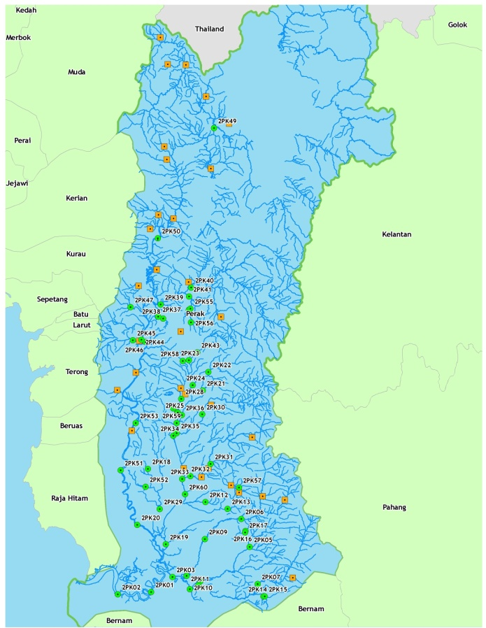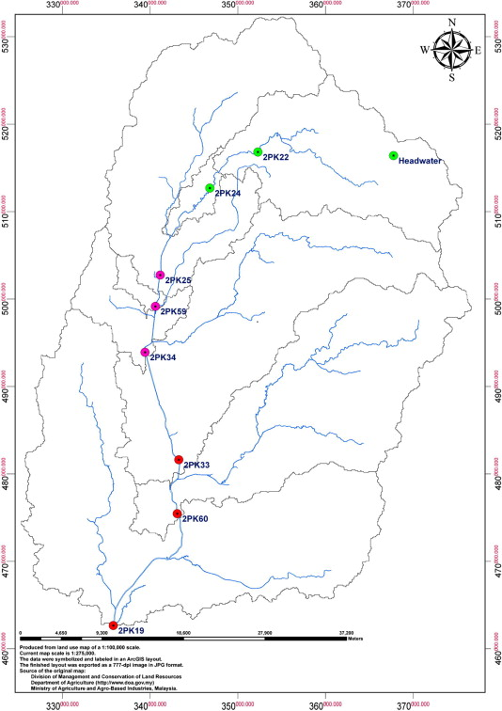

Fig. 1: Sampling points at Sungai Kinta, Perak Darul Ridzwan
(Source: Alam Sekitar Malaysia)

Table 3: Sampling locations

Sampling Station | Coordinate |  | Location (Area description)
Sampling Station | Longitude | Latitude | Location (Area description)
2PK 19 | E 101° 01.211’ | N 04° 07.123’ | Laksamana Bridge, Hilir Perak Border
2PK 22 | E 101° 09.372’ | N 04° 40.119’ | Tanjung Rambutan Mosque
2PK 33 | E 101° 04.359’ | N 04° 19.595’ | Corner before Tanjung Tualang town
2PK 34 | E 101° 02.681’ | N 04° 27.883’ | Kampung Pisang, batu Gajah (Car Wash)
2PK 59 | E 101° 03.300’ | N 04° 30.355’ | Jalan Kampung Pengkalan
2PK 60 | E 101° 04.950’ | N 04° 16.679’ | Kampung Baru Timah-Kampung Tronoh

Sample and standard preparation
Inorganic mercury and methylmercury were used for the preparation of standard stock solution. 2 to 3 drops of 2-mercaptoethanol for electrophoresis were added to methyl mercury to aid in dissolving. The stock solutions were stored at 4 °C prior to the analysis. Analytical working solutions were prepared daily by diluting the stock solutions with calibration blank prior to analysis. Mixed standards of the following two species were made: 5, 10, 15, and 20 µgL⁻¹. These were prepared by mixing the individual stock species standards and prepared daily.

All samples were stored in sampling bottle at 4 °C without acidification to prevent changes in species distribution. Samples were filtered through Whatman 0.45 µm nylon filter membranes 30mm diameter directly into the auto sampler vial and injected in the chromatographic system, and analyzed in duplicate.

Results and Discussion

Method validation

The validity of methods and procedures used for mercury speciation are determined by linearity, limit of detection
(LOD) and recovery. The linearity of the method was studied using deionised water spiked with mercury species i.e. Hg²⁺ and MeHg⁺ at the levels 1, 1.5, 2, and 2.5 µgL⁻¹. Linear regression analysis was used to evaluate whether the mercury results were significantly different from the standard calibration curve. Good linearity was obtained for the mercury species with a determination coefficient (R²) in the range 0.966 to 0.999 as shown in Table 4. The detection limits were found to be 1 ngL⁻¹ and 1.5 µgL⁻¹ for Hg²⁺ and MeHg⁺, respectively. Under the optimized condition the limit of detection (LOD) and accuracy were calculated to ascertain the applicability of the proposed method. The recovery of the mercury species that were added to the deionised water was in the range 95 to 104% for Hg²⁺ and 101 to 111% for MeHg⁺. Fig. 2 shows a chromatogram of a standard solution containing Hg²⁺ and MeHg⁺ under optimized conditions. The calibration curves of the mercury species under optimized experimental conditions were drawn within the range of 1.0 µL⁻¹ - 2.8 µgL⁻¹.

Table 4
Study of the linearity range and detection limits
Mercury species | Linearity range  (µgL⁻¹) | R² | Retention time (min) | Instrumental LOD
Hg²⁺ | 1-2.5 | 0.999 | 2.17 | 1.0 ngL⁻¹
MeHg⁺ | 1-2.5 | 0.966 | 4.20 | 1.5 µgL⁻¹

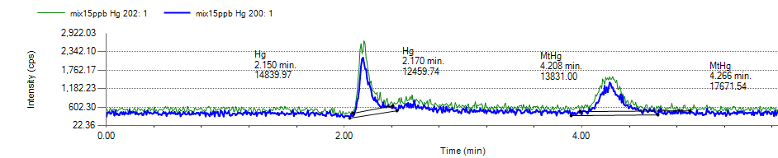
Fig. 2: HPLC-ICP-MS of two mixed Hg species standards in pure water: Hg²⁺ 2.17min, MeHg⁺ 4.20min

Possible matrix effects on the calibration were estimated by spiking representatives real river water samples. These samples were collected at various locations in order to have different matrix contents, e.g. high suspended solids. Samples collected were spiked with a standard mixture of mercury species giving an added mercury concentration of 10 µgL⁻¹ each. When the LC-ICP-MS procedure was applied to the analysis of six spiked real river water samples, recoveries were satisfactorily with values ranging from 85% to 115%.

Analysis of samples

Table 5
Analysis of mercury species in Sungai Kinta (µgL⁻¹) and the pH value

Sampling Time | Station | Hg²⁺ | MeHg⁺ | pH
February 2011 | SP1 (upstream) | 0.20 | <1.5 | 6.68
 | SP1 (upstream) | 0.20 | <1.5 | 6.95
 | SP2 (middlestream) | 0.19 | <1.5 | 7.06
 | SP2 (middlestream) | 0.20 | <1.5 | 6.87
 | SP3 (downstream) | 0.18 | <1.5 | 6.93
 | SP3 (downstream) | 0.23 | <1.5 | 6.62
 |  |  | <1.5
Mac 2011 | SP1 (upstream) | 0.21 | <1.5 | 6.73
 | SP1 (upstream) | 0.22 | <1.5 | 6.74
 | SP2 (middlestream) | 0.19 | <1.5 | 7.41
 | SP2 (middlestream) | 0.20 | <1.5 | 6.72
 | SP3 (downstream) | 0.19 | <1.5 | 6.92
 | SP3 (downstream) | 0.23 | <1.5 | 6.89
 |  |  | <1.5
May 2011 | SP1 (upstream) | 0.22 | <1.5 | 6.62
 | SP1 (upstream) | 0.20 | <1.5 | 6.62
 | SP2 (middlestream) | 0.19 | <1.5 | 7.31
 | SP2 (middlestream) | 0.22 | <1.5 | 6.82
 | SP3 (downstream) | 0.17 | <1.5 | 6.63
 | SP3 (downstream) | 0.22 | <1.5 | 6.87
Results correspond to mean values, n=2 (standard deviation for Hg²⁺ and MeHg⁺ are 0.01 and 0.08, respectively)
For mercury in natural waters, the main species to be identified and determined are Hg²⁺ and MeHg⁺ . The results are shown in Table 5. It was observed that the Hg²⁺ was dominating the Sungai Kinta, the MeHg⁺ was not detected or below the instrumental limit of detection. Therefore, it could not be considered as an important source of MeHg to downstream waters. MeHg concentration is independent of total Hg levels provided that some Hg is available for methylation [24]. Methylmercury is formed from inorganic mercury by the action of anaerobic organisms that live in aquatic systems including lakes, rivers, wetlands, sediments, soils and the open ocean [23]. This methylation process converts inorganic mercury to methylmercury in the natural environment. It indicates that Hg methylation is a complex process and is affected by many factors such as temperature, pH, dissolved oxygen, organic matter, and so on [25]. It is noted that in natural waters MeHg⁺ levels are usually much lower than those of Hg⁺ [6]. Recent report [5] estimates a total mercury concentration in natural waters ranging from 0.2 to 100 ngL⁻¹, while MeHg⁺ levels are much lower i.e. 0.05 ngL⁻¹ [6]. According to the National Water Quality Standards For Malaysia, the limit for total mercury is classified according to the classes: Class I is absent, Class IIA/IIB is 0.001 mg/L, Class III is 0.0001 mg/L and Class IV is 0.002 mg/L and Class V level above IV.

Conclusion
HPLC-ICP-MS is appropriate for water samples analysis, even when the matrix in the water sample is high. One of the advantages of the HPLC-ICP-MS system is the ability of the argon plasma to decompose and ionize an element, irrespective of the chemical structure of the species.The detection limits for MeHg⁺ and Hg²⁺ are better than 10ngL⁻¹ and meet the current regulatory requirements[17]. The detection limits obtained for MeHg⁺ and Hg²⁺ were 1.5 µL⁻¹ and 1 ngL⁻¹, respectively.

References
- Lan-Fang C., Shiuh-Jen J., and Sahayam A.C. (2007). “Speciation analysis of mercury and lead in fish samples using liquid chromatography–inductively coupled plasma mass spectrometry.” Journal of Chromatography A. 1176. 143–148.
- Jianguo, C., Hengwu C., Xianzhong J., and Haiting C. (2009). “Determination of ultra-trace amount methyl-, phenyl- and inorganic mercury in environmental and biological samples by liquid chromatography with inductively coupled plasma mass spectrometry after cloud point extraction preconcentration.” Talanta. 77. 1381–1387.
- Castillo, A., Roig-Navarro A.F., and Pozo O.J. (2006). “Method optimization for the determination of four mercury species by micro-liquid chromatography–inductively coupled plasma mass spectrometry coupling in environmental water samples.” Analytica Chimica Acta. 577. 18–25.
- Cairns, W.R.L., Ranaldo M., Hennebelle R., Turetta C., Capodaglio G., Ferrari C.F., Aur´elien D., Cescon P., and Barbante C. (2008 ). “Speciation analysis of mercury in seawater from the lagoon of Venice by on-line pre-concentration HPLC–ICP-MS.” Analytica Chimica Acta. 622. 62–69.
- Susan, C. Hight, and John C. (2006). “Determination of methylmercury and estimation of total mercury in seafood using high performance liquid chromatography (HPLC) and inductively coupled plasma-mass spectrometry (ICP-MS): Method development and validation.” Analytica Chimica Acta. 567. 160–172.
- Roberto, M.B., Margarita T.V., Jose E.S.U, and Alfredo S.M. (2000). “Field sampling, preconcentration and determination of mercury species in river waters.” Analytica Chimica Acta. 419. 137–144.
- José, S.D.S., Miguel de la G., Augustin, P., Maria, L. PD.S. (2009). “Determination of organic and inorganic mercury species in water and sediment samples by HPLC on-line coupled with ICP-MS.” Talanta. 80. 207–211.
- Wang, M.F., Weiyue, S. J, Zhang, F., Wang B., Zhu M., Li B. Z. Y., Chai, Z. (2007). “Development of a mild mercaptoethanol extraction method for determination of mercury species in biological samples by HPLC–ICP-MS.” Talanta. 71. 2034–2039.
- Cattani, I., Spalla, S., Beone, G.M., Del Re., A.A.M., Boccelli, R., Trevisan, M. (2008). “Characterization of mercury species in soils by HPLC–ICP-MS and measurement of fraction removed by diffusive gradient in thin films.” Talanta. 74. 1520–1526.
- María, M.S., Julio, A.L. (2009). “Analytical speciation of mercury in fish tissues by reversed phase liquid chromatography–inductively coupled plasma mass spectrometry with Bi³⁺ as internal standard.” Talanta. 79. 706–711.
- Isabel, L., Susana, C., Carmen, C., Yolanda M. (2010). “Approach for rapid extraction and speciation of mercury using a microtip ultrasonic probe followed by LC–ICP-MS.” Talanta, 82. 594–599.
- Chwei-Sheng, C., Shiuh-Jen, J., Danadurai K. S.K. (2001). “Determination of mercury compounds in fish by microwave-assisted extraction and liquid chromatography-vapor generation-inductively coupled plasma mass spectrometry.” Spectrochimica Acta Part B. 56. 1133-1142.
- Haiting, C., Jianguo, C., Xianzhong, J., Danyi, W. (2009). “Determination of trace mercury species by high performance liquid chromatography–inductively coupled plasma mass spectrometry after cloud point extraction.” Journal of Hazardous Materials. 172. 1282–1287.
- Yong-guang, Y., Ming, C., Jin-feng, P., Jing-fu, L., Gui-bin, J. (2010). “Dithizone-functionalized solid phase extraction–displacement elution-high performance liquid chromatography–inductively coupled plasma mass spectrometry for mercury speciation in water samples.” Talanta. 81. 1788–1792.
- Jairo, L. R., Samuel, S. de. S., Vanessa, C. de. O.S., Fernando, B. Jr. (2010). “Methylmercury and inorganic mercury determination in blood by using liquid chromatography with inductively coupled plasma mass spectrometry and a fast sample preparation procedure.” Talanta. 80. 1158–1163.
- Xiaoyu, J, Yi H., Xinli L., Taicheng, D. H.Chen. (2010). “Speciation of mercury in water samples by dispersive liquid-liquid microextraction combined with high performance liquid chromatography-inductively coupled plasma mass spectrometry.” Spectrochimica Acta Part B: Atomic Spectroscopy.
- Dengyun, C., Miao, J., Xiaoru, W. (2005). “Determination of Methyl Mercury in Water and Soil by HPLC-ICP-MS.” Agilent Technologies.
- Martine, L., Willy, B. P. Q., Milena, H. (2005). “Mercury in environmental samples:Speciation, artifacts and validation.” Trends in Analytical Chemistry. 24. No. 5.
- Yao-Chin, W. and Chen-Wen, W. (1993). “High-performance liquid chromatography of inorganic mercury and organomercury with 2-mercaptobenzothiazole.” Journal of Chromatography. 28. 133-137.
- Kerstin, L.d, Michael, F., Paul, W. (2010). “Methods for the determination and speciation of mercury in natural waters—A review.” Analytica Chimica Acta. 663. 127–138.
- L. –P. Yu., X. –P. Yan (2003). “Factors affecting the stability of inorganic and methylmercury during sample storage.” Trends in Analytical Chemistry. 22. 245-253.
- Quarterly DOE Update on Environment, Development & Sustainability, Issue 3/2006. Available from http://www.doe.gov.my.
- Ullrich, S., Tanton, T. and Abdrashitova, S. (2001). "Mercury in the Aquatic Environment: A Review of Factors Affecting Methylation". Critical Reviews in Environmental Science and Technolog.y 31. (3): 241.
- Winch, S., Praharaj, T., Fortin, D. and Lean, D.R.S. (2008). “Factors affecting methylmercury distribution in surficial, acidic, base-metal mine tailings.” Science of the Total Environment. 392. 242-251.
- Ebinghaus, R., Wilken, R.D. and Gisder, P. (1994). “Investigations on the formation of monomethylmercury (II) in the Elbe.” Vom Wasser. 82. 19-25.

