EFFECTS OF VARIOUS PARAMETERS ON IN-HOUSE COCKTAIL DEVELOPED FOR THE MEASUREMENT OF GROSS ALPHA AND BETA IN AQUEOUS ENVIRONMENTAL SAMPLES USING LIQUID SCINTILATION COUNTING TECHNIQUE

(Kesan pelbagai parameter ke atas koktil yang dibangunkan sendiri bagi pengukuran gros alfa dan beta di dalam sampel air persekitaran menggunakan teknik pembilang sintilasi cecair)

Zaini Hamzah¹, Masitah Alias¹, Ahmad Saat², Abdul Kadir Ishak³ and Zaharudin Ahmad³

¹Faculty of Applied Sciences, Universiti Teknologi MARA, 40450 Shah Alam, Selangor
²International Education Centre (INTEC), Universiti Teknologi MARA, 40200 Shah Alam, Selangor
³Radiochemistry and Environmental Laboratory, Malaysian Nuclear Agency, 43000 Bangi, Selangor

E-mail: ellyaa@yahoo.com

Abstract

Liquid scintillation counting (LSC) is a versatile technique for measuring beta emitters in organic liquid samples. When this technique is applied to the aqueous environmental samples, the limitation is to incorporate the aqueous phase which contains the radionuclides of interest into an organic phase which can readily mix with a scintillator that is responsible for the detection of photon through excitation processes. The in-house cocktail was developed by mixing the organic solvent which contains primary and secondary solutes with a specific emulsifier (Triton-N101) which is capable of linking the aqueous phase to the organic phase through its hydrophilic and hydrophobic tails. The best proportion for water: toluene: Triton-N101 is 2: 4: 4, respectively. Since the aqueous environmental samples are analyzed, there is a need to study various effects such as pH, buffer and salts on the cocktail to ensure the stability of the cocktail being used. ³H and ²³²U tracers were used throughout this study. pH value shows an optimal condition for both tracers, while acid, base, buffer and salts all show decreased in counting efficiency when the their concentrations increased.

Keywords: liquid scintillation counting, cocktail, emulsifier, Triton N101, tritium

Abstrak

Pembilang sintilasi cecair (PSC) adalah merupakan teknik yang terbaik untuk mengukur pemancar beta di dalam sampel cecair. Apabila teknik ini digunakan untuk sampel air sekitaran, keterbatasannya adalah dari segi menggabungkan fasa akuas yang mengandungi radionuklida yang ingin dikaji ke dalam fasa organik yang mengandungi sintilator yang bertanggungjawab ke atas pengesanan foton melalui proses pengujaan. Koktil yang dibangunkan di makmal mengandungi pelarut organik yang mengandungi bahan larut primer dan sekunder dengan emulsifier khusus yang mampu menghubungkan fasa akuas dengan fasa organik melalui ekor hidroforbik dan hidrofiliknya. Nisbah terbaik untuk setiap bahagian air:toluen:Triton-N101 ialah 2:4:4 masing-masing. Disebabkan sampel yang dikaji adalah sampel persekitaran, adalah perlu untuk mengkaji kesan pelbagai keadaan seperti pH, asid, bes, buffer dan garam ke atas koktil. Penyurih ³H dan ²³²U telah digunakan di sepanjang kajian ini. pH menunjukkan keadaan optima untuk kedua-dua penyurih, manakala asid, bes, buffer dan garam semua menunjukkan penurunan efisiensi pembilangan apabila kepekatannya meningkat.

Katakunci: Pembilang sintilasi cecair, koktil, emulsifier, Triton N101, tritium

Introduction

The sample preparation procedures for liquid scintillation counting (LSC) is obtain a homogeneous solution for efficient energy transfer from the sample to the liquid scintillation cocktail. Aqueous solutions are some of the simplest and most commonly found in liquid scintillation analysis. In general, they provide the environment necessary for many assays and separations, including the most encountered solvent media for the numerous radioisotopes used in LSC [1]. The main methods for producing aqueous samples are by dissolution, extraction, and distillation. Dissolution simply involves dissolving the sample in water. Extraction can be either extraction of the sample from a solid matrix by water (solid/liquid extraction), or extraction of the sample from a liquid matrix by water (liquid/liquid extraction). Distillation involves separation of the aqueous component evaporation [1].

Measurement of environmental beta emitter in aqueous solution is not an easy task since the common method of liquid scintillation counting has its own limitations. Apart from Cerenkov counting method, one needs to incorporate the aqueous phase into the organic phase where the energy transfer from beta particles to the solvent and later scintillator occurs. The use of commercial cocktail to serve this purpose does not always give desired result. For example, the use of emulsifying cocktails, such as ULTIMA Gold AB, contains phosphate esters and is buffered to a slightly acidic. The addition of the sodium carbonate solution to the cocktail results in a reaction between the slightly acidic phosphate ester and the sample of interest. Carbon dioxide, a by-product of this reaction, is released into the air. Unfortunately, the radioactive carbon from the sample becomes involved with the reaction, resulting in the release of ¹⁴CO₂ [2].

Commercial cocktails, despite convenience, are always expensive and pose some degree of limitation for their use. To overcome this little problem, one can develop one’s own cocktail using the Van der Laarse method to reduce the cost and localize the application [3]. The main focus for this cocktail development is to get the best proportion between water, solvent and emulsifier to produce a solution which can incorporate more volume of water, clear and stable solution, giving the best count rate and the best merit value. The choice of emulsifier is quite crucial for it is responsible for the formation of micelle. The smaller the micelle, the more likely is the emission from the isotope located in the aqueous layer to promote a scintillation event from the adjacent scintillation solution. The presence of any hydrophilic quenching agent is localized in the aqueous part of the micelle so it cannot compete with the scintillation process, hence quench effects are reduced or absent (obviously hydrophobic impurities may still become an impurity quench). The formation of micelles is time dependent and any sample should be allowed to stabilize before counting. This depends upon the nature of the sample (and detergent) and should be determined by repeated counts over a period of time until stable counts are observed [4].

This cocktail is used for the measurement of gross alpha and beta activity in aqueous environmental solutions. Gross alpha and beta analyses are widely used as the first step of the radiological characterization of drinking waters and it makes it possible to screen samples for relative levels of radioactivity there on [5]. Natural waters contain both alpha (e.g. ²³⁸U) and beta (e.g. ⁴⁰K) emitters in widely varying concentrations which are responsible for a generally small fraction of the total dose received from natural and artificial radioactivity [6, 7]. Radium isotopes formed as a result of radioactive decay of ²³⁸U and ²³²Th, both of which occur naturally in the environment. ²²⁶Ra is an alpha emitter. Radium, which has similar chemical properties to calcium, is one of the major sources of the radioactivity found in water. ²²⁶Ra may internally radiate the human body for a long time, since its half-life of 1620 years [8]. Therefore, the harmfulness of ²²⁶Ra dissolved in water is said to be about 40 times that of ⁹⁰Sr [9].

The aim of this study is to develop the best cocktail mixture for the measurement of aqueous environmental sample using liquid scintillation counting technique. The effects of pH, acid, base buffer and salt were also studied to ensure the best counting efficiency for the measurement of environmental samples. The cocktail was then tested for the measurement of a few environmental samples for its applicability.

Experimental

The preparation of in-house cocktail was done according to the method explained by Zaini [3]. The effects of pH, acid, base, buffer and salts were dealt here individually to see their effects on the in-house cocktail developed for this investigation.

Effect of pH on the stability and detection efficiency of the mixture

Acetic acid was prepared in 250 mL volumetric flask by diluting concentrated acetic acid 95% pure purchased from Merck with water. In another 250 mL volumetric flask, 20.5 g of sodium acetate 95% pure (Merck) was dissolved in water together with tritium and uranium-232 solutions with specific activity 25.5 Bq/mL and 23.05 Bq/mL respectively was added and made up to 250 mL. Twelve buffer mixtures were prepared in twelve different small flasks, according to the Table 1. Respective mixtures of 2.0 mL were transferred into a counting vial and mixed with 8.0 mL of toluene-Triton N-101 (both were purchase from Merck) mixtures to obtain the right proportions. Every vial was shaken well for a few minutes and left for one day to stabilize the mixture. All of these vials were then counted for the activity of tritium and the appearance recorded.

Table 1: pH of acetic acid – sodium acetate buffer mixture

Acetic Acid 0.2M (x ml) | Sodium acetate 0.2M (y ml) | Tritium |  |  | Uranium-232
Acetic Acid 0.2M (x ml) | Sodium acetate 0.2M (y ml) | pH Value | % Detection Efficiency | Appearance | pH Value | % Detection Efficiency | Appearance
9.5 | 0.5 | 4.0 | 45.53 | Clear | 3.9 | 22.24 | Clear
9.0 | 1.0 | 4.2 | 40.39 | Clear | 4.3 | 18.62 | Clear
8.0 | 2.0 | 4.6 | 37.14 | Clear | 4.7 | 16.31 | Clear
7.0 | 3.0 | 4.8 | 33.25 | Clear | 4.9 | 15.42 | Clear
6.0 | 4.0 | 5.0 | 29.67 | Clear | 5.1 | 12.63 | Clear
5.0 | 5.0 | 5.2 | 28.70 | Cloudy | 5.3 | 10.61 | Cloudy
4.0 | 6.0 | 5.4 | 27.66 | Cloudy | 5.5 | 9.24 | Cloudy
3.0 | 7.0 | 5.6 | 26.97 | Cloudy | 5.7 | 9.28 | Milky
2.0 | 8.0 | 5.8 | 26.01 | Milky | 5.9 | 8.53 | Milky
1.0 | 9.0 | 6.1 | 25.1 | Milky | 6.3 | 7.03 | Milky
0.5 | 9.5 | 6.5 | 25.28 | Milky | 6.6 | 6.25 | Milky

Effects of acids and bases on the stability and detection efficiency of the mixture

- The effect of hydrochloric acid on the stability and detection efficiency of tritium

A series of 50 ml of 0.0, 0.1, 0.2, 0.3, 0.4, 0.5, 0.6, 0.7, 0.8, 0.9 and 1.0 M of hydrochloric acid solutions were prepared by dilution of the concentrated stock. These acid solutions were made radioactivity by adding a standard amount of tritium and uranium-232 solutions with specific activity 25.25 Bq/mL and and 11.51 Bq/mL respectively. These solutions which are 4.0 mL were transferred into a set of counting vials, each containing 8.0 mL of toluene-Triton N-101 with PPO and POPOP as scintillator. All vials were shaken well and left for one day before they were counted.

- The effect of sodium hydroxide on the stability and detection efficiency of tritium

This experiment was carried out in the same way as in section (a) except that sodium hydroxide was used in the place of hydrochloric acid.
- The effect of hydrochloric acid and ammonium acetate (Buffer) on the stability and detection efficiency of tritium

The experiment similar to the one done on hydrochloric acid on the stability and detection efficiency, but instead ammonium acetate was added as buffer. Ammonium acetate of 0.25 g and 0.5 g were added into two sets of mixtures respectively.

- The effect of Sodium Hydroxide and Ammonium acetate (Buffer) on the stability and detection Efficiency of Tritium

This experiment was done in the same manner as above but substituting hydrochloric acid with sodium hydroxide.

Effect of buffers on the stability and detection efficiency of the mixture

The aim of the experiments was to study the effect of buffer alone on the cocktail and to determine the optimum concentration of this buffer in order to obtain the best counting value. Ammonium acetate was chosen as the buffer for this analysis. The effect of ammonium acetate on the stability and detection efficiency of the mixture was studied. A series of 0.0, 0.2, 0.4, 0.6, 0.8 and 1.0 g of ammonium acetate were transferred into six counting vials. The aqueous solution containing 2 mL of tritium and uranium-232 solutions with specific activity 25.25 Bq/mL and and 11.51 Bq/mL respectively and the vials were shaken well. When all the ammonium acetate has dissolved, 8.0 mL of toluene-Triton N 101 was added to make up the total volume of 10 mL. All vials were shaken well, left for one day before being counted. The optimum concentration of ammonium acetate in the mixture was determined by repeating the above experiment in the range of 0.0 to 0.2 g of ammonium acetate.

Effects of salts on the stability and detection efficiency of the mixture

Eight clean counting vials were prepared followed by addition of 0.0, 0.2, 0.4, 0.6, 0.8, 1.0, 1.2 and 1.4 g of Analar sodium chloride (Merck) were weighted into each of counting vial in sequence. The water including 4.0 mL tritium and uranium-232 solutions with specific activity 25.25 Bq/mL and and 11.51 Bq/mL respectively was added and vials were shaken well to dissolve the sodium chloride. The 8.0 mL toluene–Triton N-101 with the scintillator was added into each vial and shaken well. After one day, all the vials were counted to measure the detection efficiency of tritium and uranium-232.

Results & Discussion

Effect of pH on the stability and detection efficiency of the mixture

As indicated by Figures 1a and 1b, the counting efficiency is decreasing with increasing of pH (Figures 1a and 1b). pH value is important since the solubility of the radionuclide is dependent on pH, in which radionuclides are more soluble in the acidic region. Aqueous environmental samples are normally present in the pH range of 6 – 8 [10]. Hence, preserved environmental water samples at pH less 2 will give better results as compared to the unpreserved one.

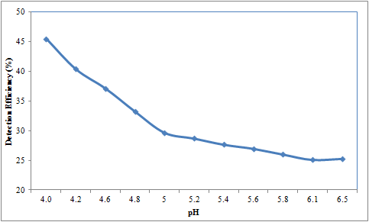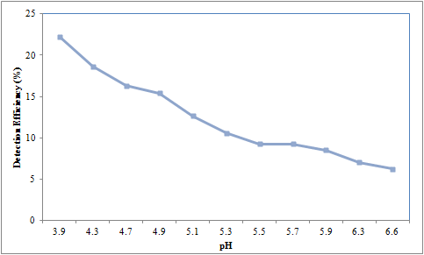
Figure 1(a) Effect of pH on the detection Figure 1(b) Effect of pH on the detection
efficiency of aqueous tritium in the mixture efficiency of aqueous uranium-232 in the mixture

Effect of Acids and Bases on the stability and detection efficiency of the mixture

The effect of acid and base on the stability and detection efficiency of the mixture is shown in Figures 2(a & b) where the efficiency seems to increase with the increasing molarity of the acid. Figures 3(a & b) show the decreasing detection efficiency with the increasing molarity of base. Since the molarity of the acid and base has a direct relationship with pH , therefore a slight increase in the amount of acid and base in the water samples and cocktail will inadvertently the efficiency of radionuclides detection efficiency.

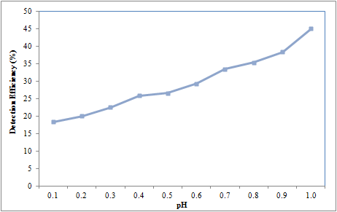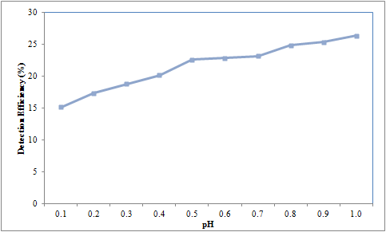
Figure 2(a) Effect of hydrochloric acid on Figure 2(b) Effect of hydrochloric acid on
the detection efficiency of tritium the detection efficiency of uranium -232

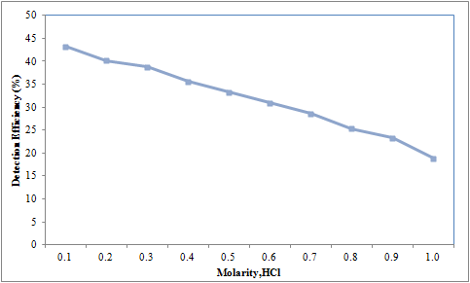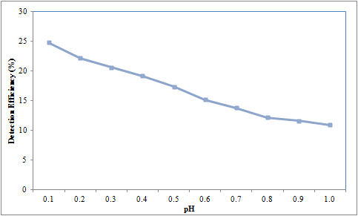
Figure 3(a) The effect of sodium hydroxide on Figure 3(b) The effect of sodium hydroxide on the
the detection efficiency of tritium detection efficiency of uranium -232
Effects of buffers on the stability and detection efficiency of the mixture

Similarly, with the addition of buffer into the system, the effect remains the same. Buffer will stabilize the system and produce smooth graphs at reasonable concentration interval (see Fig 4a and 4b).

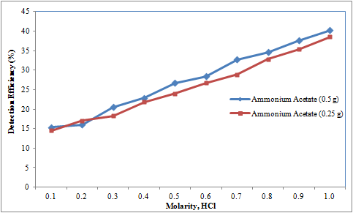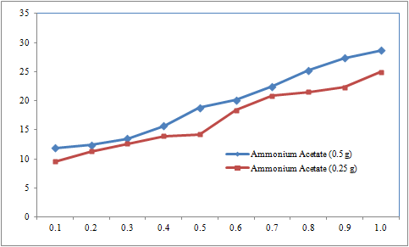
Figure 4(a): The effect of buffer –acid on Figure 4(b): The effect of buffer-acid on the
the detection efficiency of tritium detection efficiency of uranium -232

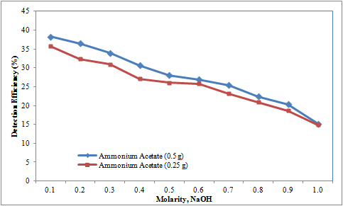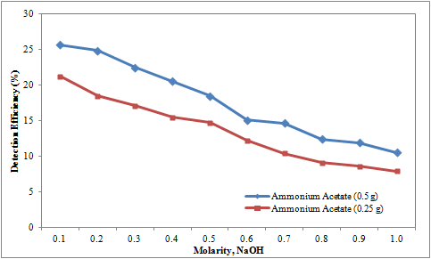
Figure 4(c): The effect of buffer –bases on Figure 4(d): The effect of buffer-base on the
the detection efficiency of tritium detection efficiency of uranium -232

Addition of ammonium acetate to cocktail system will stabilize the effect on the efficiency, where the counting efficiency is increase and after reaching optimum efficiency will decrease as the amount of ammonium acetate increased as shown in Figure 4. The optimum amount of ammonium acetate is 0.25 g.

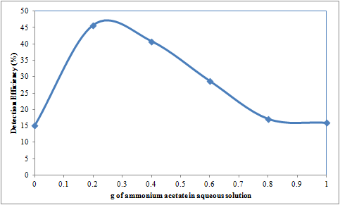
Figure 4: The effect of ammonium acetate (buffer) on the detection efficiency of tritium

Effects of salts on the stability and detection efficiency of the mixture

Addition of more than 0.2 g of salt (sodium chloride) will cause the efficiency to decrease rapidly as shown in Figure 5.

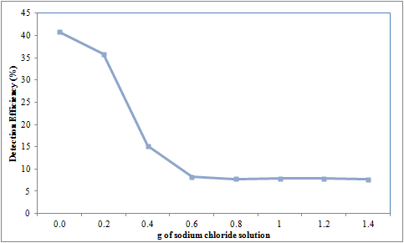
Figure 5: The effect of sodium chloride on the detection efficiency of tritium

Overall, the results show some effect of these parameters to the stability and efficiency of the cocktail-water system. One needs to study these effects to set the optimum condition for the counting of specific radionuclides. More over with the latest LSC equipment incorporating the alpha beta counting mode, one could explore more in term of analyzing specific radionuclides in the environmental samples. Therefore, one can move away from counting gross alpha and gross beta only but with the help of alpha and beta spectra we can calculate the activity of each radionuclide present in the sample. These optimum conditions help to reduce the background counts and provide improved spectra for subsequence analyses.

Analysis of water samples

Using the optimum condition above, different types of water samples were collected, prepared and measured using the alpha/beta counting mode of LSC and the results are shown in Table 2. The results show that hot spring water contains relatively high alpha compared to river water. Khazanah River in Cameron Highlands has a slightly higher alpha because it is located not far from the entrance to the Sultan Abu Bakar Dam. Samples from Lata Rek dam and Former tin mining lake (SK2) have slightly high alpha content due to its geological background. Lata Rek is situated on the granite rocks and former tin mining lake has the accumulation of heavy minerals which contains natural radiaonuclides in it. Other river waters show low alpha activity concentration.

Table 2: Gross alpha and gross beta in different type’s water
Sample Code | Types of water | Activity Concentration (mBq/L)
Sample Code | Types of water | Gross Beta | Gross Alpha
HS-Labok | Hot Spring | 650 ± 46 | 568 ± 22
HS-Sungkai | Hot Spring | 958 ± 71 | 856 ± 48
Bertam river | River Water | 930 ± 68 | 304 ± 29
Khazanah river | River Water | 912 ± 66 | 282 ± 28
Lata Rek Dam | River Water | 2193 ± 159 | 577 ± 52
Lata Rek (DS) | River Water | 1096 ± 79 | 291 ± 29
Kuala Tahan | River Water | 1053 ± 77 | 347 ± 33
Jeti K. Keniam | River Water | 1184 ± 87 | 217 ± 21
SK2 | Lake Water | 6080 ± 20 | 517 ± 92
LT2 | Lake Water | 9223 ± 14 | 328 ± 50
MDA Gross Alpha 50 mBq/L; Gross Beta 220 mBq/L

Gross beta is from beta emitter in the uranium and thorium decay series such as ²¹⁸Po, ²¹⁴Pb and ²¹⁴Bi, ²¹²Pb, ²¹²Bi and ⁴⁰K which dissolved in water. Among the radionuclides ⁴⁰K and ²²⁸Ra are sufficiently soluble and abundant to contribute beta activities to some ground water. The energy of beta particle emitted by ⁴⁰K is high enough to be measured by the gross-beta technique. In contrast, ²²⁸Ra emits a relatively weak beta particle that may not be detected by gross-beta measurements. Although it is not expected to be present at the time of sampling, ingrowth of ²²⁸Ac from ²²⁸Ra approaches 95% of secular equilibrium with ²²⁸Ra within about a day. Although not well studied, Ac probably is sparingly soluble in most ground water [11]. Thus, gross-beta activity from these two radionuclides is approximately equal to the activity of ²²⁸Ra in ground water at the time of sampling.

Figures 6 (a and b) show the spectra of alpha and beta from the sample measured. The spectrum here contain mixed radionuclides and difficult to analyze, unless the radiochemical separation was applied prior to the analysis. The circle indicates the possible radionuclides present in the samples.

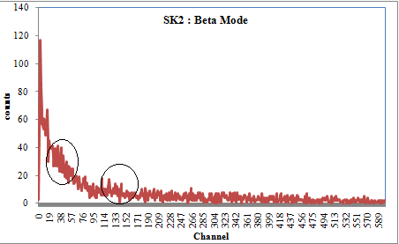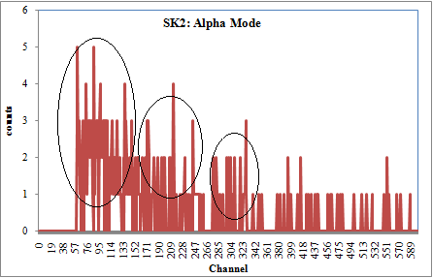
Figure 6 (a): show the spectra of beta Figure 6 (b): show the spectra of alpha

Conclusion

In house cocktail can be used for measuring of gross alpha and gross beta in the environmental aqueous samples. There is a need to consider various effects such as pH, acid and base, buffer and salt for optimization purpose. In general, when the amount of acid, base, buffer and salt are increased, the efficiency will decreased and the effect of pH is reduced if we chose the optimum pH. The gross alpha and gross beta measurement is important for screening purpose and radiochemical separation is needed to get the individual radionuclide which can be confirmed from the spectrum analysis.

Acknowledgment

The authors would like to thank Malaysian Nuclear Agency for allowing the project to be carried out at Malaysian Nuclear Agency (NM) laboratory in Bangi.

References

[1] LSC Technical Tips from Packard (SC-005) (1997). Counting Solutions

[2] Perkin Elmer Application Note (2007). LSC in Practice Counting ¹⁴C in High Activity Sodium
Carbonate Solution.

[3] Zaini Hamzah, Masitah Alias, Zaharudin Ahmad, 2011. Discriminator setting cocktail preparation for analysis of alpha and beta emitters in aqueous solution using liquid scintillation counter. The Malaysian Journal of Analytical Sciences, 15(1), 27-36

[4] A. Dyer (1980). Liquid Scintillation Counting Practice, publisher (pg 30)

[5] Victor Jobbagy, Norbert Kavasi, Janos Somlai, Peter Dombavari, Csaba Gyongvosi, Tibor Kovacs. (2011). Gross alpha and beta activity concentrations in spring waters in Balaton Upland, Hungary. Radiation Measurement, 46: 159-163.

[6] Gursel Karahan, Neset Ozturk and Ahmet Bayulken (2000). Natural radioactivity in various surface waters in Istanbul, Turkey. Water Resources, 34(18), 4360-4370.

[7] UNSCEAR, United Nations Scientific Committee on Exposure to Atomic Radiation Report 1993.

[8] H. Ozmen, F. Kulaher, A. Cukurovah, M. Dogru (2004). Concentration of heavy metal and radioactivity in surface water and sediment of Hazar Lake (Elazig, Turkey). Chemosphere, 55, 401-408.

[9] Higuchi, H. (1981). The analysis of radium in the environmental samples. Radioisotopes, 30, 618.

[10] United Nation, Guidance on Transformation/Dissolution of Metals and metal Compounds in Aqueous Media Report 2007.

[11] Alan H. Welch, Zoltan Szabo, David L.Parkhurst, Peter C. Van Metre (1995). Gross beta activity in ground water: natural sources and artifacts of sampling and laboratory analysis. Applied Geiochemistry, 10, 491-503.

