STABILITY OF THE ABSORBED DOSE TO WATER CALIBRATION COEFFICIENT, N_{D,w} FOR THERAPY LEVEL IONIZATION CHAMBERS BELONGING TO LOCAL RADIOTHERAPY CENTRES: ANALYSIS OF RESULTS OBTAINED DURING 2004 -2010

(Kestabilan Pekali Kalibrasi Dos Terserap Terhadap Air, N_{D,w} Untuk Kebuk Pengionan Tahap Terapi Kepunyaan Pusat Radioterapi Tempatan: Analisis Keputusan
Yang Diperoleh Sepanjang 2004-2010)

S. B. Samat¹, W. Priharti¹, S. S. Chong¹, T. Kadni² and M.T. Dolah²

¹School of Applied Physics
Universiti Kebangsaan Malaysia (UKM)
43600 UKM Bangi, Selangor

²Secondary Standard Dosimetry Laboratory (SSDL)
Malaysian Nuclear Agency (Nuclear Malaysia)
43000 Kajang, Selangor

Corresponding author: sbsamat@ukm.my

Abstract
According to the IAEA, the calibration of therapy level ionization chambers in terms of absorbed dose to water calibration coefficient, N_{D,w} must be within ± 1.5% acceptance limit. This is for the purpose of getting accurate absorbed dose for the patient undergoing radiotherapy treatment. The objective of this work is to evaluate the deviation of N_{D,w} for 29 chambers belonging to 16 local radiotherapy centres. Eight types of chambers have been calibrated at the SSDL Laboratory of Malaysian Nuclear Agency for the period of seven years. The mean µ of the N_{D,w} deviation together with its standard error (SE) and standard deviation σ_{N-1} were calculated. It is found that out of 29 chambers, 26 chambers yielded µ ± SE within the permitted value of ± 1.5%. For the other three chambers, despite their values of µ ± SE lie slightly outside the range of ± 1.5%, they are still within the 95% confident interval of the ± 1.5%. It is concluded that the N_{D,w} of the chambers belonging to the local radiotherapy chambers are stable in their performance the dose to the patients measurement.

Keywords: absorbed dose to water calibration coefficient N_{D,w}, local radiotherapy centres, percentage deviation, SSDL Malaysia, stability of N_{D,w}

Abstrak
Menurut IAEA, julat penerimaan pekali kalibrasi dos terserap terhadap air, N_{D,w} untuk kebuk pengionan tahap terapi mesti berada antara ± 1.5%. Hal ini bertujuan untuk mendapatkan dos terserap yang tepat bagi pesakit yang menjalani rawatan radioterapi. Objektif kerja ini adalah untuk menilai sisihan N_{D,w} bagi 29 kebuk pengionan kepunyaan 16 pusat radioterapi tempatan. Lapan jenis kebuk telah dikalibrasi di makmal SSDL Agensi Nuklear Malaysia dalam tempoh tujuh tahun. Nilai purata µ untuk sisihan N_{D,w} bersama dengan nilai ketidakpastian standard (SE) dan juga sisihan standard σ_{N-1} dikira. Didapati bahawa 26 daripada 29 kebuk menunjukkan nilai µ ± SE berada dalam julat yang dibenarkan iaitu ± 1.5%. Walaupun nilai µ ± SE untuk tiga kebuk yang lain berada di luar julat ± 1.5%, namun ianya masih berada dalam aras keyakinan 95% daripada ± 1.5%. Dapat disimpulkan bahawa nilai N_{D,w} untuk kebuk pengionan kepunyaan pusat radioterapi tempatan adalah stabil bagi pengukuran dos kepada pesakit.

Kata kunci: Pekali kalibrasi dos terserap terhadap air, N_{D,w,} pusat radioterapi tempatan, peratus sisihan, SSDL Malaysia, kestabilan N_{D,w}

Introduction
It has been well documented that accuracy in the beam calibration of the radiotherapy machines would contribute to the accurate dose delivery to the patients [1,2]. Therapy level ionization chamber (IC) is the important tool for the calibration, therefore its accurate absorbed dose to water calibration coefficient, N_{D,w} certainly would contribute to the accurate dose delivery [3]. It is anticipated that the N_{D,w} of an IC would change with time, therefore the IAEA has recommended that an IC should be calibrated every year for its N_{D,w} [4].

For the determination of N_{D,w}, SSDL Malaysia of Malaysian Nuclear Agency (Nuclear Malaysia) has participated in the postal IC intercomparison programmes [5]. Some of the results are shown in Table 1, which shows that the laboratory has provided therapy-level N_{D,w} values within the internationally accepted standards i.e. within the ± 1.5%. For this reason, Nuclear Malaysia is capable for providing the N_{D,w} values for IC belonging to the local radiotherapy centres (RC).

The purpose of this work is to study the N_{D,w} values of 29 ICs belonging to the 16 RC, from the year 2004 to 2010. These N_{D,w} values were determined by Nuclear Malaysia. The objective is to find out how the N_{D,w} values vary with time i.e. its stability.

Table 1: The intercomparison results of N_{D,w} between Nuclear Malaysia (NM) and IAEA

Calibration Year | IC Model | N_{D,w} (mGy/nC) |  | Deviation  (%)
Calibration Year | IC Model | NM | IAEA | Deviation  (%)
1995 | NE 2581 | 57.20 | 56.79 | 0.72
1997 | NE 2581 | 57.08 | 57.07 | 0.02
1998 | NE 2571 | 45.33 | 45.39 | - 0.13
2002 | M 30001 | 52.46 | 52.35 | 0.21
2004 | M 30001 | 52.52 | 52.35 | 0.32

Experimental

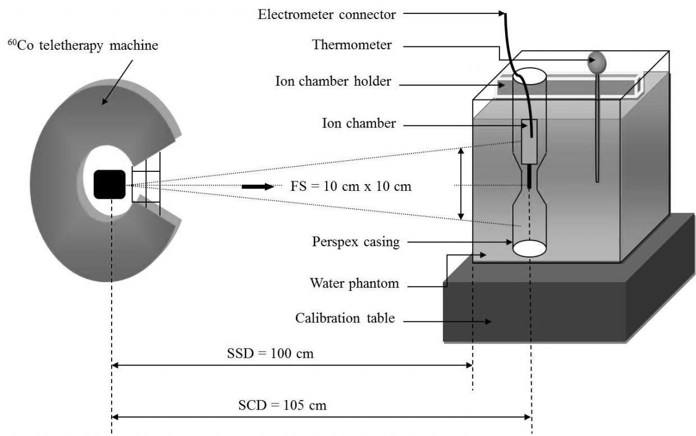

Figure 1: Experimental setup of N_{D,w} calibration
Figure 1 shows the experimental set-up for the determination of N_{D,w}. The method follows the procedures of substitution method recommended by the IAEA [6]. The PMMA water phantom is of size 30 cm × 30 cm × 30 cm. A waterproof sleeve is used to place the IC at its reference point at a depth 5 g/cm² in the water phantom. In this work a reference standard chamber of 0.6 cm³ NE2571(#1028) is used.

Table 2 lists the type of the 29 ICs belonging to the 16 RCs. The table also shows the N_{D,w} calibration frequency for a period of seven years from the year 2004 to 2010. The IAEA requires each IC to be calibrated every year for purpose of getting the most recent value of N_{D,w}. However in this work, the determination of RC’s N_{D,w} is based on the request by the RC themselves not the request by the SSDL Malaysia. Whenever SSDL Malaysia receives the IC, the calibration work will be done immediately. In other words, the frequency of each IC calibration is determined by the radiotherapy centres themselves.

Table 2: N_{D,w} calibration frequency for chambers belonging to local radiotherapy centres

IC Model | IC No | RC No | Freq. | N_{D,w} calibration frequency
 |  |  |  | 2004 | 2005 | 2006 | 2007 | 2008 | 2009 | 2010
CC 13#7063 | 1 | 4 | 3 |  |  |  | $$√$$ | $$√$$ | $$√$$
FC 65-G#1328 | 2 | 3 | 3 |  |  |  | $$√$$ | $$√$$ | $$√$$
FC 65-G#1371 | 3 | 5 | 4 | $$√$$ | $$√$$ | $$√$$ | $$√$$
FC 65-G#367 | 4 | 7 | 7 | $$√$$ | $$√$$ | $$√$$ | $$√$$ | $$√$$ | $$√$$ | $$√$$
FC 65-G#368 | 5 | 4 | 6 | $$√$$ |  | $$√$$ | $$√$$ | $$√$$ | $$√$$ | $$√$$
FC 65-G#369 | 6 | 4 | 4 |  |  | $$√$$ | $$√$$ | $$√$$ | $$√$$
FC 65-G#371 | 7 | 5 | 3 |  |  |  |  | $$√$$ | $$√$$ | $$√$$
FC 65-G#744 | 8 | 14 | 6 | $$√$$ |  | $$√$$ | $$√$$ | $$√$$ | $$√$$ | $$√$$
FC 65-G#WD 362 | 9 | 11 | 3 | $$√$$ | $$√$$ |  | $$√$$
FC 65-G#WD 445 | 10 | 13 | 6 | $$√$$ | $$√$$ | $$√$$ | $$√$$ | $$√$$ | $$√$$
FC 65-G#WD 878 | 11 | 11 | 5 |  | $$√$$ | $$√$$ | $$√$$ | $$√$$ | $$√$$
FC 65-G#WD1219 | 12 | 6 | 5 |  |  | $$√$$ | $$√$$ | $$√$$ | $$√$$ | $$√$$
FC 65-P#1437 | 13 | 8 | 3 |  |  |  | $$√$$ | $$√$$ |  | $$√$$
FC 65-P#742 | 14 | 14 | 5 | $$√$$ |  | $$√$$ |  | $$√$$ | $$√$$ | $$√$$
NE 2571#2257 | 15 | 8 | 4 | $$√$$ | $$√$$ | $$√$$ | $$√$$
NE 2571#2798 | 16 | 15 | 5 | $$√$$ |  | $$√$$ | $$√$$ | $$√$$ | $$√$$
NE 2581#1180 | 17 | 12 | 6 |  | $$√$$ | $$√$$ | $$√$$ | $$√$$ | $$√$$ | $$√$$
NE 2581#621 | 18 | 3 | 7 | $$√$$ | $$√$$ | $$√$$ | $$√$$ | $$√$$ | $$√$$ | $$√$$
PPC 40#310 | 19 | 13 | 4 |  |  | $$√$$ | $$√$$ | $$√$$ | $$√$$
PPC 40#314 | 20 | 9 | 3 |  |  |  | $$√$$ | $$√$$ | $$√$$
TM 30013#1745 | 21 | 10 | 4 |  |  | $$√$$ | $$√$$ | $$√$$ | $$√$$
TM 31010#0426 | 22 | 5 | 4 |  |  | $$√$$ | $$√$$ |  | $$√$$ | $$√$$
TW 30001#2120 | 23 | 15 | 5 |  |  | $$√$$ | $$√$$ | $$√$$ | $$√$$ | $$√$$
TW 30013#1646 | 24 | 1 | 4 |  |  | $$√$$ | $$√$$ | $$√$$ | $$√$$
TW 30013#1681 | 25 | 16 | 5 |  |  | $$√$$ | $$√$$ | $$√$$ | $$√$$ | $$√$$
TW 30013#2139 | 26 | 16 | 4 |  |  | $$√$$ | $$√$$ | $$√$$ | $$√$$
TW 31010#1005 | 27 | 16 | 4 |  |  | $$√$$ | $$√$$ | $$√$$ | $$√$$
W 30001#1210 | 28 | 15 | 5 | $$√$$ | $$√$$ |  | $$√$$ | $$√$$ | $$√$$
WDIC 70#062 | 29 | 2 | 5 | $$√$$ | $$√$$ |  | $$√$$ | $$√$$ | $$√$$
Table 3 shows an example of N_{D,w} calibration results for IC=4 and RC=7. Since there are seven values of N_{D,w}, there are only six deviations Δ(%) that can be calculated, as the first N_{D,w} was taken as the standard. These six deviations were then used to get the mean µ, standard error SE and standard deviation σ_{N-1}. The SE and σ_{N-1} are calculated at 68.26% confident interval (CI). The same calculation was repeated for the other ICs.

In this work, the results of µ ± SE and µ ± σ_{N-1} were compared with the deviation limit of ± 1.5% accepted by the IAEA [7]. If µ ± SE is within the limit, it is said that the chamber is stable in maintaining its N_{D,w}.

Table 3: The results of N_{D,w} for chamber FC 65-G#367 calibrated each year from 2004-2010
IC No | RC No | Calibration Year | N_{D,w} (mGy/nC) |  | Deviation  (%)
IC No | RC No | Calibration Year | First | Consequent | Deviation  (%)
4 | 7 | 2004 | 48.69 | -
 |  | 2005 |  | 47.87 | -1.68
 |  | 2006 |  | 48.24 | -0.92
 |  | 2007 |  | 47.81 | -1.81
 |  | 2008 |  | 48.45 | -0.49
 |  | 2009 |  | 48.20 | -1.01
 |  | 2010 |  | 48.33 | -0.74

Results and Discussion
The results of µ ± SE and µ ± σ_{N-1} for the Δ(%) are given in Figures 2 and 3 respectively. In general it can be seen that (a) all µ for the 29 ICs lie within the limit of ± 1.5%, which shows that the 29 ICs are stable in providing their N_{D,w}, (b) the value of µ ± SE (Figure 2) is smaller than µ ± σ_{N-1} (Figure 3) by a factor of square root of N, where N is the number of the deviations, as expected. For the results of IC=4 and RC=7 mentioned above, the µ ± SE and µ ± σ_{N-1} are indicated by the arrows in the two figures.

We shall now examined µ ± SE only (Figure 2) for all the ICs as SE is in actual fact is the uncertainty in the mean. It can be seen that there are three ICs (IC no 7, 20 and 24) that give the values slightly higher than ± 1.5%. If we examine carefully the values of the SE for three ICs that lie outside acceptable limit of ± 1.5%, we found that their values are acceptable as they are less than 95% confidence interval of the limit, i.e. 79.6% or 1.27 standard deviation (SD) for IC no. 7 (1.91=1.27×1.5), 94.4% or 1.91 SD for IC no. 20 (2.86=1.91×1.5) and 75% or 1.15 SD for IC no. 24 (1.72=1.15×1.5).

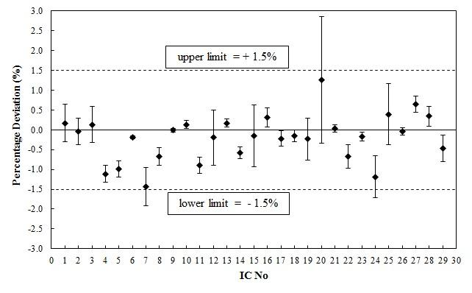

Figure 2: Deviation of µ ± SE
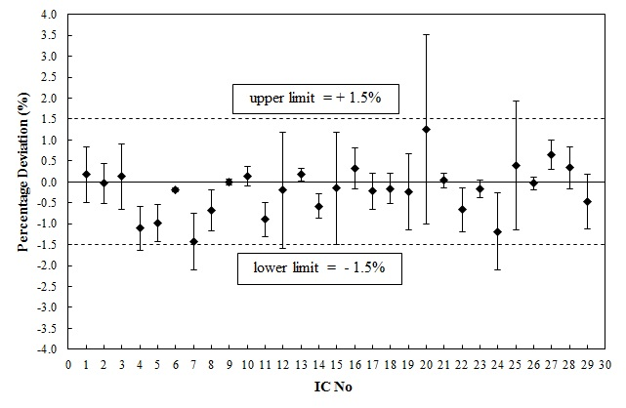
Figure 3: Deviation of µ ± σ_{N-1}

Conclusion
As the N_{D,w} calibration coefficient are stable with time, it is concluded that the chambers being studied are in their good performance for the purpose patients dose measurement.

Acknowledgement
We gratefully acknowledge Universiti Kebangsaan Malaysia for a research grant, Project code UKM-ST-07-FRGS0154-2010.

References
- IAEA. 1998. Building a better future: Contributions of nuclear science and technology. Vienna.
- IAEA. 2004. Radiation, people and the environment. Vienna.
- Samat, S.B., Evans, C.J., Kadni, T. Ooi, A.S. & Dollah, M.T. 2003. The -10% and 13% errors arising from mis-interpretation of the two IAEA protocols TRS-277 and TRS-398: Causes and prevention. SSDL Newsletter 48: 16-18.
- IAEA. 2000. Absorbed Dose Determination in External Beam Radiotherapy: An International Code of Practice for Dosimetry Based on Standards of Absorbed Dose to Water, TRS 398, Vienna.
- Samat, S.B., Evans, C.J., Kadni, T. & Dollah, M.T. 2009. Malaysian participation in the IAEA/WHO postal TLD and postal ionization chamber intercomparison programme: Analysis of results obtained during 1985-2008. Rad. Prot. Dos. 133(3): 186-191.
- IAEA. 1994. Calibration of dosimeters used in radiotherapy: A manual sponsored by the IAEA and WHO. TRS 374. Vienna
- IAEA. 2003. Results of comparison of therapy level ionization chamber calibration coefficient (Reference:MAL/02/01). IAEA/WHO Network of Secondary Standard Laboratories.

