ALIPHATIC HYDROCARBONS IN SURFACE SEDIMENTS FROM SOUTH CHINA SEA OFF KUCHING DIVISION, SARAWAK

(HidrokarbonAlifatik diPermukaanEnapanLautCina Selatan Bahagian Kuching)

Hafidz B. Yusoff¹, Zaini B. Assimand¹, Samsur B. Mohamad²

¹Department of Chemistry,
²Department of Aquatic Sciences,
Faculty of Resource Sciences and Technology,
Universiti Malaysia Sarawak, 94300 Kota Samarahan, Sarawak

*Corresponding author: zaini@frst.unimas.my

Abstract
Eighteen surface sediment samples collected from South China Sea off Kuching Division, Sarawak were analyzed for aliphatic hydrocarbons. These hydrocarbons were recovered from sediment by Soxhlet extraction method and then analyzed using gas chromatography equipped with mass spectrometer (GC/MS). Total concentrations of aliphatic hydrocarbons in surface sediments from South China Sea off Kuching division are ranged from 35.6 ug/g to 1466.1 ug/g dry weights. The sediments collected from Bako Bay, Kuching showed high concentrations of total aliphatic hydrocarbons. Several molecular indices were used to predict the predominant sources of hydrocarbons. Carbon preference index (CPI) value revealed widespread anthropogenic input in this study area (CPI= 0 to 4.1). The ratio of C₃₁/C₁₉and C₂₉/C₃₁indicated that major input of aliphatic hydrocarbon mostly transfer by lateral input to the marine environment than atmospheric movements. Generally, the concentrations of aliphatic hydrocarbons in sediment from South China Sea off Kuching division are generally higher compare to other area in the world.

Key words: Aliphatic hydrocarbons, surface sediment, South China Sea, Soxhlet extraction, gas chromatography/mass spectrometer (GC/MS), carbon preference index (CPI)

Abstrak
Kajian telah dilakukan terhadap lapan belas enapan permukaan Laut Cina Selatan bahagian Kuching. Sampel enapan ini telah dianalisis bagi mengenalpasti kandungan hidrokarbon alifatik. Hidrokarbon alifatik daripada enapan telah diekstrak dengan menggunakan kaedah pengekstrakan Soxhlet dan di analisis dengan menggunakan kromatografi gas/spektrometerjisim (KG/SJ).Jumlah kepekatan hidrokarbon alifatik adalah dalam julat 35.6 ug/g sehingga 1466.61 ug/g berat kering. Sampel enapan dari Teluk Bako menunjukkan kandungan hidrokarbon aliftik yang tinggi. Indek penanda hidrokarbon telah digunapakai untuk mengenalpasti sumber hidrokarbon.Indek kecenderungan karbon (IKK) menunjukkan taburan hidrokarbon antropogenik yang tinggi di kawasan kajian (IKK= 0 sehingga 4.1) NisbahC₃₁/C₁₉ dan C₂₉/C₃₁ menunjukkan kebanyakan sumber hidrokarbon alifatik dipindahkan secara lateral ke kawasan persekitaran marin. Secara umumnya, kandungan hidrokarbon alifatik di Laut China Selatan bahagian Kuching adalah tinggi berbanding dengan kawasan lain di seluruh dunia.

Kata kunci: Hidrokarbonalifatik, enapanpermukaan, Laut China Selatan, pengekstrakanSoxhlet, kromatografi gas-pektrometerjisim (KG-SJ), Indekkecenderungankarbon (IKK)

Introduction

Kuching is one of the most urbanized and developed areas in Sarawak. The term of development usually covers the usage of well-known energy of oil. Oil includes variety of compounds and elements such as aliphatic hydrocarbons that is potential for environmental hazard for ecosystem and human life. Aliphatic hydrocarbons are ubiquitous sedimentary contaminants due to their tendency to accumulate in sediments. Sedimentary aliphatic hydrocarbons have both naturaland anthropogenic sources. The anthropogenic hydrocarbons in sediment originate mainly from petroleum residues but natural hydrocarbons produce by organism such as planktons, algae and bacteria or come from terrestrial plants [1,2].Generally, non-polluted area demonstrates hydrocarbons concentrations less than 10 ng/mg dry weight [3].

Aliphatic hydrocarbon from anthropogenic and biogenic sources can be determined using different indices. The combination of different indices will provide a better comprehension for the hydrocarbon origin. Ratio of isoprenoidpristane and phytane (Pr/Ph) can be used as molecular indices to indicate the origin of hydrocarbon in sediments. In sediments uncontaminated with oil, the Pr/Ph ratio is higher than 1 usually between 3 and 5 [4]. Carbon Preference Index (CPI) indicates the ratio of odd carbon numbers over even carbon numbers with different carbon groups. CPI is using frequently and been introduced by Farrington and Tripp in 1977 [5] and developed by other researchers [2, 6, 7].

There are two major rivers in Kuching City, namely Sarawak River and Santubong River. The areas around Sarawak River are intense with industrial activities and rapid urbanization while areas around Santubong area are intense with mangrove forest and urban area. This study were conducted in order to find the distributions and concentrations of natural and anthropogenic hydrocarbons in marine sediment from South China Sea off Kuching division and to find out the possible sources and origins of hydrocarbon in the study area.

Experimental

Sample collections

Eighteen sediment samples were collected from South China Sea off Kuching division in Mac 2009.The locations of sampling stations from S.C.S off Kuching division were shown in Figure 1. The exact positions of each sampling site as presented in Table 1 have been recorded using a Global Positioning System (GPS). The sediment samples were collected using a gravity core sampler and then sliced at 5 or 10 cm interval. However only top layers (0-5) cm was considered in this study. The sediments were then wrapped with aluminum foil and stored in cooler box during the sampling. All the sediments were then stored in cold room until further analysis.

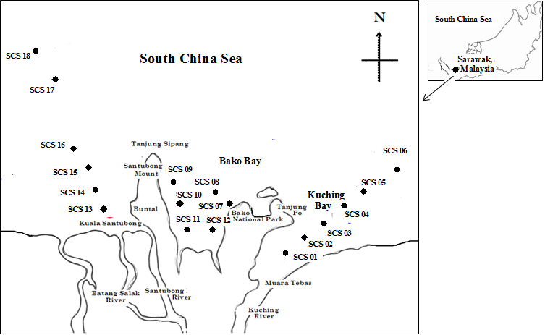

Figure 1:Sampling location at South China Sea off Kuching Division

Table 1: Sampling location at South China Sea off Kuching Division

Sampling Site | Location | Position based on GPS reading | Water Depth (m)
Station 1 | Behind Chinese Cemetery at  MuaraTebas | N 01° 39’ 03.1”  E 110° 29’ 41.4” | 3.5
Station 2 | Open Sea adjacent to PasirPuteh | N 01° 39’62.1”  E 110° 31’ 22.5” | 5.0
Station 3 | Open Sea near to the Marine Department Buoy | N 01° 40’17”  E 110° 32’ 37.8” | 7.5
Station 4 | Ocean Input | N 01° 45’07.5”  E 110° 41’ 37.7” | 10.0
Station 5 | Ocean Input | N 01° 47’10.9”  E 110° 41’ 56.5” | 15.0
Station 6 | Ocean Input | N 01° 49’18.1”  E 110° 41’ 25.7” | 20.0
Station 7 | Bako National Park Zone | N 01˚40’ 24.5”  E 110˚ 14’24.6” | 7.5
Station 8 | Ocean Input | N 01˚44’18.2”  E 110˚25’39.9” | 10.0
Station 9 | Ocean Input | N 01˚44’42.3”  E 110˚24’36.5” | 8.5
Station 10 | Buntal Coastal Zone | N 01˚43’48.8”  E 110˚23’31.1” | 12.5
Station 11 | Tabo Coastal Zone | N 01˚43’47.6”  E 110˚24’44.5” | 10.5
Station 12 | Bako National Park Zone | N 01˚43’31.3”  E 110˚26’08.6” | 12.5
Station 13 | Adjacent to Santubong Estuary | N 01° 46’147”  E 110° 16’ 691” | 1.2
Station 14 | Ocean Input | N 01° 42’69”  E 110° 49’ 21.4” | 2.5
Station 15 | Ocean Input | N 01° 47’702”  E 110° 13’ 684” | 5.3
Station 16 | Ocean Input | N 01° 50’906”  E 110° 13’ 684” | 10.2
Station 17 | Ocean Input | N 01° 54’626”  E 110° 12’ 049” | 15.3
Station 18 | Ocean Input | N 01° 58’000”  E 110° 30’ 380” | 20.5
n.a; not available

Extraction and fractionation of geolipid

Extractions of geolipids from sediments were performed using Soxhlet extraction, 8 g sediment were placed in the extraction thimbles (30 mm x 100 mm, Whatman) and extracted with 200 ml methylene chloride for 8 hours extraction times [8]. 50 μL of internal standard consisting of 50 ng/μLeicosene in DCM were spiked into the sample. Geolipid is dissolved in 5 ml n-hexane and then subject to fractionate on a chromatography column (1.1 cm X 50 cm) which are pack with 7.5 g activated silica gel (60 mesh). 40 ml hexane was used as eluting solvent.

Elemental Sulfur Removal

The presence ofSulfur in appreciable quantities needs to be removed due to its interferences in the accurate gravimetric determination of aliphatic hydrocarbon content of the samples in fractions 1. The elemental Sulfur, S₈ was removed from fractions 1 by using the activated copper column. A bed (~3 cm high) of copper powder (~40 mesh) packed dry into a glass chromatographic column was used to treat the TAH fractions.The sample was allowed to elute slowly through the column with 25 mL dichloromethane [9].

GC-MS Analysis

Concentrations of aliphatic hydrocarbons in sediments were determined using Shimadzu GasChromatography/Mass Spectrometer(GC/MS) QP 2010. Chromatographic separation was achieved by a BPX-5 capillary column (29.5 m×0.25 mm i.d., 0.2 μm film thickness) with a splitless injector and mass spectrometerdetector. Helium was used as the carrier gas (0.98 ml min−1). Sampleswere injected in the splitless mode with an injector temperature of 250 °C. Oven temperature was programmed from 60 °C to 240⁰C (5 min hold), at 6 °C min⁻¹, and from 240 °C to 300 °C (15 min hold), at 6 °C min⁻¹ rate.The concentration of individual n-alkanes was determined by using authenticstandards of n-alkanes (C₁₁-C₃₃). Individualn-alkanes (C₁₁–₃₃)were identified based on the retention times andmass spectra of target compounds against the authentic standards.

Results and Discussion

Aliphatic hydrocarbons in surface sediment from South China Sea off Kuching division

Quantification was carried out for individual n-alkanes in range between n-C₁₁ and n-C₃₃ including isoprenoid hydrocarbons, pristane and phytane. The identification of individual components in sample was based on retention time of standard, which was analyzed prior to the analysis of sediment samples. The aliphatic hydrocarbon concentrations in this study are varying between not detected to 412.2µg/g dry weights. The lowest concentrations of total aliphatic hydrocarbons (35.6ug/g) in sediments was detected from SCS18(open sea area) while the highest concentrations of total aliphatic hydrocarbon concentrations(1466.1ug/g) was recorded from SCS11 at Tabo coastal area. Table 2 shows the distributions of aliphatic hydrocarbons in the study area. Chromatograms can reveal many characteristic of samples.Most of the samples showed a baseline elevation or hump that cannot be resolved by capillary GC column except station 13 and 14 which located adjacent to Santubong estuary (see Figure 2, 3 and4). This hump is due to unresolved complex mixture (UCM) which usually exists in the carbon number of 16-34 that indicates oil pollution [10]. In this study most of the UCM humps were appeared ranging from C₁₆-C₃₂ (see Figure 2 and 3). It is also indicate the presence petrogenic input or biodegradation in most of the sediment samples. UCM also indicate the weathering condition of the environmental samples [11].

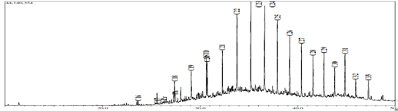
Figure 2: Gas chromatogram of aliphatic hydrocarbon from SCS 03 at Kuching Bay

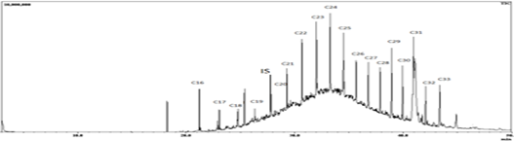

Figure 3: Gas chromatogram of aliphatic hydrocarbon from SCS 07 at Bako Bay
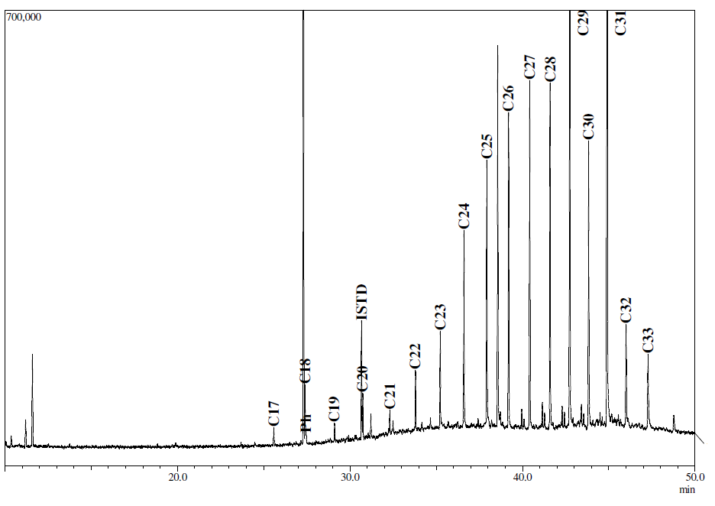

Figure 4: Gas chromatogram of aliphatic hydrocarbon frm SCS 13 adjacent to Santubong estuary
Table 2: Concentrations (ug/g) of aliphatic hydrocarbons in surface sediments from South China off Kuching Division

Carbon Numbers | Sampling Stations (SCS)
Carbon Numbers | 01 | 02 | 0 3 | 04 | 05 | 06 | 07 | 08 | 09 | 10
C11 | 0.2 | n.d | n.d | n.d | 0.5 | n.d | n.d | n.d | n.d | n.d
C12 | 0.8 | n.d | n.d | n.d | 0.1 | n.d | n.d | n.d | n.d | n.d
C13 | 16.1 | n.d | n.d | 0.2 | 0.8 | n.d | n.d | n.d | n.d | n.d
C14 | 11 | n.d | n.d | 0.1 | 0.5 | n.d | n.d | n.d | n.d | n.d
C15 | 24.2 | n.d | 0.1 | 0.3 | 1.3 | n.d | n.d | n.d | n.d | n.d
C16 | 10.1 | 3.3 | 0.4 | 0.2 | 3.8 | 10.8 | 1.6 | n.d | 4.1 | 2.6
C17 | 5.5 | 26.5 | 1.5 | 0.4 | 20.1 | 64.2 | 7.9 | 49.8 | 10.2 | 19.2
Pr | 1.2 | 2 | 0.7 | 0.1 | 1.2 | 2.9 | 50.5 | 19.3 | 8.5 | 2.9
C18 | 4.1 | 39.3 | 2.8 | 0.5 | 21.9 | 75.7 | 51.1 | 87.8 | 8.3 | 11.4
Ph | 4.6 | 21.6 | 2 | 0.4 | 11.9 | 38.6 | 22.9 | 7.1 | 14.3 | 7.9
C19 | 3.7 | 53.7 | 4.4 | 0.8 | 19.7 | 87.6 | 6.1 | 138.3 | 13.6 | 17.2
C20 | 3.7 | 28 | 6.3 | 1.2 | 11.8 | 38.9 | 6.4 | 69.1 | 20.8 | 37.6
C21 | 1.8 | 32.4 | 9.5 | 1.8 | 14.1 | 48.8 | 9.1 | 69.6 | 35.6 | 61.7
C22 | 3.4 | 55.7 | 15.8 | 3.7 | 20.8 | 68.1 | 10.6 | 110.8 | 72.4 | 106.9
C23 | 1.6 | 73.1 | 18.9 | 7.9 | 27.6 | 86.2 | 17.5 | n.d | 104.4 | 119.3
C24 | 1.7 | 64.5 | 19 | 8.8 | 21.2 | 114.6 | 18.9 | 140.3 | 116.7 | 116.8
C25 | 2.7 | 42.1 | 16.3 | 9.8 | 18.3 | 66.1 | 25.5 | 125.9 | 100.8 | 96.9
C26 | 4.4 | 24.9 | 12.8 | 8.6 | 14.2 | 34.9 | 25.9 | 98 | 83.1 | 59.2
C27 | 6.8 | 33.3 | 10.4 | 10.4 | 14 | 54.2 | 34.8 | 83.7 | 93.5 | 59.2
C28 | 9.3 | 29.5 | 8.7 | 8.1 | 9 | 21.1 | 31 | 77.5 | 79.3 | 56.8
C29 | 26.9 | 11.5 | 8.5 | 12.5 | 13.9 | 61.7 | 53.8 | 79.4 | 90.1 | 70.1
C30 | 59.7 | 137.3 | 13.1 | 13.1 | 14.4 | 60.5 | 22.1 | 49 | 47.8 | 36.7
C31 | 139 | 59.1 | 13.2 | 29.5 | 31.3 | 193.5 | 42.4 | 65.1 | 82 | 81.7
C32 | 76.2 | 176.2 | 5.9 | 8.5 | 8.6 | 60 | 16.2 | 37.7 | 34.2 | 32
C33 | 104 | 412.2 | 5.4 | 14.5 | 15.3 | 106.3 | 28.6 | 49.4 | 49 | 54.8
TAH | 522 | 1326 | 176 | 142 | 316 | 1295 | 482.9 | 1358 | 1068.8 | 1051
Notes; n.d: not detected or below detection limit, TAH: total aliphatic hydrocarbon

Carbon Numbers | Sampling Stations (SCS)
Carbon Numbers | 11 | 12 | 13 | 14 | 15 | 16 | 17 | 18
C11 | n.d | n.d | n.d | n.d | n.d | n.d | 0.1 | n.d
C12 | n.d | n.d | n.d | n.d | n.d | n.d | n.d | n.d
C13 | n.d | n.d | n.d | 0.8 | n.d | n.d | n.d | n.d
C14 | n.d | n.d | n.d | 0.8 | n.d | n.d | 0.3 | n.d
C15 | n.d | n.d | n.d | 0.9 | n.d | n.d | 0.7 | n.d
C16 | n.d | 5.5 | n.d | 0.8 | 1 | 0.9 | 0.9 | 0.6
C17 | 30.9 | 45.9 | 1.1 | 2.7 | 6.6 | 5.6 | 1.9 | 1.9
Pr | 7.6 | 12.9 | n.d | n.d | 6.6 | n.d | n.d | n.d
C18 | 12 | 12.6 | 2.7 | 4.8 | 1.6 | 5 | 3.8 | 3.2
Ph | 15.5 | 12.5 | 0.5 | 0.9 | 1.6 | 1.1 | 0 | 0.4
C19 | 19.4 | 18.8 | 1 | 3.1 | 4.7 | 3.8 | 1.3 | 1.6
C20 | 44.7 | 32.1 | 2.6 | 5.4 | 6.7 | 5.8 | 2.8 | 3.5
C21 | 69.9 | 63.6 | 1.4 | 3.5 | 4.2 | 3.7 | 1.2 | 1.6
C22 | 113.7 | 114 | 3.4 | 4.6 | 5.4 | 4.4 | 2.3 | 3.1
C23 | 121.6 | 139.6 | 6 | 4.1 | 4.7 | 4 | 1.5 | 2.1
C24 | 115.3 | 168.7 | 20.2 | 4.5 | 6.9 | 4.2 | 2.1 | 2.8
C25 | 90.6 | 127.5 | 19.8 | 3.6 | 4.2 | 3.4 | 1.4 | 1.9
C26 | 87.7 | 59.9 | 23.9 | 4.3 | 4 | 3.9 | 1.6 | 1.7
C27 | 107.5 | 75.3 | 26.4 | 5.8 | 4.3 | 4.6 | 1.5 | 2.1
C28 | 113.3 | 72.1 | 20.2 | 5.3 | 4.2 | 5.7 | 1.4 | 1.8
C29 | 127.6 | 101.4 | 41.3 | 24.4 | 5.1 | 7.2 | 2.1 | 1.8
C30 | 79.1 | 57.2 | 48.4 | 8.6 | 6.1 | 12.3 | 2.1 | 2
C31 | 125.5 | 123.8 | 96.5 | 16 | 8.3 | 15.4 | 13.3 | 2.3
C32 | 69.7 | 44.6 | 13.5 | 4.8 | 4.2 | 8.8 | 1.2 | 0.8
C33 | 114.5 | 52.9 | 11 | 10.8 | 3.1 | 7.7 | 3.3 | 0.5
TAH | 1466 | 1340.9 | 339.9 | 120.2 | 93.5 | 107.7 | 46.8 | 35.6

Source of Aliphatic Hydrocarbons in sediment from South China Sea off Kuching Division

Molecular biomarkers are organic compounds detected in the geosphere with structures suggesting an unambiguous link with known contemporary natural products. These specific indicator compounds which are found in extracts of geological and environmental sample can be utilized for genetic source correlations [12]. Distributions of aliphatic hydrocarbon in the samples including isoprenoids (pristane and phytane ) were used to predict the source of organic matter in sediments, where there are used in terms of ratios either isoprenoid to isoprenoid or isoprenoid to n-alkanes [13]. Some of these biomarkers indices include the ratio of low molecular weight (LMW) / High molecular weight (HMW) of hydrocarbon, Carbon preference index (CPI), nC₃₁/nC₁₉, nC₂₉/nC2₃, nC₂₅/nC₁₅, pristane/phytane and pristane/C₁₇value. Table 3 shows the biomarkers indices for aliphatic hydrocarbons in sediments for sampling stations at South China Sea off Kuching division.

High concentration of LMW carbon indicates an anthropogenic site, while high concentration of HMW indicates a biogenic site. Thus the ratio of LMW/HMW below the unity shows natural input from marine and terrestrial biogenic sources and around and above unity for petroleum origin [14, 15]. The results from LMW/HMW ratio indicate that most of the sampling stations were dominated with LMW of hydrocarbons except station SCS01, SCS02, SCS04, SCS13 and SCS14. All samples collected from Bako Bay were dominated with LMW of aliphatic hydrocarbons and showed ratio LMW/HMW above unity. These results suggest that major inputs of aliphatic hydrocarbon in sediment from Bako Bay are from petroleum, might be from shipping activities and transportation at Bako National Park. Most of the stations located adjacent to the Santubong estuary were dominated by high molecular weight of hydrocarbons suggesting inputs of hydrocarbons in this area are from natural sources. Mangrove forest along the Santubong River might be the main sources of biogenic hydrocarbons in this area.

CPI value close to one is sourced by recycled organic matters and/ or marine microorganism [7] as well as petroleum [5]. Predominant of vascular plants input to the environment usually demonstrate the CPI value from 3 to 6 [6]. In this study, the CPI value was shown that the natural input proportion is significantly lower than anthropogenic release (see Figure 5). Among stations, SCS 17 and SCS 18 which located at the open sea area showed high CPI value (3 and 4.1 respectively) indicative of predominant of natural input. The rest of the stations showed the numbers lower and around unity that represent anthropogenic inputs.

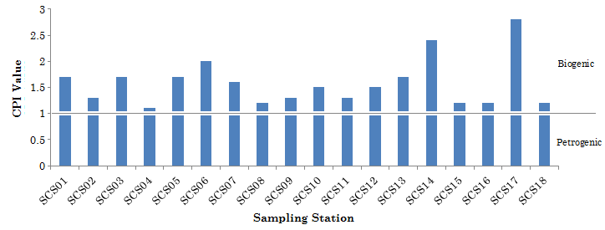

Figure 5: CPI values among stations

The carbon number of C₃₁ is known to be an indication of land derived hydrocarbon while C₁₉ presents the marine biogenic sources. The ratio of C₃₁/C₁₉ use to identify the predominant of hydrocarbon input from land or sea basis. The value below 0.4 indicates the predominant of marine biogenic sources while number over 0.4 show land derived hydrocarbons [16]. In this study, most of the stations showed land derived hydrocarbon except station 8 which located at the open sea area adjacent to Bako Bay. The ratios C₂₉/C₃₁ below than one also indicate that hydrocarbon input from land while ratio over than one indicate atmospheric cycle. Most of the sampling stations showed ratio of C₂₉/C₃₁ below one indicating majority of hydrocarbon input from land. Pristane and phytane are common isoprenoids found in coastal marine sediment. They are presence in most petroleum, usually as major constituents, within a much wider range of isoprenoid alkanes. The ratio of Pr/Ph close to one indicates petroleum contamination while value greater than 1 indicating biogenic origins [4]. In this study, majority of sediment samples showed value of Pr/Ph is lower than one indicates petroleum contaminantion while 2 samples from SCS12 and SCS15 adjacent to Santubong area showed Pr/Ph value more than one indicating biogenic origin.

Table 3: Biomarkers indices for aliphatic hydrocarbons in sediments from South China Sea off Kuching division

Ratio and  Index | Stations (SCS)
 | 01 | 02 | 03 | 04 | 05 | 06 | 07 | 08 | 09 | 10 | 11 | 12 | 13 | 14 | 15 | 16 | 17 | 18
ªLMW | 1093 | 4671 | 1108 | 449 | 2097 | 7372 | 254 | 916 | 592 | 659 | 728 | 813 | 826 | 444 | 582 | 459 | 219 | 712
^{b}HMW | 4210 | 8591 | 652 | 965 | 1064 | 5571 | 228 | 441 | 475 | 391 | 737 | 527 | 2572 | 757 | 352 | 617 | 248 | 2760
^{c}LMW/  HMW | 0.1 | 0.1 | 1.7 | 0.5 | 2.0 | 1.3 | 1.1 | 2.1 | 1.2 | 1.7 | 1.0 | 1.5 | 0.3 | 0.6 | 1.7 | 0.7 | 0.9 | 0.3
^{d}CPI | 1.8 | 1.3 | 0.9 | 1.6 | 1.4 | 1.7 | 1.3 | 1.0 | 1.3 | 1.3 | 1.4 | 1.4 | 1.5 | 2.2 | 1.0 | 1.1 | 3.0 | 4.1
^{e}nC31/nC19 | 37.6 | 1.1 | 3.0 | 35.1 | 1.6 | 2.2 | 7.0 | 0.5 | 6.0 | 4.8 | 6.5 | 6.6 | 91.9 | 5.2 | 1.7 | 4.0 | 10.3 | 12.8
^{f}nC29/nC31 | 0.2 | 0.2 | 0.6 | 0.4 | 0.4 | 0.3 | 1.3 | 1.2 | 1.1 | 0.9 | 1.0 | 0.8 | 0.4 | 1.5 | 0.6 | 0.5 | 0.2 | 0.8
^{g}nC25/nC15 | 0.1 | n.a | 111.2 | 35.3 | 13.9 | n.a | n.a | n.a | n.a | n.a | n.a | n.a | n.a | 4.1 | n.a | n.a | 2.1 | n.a
^{h}Pr/Ph | 0.3 | 0.1 | 0.4 | 0.2 | 0.1 | 0.1 | 0.4 | 0.4 | 0.6 | 0.4 | 0.5 | 1.0 | n.a | n.a | 4.0 | n.a | n.a | n.a
ª Sum of aliphatic hydrocarbon range from C₁₁ to C₂₆; ^{b} Sum of aliphatic hydrocarbon range from C₂₇ to C₃₃; ^{c} Ratio of low molecular weight of aliphatic hydrocarbon over high molecular weight of aliphatic hydrocarbon; ^{d} Carbon Preference Index, the ratio of average Odd to Even number carbons range from C₂₅ to C₃₃; ^{e}Ratio of C₃₁ over C₁₉; ^{f}Ratio of C₂₉ over C₃₁; ^{g}Ratio of C₂₅ over C1₅; ^{h}Ratio of Pristane over Phytane

Comparison of Aliphatic Hydrocarbons Data with Other Places
As comparison to this study, the concentration of total aliphatic hydrocarbons (TAH) for this study and other places is presented in Table 4. TAH in this study ranged from 35.6-1466.1 µg/g dry weight.The concentrations observed in sediments from S.C.S off Kuching division (this study) are higher compare toJiaouzhou Bay, China [15], Arabian Gulf (Bahrain) [17],Black Sea (Turkey, Russia and Ukraine) [18] and Sao Sebastio, Brazil [19] .The concentrations are much lower than recorded in sediment fromPrai Strait, Penang Malaysia [2]. However, these concentrations are within the same magnitude as recorded at Patagonia, Argentina [14].

Table 4: Concentrations of total aliphatic hydrocarbons (TAH) in marine sediments from other areas

Location | Activities | TAH (µg/g dw) | References
Jiaozhou Bay, Qingdao (China) | Harbour and industrial regions | 0.50 to 8.20 | [15] (2006)
Arabian Gulf (Bahrain) | Oil refineries | 0.67 to 4.30 | [17] (2005)
Sao Sebastiao (Brazil) | Oil refineries, harbour and sewage outfalls | n.d - 28.8 | [19] (2009)
Black Sea (Turkey, Russia and Ukraine) | Harbour, industrial regions and urban areas | 0.10 to 3.40 | [18] (2002)
Patagonia, Argentina | Oil refineries and fisheries area | n.d-1304.7 | [14] (2000)
Prai Strait, Penang Malaysia | Indutrial regions, urban and tourism area | 421-3135 | [2] (2008)
South China Sea off Kuching division | Petrochemical industries, fisheries area mangrove region and open sea | 35.6-1466.1 | This study (2010)

Conclusion

Total concentrations of aliphatic hydrocarbons in marine sediments from South China Sea off Kuching division are varying between 35.6-1466.1 µg/g dry weights.Concentrations of aliphatic hydrocarbons in samples sediments fromBako Bay are higher compare to other stations.The study conducted on South China Sea off Kuching division has confirmed the presence of hydrocarbon biomarkers which are emission source specific as terrestrial and oil pollution indicators.Distributions of aliphatic hydrocarbons in South China Sea off Kuching division have shown that majority of aliphatic hydrocarbons in sediments from Bako Bay were dominated withpetrogenic sources. These sources might be from shipping activities and transportation at Bako National Park.Most of the hydrocarbons in sediments from South China Sea off Kuching division were transferred by lateral input to the marine environment than atmospheric movements.The total concentrations of aliphatic hydrocarbons observed for marine sediment of South China Sea off Kuching division are generally higher compare to other areas in the world.

Acknowledgement

We gratefully acknowledge IRPA Grant 0802-09-0507 which supports the funding for this project. Thanks to crews of Marine Department Sarawak for helping in collecting the samples. Thanks also to UNIMAS fellowship (ZPU) for financial support to the first author. Assistance by several lab assistants in laboratories and fieldwork are kindly appreciated

References
- Doskey, P.V., 2001. Spatial variations and chronologies of aliphatic hydrocarbonsin Lake Michigan sediments. Environmental Science and Technology, 35, 247-254.
- Sakari, M., Zakaria, M.P., Nordin, L., Abd Rahim, M., Pourya, S.B., Sofia, A and Kuhan,C. (2008). Characterization, distributions, sources and origins of aliphatic hydrocarbons from surface sediments of Prai Strait, Penang, Malaysia: A Widespread Anthropogenic Input. Environment Asia, 2, 1-14.
- UNEP (1995). Determination of Petroleum Hydrocarbons in sediments. Reference Methods for Marine Pollution Studies, 20.
- Steinhauer, M.S. and Boehm, P.D. (1992). The composition and distributions of saturated and aromatic hydrocarbons in near shore sediment, river sediments, and coastal peat of the Alaskan Beaufort Sea: implications for detecting anthropogenic hydrocarbons input, Marine Environmental Research, 33,223-253.
- Farrington, J.W. and Tripp, B.W. (1977). Hydrocarbons in Western North Atlantic surface sediments. GeochemicaCosmochemicaActa, 41, 1627-1641.
- Colombo, J.C., Pelletier, C., Brochu, C. and Khalil, M. (1989). Determinations of hydrocarbons sources using n-alkanes and polyaromatic hydrocarbon distribution indexes. Case Study: Rio de la Plata estuary, Argentina. Environmental Science and Technology, 23,888-894.Blumer, M.(1957). Removal of elemental sulfur from hydrocarbon fractions. Analytical Chemistry, 29,1039-1041.
- Kennicutt, M.C., Barker, C., Brooks, J.M., DeFreitas, D.A., Zhu, G.H. (1987). Selected organic matter source indicators in the Orinoco, Nile and Changjang deltas. Organic Geochemistry, 11, 41-51..
- Zakaria, M.P., Horinouchi, A., Tsutsumi, S., Takada, H., Tanabe, S. and Ismail, A. (2000). Oil Pollution in the straits of Malacca, Malaysia. Application of molecular marker for sources identification, Environmental Science and Technology, 34,1189-1196.
- Blumer, M. (1957). Removal of elemental sulfur from hydrocarbon fractions. Analytical Chemistry, 29, 1039-1041.
- Nishigima, F.N., Weber, R.R. and Bicego, M.C. (2001). Aliphatic and aromatic hydrocarbons in sediment of Santos and Canania, SP, Brazil. Marine Pollution Bulletin, 42, 1064-1072.
- Chandru, K., Zakaria, M.P, Anita, S., Shahbazi, A., Sakari, M., Bahry, P.S.,and Mohamed, C.A.R. (2008). Characterization of alkane, hopane and polycyclic aromatic hydrocarbons in tarballs collected from the East Coast of Peninsular Malaysia. Marine Pollution Bulletin, 56 (5), 95-962.
- Simoneit, B.R.T. (1978). The organic chemistry of marine sediments. In: J.P Riley and R. Chester (Eds). Chemical Oceanography. Academic, New York, 2nd ed., pp. 233-311.
- Hedges, J.I. and Prahl, F.G. (1993). Early diagenesis: consequencesfor applications of molecular markers. In: M.H. Engel and S.A. Macko (Eds). Organic Geochemistry-Principles and Applications. Plenum. New York, pp 237-253.
- Commendatore, M.G., Esteves, J.L. and Colombo, J.C. (2000). Hydrocarbons in Coastal Sediments of Patagonia, Argentina: Levels and Probable Sources. Marine Pollution Bulletin, 40 (11), 989-998.
- Wang, X.C., Sun S., Ma, H.Q. and Liu Y. (2006). Sources and distribution of aliphatic and polyaromatic hydrocarbons in sediments of Jiaozhou Bay, Qingdao, China. Marine Pollution Bulletin, 52(2),129-138.
- Moldowan, J.M., Seifert, W.K., Gallegos, E.J. (1985). Relationship between petroleum composition and depositional environment of petroleum source rocks, AAPG Bulletin, 69, 1255-126.
- Tolosa, I., De Mora, S.J., Fowler, S.W., Villeneuve, J.P., Bartocci, J. and Cattini, C. (2005). Aliphatic and aromatic hydrocarbons in marine biota and coastal sediments from the Gulf and the Gulf of Oman. Marine Pollution Bulletin, 50, 1619-1633.
- Readman, J.W., Fillmann, G.,Tolosa, I., Bartocci, J., Villeneuve, J.P., Catinni, C., Mee, L.D. (2002). Petroleum and PAH contamination of the Black Sea. Marine Pollution Bulletin, 44, 48–62.
- Da Silva A.M.D. and Bicego, M.C. (2009). Polycyclic aromatic hydrocarbons and petroleum biomarkers in São Sebastião. Marine Environmental Research, 69, 277-286.

