DETERMINATION OF ORGANOPHOSPHORUS PESTICIDES
USING MOLECULARLY IMPRINTED POLYMER
SOLID PHASE EXTRACTION

(Penentuan Pestisid Organofosforus Menggunakan Pengesktrakan Fasa Pepeal dengan Polimer Cap)

Mohd Marsin Sanagi^{1,2}*, Syairah Salleh², Wan Aini Wan Ibrahim^{1,2}, Ahmedy Abu Naim¹

¹IbnuSina Institute for Fundamental Science Studies, Nanotechnology Research Alliance,
UniversitiTeknologi Malaysia, 81310 UTM JohorBahru, Johor, Malaysia

²Department of Chemistry, Faculty of Science,
UniversitiTeknologi Malaysia, 81310 UTM JohorBahru, Johor, Malaysia

*Corresponding author: marsin@kimia.fsutm.my

Abstract
Molecularly imprinted polymer solid phase extraction (MIP-SPE) method has been developed for the determination of organophosphorus pesticides (OPPs) in water samples. The MIP was prepared by thermo-polymerization method using methacrylic acid (MAA) as functional monomer, ethylene glycol dimethacrylate (EGDMA) as crosslinker, acetonitrile as porogenic solvent and quinalphos as the template molecule. The three OPPs (diazinon, quinalphos and chlorpyrifos) were selected as target analytes as they are widely used in agriculture sector. Various parameters affecting the extraction efficiency of the imprinted polymers have been evaluated to optimize the selective preconcentration of OPPs from aqueous samples. The characteristics of the MIP-SPE method were validated by high performance liquid chromatography (HPLC). The accuracy and selectivity of the MIP-SPE process developed were verified using non-imprinted polymer solid phase extraction (NIP-SPE) and a commercial C₁₈-SPE was used for comparison. The recoveries of the target analytes obtained using the MIPs as the solid phase sorbent ranged from 83% to 98% (RSDs 1.05 - 1.98%; n=3) for water sample. The developed MIP-SPE method demonstrates that it could be applied for the determination of OPPs in water samples.

Key Words: Organophosphorus pesticides, Molecularly imprinted polymer, Solid phase extraction

Abstrak
Pengesktrakan fasa pepejal polimer cap molekul (MIP-SPE) telah dibangunkan bagi penentuan racun organofosforus (OPPs) dalam sampel air. MIP telah disediakan dengan kaedah pempolimeran terma menggunakan asid metakrilik (MAA) sebagai monomer berfungsi, etilina glikol dimetakrilik (EGDMA) sebagai rantai silang, asetonitril sebagai pelarut porogen dan kuinalfos sebagai molekul templat. Tiga OPPs (diazinon, kuinalfos dan klorpirifos) dipilih sebagai analit sasaran kerana ia digunakan secara meluas dalam sektor pertanian. Pelbagai parameter yang mempengaruhi kecekapan pengekstrakan polimer cap telah dinilai bagi mengoptimumkan pra-pemekatan bagi sebatian OPPs dalam sampel akueus. Kaedah MIP-SPE telah disahkan menggunakan kromatografi cecair prestasi tinggi (HPLC).Ketelitian sertak etepatan kaedah MIP-SPE telah diuji dengan menggunakan pengesktrakan fasa pepejal polimer bukan cap (NIP-SPE) dan komersial C₁₈-SPE telah digunakan sebagai perbandingan. Peratus pengembalian yang diperolehi bagi sasaran analit menggunakan MIP sebagai penyerap fasa pepejal adalah dalam lingkungan 83% hingga 98% (sisihan piawai relatif, RSD 1.05 hingga 1.98%) bagi sampel air. Kaedah MIP-SPE yang telah dibangunkan terbukti boleh digunakan untuk penentuan OPPs dalam sampel air.

Kata kunci: Racun organofosforus, Polimer cap molekul, Pengekstrakan fasa pepejal

INTRODUCTION

Molecularly imprinted polymers (MIPs) are crosslinked polymers with specific recognition sites complementary in term of size, shape and functionality, to the template molecule, involving an interaction mechanism based on molecular recognition [1]. In recent years, the development of MIPs for solid phase extraction (SPE) has been extensively reported since it provides good selectivity as separation materials [2-4]. These applications deal with the selective enrichment and sample clean-up of traces of organic compounds from aqueous samples (such as tap, river and waste waters) or for the purifications of extracts resulting from the treatment of solid samples (such as soil or sediment).

Organophosphorus pesticides (OPPs) are important compounds to be analyzed because over the last few years’ pesticide contamination of drinking water and agricultural products has become a major concern and the number of pesticide has been steadily increasing [5]. They are widely used in agriculture and animal production for the control of various insects.Hence, it is of great interest to developa new MIP-SPE that usesOPP as a template for the determination of OPPs. In this work MIP-SPE was developed using quinalphos as a template, methacrylic acid as a functional group and ethylene glycol dimethacrylate as a cross linker by non-covalent imprinting through bulk polymerization method. The target analytes with structures similar to quinalphos, namely diazinon and chlorpyrifoswere considered in this study(Figure 1). The extraction efficiency of the MIP-SPE of OPPs from environmental water samples was evaluated using HPLC and analytical parameters of the method, linearity, detection limits and repeatability were established. The method was validated and successfully applied to determined OPPs compounds from environmental water samples.

Quinalphos Diazinon Chlorpyrifos
(Template)

Figure 1: Structures of target analytes

EXPERIMENTAL

Preparation of molecularly imprinted polymers with bulk methods

Polymer preparation has been described in detail in our previous study [6]. In the procedure, 1mmol of template (quinalphos) and 4mmol of MAA were dissolved in 6 mL of porogenic solvents (acetonitrile) in a glass polymerization test tube. After oscillating for 15 min, ethylene glycol dimethacrylate (EGDMA, 20 mmol) as cross-linker and2,2′-Azobisisobutyronitrile (AIBN, 50 mg) as initiator were added into the solution. The test tube was placed on ice and purged with nitrogen for 15min. The glass tube was sealed under vacuum and placed in water bath at 60°C for 24 h. The bulk polymers obtained was crushed, ground and sieve through 75 µm sieve. The polymer particles obtained were washed with 10% acetic acid methanol solution until quinalphos template could not be detected by UV spectrophotometry. The extracted particles were then washed with methanol to remove residual acetic acid. Finally, the collected particles were dried at 55 °C in an oven under vacuum for 12h. Non-imprinted polymers were prepared in the same manner, but without the addition of the template molecule.

Molecularly imprinted polymer solid phase extraction procedure

Dry imprinted and non-imprinted polymer particles (100g each)were packed into empty cartridge (3 mL) with glass-wool frit at each end. The cartridges were conditioned with methanol (10 mL) and 5 mL of deionized water from a MilliQwater system from Thermo Scientific (Barnstead, MA, USA).For each cartridge, 10 mL of OPPs mixture-spiked river water sample (0.1 mgL⁻¹ for each) was passed through each cartridge at 1 mLmin⁻¹ using a vacuum system. The extract was cleaned up by 5 mL of acetonitrile-water mixture (3:7, v/v) to eliminate molecules retained by non-specific adsorption to the polymer, followed by 10 min drying of cartridge was operated by vacuum in order to remove the residuals solvent. The extractwasthen eluted with a 5 mL of methanol-acetic acid (95:5, v/v) mixture solution. Finally, the obtained extract solution was blown under nitrogen and re-dissolved with 0.2 mL of acetonitrile for HPLC analysis.

C₁₈SPE

Two C₁₈cartridges from Sigma Aldrich were conditioned with 10 mL of methanol and 5 mL of MilliQwater. For each cartridge, 10 mL of OPPs-spiked river water sample were loaded on the cartridge. OPPs were washed with 5 mL of acetonitrile-water mixture (3:7, v/v) and subsequently eluted using5 mL of methanol. The extracts were evaporated to dryness and re-dissolved in 0.2 mL of acetonitrile for HPLC analysis.

Sample Preparation

The river water sample was obtained from a river running across the UTM Johor Bahrucampus. The samples were kept refrigerated at 2-5ºC prior to analysis to minimize degradation. The samples were filtered using 0.45 μm filter paper from Whatman(NJ, USA) to ensure the samples were free from particles that might block the SPE cartridge and HPLC system.

RESULTS AND DISCUSSION

Characterization of Imprinted polymer

Characterization was performed by Fourier transform infrared (FTIR) spectroscopy to observe the functional absorption of certain groups in MIP before and after washing stage and also NIP by using the KBr pellet method (Figure 2). A C=O stretching vibration occurs in the region 1700 -1750 cm⁻¹ because of the cross-linked polymerization of EDMA and MAA, and repeated EDMA as cross-linking unit was carried out. The absorbance peaks for all spectrawere almost identical except for the intensity of the peak at 3600-3400 cm⁻¹ for O-H band, where the peak intensity for MIP before washing was lower than that for MIP after washing, but it was similar tothat for NIP. A possible reason for this phenomenon is that the template molecule (quinalphos) was assembled with monomer (MAA) via hydrogen bonding with hydroxyl group in monomer during the preparation of MIP before washing. The proposed interaction is illustrated in Figure 3. However, after the template removal, a strong and broad stretching vibration absorbance peak of hydroxyl group from monomer was observed clearly due to the absence of any hydrogen bond disruption which is in agreement with a study reported byBruneet al., (1999) [7]. The difference in intensity indicates that the template has been leached out.

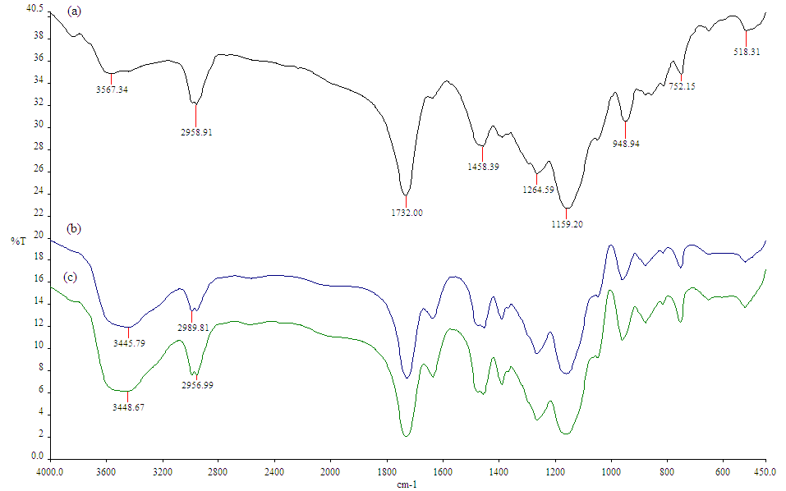

Figure 2: FTIR spectra of MIP (a) before washing, (b) after washing, (c) NIP.

Figure 3: Proposed interaction between monomer (methacrylic acid) and template (quinalphos).

Scanning electron microscopy (SEM) was used to determine the surface morphology and image of the MIP.Figure 4 shows SEM micrographs ofMIP at various magnifications which generally shows rough MIP surface with irregular pores.

(a)
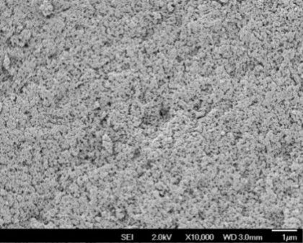

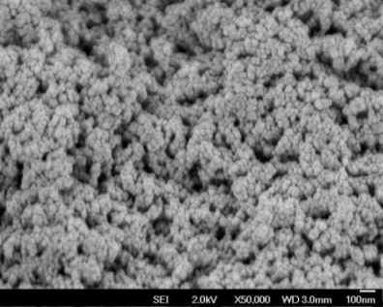
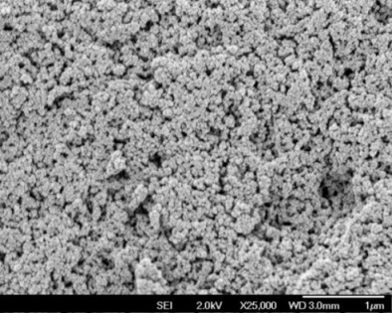
(b) (c)

Figure 4: The SEM images of MIP at differentmagnifications: (a) × 10,000, (b) ×25,000 and (c) ×50,000

Optimization of MIP-SPE procedure

In order to evaluate the imprinting affect and applicability of the MIPs for the extraction and determination of trace quinalphos, the MIP-SPE process was optimized by evaluating the washing solvent, volume of loading sample, andthe composition and volume of the eluting solvent to achieve good sensitivity and precision of this method.

Washing solvent

Thetype of the washing solution plays a vital role on the selectivity of the MIPs in order to maximize the specific interaction between analyte and binding site and to simultaneously discard matrix component in the polymer by decrease the non-specific interaction at binding site [8]. Samples (10 mL) containing 0.1 mgL⁻¹ quinalphos dissolved in water were loaded onto the cartridgesand washed with various solvent tested and eluted with10 mL of methanol-acetic acid (9:1, v/v) mixture solution. The concentration recoveries were determined by HPLC.

Since recognition is often best in the porogen solvent used in polymerization of the MIP [9], it was decided that acetonitrile (ACN)should be used as washing solvent in combination with water.Figure 5 shows the effect of washing with various percentage of acetonitrile in the acetonitrile-water mixtures(10, 20, 30, 40 and 50 %) on the recovery of quinalphos.The results showed that washing solvent containing up to20% acetonitrile in mixture had no significant effect on theretention of quinalphos on both MIP and NIP cartridges. However, with increased acetonitrile in the washing solutionsof 30%, the recovery of quinalphos in NIP cartridge was markedly decreased to 37.6%, while the recovery of quinalphos by the MIP cartridges was essentially not reduced (96.7% recovery). Thisindicates that the presence of specific interactions taking place in the binding sites. However, higher portions of acetonitrile in mixture solvent of >40% led to a large decrease of quinalphos retention both on the MIP and NIP cartridges due to the disruption of specific interactions between the analytes and binding sites. In this study, therefore, a mixture of acetonitrile-water 30:70% v/v was selected as washing solution.

Figure 5: Recovery of quinalphoswith different acetonitrile percentagesin washing solvent for MIP-SPE and NIP-SPE.

Elution solvent and volume

Samples (10 mL)containing 0.1 mgL⁻¹ quinalphos dissolved in water were loaded onto the cartridges, washed with 5 mL mixture of 30% acetonitrile in water, and eluted with different percentages of acetic acid in methanol (1, 5, and 10%). The concentration of the quinalphos was determined with HPLC at 200 nm wavelength of detection.Methanol was used as eluentsince it has the properties of having stronger hydrogen bond and the easy permeability of analyte in methanol that may induce efficient elution. The addition of a small percentage of acetic acid (1 to10%)in the mixture was applied in order to overcome strong interactions between analyte and the MIP and thus enhancing the enrichment factor.

In this experiment, pure methanol (0% acetic acid) was tested in order to confirm that acetic acid played an important role in desorbing quinalphos from the MIP in elution solvent. The results showed thatthe addition of acetic acid increased the analyte recovery and themost likely explanation was that acetic acid competed with quinalphos for the functional group in the binding sites (Figure 6). However, solvent with relatively high percentage (10%) of acetic acid apparently tend to decrease the analyte recovery.Thus, 5% of acetic acid in methanol was selected as optimal elution solvent for the following study.

Figure 6: Recovery of eluting solvent for MIP-SPE experiment.

In order to determine the optimum eluting volume, 5 mL of water sample spiked with 1 mgL⁻¹ quinalphos was percolated through MIP-SPE, and a different volumes (3, 6, 10 and 15 mL) of a mixture of methanol with 5% acetic acid were applied as eluting solvent and the elutes were analyzed by HPLC. The results showed thatincreasing solvent volume from 3 mL to 10 mL increased the recovery of selected analyte extracted (Figure 7).However, the analyte recoverystarted to decreased when15 mL of elution solvent was used. The use of 10 mL solvent volume showed highest recovery of quinalphos. Thus, 10 mL of methanol with 5% acetic acid was selected as the eluting solvent.

Figure 7: Recovery of different volume of eluting solvent for MIP-SPE

Experiment of the sample volume

In order to determine the optimum loading volume, experiments were carried out on using various sample volumes ranging from 5 mL to 50 mL and the extraction efficiency was investigated. It was found that the examined sample volumes, 5 mL, 10 mL, 15 mL, 25 mL and 50 mL, gave analyte recoveries of 61%, 92%, 45%, 29% and 16% respectively (Figure 8). It was noted that the highest recovery was observed when sample volume was at 10 mL.Hence, 10 mL was selected as the optimal sample volume.

Figure 8: Analyte recovery for different loading volume of sample MIP-SPE.

Determination of Organophosphorus Pesticides with HPLC

Determination of organophosphoros pesticides (quinalphos, diazinon, and chlorpyrifos) was carried out usingHPLC-UV as described in the procedure. The mobile phase consisted of acetonitrile-water (6:4, v/v) and the flow rate of the mobile phase was 0.4 mLmin⁻¹. The oven temperature was set at 60°С, the injection volume was 0.5 µL, and all compounds were detected at 200 nm. The method performance was evaluated by determination of linearity, sensitivity, repeatability, and accuracy of the method.

The linearity of calibration curves were obtained by the determination of the peak areas from analysis of 0.005 mgL⁻¹ to 0.15 mgL⁻¹ of each analyte and the all r-values were 0.999 (Table 1). The limit of detection (LOD), defined as the lowest analyte concentration with a signal-to-noise ratio of 3, were also investigated through the detection of spiked MilliQwater at serial concentrations. The results showed that the LODs were between 0.0063 mgL⁻¹ to 0.0076 mgL⁻¹, which indicated that this method could be used to detect the analytes in polluted water samples.

Table 1: Validation parameters for Molecularly Imprinted Polymer Solid Phase Extraction

Analytes | Correlation, r | Linear range (mgL⁻¹) | LOD  (µgL⁻¹) | LOQ  (µgL⁻¹) | RSD  (n=3)
Quinalphos | 0.994 | 0.01-0.15 | 6.67 | 20.22 | 1.96
Diazinon | 0.997 | 0.01-0.15 | 7.62 | 23.08 | 2.44
Chlorpyrifos | 0.995 | 0.01-0.15 | 6.33 | 19.27 | 1.89

Determination of OPPs in spiked water sample

The developed MIP-SPE method was applied for the enrichment of OPPs in river water samplesto demonstrate the applicability and reliability of this method. However, no target analyte was detected which suggested that there was no detectable OPPs in the river water sample. Thus, to assess matrix effects, river water samples were spiked and the extracted performance was evaluated. Figure 9showsHPLC tracings of the OPPs in river water before and after spiking at 0.1 mgL⁻¹. The results suggested that the matrix effect on MIP-SPE for river water sampleswas negligible.
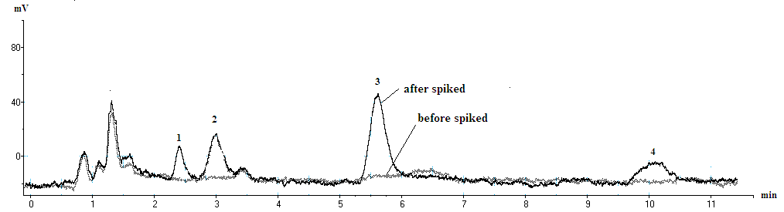

Figure 9: Chromatograms of river water sample before (grey line) and after spiked with 0.1 mgL⁻¹ of each analyte(black line). (1) diazinon, (2) hexaconazole (internal standard), (c) quinalphos, (d) chlorpyrifos.

Table 2: Recoveries (%) and precision (RSD) of OPPs in water samples spiked with 0.1 mgL⁻¹.

OPPs | MIP-SPE |  | NIP-SPE |  |  |  | C₁₈SPE
OPPs | Recovery  (%) | RSD  (n=3) |  | Recovery  (%) | RSD  (n=3) |  | Recovery  (%) | RSD  (n=3)
Quinalphos | 98.71 | 1.05 |  | 68.87 | 2.05 |  | 59.34 | 3.47
Diazinon | 90.25 | 1.39 |  | 65.75 | 2.67 |  | 57.59 | 1.50
Chlorpyrifos | 83.14 | 1.98 |  | 53.79 | 2.51 |  | 56.62 | 2.70

The analyte recoveries obtained using MIPs as the solid phase sorbent for quinalphos,diazinon and chlorpyrifoswere in the range between 83% and 98% for water sample (Table 2). The RSD values of the target analytes were excellent with values of <2%. However, the analyte recoveries obtained using NIP as the solid phase sorbent for target analytes in water sample were significantly lower with values only between 68% and 53%. Meanwhile, the extraction recoveries by usingC₁₈SPE as sorbent were below than 59% for all spiked OPPs compounds.

Comparison of the results from the enrichment methods studied (MIP-SPE, NIP-SPE, orC₁₈ SPE) clearly demonstrated the advantage of using molecularly imprinted polymers as selective sorbents for the determination of OPPs in water samples.

CONCLUSION

In this work, aquinalphos imprinted polymer was prepared by bulk polymerization using MAA, EDMA, and acetonitrile as functional monomer, cross linker, and porogen solvent, respectively. The imprinted polymers showed good selectivity and enrichment efficiency over non-imprinted polymer and commercial SPE-C₁₈. The MIP polymer used as adsorbents in SPE coupled with HPLC was successfully applied for the enrichment and analysis of OPPs in river water samples. High analyte recoveries (83-98%) and precision (1.05-1.98%) for the OPPs proved that the method was valid for the analysis of target analyte in water sample.

ACKNOWLEDGMENTS

The authors would like to thank UniversitiTeknologi Malaysia for facilitations and the Ministry of Higher Education Malaysia (MOHE) for financial support through Fundamental Research Grant Scheme Vote number 78477 and studentship for SyairahSalleh.

REFERENCES

[1] Pichon, V. and Hugon, F.C. (2008). Role of Molecularly Imprinted Polymer for Selective Determination of EnvironmentalPollutants–A Review.Anal.Chim. Act.622, 49.
[2] Gomes, R. andAugusto F. (2006).Sol–Gel Molecular Imprinted Ormosil for Solid-Phase Extraction of Methylxanthines.J.Chromatogr A.1114.216–23.
[3] Liu, H.Y., Wang, M.M., Liu, S.B., and Chen, Y. (2006).Chromatographic Characterization and Solid-Phase Extraction on Diniconazole-Imprinted Polymers Stationary Phase.React. Funct.Polym.66. 579–83.
[4] Baggiani C, Baravalle P, Giraudi G, and Tozzi C. (2007). Molecularly Imprinted Solid-Phase Extraction Method for the High Performance Liquid Chromatographic Analysis of Fungicide Pyrimethanil in Wine.J Chromatogr.A1141.158-64.
[5] Raharjo,Y., Sanagi,M.M., Wan Ibrahim, W.A., Abu Naim, A., andAboul-Enein, H.Y. (2009). Application of Continual Injection LPME Method Coupled with Liquid Chromatography to the Analysis of Organophosphorus Pesticides. J. Sep. Sci.32. 623.
[6] Sanagi, M. M., Salleh, S., Wan Ibrahim, W.A., and Naim, A. A. (2010). Molecularly imprinted polymers for solid phase extraction of orghanophosphorus pesticides.J. Fundamental Sci.,6. 27-30.
[7] Brune, B. J., Koehler, J. A., Smith, P. J. and Payne, G. F. (1999).Correlation between adsorption and small molecule hydrogen bonding.Langmuir. 15. 3989
[8] He, C.Y., Long, Y.Y., Pan, J.L., Li, K.A., and Liu, F. (2007).Application of Molecularly Imprinted Polymers to Solid-Phase Extraction of Analytes from Real Samples.J.Biochem.Biophys.Methods. 70. 133.
[9] Sellergren, B. (1999). Polymer and Template-Related Factors Influencing the Efficiency in Molecularly Imprinted Solid-Phase Extractions. Trends Anal. Chem.18.164.

