DETERMINATION OF ORGANOPHOSPHORUS PESTICIDES BY DISPERSIVE LIQUID-LIQUID MICROEXTRACTION COUPLED WITH GAS CHROMATOGRAPHY-ELECTRON CAPTURE DETECTION

(Penentuan Pestisid Organofosforus dengan Pengekstrakan Cecair-Cecair Serakan berganding dengan Kromatografi Gas-Pengesanan Penangkap Elektron)

MohdMarsin Sanagi,^{1,2*}SitiUmairah Mokhtar,¹Mazidatulakmam Miskam,¹ Wan Aini Wan Ibrahim^{1,2}

¹Department of Chemistry, Faculty of Science, UniversitiTeknologi Malaysia,
81310 UTM Johor Bahru, Johor, Malaysia

²Ibnu Sina Institute for Fundamental Science Studies, Nanotechnology Research Alliance,
UniversitiTeknologi Malaysia, 81310 UTM Johor Bahru, Johor, Malaysia

*Corresponding author: marsin@kimia.fs.utm.my

Abstract

A simple, rapid and sensitive method termed as dispersive liquid–liquid microextraction (DLLME) combined with gas chromatography-electron capture detector (GC-ECD) was developed for the determination of selected organophosphorus pesticides (OPPs) namely chlorpyrifos, dimethoate and diazinon in water sample. In this method, a mixture of carbon disulfide, CS₂ (extraction solvent) and methanol (disperser solvent) was rapidly injected using syringe into the 5.00 mL water sample to form a cloudy solution where the OPPs were extracted into the fine droplets of extraction solvent. Upon centrifugation for 3 min at 3500 rpm, the fine droplets were sedimented at the bottom of the centrifuge tube. Sedimented phase (1μL) was injected into the GC-ECD for separation and determination of OPPs. Important extraction parameters, such as type of disperser solvent, volume of extraction solvent and volume of disperser solvent were investigated. The optimized conditions for DLLME of the selected OPPs were methanol as disperser solvent, 30 μL of extraction solvent (CS₂) and 1.0 mL of disperser solvent (methanol). Under the optimum extraction conditions, the method showed good linearity in the range of 0.1 to 1.0 μg/mL with correlation coefficient (r²), in the range of 0.9976 to 0.9994 and low limits of detection (LOD) between 0.047 and 0.201 μg/mL. The proposed method provided acceptable recoveries (72.67- 144%) with good RSDs ranging from 2.74% to 7.48%. This method was successfully applied to the determination of OPPs in water samples obtained from a golf course and chlorpyrifos and diazinon were detected at concentration 0.18 μg/mL and 0.07 μg/mL, respectively.

Keywords: Dispersive liquid–liquid microextraction; GC-ECD; Organophosphorus pesticides

Abstrak

Satu kaedah yang mudah, cepat dan peka yang dikenali sebagai pengekstrakan cecair-cecair serakan (DLLME) yang digandingkan dengan kromatografi gas-pengesanan penangkap electron (GC-ECD) telah dibangunkan bagi penentuan pestisid organofosforus (OPPs) terpilih, iaitu kloropirifos, dimetoat dan diazinon dalam sampel air. Dalam kaedah ini, satu campuran karbon disulfide CS₂ (pelarut pengekstrakan) dan methanol (pelarut serakan) disuntik dengan cepat menggunakan picagari ke dalam sampel air 5.00 mL untuk membentuk larutan keruh di mana OPPs terekstrak ke dalam butiran halus pelarut pengekstrakan. Setelah pengemparan selama 3 min pada 3500 rpm, butiran halus itu termendak di dasar tabung pengemparan. Fasa termendak (1 1 μL) disuntik ke dalam GC-ECD) bagi pemisahan dan penentuan OPPs.Parameter pengesktrakan yang penting termasuk jenis pelarut serakan, isipadu pelarut pengekstrakan dan isipadu pelarut serakan telah dikaji. Keadaan optimum DLLME bagiOPPs terpilih ialah methanol sebagai pelarut serakan, 30 µL pelarut pengekstrakan (CS₂) dan 1.0 mL pelarut serakan (metanol). Di bawah keadaan optimum, kaedah ini menunjukkan kelinearan baik dalamjulat 0.1 hingga 1.0 μg/mL dengan koefisien korelasi(r²), dalam julatdari 0.9976 hingga 0.9994 dan had pengesanan(LOD) di antara 0.047 dan 0.201 μg/mL. Kaedah yang dicadangkan ini memberi pulangan yang baik (72.67- 144%) dengan sisihan piawai relatif (RSD) yang baik di antara 2.74% dan 7.48%. Kaedah ini telah berjaya diaplikasikan dalam pengesanan OPPs dalam sampel air yang diperolehi dari padang golf. Klopirifos dan diazinon telah dikesan masing-masing pada kepekatan 0.18 μg/mL dan 0.07 μg/mL.

Kata kunci:Pengekstrakan cecair-cecair serakan; GC-ECD; Pestisid organofosforus
INTRODUCTION

According to the status list of all active pesticide substances on the European Union (EU) market, more than 1100 pesticides are currently registered [1]. The pesticides industry is made up of companies, both multinational and local companies that are involved in manufacturing, formulating or trading activities. The majority of pesticides are imported as technical materials, which are then blended, diluted or formulated. Pesticides are widely used for agricultural activities due to their relatively low price and high effective ability to control pests, weeds, and diseases [2]. The increasing production of pesticides for agricultural and non-agricultural purposes has caused the pollution of air, soil, ground, and surface water which involves a serious risk to the environment and as well as human health due to either direct exposure or through residues in food and drinking water [3].

Organophosphorus pesticides (OPPs) are widely used in many countries for agriculture and pests control. OPPs (phorate, diazinon, disolfotane, methyl parathion, sumithion, chloropyrifos, malathion, fenthion, profenphose, ethion, phosalone, azinphose-methyl) are widely found in water resources. These pesticides are commonly use on golf courses in order to maintain the quality of the turfs.As the result, the caddies and green keepers often experience health problems due to the exposure to the evaporated chemicals and contaminated soil. In additions, the golfers themselves breathe in the toxins as they walk the course before the newly sprayed pesticides could settledown. The need for accurate determination of pesticides at the trace levels in the environmental samples is therefore obvious. With the improvement of self-safeguard consciousness and the development in analytical instruments, levels of pesticides in vegetables and fruitsare currently regulated by international and national organizations [4]and maximum residue levels (MRLs) have been established in many countries [5].

Sample preparation is normally required to isolate and concentrate compounds of interest from the sample matrix, before analysis [6]. Ultimately, the concentration of target compounds is enhanced (enrichment) and the presence of matrix components is reduced (sample clean up). In order to achieve a low detection limit, an enrichment step should be conducted prior to analysis [7].

Classical liquid-liquid extraction is considered to be a time-consuming and multistage operation, where problems of emulsion formation obstruct automation [8].The demand for automation in analytical liquid-liquid extraction (LLE) combines with a small amount or elimination of solvent has led to recent development of dispersive liquid-liquid extraction (DLLME). DLLME was first reported by Asadi and his co-workers in 2006 [1]. It is a novel liquid-phase microextraction technique which is based on a ternary component solvent system in which extraction solvent and disperser solvent are rapidly injected into the aqueous sample in a conical test tubeusing a syringe. The mixture is then shaken and a cloudy solution is usually formed in the test tube. After centrifugation, the fine particles of extraction solvent were sedimented in the bottom in the conical test tube. The resultant sedimented phase is taken with a microsyringe and injected into GC for analysis [1,9-10]. DLLME is a miniaturized LLE that uses microliter volumes of extraction solvent. The advantages of DLLME method are the simplicity of operation, rapidity, low cost, high-recovery, high enrichment factor, and environmental benignity, with wide application prospects in trace analysis.

In this work, DLLME was used for the extraction of OPPs namelychlorpyrifos, dimethoate and diazinon in water sample. The objectives of this study are to determine the effect of selection solvents, disperser solvents, volume of extraction solvent and volume of disperser solvents and to apply the optimum DLLME conditions in the analysis of OPPs in water sample.

EXPERIMENTAL

Chemicals and Reagents

The selected OPPs used in this research namely dimethoate, diazinon and chlorpyrifos(Figure 1) were analytical grade from Sigma-Aldrich (USA). Carbon disulfide used as an extraction solvent while methanol as a disperser solvent was purchased from Fluka, Switzerland. Doubly-distilled water used for preparation of aqueous solution at least 18MΩ was purified by Nano ultra-pure water system (Barnstead, USA).The standard stock solutions of 1000 ppm of the analytes were prepared in acetonitrile and were stored in fridge prior usage. The working standard solutions of lower concentrations were prepared by diluting standard stock solution with acetonitrile.

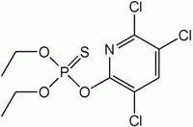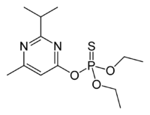
Diazinon
Chlorpyrifos

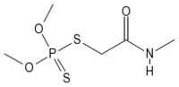
Dimethoate

Figure 1: Structures of selected organophosphorus pesticides.

GC-ECD Conditions

A Perkin Elmer XL gas chromatography (GC) equipped with an electron capture detector (ECD) (San Jose, United State) was employed for the analysis of pesticides. High purity of nitrogen gas use as carrier gas and make up gas. Ultra pure helium passes through a molecular sieve trap and oxygen trap was used as the carrier gas at constant velocity of 2.3 mL/min. The injection port was held at 250˚C and used in the splitless mode. Separation was carried out on a DB-5 capillary column, 30 m x 0.25 mm with 0.25 μm film thickness which also known as Ultra 2. The oven temperature programmed as follows: initial 150˚C (held 2 min) and then ramped at 4˚C min⁻¹ to 220˚C, held for 1 min and finally ramped at rate of 10˚C/min to 275˚C and held for 5 min. The ECD temperature was maintained at 300˚C.

Dispersive Liquid Liquid Microextraction Procedure

A 5 mL of doubly-distilled water was placed in a 10 mL screw cap glass test tube with conical bottom and spike the selected OPPs. Methanol (1 mL), as disperser solvent and 45.0 μL carbon disulfide (as extraction solvent) were injected rapidly into the sample solution by using a 1 mL syringe and the mixture was gently shaken. A cloudy solution (water/methanol/carbon disulfide) was formed in the test tube. In this step, the OPPs in water sample were extracted into the fine droplets of carbon disulfide. The mixture was then centrifuged for 3 min at 3500 rpm. After this process the dispersed fine droplets of carbon disulfide were sedimented in the bottom of test tube. Sedimented phase (1 μL) was withdrawn using 1 μL micro syringe (zero dead volume, cone tip needle) and injected into GC-ECD.

Sample Preparation

The optimum conditions for DLLME were applied for the analysis of water sample collected near the golf courses. The water sample was filtered through 0.45 µm Whatman nylon filter membrane to remove adhering particles and the sample was stored in refrigerator prior to use.

RESULTS AND DISCUSSION

Optimization of Extraction Conditions

In order to optimize the DLLME of OPPs from water samples, analytical factors that potentially affect sample were studied. The parameters involved were the selection of disperser solvent, volume of disperser solvent and volume of extraction solvent.

Selection of Disperser Solvent

In this research, two different disperser solvents were evaluated which are acetonitrile and methanol (Figure 2). Disperser solvent is soluble in extraction solvent and should be miscible in water, thus enabling the extraction solvent to be dispersed as fine particles in aqueous phase to form a cloudy solution (water/disperser solvent/extraction solvent). In such a case, the surface area between extraction solvent and aqueous phase (sample) can be definitely large, thus increasing the extraction efficiency [1]. The key point for the selection of disperser solvent is the miscibility in both the extraction solvent and the aqueous sample [11]. Therefore, methanol and acetonitrile were selected for this purpose of this study.

Figure 2 shows a series of sample solution was studied by using 1 mL of methanol, and acetonitrile containing carbon disulfide (as extraction solvent). According to the figure,methanol gave the highest peak area compared to acetonitrile. Thus, this indicates that methanol have high extraction efficiency to extract the compound from aqueous sample and was employed in the subsequent experiments.

Figure 2: Selection of disperser solvent for each OPPs studied.

Effect of Extraction Solvent Volume

The extraction solvent volume has great effects on the enrichment factor. With the increase of the extraction solvent volume, the final organic phase obtained by centrifugation is increased, resulting in a decrease of the concentration of the target analyte in organic phase.

In this research, the extraction solvent was fixed to carbon disulfide since other chlorinated solvent could damage the instrument. In order to examine that effect, different volumes of carbon disulfide were examined between 30, 45 and 60 μL. As depicted in Figure 3, as the volume of extraction solvent increased, the peak area decreased significantly. 30 µL of extraction solvent gave the highest peak area and providehigh enrichment factor and high sensitivity for the determination of OPPs. Therefore, 30 μL of carbon disulfide was chosen as optimum condition and utilized through out the subsequent experiments.

Figure 3: Effect of extraction solvent volume on the DLLME of OPPs.

Effect of Disperser Solvent Volume

To evaluate the effect of the dispersive solvent to enrichment factor, the volume of methanol was varied between 0.5 to 1.5 mL. As depicted in Figure 4, the peak area increased when the volume of methanol was increased to 1.0 mL. However, when the volume of the disperser solvent was increased to 1.5 mL, the peak area decreased. This result may be attributed to the increased solubility of the extraction solvent in the water as the volume of methanol increased. Thus, 1.0 mL of methanol was chosen as optimum and employed to all subsequent experiments.

Figure 4: Effect of disperser solvent volume on the DLLME of OPPs.

Method Validation

For validation of the DLLME method, optimized conditions (methanol as disperser solvent with volume of 1.0 mL, and volume of extraction solvent (CS₂): 30 µL) were used for the extraction of OPPs using DLLME. The correlation coefficient (r²), limit of detection (LOD) and limit of quantification (LOQ) of each pesticide are shown in Table 1. LOD represents the lowest concentration that can be detected by GC-ECD, which gives a signal-to-noise ratio of 3. Meanwhile, LOQ is known as the concentration of pesticides that produces a peak ten times higher than the noise level corresponding to signal to noise of S/N = 10.The LODs of the pesticideswere found to be 0.095 µg/mL for chlorpyrifos,0.266 µg/mL for diazinon and 0.085 µg/mL for dimethoate.The LOQs of the pesticides ranged from 0.283µg/mL to 0.888 µg/mL.

Table 1: Correlation coefficients, LOD and LOQ of selected OPPs using DLLME combined with GC-ECD.

OPPs studied | Correlation coefficient, r² | LOD (μg/mL) | LOQ (μg/mL)
Chlorpyrifos | 0.9994 | 0.095 | 0.318
Diazinon | 0.9976 | 0.266 | 0.886
Dimethoate | 0.9987 | 0.085 | 0.283

Real Sample Analysis

In order to investigate the applicability of the proposed trace enrichment microextraction method, the selected water sample was studied. The optimum conditions obtained in the optimization of DLLME was then applied to the determination of OPPs in water sample.

The water sample without spiking was analyzed in triplicate by the proposed method and the representative chromatograms can be seen in Figure 5. As depicted in the chromatogram, it can be seen that chlorpyrifos and diazinon were detected in the water sample with concentration of 0.18 μg/mL and 0.07 μg/mL respectively. This indicates that the selected OPPs were used in the area for the sample collection.
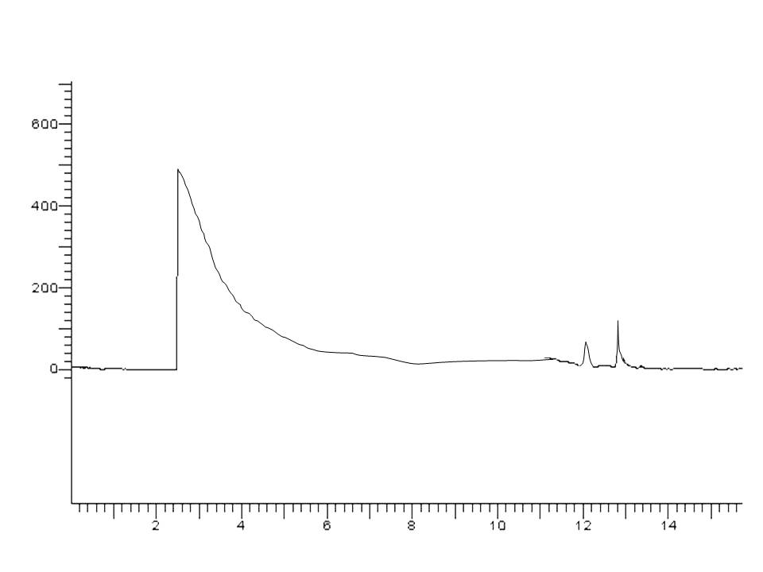
Time (min)
1
2
Solvent
Peak area (mAU)
Figure 5: GC-ECD chromatogram of OPPs in water sample obtained by DLLME under optimized conditions. Peaks: (1) chlorpyrifos, (2) diazinon.

To study the recoveries of the OPPs in the real sample, the water sample was spiked with 1.5 μg/mL of each OPPs. The recoveries were calculated for triplicate samples. Table 2 shows the relative recoveries of the spiked samples respectively. In general, the relative recovery ranged between 72% to 144% with RSD less than 8 %.In spiked technique, high recoveries in analysis of samples usually correspond to high accuracy. The relative recovery is calculated from percentage of standard pesticides spiked expected area by comparison with standard solution of pesticides at the same level.

Table 2: Percent recovery and relative standard deviation (RSD) of spiked water sample by DLLME

Analyte | Recovery (%) | RSD (%)
Chlorpyrifos | 72.67 | 2.74
Diazinon | 144 | 7.48
Dimethoate | 79 | 5.64

CONCLUSION

A method based on DLLME coupled with GC-ECD was developed for the determination of OPPs in water sample. The LOD was between 0.085 µg/mL and0.266 µg/mL while the LOQ was between 0.283 µg/mL and0.886 µgm/L. The recovery was in the range 72.67-144%. The relative standard deviations were in the range of 2.74-7.48%. The method has the merits of simplicity, low cost, and relatively short time for equilibrium extraction.

ACKNOWLEDGMENTS

The authors are grateful to UniversitiTeknologi Malaysia for the facilitations and Ministry of Science, Technology and Innovation (MOSTI) Malaysia and the Ministry of Higher Education (MOHE) Malaysia for financial supports through research grant vote number 78477.

REFERENCES

[1] Fu, L., Liu, X., Hu, J., Zhao, X., Wang, H., Wang, X., (2009). Application of Dispersive Liquid Liquid Microextraction for the Analysis of Triazophos and Carbaryl Pesticides in Water and Fruit Juice Samples.Anal.Chim.Acta,632, 289-295.
[2] Zang, X.H., Wu, Q.H., Zhang, M.Y., Xi, G.H., Wang, Z. (2009). Developments of Dispersive Liquid –Liquid Microextraction Technique.Chin. J. Anal. Chem.37, 161-168.
[3] Wan, H.B., Wong, M.K., Mok, C.Y. (1996). Pesticides in Golf Course Waters Associated with Golf Course Runoff. Environ.Contamin.Toxicol.,56, 205-209.
[4] Wan Ibrahim, W.A., Farhani, H.,Sanagi, M.M.and Aboul-Enein, H.Y. (2010).Solid phase microextraction using new sol–gel hybridpolydimethylsiloxane-2-hydroxymethyl-18-crown-6-coated ﬁber fordetermination of organophosphorous pesticides.J. Chromatogr. A.1217, 4890–4897.
[5] Zhao, E., Zhao, W., Han, L., Jiang, S. and Zhou, Z. (2007). Application of Dispersive Liquid Liquid Microextraction for the Analysis of organophosphorus Pesticides in Watermelon and Cucumber. J. Chromatogr. A.1175, 137-140.
[6] Xu, H., Liao, Y.and Yao, J. (2007). Development of a Novel Ultrasound-assisted Headspace Liquid-phase Microextraction and its Application to the Analysis of Chlorophenols in Real Aqueous Samples.J. Chromatogr. A. 1167, 1-8.
[7] Liu, X.; Chen. X.; Yang, S. and Wang, X. (2007).Comparison of Continuous-flow Microextraction and Static Liquid-phase Microextraction for the Determination of p-toluidine in Chlamydomonasreinhardtii.J. Sep. Sci.30, 2506-2512.
[8] Sanagi, M.M., See, H.H., Wan Ibrahim, W.A. andAbu Naim, A. (2007). Determination of pesticides in water by cone-shaped membrane protectedliquid phase microextraction prior to micro-liquid chromatography. J.Chromatogr. A, 1152, 215–219.
[9] Huan, Z.X, Hua, W.Q., Yue, Z.M., Hong, X.G.and Zhi, W. (2009). Developments of Dispersive Liquid-Liquid Microextraction Technique.Chin. J. Anal. Chem.37(2), 161-168.
[10] Xiong, J. and Hu, B. (2008). Comparison of Hollow Fiber Liquid Phase Microextraction and Dispersive Liquid-Liquid Microextraction for the Determination of Organosulfur Pesticides in Environmental and Beverages Samples by Gas Chromatography with Flame Photometric Detection.J. Chromatogr. A.1193, 7-18.
[11] Liu, Y., Ercheng, Z., Wentao, Z., Haixiang, G. and Zhiqiang, Z.(2009). Determination of Four Heterocyclic Insecticides by Ionic Liquid Dispersive Liquid–Liquid Microextraction in Water Samples.J. Chromatogr. A.1216, 885–891.

