PHOTOLUMINESCENCE OF POROUS SILICON PREPARED BY CHEMICAL ETCHING METHOD

Dwight Tham Jern Ee, Chan Kok Sheng and M.I.N. Isa*

Department of Physics, Faculty Science and Technology Universiti Malaysia Terengganu,
21030 Kuala Terengganu, Terengganu, Malaysia

*Corresponding author: ikmar_isa@umt.edu.my

Abstract
Recently, porous silicon (PS) was intensely studied by researcher due to its photoluminescence (PL), which has potential application in optoelectronic devices and sensor. In this work, the PS was prepared by chemical etching of p-type silicon wafer where the etchant consist of mixture of hydrofluoric acid (HF) and nitric acid (HNO₃). The PS was characterized by Scanning Electron Microscope (SEM) and Photoluminescence Spectrometer. The porosity of the PS was in the range of (49-80) % and it is dependent on etching time. The peak of the PL ranges from 636 nm to 640 nm and the intensity of PL increase proportionally with the etching time. Band gap energy of PS was higher than silicon (1.11 eV) which is from 1.93 eV to 1.95 eV and the blue shift of the PL peak observed as the porosity increases.

Keywords: Porous Silicon, Chemical Etching, Photoluminescence
Abstark
Baru-baru ini, penyelidikan poros silicon (PS) telah dijalankan dengan ketara atas sebab kebolehannya mengeluarkan fotoluminesen (PL) yang menjadikan PS berpotensi dalam aplikasi optoelektronik dan sensor. Dalam penyelidikan ini, PS dihasilkan dengan mengunakan cara punaran kimia atas silicon wafer jenis-p, dimana kandungan bahan punar itu terdiri daripada campuran asid hidrofluorik (HF) dan asid nitrik (HNO₃). PS telah dicirikan dengan mengunakan mikroskop imbasan electron (SEM) dan spektrometer fotoluminesen. Poros yang dihasilkan atas PS adalah dalam julat (49-80) % dan ia bersandar dengan masa punaran. Puncak PL berjulat dari 636 nm ke 640 nm dan keamatan PL meningkat secara bekadaran dengan masa punaran. Tenaga jurang jalur PS lebih tinggi daripada silicon (1.11 eV) iaitu dari 1.93 eV ke 1.95 eV dan anjakan biru di puncak PL dapat dilihat apabila keporosan PS meningkat.

Kata kunci : Silikon Poros, Punaran Kimia, Fotoluminesen

Introduction
Recently, porous silicon (PS) was intensely studied by researchers since it was reported for visible photoluminescence by Canham in 1990. According to Canham, porous silicon has potential application in optoelectronic and sensor [1]. Generally, there are two methods used to produce porous silicon namely electrochemical etching and chemical etching in the HF based solution. The difference between both method is chemical etching is performed etching without using external bias, which can be considered as a localized electrochemical process started chemically [2]. The etchant consist of HF and HNO₃ are used in the etching process. In chemical etching, anode and cathode site are formed on the etched surface which caused the local current to flow on the surface during the etching process. The oxidation process at the anode is proposed to be the dissolution of Si which forms Si²⁺ and Si⁴⁺, while the cathode reaction is a complex reduction of H⁺ which the hole injection process happened on the Si surfaces.[2,3]. Photoluminescence (PL) is a spontaneous emission of light from a material under optical excitation. The PL Spectrum produced by the material is able to be used to characterize the electrical parameters [4]. In this work, the PS was prepared by chemical etching method then the photoluminescence property, porosity and surface morphology were studied.

Experimental Method
The porous silicon was fabricated by using the light doped p-type silicon wafer, where the dopant was boron. The wafers were cleaned by using solvent clean method to remove oil and organic residue that is on its surface. In the cleaning process two solvents were needed which is acetone and ethanol. For acetone, it will leave it own residue; therefore, ethanol is used to clean off the acetone residue [5].Then, the silicon wafers were dipped in the prepared etching solutions which contain concentrated hydrofluoric acid (48%) and nitric acid (65%).
The etching time was fixed with the interval of 5 minutes. Five PS samples were prepared. After the etching, slow evaporation drying method was used to reduce the crack of the formed porous silicon by rinsing the sample with ethanol [6 ]. Then the sample is dried in the fume hood.

The PS surface was observed by using SEM and the elemental analysis on the surface of PS was analyzed by using Energy Dispersive Spectroscopy (EDS). The porosity of the PS was measured by using gravimetric method of the sample. Besides, the photoluminescence of the PS was characterized in the range of 500 nm to 800 nm by using photoluminescence spectroscopy system, model Jobin Yvon HR 800 UV. Then, from the PL spectrum, the energy gap was determined by equation (1):-
E_{gap} = $\frac{hc }{λ}$ (1)
where E_{gap} is energy gap of the PS, h is Planck constant, c is the speed of light and λ is the peak wavelength of the photoluminescence.

Results and Discussion
Porosity by Gravimetric Method
The weight of the sample, before and after etching was measured to determine the weight loss and the porosity of the sample. The obtained porosity, (%) shows that it was dependent on the etching time as depicted in Figure 1. The porosity of the PS produced by the chemical etching method is in the range between (49-80) %. Besides, the etching rate shows a gradual decrease with time. This might be due to the hindrance of the bubble produced during the etching process. As bubble formed on the sample surface, it reduces the surface area for etching process for a short moment before the bubble released from the sample surface. [7]

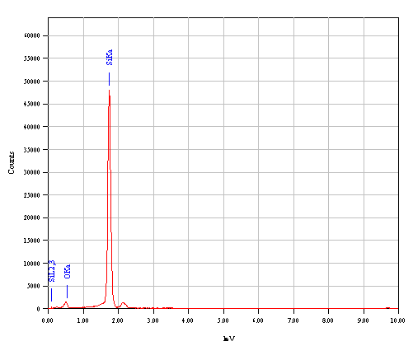
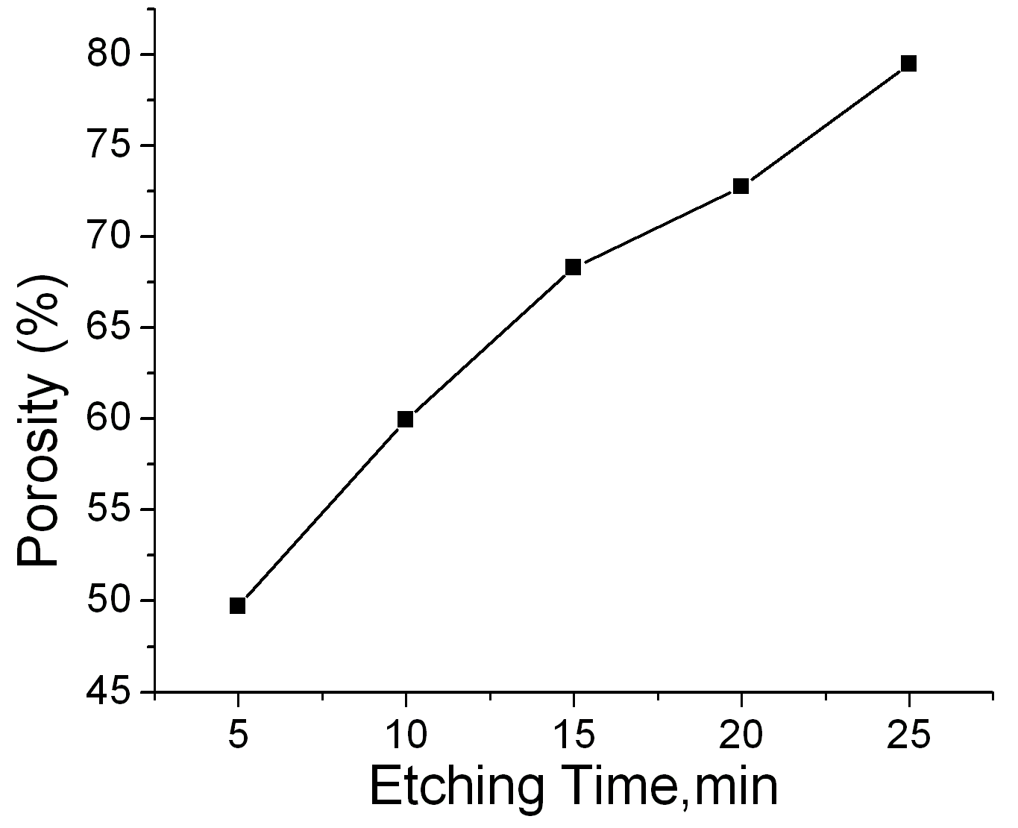

Figure 1: The Porosity of PS versus Etching Time Figure 2: The EDS spectra for PS

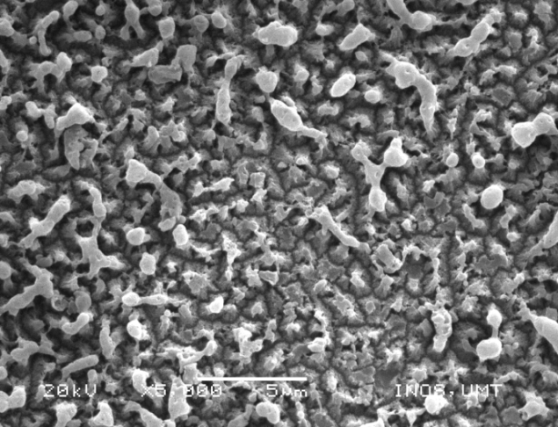
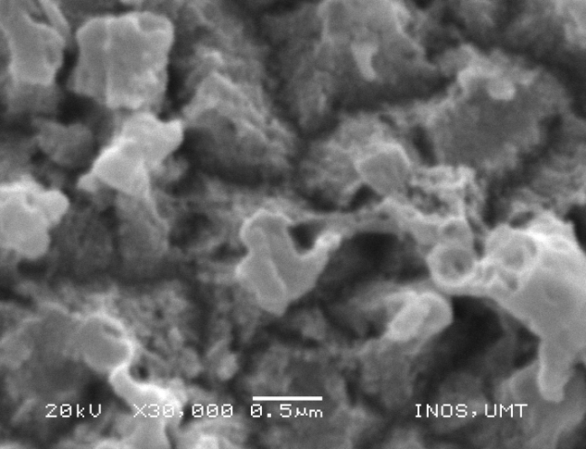

(a) (b)

Figure 3: SEM images of PS prepared at 5 minutes of etching time with magnification of (a) ×5000 and (b) ×30000

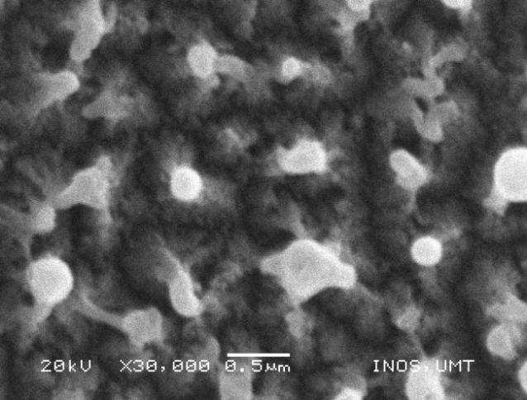
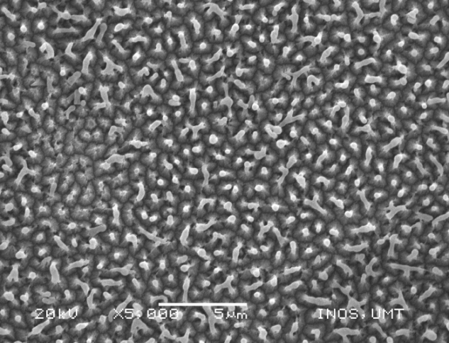

- (b)
Figure 4: SEM images of PS prepared at 25 minutes of etching time with magnification of (a) ×5000 and (b) ×30000

Surfaces investigation by SEM and EDS
The surface of the PS was investigated by using SEM, where it shows that after the chemical etching process, there is an obvious increase in surface area due to the formation of crystallites and pore population. The surface morphology of the PS after 5 minutes etching time as shown in Figure 3 was mixture of anisotropic crystallites and pores population. Such morphology was due to the frequent attacked of HF acid at the grain boundary. The superficial anisotropic crystallites are residue of etched layer. While in Figure 4, it depicts that, the surface morphology after 25 minutes etching time has smaller crystallites and pore population. The small crystallites are in cylindrical columnar shape as shown in figure 4b. The elemental analysis on the surface of the PS was performed by EDS. Figure 2 shows that the PS surface only consist of silicon and oxygen, for it can be concluded that most of the surface species of the PS contain Si-O bonds.

The Photoluminescence Properties and Energy gap by Photoluminescence Spectroscopy
The PL Spectrum, was obtained when the excitation wavelength is shorter than the emission wavelength. This is because shorter wavelength has higher energy to cause photoluminescence. The PS produced is able to illuminate visible light which fall in the range (636-640) nm as can be seen in Figure 5. Hence, orange red luminescence was observed from the PS. The PS is able to illuminate light because of the surface states and the quantum confinement that developed on the PS after the etching process.[1,8] From Figure 5 and Figure 6, it shows that the PL intensity increase with etching time. This is because PL intensity is affected by porosity or the total volume of crystallites on the surface of PS [9]. The information obtained from Figure 5 is used in plotting Figure 6 and Figure 7, so that it is able to show a better relationship between all parameters. A slight blue shift can be seen in the Figure 5 and Figure 7 as the etching time increase. This effect is due to the decrease of the cylindrical crystallites size and the pore population [10]. The energy gap was then calculated using equation 1 and plotted in Figure 8. The PS energy gap is definitely having higher energy gaps compare to Silicon (1.11eV) and it increases from (1.93 - 1.95)eV as etching time and porosity increased.

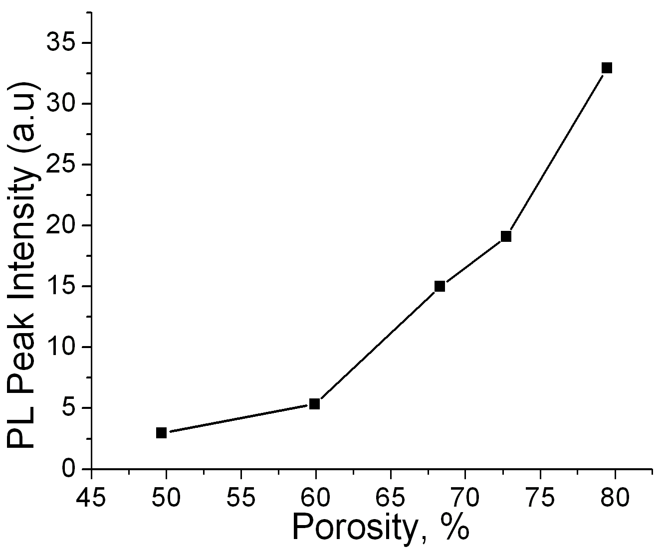
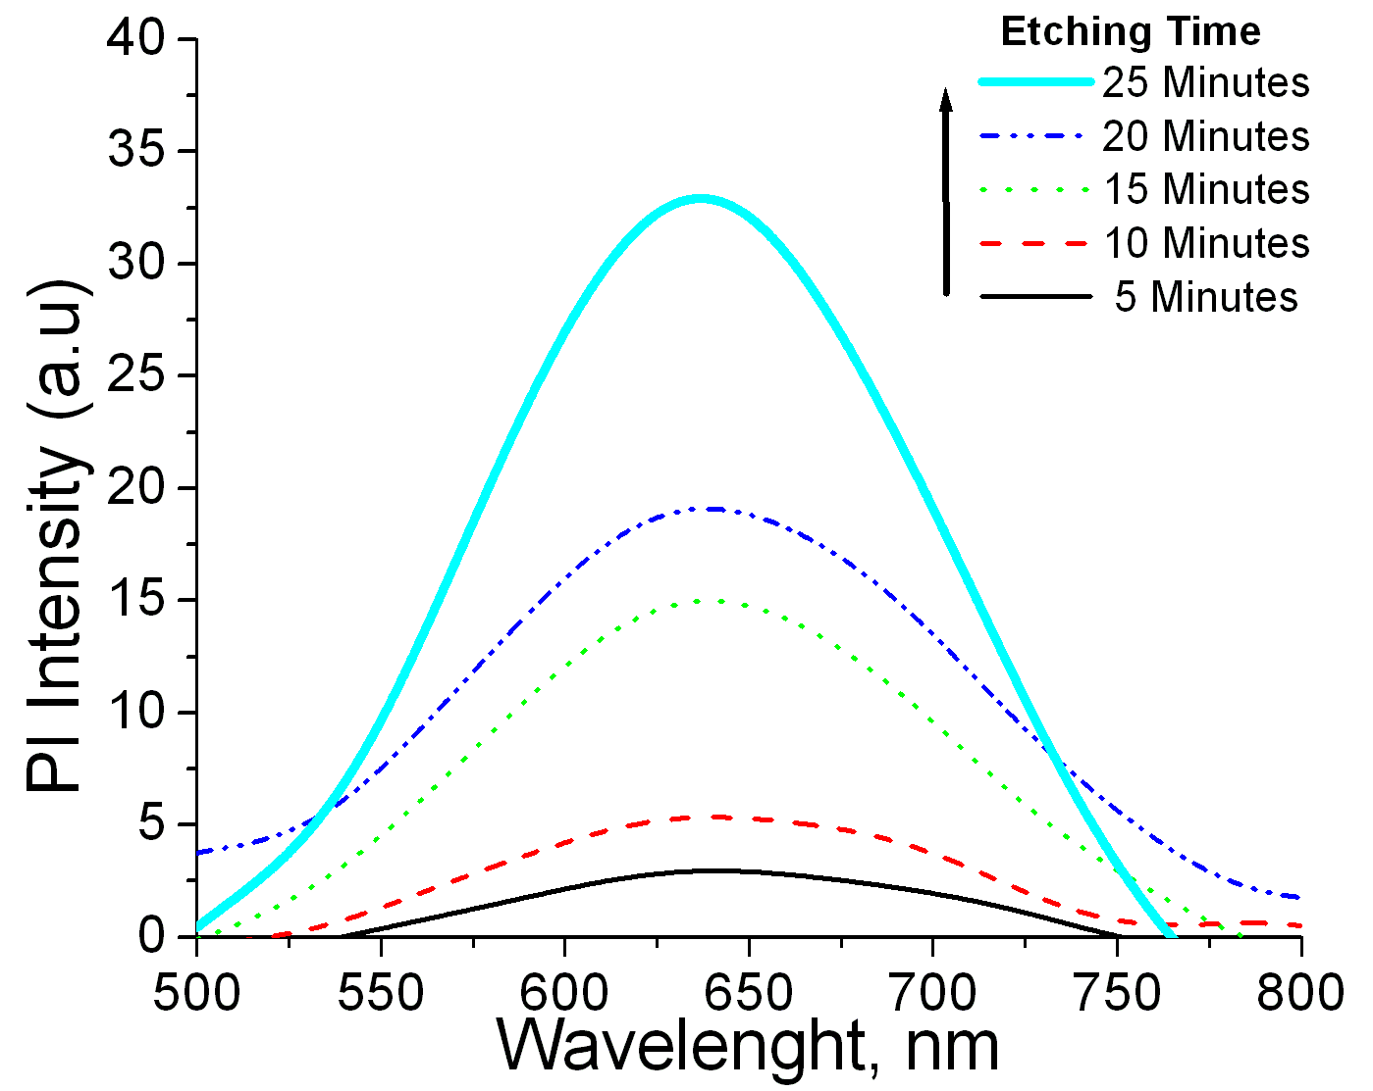

Figure 5: The Photoluminescence Spectrum of the PS Figure 6: Relationship between PL Peak Intensity and Porosity
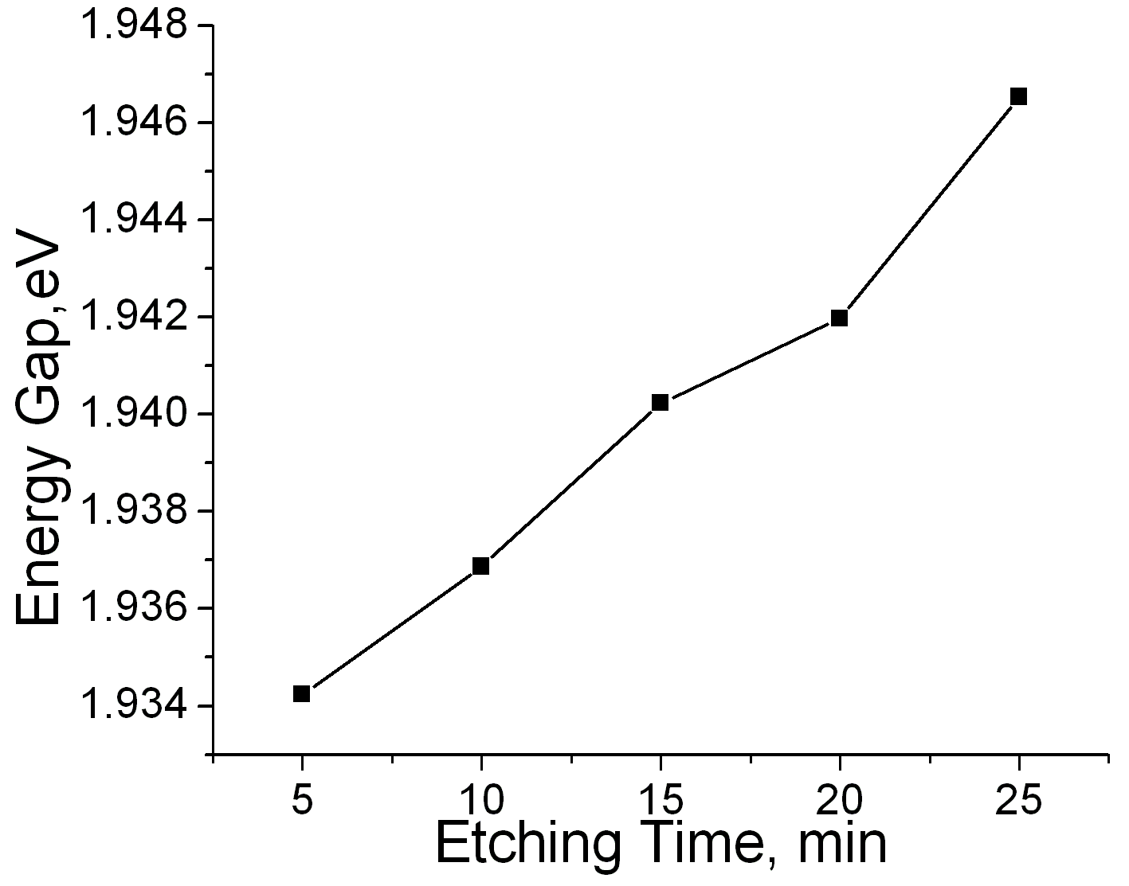
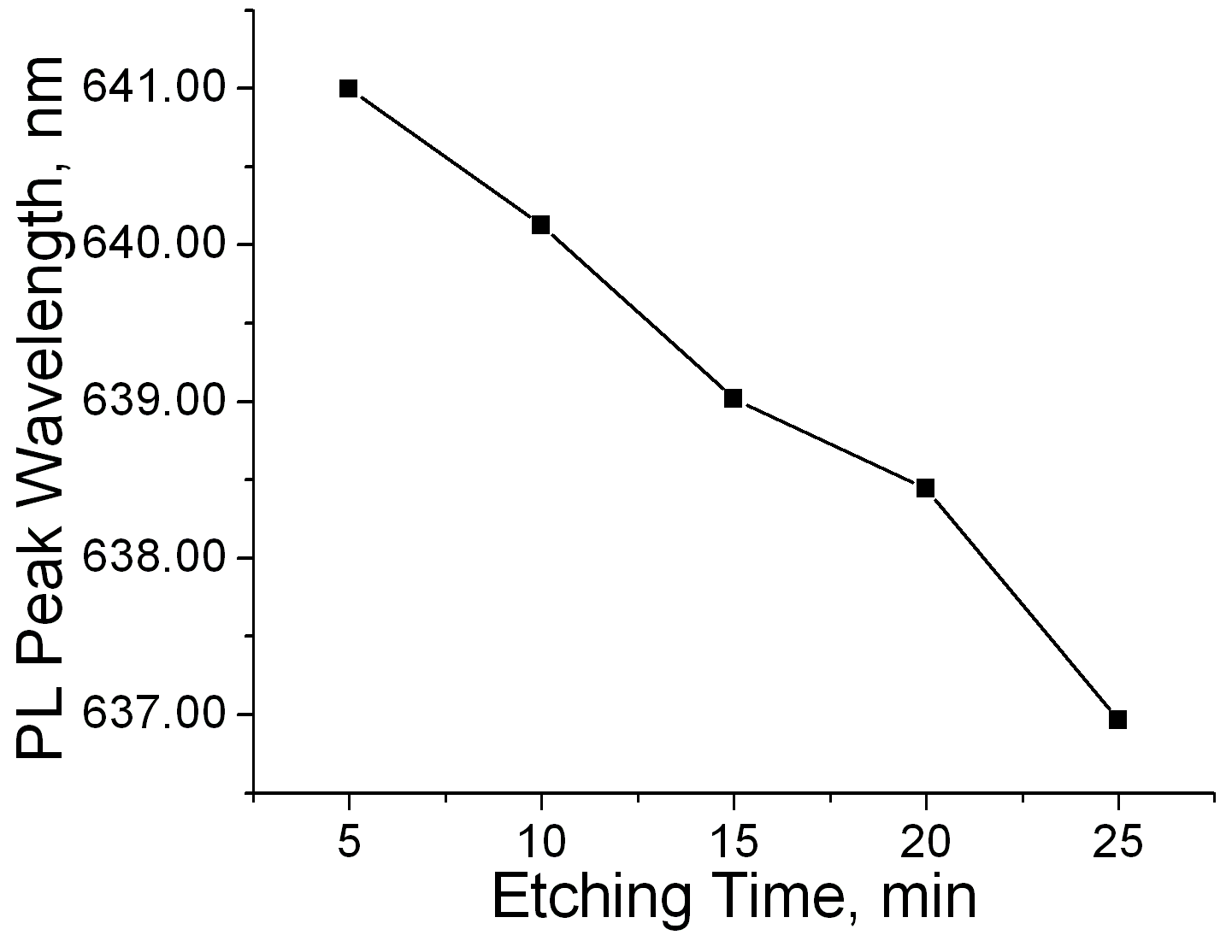

Figure 7: PL Peak wavelength against Etching Time. Figure 8: PS Energy Gap against Porosity

Conclusion
In conclusion, the PS has been successfully fabricated by chemical etching. The results obtain form chemical etching PS, show the effect of different etching time on the morphology, porosity, PL spectrum and energy gaps of the PS. The porosity formed by this method increases with etching time are in the range of (49-80) %. The crystallite size decreases with etching time, hence this behavior contributes to the blue shift and the increase of energy gaps. The PL produced by the PS is in orange red light.

Acknowledgement
The authors would like to thank Physical Sciences Department of University Malaysia Terengganu for the helps and financial support of this work.

References
[1] Canham, L.T. 1990. Silicon quantum wire array fabricated by electrochemical and chemical dissolution of wafers. Applied Physics Letter 57:1046-1048
[2] Lemus, R.G., Rodriguez, C.H., Hander, F.B. and Duart, J.M.M. 2002. Anodic and optical characterisation of stain-etched porous silicon antireflection coatings Solar Energy Materials & Solar Cell 72:495-501
[3] Shih, S., Jung, K. H., Hsieh, T. Y., Sarathy, J., Campbell, J. C., Kwong, D. L. 1992. Photoluminescence and formation mechanism of chemically etched silicon. Applied Physics Letters 60:1863
[4] Gfroerer, T.H. 2000. Photoluminescenc in Analysis of Surfaces and Interfaces. In Encyclopedia of Analytical Chemistry, ed. R.A. Meyer, pp 9209-9231. Chichester: John Wiley & Sons Ltd.
[5] Kern, W. 1993. Overview and Evolution of Semiconductor Wafer Contamination and Cleaning Technology. In Handbook of Semiconductor Wafer Cleaning Technology, ed. W. Kern, pp 3-57. Park Ridge, New Jersey: Noyes Publishing.
[6] Canham, L.T. 1997. ‘Drying of porous silicon’, in Properties of Porous Silicon, Institution of Engineering and Technology, London:43.
[7] Lehmann, V., Foll, H. 1990. Formation Mechanism and Properties of Electrochemically Etched Trenches in n-Type Silicon. Journal of the Electrochemical Society .137:653-658
[8] Lehmann, V., Gosele, U. 1991. Porous silicon formation: A quantum wire effect. Applied Physics Letters 58:856-858
[9] Kim, D.-A., Shim, J.-H., Cho, N.-H. 2004. PL and EL features of p-type porous silicon prepared by electrochemical anodic etching. Applied Surface Science. 234:256-261
[10] Gelloz,B. 1997. Possible explanation of the contradictory results on the porous silicon photoluminescence evolution after low temperature treatments. Applied Surface Science. 108:449-454.

