Extraction of Eu (III) in Monazite from Soils Containing ‘Amang’ Collected From Kg Gajah Ex-Mining Area
(Pengekstrakan Eu(III) dalam monazite daripada tanih mengandungi amang dari kawasan bekas lombong Kg. Gajah)

Zaini Hamzah¹, Nor Monica Ahmad^{1*}, and Ahmad Saat²

¹Faculty of Applied Sciences, Universiti Teknologi MARA (UiTM), 40450 Shah Alam, Selangor Darul Ehsan

²Institute of Science (IOS), Universiti Teknologi MARA (UiTM), 40450 Shah Alam, Selangor Darul Ehsan

*Corresponding author e-mail: normonica@gmail.com

ABSTRACT

Malaysia was once a major tin exporting country. One of the by-products of the tin-mining activities is tin-tailing which known as `amang` very rich in rare earth elements, especially the lanthanides which are present as a mixture of phosphate minerals, mainly as ilmenite, xenotime and monazite. In this study, Kg Gajah in Kinta Valley occupying the State of Perak was chosen as a study area, since this area used to be the largest mining area in the 60’s and 70’s. The soil samples were separated using wet separation technique followed by magnetic separation. The monazite was then digested using a mixture of HF/HNO₃ acids. The digested sample was extracted for its cerium content. The extraction behaviour of cerium in those samples has been investigated as a function of Cyanex 302 concentration in diluents and the time taken to reach the equilibrium. Extractant of bis(2,4,4-trimethylpentyl)-mono-thiophosphinic acid (Cyanex302) in n-heptane was used throughout the analysis. Aqueous phase from extraction was analyzed spectrometrically using Arsenazo (III) while organic phase was subjected to rotavapour followed by analysis by FTIR. The aim of this study is to have the best concentration for Cyanex302 in order to extract as much as possible of Europium and to confirm the transfer of Eu (III) to the Cyanex 302 as an extractant. Result from UV/VIS shows that 0.7 M is the best concentration of Cyanex 302 for the Eu (III) extraction from samples. Result from FTIR confirmed the structure of Cyanex302 has been replaced by Ce(IV).

Keyword: `Amang`, Rare earth elements (REE), Cyanex302, Arsenazo III

ABSTRAK

Malaysia pernah menjadi negara pengekspot timah yang utama. Salah satu dari hasil sampingan aktiviti lombong bijih timah ialah tahi bijih yang dikenali sebagai ‘amang’ yang kaya dengan unsur nadir bumi, terutamanya lantanid yang wujud sebagai campuran mineral fosfat, terutamanya ilminite, xenotime dan monazite. Di dalam kajian ini, Kg Gajah dalam kawasan Lembah Kinta di negeri Perak telah dipilih sebagai kawasan kajian, memandangkan kawasan ini pernah menjadi kawasan lombong timah terbesar dalam tahun 60an dan 70an. Sampel tanah diasingkan menggunakan teknik pemisahan basah dikuti dengan pemisahan magnet. Monozite kemudiannya dihadhamkan menggunakan campuran asid HF/HNO₃. Sampel yang telah hadham telah diekstrak kandungan europium nya. Sifat pengekstrakan europium di dalam sample tersebut telah dikaji sebagai fungsi kepekatan Cyanex 302 di dalam pelarut dan juga masa yang diambil untuk mencapai keseimbangan. Pengekstrak bis(2,4,4-trimethylpentyl)-mono-thiophosphinic acid (Cyanex 302) dalam toluen telah digunakan sepanjang analysis. Fasa akuas dari pengektrakan ini telah dianalisis secara spektrometri menggunakan Arsenazo (III), manakala fasa organik telah dikeringkan menggunakan rotavapour sebelum dianalisis menggunakan spektrometer FTIR. Objektif kajian ini adalah untuk mendapatkan kepekatan terbaik bagi Cyanex 302 untuk mengekstrak sebanyak mungkin europim, dan memastikan pemindahan Eu ke dalam Cyanex 302. Hasil analisis UV/VIS menunjukan bahawa 0.7 M adalah merupakan kepekatan terbaik Cyanex 302 untuk ekstraksi Eu dari sampel. Hasil analisis FTIR mengesahkan bahawa struktur Cyanex 302 telah pun digantikan oleh Ce(IV).

Kata kunci: ’Amang’, unsur nadir bumi, Cyanex 302, Arsenazo III

Introduction

Worobiec et al, [1] and Walsh [2] have reported that beach sand and rock is a mineral resources other than ex-mining area. However, former tin mining areas contained minerals which will be economically beneficial to the mineral industries. Tin ores were processed using a physical property (wet processing technique or smelting process) to recover the tin. ‘Amang’ is a widely accepted term in Malaysia for the heavy mineral rejects which remain after tin oxide (cassiterite) has been extracted from tin ore [3]. The remaining (‘amang’) were left there since not many people knew their uses. Nowaday, ‘amang’ is becoming more important since one can recover valuable heavy minerals from it. Some examples of heavy minerals are monazite ([Ce, La, Nd, Gd, Th] PO₄), zircon (ZrSiO₄), ilmenite (FeOTiO₂), xenotime (YPO₄) and struverite (Nb.Ta.TiO₂) which have various uses in minerals industries [4].

High grade (99.99%) europium oxide has important uses as red phosphor in television screen and in computer monitors, compact fluorescent light bulbs, X-ray and tomography scans, X-ray screen, high intensity mercury vapour lamps, neutron scintillations,charge particle detectors and optically read memory systems. Europhium is one of the least abundant of the rare earth elements, accounting for only 0.05-0.10% of thetotal rare earth content in its ores [5, 6].

Solvent extraction is generally used as the separation method for rare earth metals [7]. Extracting agents of industrial importance include tri-n-butyl phosphate, dimethyl heptyl methyl phosphonate, di (2-ethylhexyl) phosphoric acid, 2-ethylhexyl phosphoric acid mono 2-ethylhexyl ester, tetra decyl phosphoric acid and naphtenic acid [8]. Lanthanide elements are well chelated by phosphorous compounds such as phosphoric acid and phosphonic acid [9]. Cyanex302 consists of bis-(2,4,4-trimethylpentyl) mono-thiophosphinic acid, tris-alkylphosphine oxide, bis-(2,4,4-trimethylpentyl) phosphinic acid, bis-(2,4,4-trimethylpentyl)-dithiophosphinic acid, and other unknown components. A lot of work has been done on rare earth ion extraction from hydrochloric acid, nitric acid and sulfuric acid media using Cyanex302 as and extractant [10].

The use of organic dyes for the spectrometric determination of actinides including uranium, in various materials has been reported to be simple and selective. Among these, the sodium salt of Arsenazo-III has been reported to be more sensitive than other chromogenic reagents this type, such as Arsenazo-1and thorane. In other words, by specifying the pH it is possible to use Arsenazo-III very selectively. It is a commercial product, equally soluble in both water and dilutes mineral acids [11]. Arsenazo-III is a dye that forms a colored complex with europium in an acidic solution at pH 3.

A portion of the minerals were then extracted for the europium content within the minerals and the analysis was done using UV/VIS and FTIR. The aim of this study is to study the effect of Cyanex302 concentration to the extraction of Eu(III) in monazite type minerals, to confirm the ion exchange mechanism in solvent extraction and to validate the method used for the extraction procedure.

Experimental

The spectrophotometric analysis was performed on a UV/VIS spectrophotometer Perkin Elmer Lambda 35. Hanna Instrument pH213 microprocessor pH meter calibrated daily with pH 4.0 and 7.0 buffer were used to measure the acidity of solution and pH of buffer. About 40 mg of monazite was digested using sand bath using a mixture of HF:HNO₃ until the sample is turning to yellowish clear solution.. To make sure that the solutions are free from the undissolved particulates, it was then brought to the centrifuge for 2000 rpm within 7 minutes and filtered before diluted to 50.0 mL of volumetric flask. A 20.0 mL aliquot of prepared sample was pipette to the 100.0 mL of volumetric flask together with 10 mL of buffer, 10 mL NaCl and was top up with sodium citrate to the required volume for pH adjustment. Cyanex302 in n-heptane and toluene were used as extractants which were set at 0.1, 0.3, 0.4, 0.5, and 0.7 M for the organic phase. Sodium citrate and citric acid were used as a buffer while NaCl used to maintain the ionic strength of solution. Mixtures of organic and aqueous phases were shaken in the separating funnel for 5 minutes and allowed to reach the equilibrium within 5 minutes, 15 minutes and 30 minutes each. Then 0.05 % w/v of Arsenazo (III) was added to the aqueous phase for the spectrometry analysis by UV/VIS spectrometer.

Calibration
Working solution of europium was made by diluting the stock solution to the 0.1, 0.2, 0.3, 0.5, 0.7 and 0.8 for the calibration curve.

Recovery
A recovery test was performed using a known amount of analyte added to be sample and the analysis then performed and after the addition so that the amount received can be calculated [12, 13].

Extraction Eu(III) from Heavy Minerals
The pure europium was prepared in an aqueous phase and extracted using Cyanex302 diluted in toluene. Varying the concentrations of Cyanex302, we will find the best Cyanex302 concentration which extract most Eu(III) into the organic phase. The amount of Eu(III) extracted was measured by the concentration Eu(III) left in the aqueous phase. This concentration was determined using UV/Vis spectrometer by adding Arsenazo (III) into the aqueous phase to produce the colour which is related to the concentration of Eu(III) in the sample.

Results and discussion

Calibration and Linearity
The standard solution was prepared in de-ionized water and buffer (citric acid/sodium citrate pH 2.2) to maintain pH ant 2.2 and 3 for toluene and n-heptane respectively. Figure 1a and 1b show the calibration curve for standard addition methods, respectively. The correlation coefficient for the calibration curve is 0.9967 while the correlation coefficient for the standard addition method is equal to 1 which is considered as a good linearity. Both curves can be used for estimating the concentration of Eu in the solution.

- b)
Figure 1: Linearity of the study represents by (a) Calibration curves and (b) standard addition method

Recovery
Table1 show the recovery of the laboratory fortified blank and laboratory fortified matrix. Laboratory fortified blank gives recovery in the range of 100.00 to 108.57 percent. The recoveries of fortified matrix range from 82.30 to 110.45.

Table 1: The percent recovery for laboratory fortified blank of sample spiked with standard europium
Spiking level (ppm) | Fortified Blank  % Recovery | Fortified Matrix  % Recovery
0.11 | 100.00 | 110.45
0.21 | 102.86 | 94.30
0.31 | 108.57 | 97.72
0.41 | 102.86 | 96.24
0.51 | 108.57 | 82.30

Eu (III) extraction: Extraction as a function of pH
Figure 2 shows the extraction of europium as a function of the pH. Figure 2(a) shows the extraction of different pH using n-heptane as Cyanex302 diluents. It can be seen that the highest distribution ratio which lead to the highest percent extraction is at pH 3. However for the extraction using toluene as diluent, the highest distribution ratio is at pH 2.2. This pH value agreed with Ohashi et al, [7] finding, that is at pH 2.2, it could extract higher amount of europium even though their study is using cloud point extraction by di(2-ethylhexyl)phosphoric acid and Triton X-100.

(a) (b)
Figure 2: Effect of pH on the distribution ratio of Europium by (a) n-heptane (b) toluene

Nature of the extracted species
The nature of the extracted complex species was analyzed using the Log D versus Log C plots as suggested by Sarkar et al, [14, 15] and Ajgaonkar et al, [16]. In this study, the plot of log D versus log C as shown in Figure 3, show slopes of 1.876, 1.699 and 2.633 for 5, 15 and 30 minutes, respectively. However, the percent extraction was found greater in 15 minutes equilibrium time, thus indicating the best equilibrium time for europium extraction is 15 minutes.

(a) (b)

(c)
Figure 3: Plots of log D versus log C at various equilibrium time

The concentrayion of Cyanex302 were found to affect the amount of europium extracted from the aqueous phase. The higher the Cynex302 concentration, the more the europium ion will be transfered to the organic phase.

Table 2: Effect of equilibrium time to the extraction of europium
Concentration of extractant | 5 minutes  (%) | 15 minutes  (%) | 30 minutes  (%)
0.1 ppm | 14.13 | 24.74 | 0.97
0.3 ppm | 43.00 | 51.12 | 33.10
0.4 ppm | 78.44 | 64.24 | 51.45
0.5 ppm | 72.56 | 82.35 | 67.96
0.7 ppm | 85.54 | 90.82 | 44.65

Distribution coefficient of Eu(III) increases with the increase of concentration of the extractant [17]. In other study, it was found that a decrease in the concentration of Cyanex302 will give lower disribution ratio values [14, 15].

Extraction of Eu (III) from monazite samples
Table 3 shows the percent europium being extracted from two monazite samples (from Kg Gajah and Beh Minerals Sdn. Bhd., Perak) done in duplicates. It seems that the amount of europium extracted (in percent) from these monazites are comparable.

Table 3: Percent extraction of europium from duplicates samples
Sample | Amount Extracted (%)
Kg. Gajah 1 | 64.89
Kg. Gajah 2 | 62.20
Beh Minerals Sdn Bhd 1 | 50.03
Beh Minerals Sdn Bhd 2 | 57.78

Spectroscopy analysis
The replacement of other element by europium in Cyanex302 can be proved by analysis with IR spectroscopy as shown in Figures 4a and 4b. This is well agreed by Ramachandran et al, [18], Muhammad Idiris Saleh et al, [19], Francis et al, [20] Biswas et al, [21, 22].

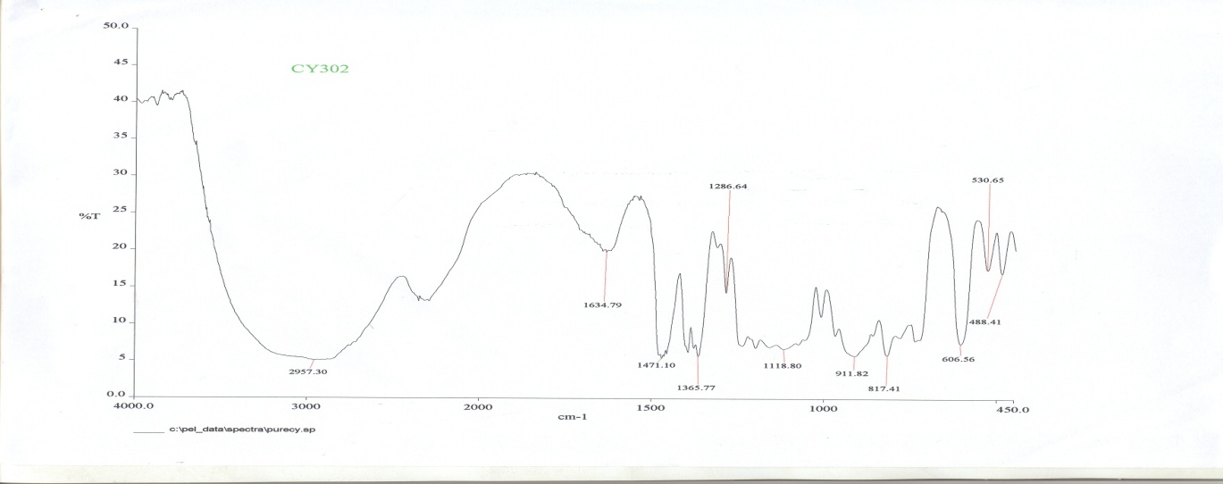
Figure 4a: FTIR spectrum of pure Cyanex302

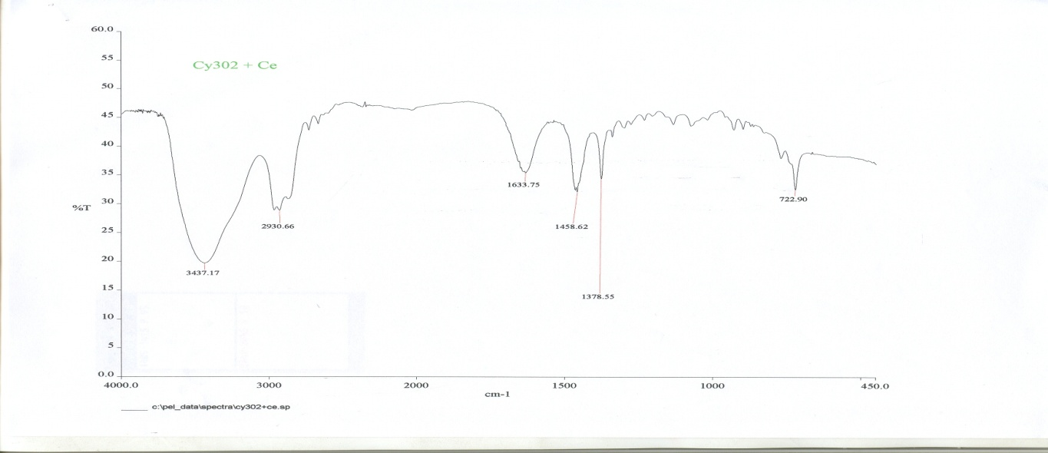
Figure 4b: FTIR spectrum of Eu-Cyanex302 complex

The IR spectra of europium complex with Cyanex302 and pure extractant were analyzed for a comparison. Cyanex302 spectrum shows two absorption bands at about 2950 cm⁻¹ and 2280 cm⁻¹ which indicates that the acids contains characteristics P(S)OH group. The bands at 750 and 905 cm⁻¹ indicate the P=S group and P-O stretching vibration in the P-O-H bond, respectively. In the spectra of Eu-Cyanex302 complex, the bands due to P(S)OH group are absent. These observations suggests when Cyanex302 molecule forms a complex with europium, the hydrogen atom of P-O-H is displaced by other ion [23].

Conclusion

Increasing the extractant concentrations will result in a better distribution ratio, D. It extracts more Eu(III) from monazite samples. The best concentration of Cyanex 302 for Eu(III) extraction in this study is 0.7 M at pH 2.2 for 15 minutes equilibrium time.

Acknowledgement

The authors would like to thank RMI (UiTM) and Faculty of Applied Sciences UiTM for the support given and MOSTI for funding this project under Science Fund (03-01-01-sf0084).

References:

[1] Worobiec, A., Stefaniak, E.A., Potgieter-Vermaak, S., Sawlowicz, Z., Spolnik, Z., Van Grieken, R. (2007). Characterisation of concentrates of heavy mineral sands by micro-Raman spectrometry and CC-SEM/EDX with HCA. Applied Geochemistry, 22, 2078-2085

[2] Walsh, J.A. (2007). The use of scanning electron microscope in the determination of the mineral composition of Ballachulish slate. Materials Characterization, 58, 1095-1103.

[3] Hu, S. J., Kandaiya, S. and T.S. Lee (1995). Studies of the radioactivity of amang effluent. Applied Radiation and Isotopes, 46, 147-148.

[4] Zaini Hamzah, Nor Monica Ahmad and Ahmad Saat (2009). Determination of heavy minerals in “amang“ from Kampong Gajah ex-mining area. The Malaysian J. Analytical Sciences, 13(2), 184-203.

[5] Morais C.A. and Ciminelli V.S.T. (1998). Recovery of europium from a rare earth chloride solution. Hydrometallurgy 49, 167-177.

[6] Morais C.A. and Ciminelli V.S.T. (1998). Recovery of europium by chemical reduction of a commercial solution of europium and gadolinium chloride. Hydrometallurgy 60, 247-253.
.
[7] Ohashi A., Hashimoto T., Imura H. and Ohashi K (2007). Cloud point extraction equilibrium of lanthanum (III), europium (III) and lutetium (III) using di(2-ethylhexyl)phosphoric acid and Triton X-100. Talanta 73, 893-898.

[8] Redling K (2006). Rare earth elements in agriculture with emphasis on animal husbandry. PhD thesis Ludwig-Maximilians-UniversitatMunchen, Germany.

[9] Gracia Valls, R. Hrdlicka, A. Perutka, J. Havel, J. Deorka, N. V. Tavlarides, L. L. Munoz, M. and Valiente, M. (2001). Separation of rare earth elements by high performance liquid chromatography using a covalent modified silica gel column. Analytica Chimica Acta, 439, 247-253.

[10] Wu, D. Xiong, Y. Li, D. and Meng, S. (2005). Interfacial behavior of Ctanex302 and kinetics of lanthanum extraction. Journal of Colloid and Interface Science, 290, 235-240.

[11] Khan, M. H. Warwick, P. and Evans, N. (2006). Spectrometric determination of uranium with arsenazo III in perchloric acid. Chemosphere, 61, 1165-1169.

[12] Gioia, M. G. Di Pietra, A. M. and Gatti, R. (2002). Validation of spectrometric method for determination of iron (III) impurities in dosage form. Journal of Pharmaceutical and Biomedical Analysis, 29, 1159-1164.

[13] Md. Pauzi Abdullah and Mohamad Nasir Othman (2007). Validation of an extraction technique based on Tributyl Phosphate for the determination of Pb(II) in water, The Malaysian Journal of Analytical Sciences, 11(2), 361-369.

[14] Sunil G.S. and Puroshattam M.D. (1999). Solvent extraction separation of antimony (III) and bismuth (III) with bis(2,4,4-trimethylpentyl) monothiophosphinic acid (Cyanex 302). Separation and Purification Technology, 15, 131-138.

[15] Sunil G.S. and Puroshattam M. D. (2000). Solvent extraction separation of Gold with Cyanex 302 as extractant. Journal of the Chinese Chemical Society, 47, 869-873.

[16] Ajgaonkar, H.S. Puroshattam, M.D (1997). Solvent extraction separation of iron (III) and aluminium (III) from other elements with Cyanex 302. Talanta. 44, 563-570.

[17] Zhifeng Z, Hongfei L, Fuqiang G, Shulan M, Deqian L. (2008). Synergistic extraction and recovery of Cerium (IV) and Fluorin from sulfuric solutions with Cyanex 923 and di-2-ethylhexyl phosphoric acid. Separation of Purification Technology, 63, 348-352.

[18] Ramachandran Reddy, B. Rajesh Kumar, J. Phani Raja, K and Varada Reddy, A. (2004). Solvent extraction of Hf(IV) from acidic chloride solutions using Cyanex 302. Minerals Engineering, 17, 939-942.

[19] Muhammad Idiris Saleh, Md. Fazlul Bari, Bahruddin Saad. (2002), Solvent extraction of lanthanum(III) from acidic nitrate-acetato medium by Cyanex 272 in toluene. Hydrometallurgy, 63, 75-84.

[20] Tania F, Prasada Rao, T. Reddy, M.L.P. (2000). Cyanex 471X as extractant for the recovery of Hg(II) from industrial wastes. Hydrometallurgy, 57, 263-268.

[21] Biswas, R.K. and Begum, D.A. (1998). Solvent extraction of tetravalent titanium from chloride solution by di-2-ethylhexyl phosphoric acid in kerosene. Hydrometallurgy,49, 263-274.

[22] Biswas, R.K. and Begum, D.A. (1998). Solvent extraction of Fe³⁺ from chloride solution by D2EHPA in kerosene Hydrometallurgy, 50, 153-163.

[23] Reddy B. R, Kumar J. R. Raja K.P. and Reddy A. V (2004). Solvent extraction of Hf(IV) from acidic chloride solution using Cyanex302. Minerals Engineering, 17, 939-942.

