IONIC LIQUID SUPPORTED ACID-CATALYSED ESTERIFICATION OF LAURIC ACID

(Mangkin Asid Disokong pada Cecair Ionik Sebagai Mangkin dalam Tindak Balas Pengesteran Asid Laurik)

Zalita Yaacob^{1*}, Nor Asikin Mohd Nordin², and Mohd Ambar Yarmo¹

¹School of Chemical Science and Food Technology, Faculty of Science and Technology, Universiti Kebangsaan Malaysia, 43600 Bangi, Selangor Darul Ehsan, Malaysia.

²Department of Science, UTM SPACE, Universiti Teknologi Malaysia International Campus Jalan Semarak, 54100 Kuala Lumpur, Malaysia.

*Corresponding author : zalita_y@yahoo.com

Abstract
Ionic Liquid (IL) based on 1-n-butyl-3-methylimidazolium bis(trifluoromethylsulfonyl)imide (BMI.NTf₂) under acidic condition was used as catalyst for the esterification reaction of fatty acid. Various acids namely sulphuric acid, perchloric acid, p-toulene sulphonic acid and various chloride salts such as zinc chloride (ZnCl₂) and iron(III) chloride (FeCl₃) immobilized in ionic liquid BMI.NTf₂ gave acidic ILs. These acidic ILs were tested as catalysts for esterification reactions. Esterification of alcohol (methanol) with fatty acid (lauric acid) using ionic liquid BMI.NTf₂ combined with H₂SO₄ (BMI.NTf₂(H₂SO₄)) gave high activity (>85%) and selectivity (100%) observed over a period of 2 hours reaction with reaction temperature 70ºC. The ester became easily separated due to IL forming biphasic with product after the reaction where ester accumulated as the upper phase and IL with water produced after reaction at lower phase. Catalytic activities comparison also be studied between acidic ionic liquid BMI.NTf₂ with acidic ionic liquid ChCl.2ZnCl₂ and conventional acid catalyst. These ILs were characterised by using FTIR, NMR and TGA. Results from FTIR were showed no significant difference between ILs with ILs in acidic condition. The TGA curve show BMI.NTf₂ thermal's decomposition is ≥400ºC but when BMI.NTf₂ combination with H₂SO₄, TGA curve show weight loss increase and becomes unstable. The advantages of ILs as catalyst are “clean process” and “green chemistry” due to its behaviour such as non-volatile, no loss of solvent through evaporation and reduced environmentally impact. This ILs-catalyst system can be recycle for futher reaction.

Keywords: 1-n-butyl-3-methylimidazolium bis(trifluoromethylsulfonyl)imide; Choline chloride; Ionic liquids; Acidic condition; Esterification; Fatty acid

Abstrak
Cecair ionik (IL) berdasarkan 1-n-butil-3-metilimidazolium bis(triflorometilsulfonil)imida (BMI.NTf₂) dalam keadaan berasid digunakan sebagai mangkin dalam tindak balas pengesteran asid lemak. Pelbagai asid seperti asid sulfurik, asid perklorik, asid p-toulena sulfonik dan pelbagai garam klorida seperti zink klorida (ZnCl₂) dan ferum klorida (FeCl₃) dipegunkan pada cecair ionik BMI.NTf₂ menjadikannya ILs berasid. ILs berasid ini diuji sebagai mangkin dalam tindak balas pengesteran. Tindak balas pengesteran alkohol (metanol) dengan asid lemak (asid laurik) menggunakan cecair ILs BMI.NTf₂ kombinasi bersama H₂SO₄ memberikan aktiviti yang tinggi (>85%) dan selektiviti yang tinggi (100%) yang mana diperhatikan pada 2 jam tindak balas pada suhu tindak balas 70ºC. Produk ester yang terhasil dapat dipisahkan dengan mudah kerana ILs membentuk bifasa dengan produk selepas tindak balas di mana ester terkumpul pada fasa atas manakala cecair ionik dan air yang terhasil pula terkumpul pada fasa bawah. Perbandingan aktiviti-aktiviti mangkin juga dikaji antara IL BMI.NTf₂ berasid dengan IL ChCl.2ZnCl₂ berasid dan mangkin asid konvensional. ILs ini kemudiannya dicirikan dengan menggunakan FTIR, NMR dan TGA. Keputusan yang didapati daripada FTIR menunjukkan tiada perbezaan antara ILs dengan ILs dalam keadaan berasid. Keluk TGA menunjukkan penguraian terma BMI.NTf₂ adalah ≥400ºC tetapi apabila kombinasi BMI.NTf₂ bersama H₂SO₄, keluk TGA menunjukkan kehilangan berat meningkat dan menjadi tidak stabil. Kelebihan menggunakan ILs sebagai mangkin adalah kerana ILs ini merupakan “proses bersih” dan “kimia hijau” kerana sifatnya yang tidak meruap, tiada kehilangan pelarut melalui penyejatan dan mengurangkan kesan kepada alam sekitar. Sistem mangkin-ILs ini boleh diguna semula untuk tindak balas berikutnya.

Kata kunci: 1-n-butil-3-metlimidazolium bis(trifluorometilsulfonil)imida; Kolin klorida; Cecair ionik; Keadaan berasid; Pengesteran; Asid lemak

Introduction
Esterification of alcohol with fatty acid is the most important reaction in oleochemical industry. The products, fatty acid esters are used as raw material for emulsifiers or as oiling agents for foods, lubricants for plastics; spin finishes and textiles; paints and ink additives and for mechanical processing; surfactants; personal care emollients and base materials for perfume; Japanese candles, etc [1,2]. Esterification reaction usually uses conventionally homogeneous catalyst such as sulphuric acid, p-toulene sulphonic acid or phosphoric acid. There are problems when using conventional catalyst where these acid catalysts are toxic, corrosive, involve expensive separation, hard to remove from product, require large volumes of salt waste during neutralization of homogeneous acid and gave environmentally effect [1,2,3,10].

Ionic liquids (ILs) are liquids referred to a new class of solvents that consists only of ions. Ionic liquids also a green reaction media (catalyst + solvent) [3,4,5]. The using of ILs as a catalyst in esterification reaction will solve the problems of using conventionally homogeneous catalysts. This is because, the special characteristics of ionic liquids which are non-volatile, negligible vapour pressure, hence are not volatile to the environment after evaporation ensure ionic liquids to be more environmentally friendly or clean process (green chemistry) [3,5,6]. Ionic liquids are also non corrosive and an interesting aspect here is that the special solubility characteristic of ionic liquids enables a biphasic with product after reaction [4,10,11]. The catalyst can be easily to be isolated effectively from product and can be reused several times [4,10,11].

In recent years the application of ionic liquids as catalyst in esterification reaction has been widely studied especially imidazolium based ILs, also knowing the modern era of ILs [12]. Esterification reaction commonly uses imidazolium based ILs in acidic condition [7,8]. The classical ionic liquids such as 1-n-butyl-3-methylimidazolium tetrafluoroborate and hexafluorophosphate (BMI.BF₄ and BMI.PF₆) are common ionic liquids used in esterification reaction as catalysts. However, these ionic liquids are not stable under acidic condition and are easily decomposed [8]. In our study, we used ionic liquid 1-n-butyl-3-methylimidazolium bis(trifluoromethylsulfonyl)imide (BMI.NTf₂) under acidic condition after combination with Bronsted or Lewis acids. We also employ ChCl-based ILs or ChCl.2ZnCl₂ as catalyst in the esterification reaction of fatty acid. We then make activity comparison of this catalyst with that of ILs BMI.NTf₂ under acidic condition by increasing reaction times. The use of ionic liquid ChCl.2ZnCl₂ is being investigated to find what extent is effectiveness when choline chloride based ionic liquids as catalyst in the esterification of lauric acid. This rational is taken because imidazolium based ionic liquids is more expensive than that based on choline chloride [7].

Previous work by Lapis et al. [8] and Sunitha et al. [7] deal with the application of ionic liquid BMI.NTf₂ with choline chloride. While the study involving the use of Lewis acid (chloride salt) combined with an ionic liquid has been carried out by Abbott et al. and Angueira et al. [9,13]. The work done by Lapis et al. reported the application of ionic liquid BMI.NTf₂ in acidic and basic condition on transesterification reaction of soybean oil. They found that, in this process, the acid is almost completely retained in ionic liquid phase and the biodiesel separates from the ionic liquid and the aqueous phase [8]. While Sunitha et al. study about the using of acidic ionic liquid ChCl.2ZnCl₂ as catalyst for esterification of long chain carboxylic acids and long chain alcohols typically referred to as ‘wax ester’ [7]. However, no report has been made regarding the use of ionic liquid BMI.NTf₂ and ChCl.2ZnCl₂ in acid or base as catalyst in the esterification reaction of fatty acid.

Experimental
Materials
1-n-butyl-3-methylimidazolium bis(trifluoromethylsulfonyl)imide (BMI.NTf₂) and zinc chloride (98%) were obtained from Merck. Choline chloride (ChCl) (>97%), iron(III) chloride anhydrous and lauric acid (98%) were obtained from Fluka. Sulphuric acid (95-98%) was obtained from ChemAr, perchloric acid (70%) was obtained from Riedel de Hëin, p-toulene sulphonic acid (98.5%) was obtained from Aldrich, stannous chloride anhydrous was obtained from Ajax Chemical and methanol (99.99%) was obtained from Fisher Scientific.

Preparation of Catalysts
BMI.NTf₂ (1.79 ml, 6.17 mmol) was mixed with concentrated sulphuric acid (0.34 ml, 6.17 mmol) with stirring until ionic liquid dissolved in sulphuric acid. Combination BMI.NTf₂ with another acid was carried out the same method. Choline chloride (20 mmol) was mixed with zinc chloride (40 mmol) and heated to 150ºC with stirring until a clear colourless solution was obtained.

Characterization Procedures
Ionic liquids were characterized for ionic liquid BMI.NTf₂ and the combination H₂SO₄ with BMI.NTf₂ by FTIR, ¹H NMR and also TGA. The FTIR spectra of ionic liquids were recorded on Perkin Elmer model gx 1605. The ¹H NMR spectra of the ionic liquids were recorded after dissolution of the complex in CDCl₃ for BMI.NTf₂ and D₂O for ChCl with TMS as reference ( 400 MHz). TGA was performed by Mettler Toledo thermal analyzer. Weights of the samples used were between 20-30 mg and all the samples were heated at 10ºC/min in nitrogen from room temperature up to 500ºC.

Esterification Procedures
Esterification of lauric acid with methanol was performed in a three-neck flask at atmospheric pressure equipped with a magnetic stirrer bar, thermometer, Dean-Stark receiver, aluminium foil and reflux condenser. The mole ratios for methanol, lauric acid, ILs BMI.NTf₂ and H₂SO₄ are 4 : 1 : 0.1 : 0.1. While the mole ratios for methanol, lauric acid, ChCl and ZnCl₂ are 4 : 1 : 1 : 2 [7]. The reaction temperature was 70ºC. The products were determined by gas chromatography (GC-FID, Agilent 6890) using DB-Wax column (30 m) with added internal standard. The parameter for the temperature program is the starting temperature is 100ºC (3 min), ramp at 5ºC min⁻¹ to 250 (10 min).

Results and Discussion
Characterization using FTIR Technique
Figure 1. shows the FTIR spectra of BMI.NTf₂, H₂SO₄ and BMI.NTf₂(H₂SO₄). While, Figure 2. shows the FTIR spectra of ChCl, ZnCl₂ and ChCl.2ZnCl₂.

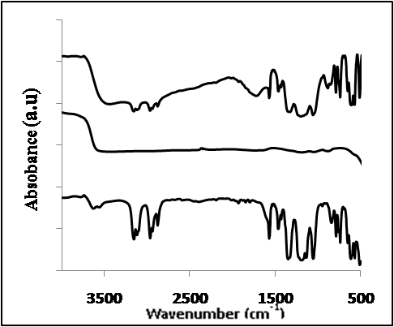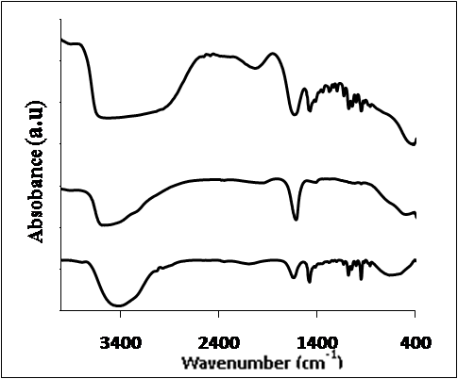
(a)
(b)
(c)
-CH₂-OH

-CH₂

-C- C-N

C-H & C-H₃

C-C & C-N

C-F
S=O
(a)
(b)
(c)

Figure 1. FTIR spectra: (a) BMI.NTf₂, (b) H₂SO₄, Figure 2. FTIR spectra : (a) ChCl, (b) ZnCl₂, (c) ChCl. (c) BMI.NTf₂(H₂SO₄) 2ZnCl₂

From Figures 1. and 2. no significant difference was shown, can see that when acids were added to BMI.NTf₂ or choline chloride it is just physical mixture between combined acids and ionic liquids. FTIR spectra from Figure 1. shows a band near 2970 cm⁻¹, indicating C-H and CH₃ stretching (C-H, C-H₃ = 2850 - 2980 cm⁻¹), a band near 1590 cm⁻¹ showing the C-C and C-N stretching (C-C, C-N = 1650 – 1590 cm⁻¹), a band near 1400 cm⁻¹ shows C-F stretching (C-F = 1000 – 1400 cm⁻¹) and a band near 1140 cm⁻¹ shows that the S=O stretching in sulphonamides group (1140 – 1350 cm⁻¹). In Figure 1. when sulphuric acid was added to BMI.NTf₂ a band near 1140 cm⁻¹ is getting broad. This might indicate the presence of sulphuric acid. In Figure 2., FTIR spectra show a band near 3420 cm⁻¹ showing the -CH₂-OH stretching (-CH₂OH = 3250 – 3420 cm⁻¹), a band near 1475 cm⁻¹ showing -C-H₂ stretching ( -C-H₂ = 1450 – 1475 cm⁻¹) and a band near 1230 cm⁻¹ shows the presence -C-C-N in amine group (-C-C-N = 1100 – 1230 cm⁻¹).

Characterization using ¹H NMR Measurement
Figures 3. Figure 4. show the ¹H NMR (400 MHz, CDCl₃ and D₂O, TMS) spectrum of BMI.NTf₂ and choline chloride respectively. Figure 3. shows the chemical shift at 0.99 ppm (-CH₂-CH₃), 1.40 ppm (-CH₂-CH₃), 1.66 ppm (HOD), 1.90 ppm (-CH₂-CH₂-), 3.97 ppm (CH₃-N-), 4.20 ppm (-CH₂-CN-), 7.29 ppm (CDCl₃ solvent) 7.32 ppm (-N-CH-CH-) and 8.79 ppm (-N=CH-N), respectively. Figure 4., the chemical shifts occured at 3.20 ppm (3CH₃’s in -N-CH₃), 3.53 ppm (-N-CH₂-CH₂-), 4.06 ppm (-CH₂-CH₂-OH) and 4.80 ppm (D₂O solvent).

1.40
1.66
1.90
3.97
4.20
7.29
7.32
8.79
0.99
0.99
1.40
1.90
3.97
4.20
7.32
7.32
8.79

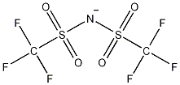

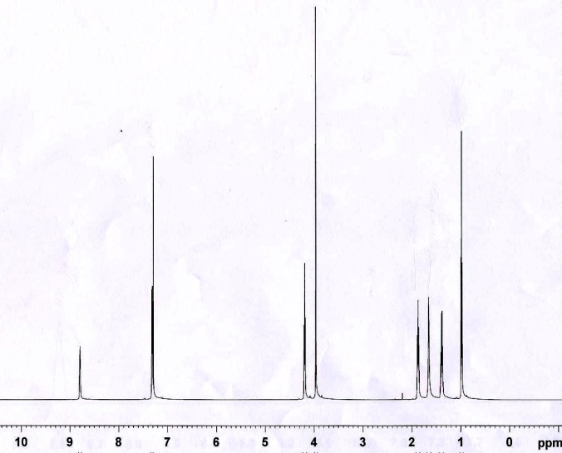
Chemical shift (ppm)
Figure 3. ¹H NMR spectrum of BMI.NTf₂

3.20
3.53
4.06
4.80
Cl⁻
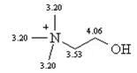

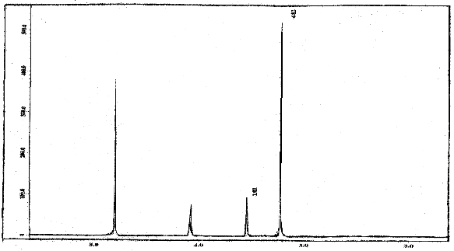
Chemical shift (ppm)
Figure 4. ¹H NMR spectrum of ChCl

Characterization using TGA Technique

Weight loss (%)

Temperature (ºC)

(a)
(b)
Figure 5. TGA curves of (a) BMI.NTf₂ and (b) BMI.NTf₂(H₂SO₄)

Base of figure 5. the TGA curves show that the thermal stability of BMI.NTf₂ (figure 5.(a)) is ≥400ºC. This is prove from literature review before that the using ionic liquids immidazolium with anion NTf₂ which gives ionic liquids salts with thermal stability of up to 400ºC. This occured because of delocalization of the negative charge, the anion and cation is probably less associated and more mobile than triflate anion. However when combining BMI.NTf₂ with H₂SO₄ the weight loss slowly increase and making it less stable than pure BMI.NTf₂. This is so maybe due to the presence of H₂SO₄ which causes the ionic liquid BMI.NTf₂ to be less stable.

Esterification Reaction

Table 1 : Esterification of lauric acid with methanol using BMI.NTf₂ combined with H₂SO₄ and ChCl.2ZnCl₂
Entry | Reaction Time [h] | Catalyst (ILs) | Conversion [%]
1  2 | 5  2 | BMI.NTf₂  BMI.NTf₂ (H₂SO₄) | 24.9  86.8
3 | 4 | BMI.NTf₂(H₂SO₄) | 88.9
4 | 5 | BMI.NTf₂(H₂SO₄) | 89.2
5 | 6 | BMI.NTf₂(H₂SO₄) | 92.2
6  7 | 8  5 | BMI.NTf₂(H₂SO₄)  ChCl | 90.0  9.0
8 | 2 | ChCl.2ZnCl₂ | 9.9
9 | 4 | ChCl.2ZnCl₂ | 23.4
10  11  12 | 5  6  8 | ChCl.2ZnCl₂  ChCl.2ZnCl₂  ChCl.2ZnCl₂ | 19.5  36.8  46.3
Reaction condition: Methanol:lauric acid, 4:1, temperature = 70ºC

Figure 6. Catalytic activity of BMI.NTf₂(H₂SO₄) and ChCl.2ZnCl₂ for esterification of lauric acid

Table 2 Esterification of lauric acid with methanol in combination with various acids to BMI.NTf₂
Entry | Catalyst | Ratioª | Conversion [%]
1 | H₂SO₄ | - | 97.8
2 | BMI.NTf₂(H₂SO₄) | 1 : 1 | 89.2
3 | HClO₄ | - | 97.8
4 | BMI.NTf₂(HClO₄) | 1 : 1 | 71.9
5 | PTSA | - | 95.9
6 | BMI.NTf₂(PTSA) | 1 : 1 | 98.3
7 | ZnCl₂ | - | 66.7
8 | BMI.NTf₂(ZnCl₂) | 1 : 2 | 84.2
9 | FeCl₃ | - | 94.1
10 | BMI.NTf₂(FeCl₃) | 1 : 2 | 76.8
Reaction condition: Methanol:lauric acid, 4:1, temperature= 70ºC, 5 hours reaction
ªThe mole ratios of BMI.NTf₂ to Lewis acid/Bronsted acid

Esterification of lauric acid with methanol was carried out using BMI.NTf₂ combined with H₂SO₄ (BMI.NTf₂(H₂SO₄)) and ChCl.2ZnCl₂ (Table 1) with increasing time of reaction and when using conventional homogenous catalyst (Table 2). All selectivity using these catalysts show high selectivity (100%). In Table 1, all BMI.NTf₂(H₂SO₄) show good catalytic activity, (>85%) conversion except BMI.NTf₂ without any combination with acid showing result 24.9% conversion. This means H₂SO₄ influenced catalytic activity. From catalytic activity combination of BMI.NTf₂ and H₂SO₄, conversion increased with number of hours of reaction. Catalytic activity of ChCl.2ZnCl₂ also increases with time of reaction. Without any combination with ZnCl₂, it gives only 9.0% conversion. However, catalytic activity of ChCl.2ZnCl₂ for esterification of lauric acid is very low (conversion, 9.0-46.3%) than BMI.NTf₂(H₂SO₄) (conversion, >85%) (see Figure 6). As observed here, catalytic activity using BMI.NTf₂(H₂SO₄) is better than using ChCl.2ZnCl₂ in the esterification of lauric acid.

Catalytic activity of combination ionic liquid BMI.NTf₂ with other acid was also carried out (Table 2). When combination BMI.NTf₂ with Bronsted acid and Lewis acid, the catalytic activity shows small decrease compared to using homogeneous acid catalyst without combination with BMI.NTf₂ except combination BMI.NTf₂ with PTSA and FeCl₃, where the conversion increased. As explained here, all acids increase catalytic activity in the esterification reaction compared to catalytic activity using BMI.NTf₂ without any combination.

As conclusion the esterification using ionic liquid BMI.NTf₂ in combination with Bronsted acid and Lewis acid gave high conversion and selectivity. Although these combination ionic liquids showed nearly similar activity as homogeneous acid catalysts, these ionic liquids have their own advantage such as the acid was retained in the ionic liquid phase and easily to separated out because ionic liquid has different phase with product but different with conventional homogeneous acid catalysts. This is because conventional homogeneous acid catalysts are difficult to separate and needs high cost for separation and neutralization. Using these combination ionic liquids has some advantages such as high activity and selectivity like homogeneous catalyst, non-corrosive, ease to separate, easy to prepare, low cost and eco-friendly as these ionic liquids are non-volatile.

Acknowledgements
The authors wish to thank the Ministry of Science, Technology and Innovation (MOSTI) for a fellowship to Zalita Yaacob and research grant UKM-GUP-BTK-08-14-306 to support this research.

References
1. Juan, Joon Ching., Zhang, Jingchang & Mohd Ambar Yarmo. 2007. Structure and reactivity of silica supported zirconium sulfate for esterification of fatty acid under solvent-free condition. Applied Catalysis, 332 : 209-215.
2. Mantri, K., Komura, K. & Sugi, Y. 2005. ZrOCl₂.8H₂O catalysts for the esterification of long chain aliphatic carboxylic acids and alcohols. the enhancement of catalytic performance by supporting on ordered mesoporous silica. Green Chemistry, 7 : 677-682.
3. Joseph, T., Sahoo, S. & Halligudi, S.B. 2005. Bronsted acidic ionic liquids: a green, efficient and reusable catalyst system and reaction medium for fischer esterification. Journal of Molecular Catalysis, 234 : 107-110.
4. Wasserscheid, P. & Keim, W. 2000. Ionic liquids – new “solutions” for transition metal catalysis. Angew. Chem. Int. Ed, 39 : 3772 – 3789.
5. Duan, Z., Gu, Y and Deng, Y. 2006. Neutral ionic liquid [BMIm]BF₄ promoted highly selective esterification of tertiary alcohols by acetic anhydride. Journal of Molecular Catalysis A: Chemical, 246 : 70-75.
6. Wassercheid, P. & Welton, T. 2008. Ionic Liquids in Synthesis. Ed. 2. Vol. 1 & 2. Weinheim: WILEY-VCH Verlags GmbH & Co. KGaA.
7. Sunitha, S., Kanjilal, S., Reddy, P.S and Prasad, R.B.N. 2007. Liquid-liquid biphasic synthesis of long chain wax esters using the Lewis acidic ionic liquid choline chloride.2ZnCl₂. Tetrahedron Letters, 48 : 6962-6965.
8. Lapis, A.A.M., Oliveira, L.F.d., Neto, B.A.D and Dupont, J. 2008. Ionic liquid supported acid/base-catalyzed production of biodiesel. ChemSusChem, 1 : 759-762.
9. Abbott, A.P., Capper, G., Davies, D.L. & Rasheed, R. Ionic liquid based upon metal halide/substituted quaternary ammonium salt mixtures. Inorg. Chem, 43: 3447-3452.
10. Zhang, Z.C. 2006. Catalysis in ionic liquids. Adv. Catal, 49: 153-237.
11. Welton, T. 2004. Ionic liquids in catalysis. Coordination Chemistry Reviews, 248 : 2459-2477.
12. Johnson, K.E. 2007. What’s an ionic liquid. The Electrochemical Society Interface, Spring, 16 : 38-41.
13. Angueira, E.J and White, M.G. 2007. Super acidic ionic liquids for arene carbonylation derived from dialkylimidazolium chlorides and MCl₃ (M = Al, Ga, or In). Journal of Molecular Catalysis A: Chemical, 277 : 164-170.

