
REMOVAL OF Zn(II), Cd(II) AND Mn(II) FROM AQUEOUS SOLUTIONS
BY ADSORPTION ON MAIZE STALKS

(Penyingkiran Zn(II), Cd(II) Dan Mn(II) Daripada Larutan Akueus Melalui Penjerapan
Pada Tangkai Jagung)

G. O. El-Sayed¹*, H. A. Dessouki ¹ and S. S. Ibrahiem²

¹ Chemistry Department, Faculty of Science,
Benha University, Benha, Egypt
² National Water Research Center, Central Lab. for Environ. Qual. Monit.,
Elqanater Elkhayria, Egypt

*Corresponding author: gamaloelsayed@yahoo.com

Abstract
The potential to remove Zn(II), Cd(II) and Mn(II) from aqueous solutions through biosorption using maize stalks as an agriculture waste, was investigated in batch experiments. Different factors influencing metal adsorption such as contact time, initial metal ion concentration (40–1000 mg/L), pH (1–8), ionic strength and temperature (298–328 K) were investigated. The adsorption process was relatively fast and equilibrium was established after about 90 min. The optimum initial pH for zinc, cadmium and manganese adsorption by maize stalks was 7.0, 6.0 and 5.0, respectively. Under optimum conditions, the maximum adsorption capacity of zinc, cadmium and manganese ions was 30.30, 18.05 and 16.61 mg metal/g dry biomass, respectively. In order to investigate the sorption isotherm, three equilibrium models, Langmuir Freundlich and Temkin isotherms, were analyzed. The adsorption process for the three metal ions was found to be exothermic in nature. Free energy of adsorption (ΔG⁰), enthalpy (ΔH⁰) and entropy (ΔS⁰) changes were calculated.

Keywords: maize stalks; metal removal; cadmium; manganese; zinc

Abstrak
Potensi penyingkiran Zn(II), Cd(II) dan Mn(II) daripada larutan akueus melalui bioerapan menggunakan tangkai jagung sebagai buangan pertanian telah dikaji menggunakan kaedah kelompok. Pelbagai factor yang mempengaruhi jerapan logam seperti masa sentuhan, kepekatan awal logam (40–1000 mg/L), pH (1–8), kekuatan ion dan suhu (298–328 K) telah dikaji. Proses penjerapan adalah agak pantas dan keseimbangan dicapai selepas 90 min. pH optimum bagi penjerapan zink, kadmium dan mangan oleh tangkai jagung masing-masingnya ialah 7.0, 6.0 dan 5.0. Pada keadaan optimum, muatan pejerapan maksimum bagi ion zink, kadmium dan mangan, masing-masing adalah 30.30, 18.05 and 16.61 mg logam/g biojisim kering. Bagi kajian isoterma erapan, tiga model keseimbangan iaitu isoterma Langmuir Freundlich dan Temkin dianalisis. Proses jerapan bagi ketiga-tiga ion logam adalah eksotermal. Perubahan tenaga bebas penjerapan (ΔG⁰), entalpi (ΔH⁰) dan entropi (ΔS⁰) telah dikira.

Kata kunci: tangkai jagung; penyingkiran logam; cadmium, mangan; zink

Introduction
Toxic heavy metal contamination of industrial wastewater is an important environmental problem. Many industries such as electroplating, pigments, metallurgical processes, and mining and leather industries release various concentrations of heavy metals. Metal ions such as cadmium, chromium, copper, lead, zinc, manganese and iron are commonly detected in both natural and industrial effluents. The commonly used procedures for removing metal ions from effluents include filtration [1], chemical precipitation [2], chemical coagulation [3], flocculation [4], ion exchange [5], reverse osmosis [6], membrane technologies [7-9] and solvent extraction [10]. These processes may be ineffective or expensive, especially when the heavy metal ions are present in high concentrations. The use of adsorbents of biological origin has emerged in the last decade as one of the most promising alternatives to conventional heavy metal management strategies. Biosorption is a fast and reversible reaction of the heavy metals with biomass. The by-products obtained from biomaterial production are a cheap source of biosorbents. Several agricultural waste materials have been studied and developed for the effective removal of heavy metals like maize bran [11], coffee husks [12], rice straw [13], sugar peat pulp [14], olive pomace [15], apple wastes [16], palm kernel fibre [17], peanut hull [18], cocoa shell [19], hazelnut husks [20], oak sawdust [21] and grape stalks [22].

Maize is an economical crop in Egypt, large areas are cultivated with it. The aim of the present study is to examine the ability of maize stalks as cheep bio-adsorbent for removal of Zn(II), Cd(II) and Mn(II) ions from aqueous solutions. The different factors affecting adsorption process were evaluated as time of contact, initial concentration of the metal, solution pH, temperature and adsorbent dosage. Furthermore, equilibrium, kinetic and thermodynamic studies on the adsorption of different metal ions onto the maize stalks were also carried out for the design of adsorption process. The advantage of using maize stalks as adsorbent is the ability of using the dry biomass after removal process in the manufacture of a sheep type of artificial wood by special treatment.

Materials and Methods
Biomass preparation
Maize stalks were collected and used as sorbent for the biosorption of Zn(II), Cd(II) and Mn(II) ions. The maize stalks sample was collected from Sharqiya Governorate region of Egypt. Samples were washed several times using deionised water to remove extraneous and dust. They were then dried in an oven at 105 ºC for 24 h. The dried biomass was chopped and filtered. The granules were sieved and the particles having sizes less than 150 μm were used in the tests. The adsorbent was kept dry in a closed container until the time of use.

Determination of point of zero charge
Point of zero charge of an adsorbent surface is the pH at which that surface has a net neutral charge. This value was evaluated by adding 0.1g of maize stalks to 50 mL of water with varying pH from 2 to 11.6 and stirred for 24 h. The initial pH was adjusted by adding either HCl or NaOH solutions and the final pH of the solution was plotted against the initial solution pH (Figure 1). pHZPC for maize stalks is determined as pH 5.2.

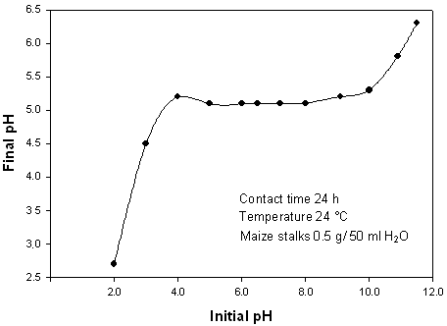
Figure 1: Point of zero charge (pHZPC) of maize stalks used for the adsorption experiments.

Batch sorption experiment
Using definite amount (0.5 g) of adsorbent in a 250 mL stopper conical flask containing 25 mL of metal ion solution, batch sorption studies were carried out at desired pH value, contact time, temperature and ionic strength. Different initial concentration of Zn(II), Cd(II) or Mn(II) solutions were prepared by proper dilution from stock 1000 mg/L metal ions standard solutions. Standard metal ions solutions were prepared from the following salts: Zn(NO₃)₂, Cd(NO₃)₂ and MnCl₂. pH of the test solution was monitored by adding 0.1M HCl and 0.1M NaOH solution as required. The amount of biosorbent was then added to the metal ion solution in the conical flask and stirred for the desired contact time using a magnetic stirrer at 100 rpm. The time required for reaching equilibrium condition estimated by drawing samples at regular interval of time till the equilibrium was reached. The content of the metal ion in the test flask was separated from biosorbent by filtration through a filter paper and was analyzed by ICP-OES 2010 Serial Optical Emission Spectrometer, Optima (PerkinElmer). The samples were analyzed three times and the mean values were computed. The amount of metal ion adsorbed per unit mass of the biosorbent was evaluated by using following equations:

$q_{max}=(C_{0}-C_{e})\frac{V}{W}$ (1)

Where, C₀ is the initial metal ion concentration, and C_{e} is the metal ion concentration at equilibrium and V is the volume of metal ion solution in milliliters, W is the mass of adsorbent in grams. The percent of metal ion removal was evaluated from the equation:

$\% Removal=\frac{(C_{0}{-C}_{e})}{C_{0}}×100$ (2)

Results and Discussion
Effect of pH on metal ion removal
The pH of the metal ion solution is an important parameter for adsorption of metal ions because it affects the solubility of the metal ions, concentration of the counter ions on the functional groups of the adsorbent and the degree of ionization of the adsorbate. To examine the effect of pH on metal ion removal efficiency, the pH was varied from 1.0 to 8.0 for Cd(II) and from 1.0 to 7.0 for Zn(II) and Mn(II) to prevent precipitation of metal hydroxides. As shown in Figure 2 the uptake of free ionic Cd(II) depends greatly on pH, where optimal metal removal efficiency occurs at pH 6.0 and then decreases at higher pH values, this behavior can be detected in other works [23]. Removal efficiency for Cd(II) increased from 7% to 46% over pH range from 1.0 to 6.0. In case of Zn(II), the metal uptake increases from 26% at pH 1.0 to 63% at pH 5.0, then it decreases by increasing the pH. The same figure indicated that the removal of Mn(II) increases from 16% at pH 1.0 to 38% at pH 7.0. This behavior is expected, as the acidity of the medium can affect the metal uptake on a biosorbent because hydrogen ions could compete with metallic ions for active sites on the biosorbent surface.

Effect of contact time and temperature
Figure 3 shows the effect of contact time on the rate of metal ion uptake onto maize stalks. At the beginning of adsorption, the values of % removal increased quickly, and then after 30 min, the change turned slow. Thus, the adsorption of the three metal ions on maize stalks was speedy. After about 90 min, the adsorbed quantity of the three metal ions showed nearly no change. The two stage sorption mechanism with the first rapid and quantitatively predominant and the second slower and quantitatively insignificant, has been extensively reported in literature [24,25]. This behavior gives away a slow approach to equilibrium. The nature of adsorbent and its available sorption sites affected the time needed to reach the equilibrium [26].

The effect of temperature of the adsorbate was also examined for solutions of 1000 mg/L metal ion and 20 g/L adsorbent at optimum pH values. Figure 4 shows the biosorption of Zn(II), Cd(II) and Mn(II) ions as a function of the temperature. The biosorption percentage decreased from 52 to 28% for Zn(II) ions, from 34 to 16% for Cd(II) ions and from 39 to 13% for Mn(II) ions as temperature was increased from 25 to 55 ºC for the equilibrium time 90 min. These results indicated the exothermic nature of Zn(II), Cd(II) and Mn(II) biosorption onto maize stalks. A decrease in metal ion biosorption with the rise in temperature may be due to either the damage of active binding sites in the biomass [27] or increasing tendency to metal desorption from the interface to the solution [28] by weakening of adsorptive forces between the active sites of the adsorbent species [29].
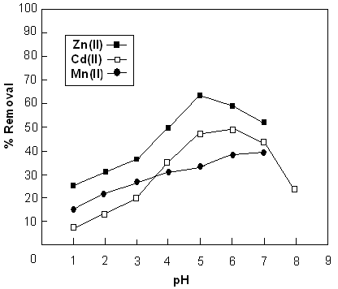
Figure 2: Effect of pH on the percent removal of Zn(II), Cd(II) and Mn(II)
using maize stalks as adsorbent

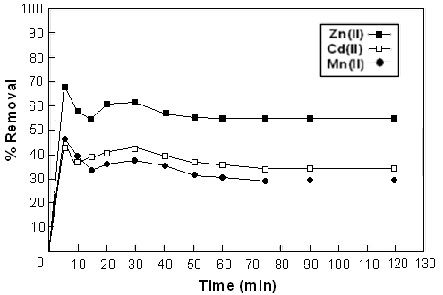
Figure 3: Effect of contact time on metal ion removal at optimum pH value

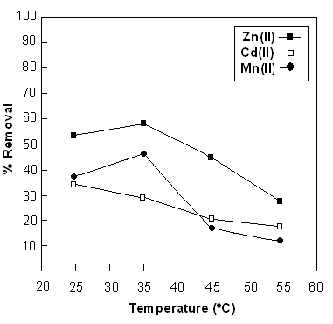
Figure 4: Effect of temperature on metal ion removal on maize stalks

Effect of ionic strength
The Influence of ionic strength I on heavy metal ions sorption by different biosorptions was investigated to determine solution chemistry effects. Different I values (0.1-1.0) were used by adding definite weights of solid KCl to a definite concentration of the metal ion (1000 mg/L). From the results obtained (Figure 5), it can be seen that the increasing of the ionic strength results in a decrease in the amount of the metal ion adsorbed as a result of the competition between the metal ions and the salt ions [30]. The reduction in uptake is probably due to the excess of K⁺ ions which inhibit the approach of adsorbed ions to the active sites of the sorbent. Generally, there are two possible ways by which increasing I can influence metal ion sorption on different adsorbents: (1) decrease the solution-phase activity of metal ion and (2) increases concentration of competing ion (K⁺). With increasing I, there is a little decrease in metal ion removal which can be attributed to the presence of sorption sites of different affinities.

Effect of initial metal ion concentration
The metal uptake mechanism is particularly dependent on the initial heavy metal concentration; at low concentrations, metal ions are adsorbed by specific active sites, while with increasing metal concentrations the binding sites become more quickly saturated as the amount of biomass concentration remained constant [31]. Figure 6 shows that the amount of metal ion sorbed per unit mass of maize stalks (i.e., sorption capacity) at optimum pH values and after 90 min of contact time was increased with the increase of the initial concentration of metal ion. It was observed also from the same figure that the adsorption capacity decreases in the following manner Zn(II) > Cd(II) > Mn(II). In the same time, the percentage removal was decreased with increasing the initial metal ion concentration for all metal ions studied.

Adsorption isotherms
To describe the adsorption process of Zn(II), Cd(II) and Mn(II) onto maize stalks, the three empirical models of Langmuir, Freundlich and Temkin isotherms were tested. The adsorption studies were conducted at fixed adsorbent dosage (0.5 g) by varying initial concentrations of heavy metals (40-1000 mg/L). These isotherms relate metal uptake per unit weight of adsorbent q_{e} to the equilibrium metal ion concentration in the bulk phase C_{e}.

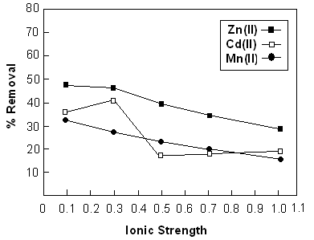
Figure 5: Effect of ionic strength on metal ion removal on maize stalks

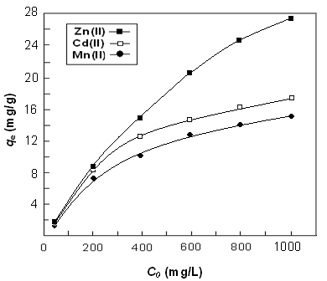
Figure 6: Effect of initial metal ion concentration on sorption capacity using maize stalks
as adsorbent

The Langmuir Model
The Langmuir isotherm models is used to describe the relationship between the amount of adsorbed material and its equilibrium concentration in solutions. The Langmuir isotherm is valid for monolayer adsorption on a surface containing finite number of identical sites. The model assumes a uniform adsorption on the surface and transmigration in the plane of the surface. The Langmuir isotherm is expressed as follows [32]:

$q_{e}=\left(K_{L}C_{e}\right)/(1+bC_{e})$ (3)

where, q_{e} is the adsorption capacity at equilibrium in mg/g, C_{e} is the concentration at equilibrium (mg/L) and K_{L} is the Langmuir equilibrium constant in (mL/mg) and is expressed as follows:
$K_{L}=Q_{0}b$ (4)

where, Q_{o} is the adsorption capacity at saturation in mg/g and b the adsorption coefficient in L/mg; The linear form of Langmuir isotherm model can be represented by using the equation below:

$\frac{C_{e}}{q_{e}}=\frac{1}{Q_{0}b}+\frac{C_{e}}{Q_{0}}$ (5)

The linear plots of Ce/q_{e} vs C_{e} show that adsorption follows the Langmuir adsorption model (Figure 7). The values of Q_{o} and b can be calculated (Table 1) from the slope and intercept of the plot, respectively. The correlation coefficients are 0.932, 0.998 and 0.989 for Zn(II), Cd(II) and Mn(II), respectively. These results reveal that the Langmuir-type sorption isotherm is suitable for equilibrium studies For Cd(II) and Mn(II) only, suggesting the formation of monolayer coverage of the adsorbate on the surface of adsorbent for these metalions [33]. The amount of metal ions adsorbed per unit mass of the adsorbent increased with the metal concentration as expected and the sorption capacities were 30.30, 18.05 and 16.61 for Zn(II), Cd(II) and Mn(II) ions, respectively.

The essential characteristics of the Langmuir isotherm can be explained by the equilibrium separation factor R_{L} defined as follows:
$R_{L}=1/(1+bC_{0})$ (6)

Depending on the value of R_{L}, the shape of the isotherm and whether the adsorption is favorable or not can be determined. The calculated R_{L} values for Zn(II), Cd(II) and Mn(II) at 298 K, were represented in Table 1. It was observed that at these experimental conditions, sorption of the different metal ions by maize stalks was found to be a favorable process [34] as the values of R_{L} are 0.719, 0.895 and 0.905 for Zn(II), Cd(II) and Mn(II), respectively.

The maximum adsorption capacities (Q₀) of adsorbent calculated from Langmuir isotherm equation which defines the maximum capacity of the adsorbent for metal ions were found to be comparable with other adsorbents reported in the literature for Zn(II), Cd(II) and Mn(II), Table 1.

The Freundlich Model
The Freundlich isotherm assuming that the adsorption process takes place on heterogeneous surfaces and adsorption capacity is related to the concentration of the adsorbent. The Freundlich model is based on the following expression [51]:

$q_{e}=K_{F}C_{e}^{1/n}$ (7)

where, K_{F} is the Freundlich constant and 1/n is a constant indicating the reaction intensity. The two Freundlich parameters K_{F} and 1/n can be determined graphically by plotting the experimental data and then using the Freundlich equation in the following form:
$ln{ q}_{e}=ln{ K}_{F}+\left(1/n\right)lnC_{e}$ (8)
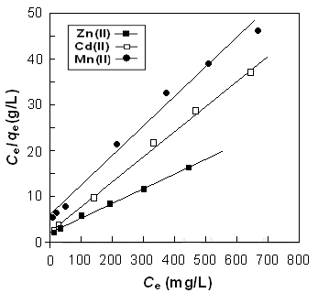

Figure 7: Langmuir isotherm plot for the adsorption of Zn(II), Cd(II) and Mn(II) on maize
stalks at optimum pH values.

Table 1: Langmuir constant for different adsorbents
Metal | Adsorbent | Langmuir constant, Q₀ (mg/g) | Reference
Zn(II) | Sunflower stalks  Black Locust  Oak saw dust  Carrot residues  Saw dust  Neem bark  Sugar beat pulp | 30.7  5.0  6.9  29.6  14.1  13.3  17.7 | 35  36  36  37  29  29  38
Cd(II) | Groundnut husk  Sugar cane bagasse  Olive cake  Lignite  Spent grain  Maize bran  Tree fern | 42.7  149.9  65.4  40.2  17.3  7.4  16.3 | 39  40  41  42  43  44  45
Mn(II) | Pseudomonas aeruginosa  natural zeolitic tuff  chitin  kaolinite  Cyanobacterium Gloeothece Magna | 22.4  10.0  0.643  0.446  0.473-0.906 | 46  47  48  49  50

The variations of ln q_{e} with ln C_{e} for zinc, cadmium and manganese cations are shown in Figure 8. It can be seen from the linear relationship that the adsorption of the three metals on maize stalks follows the Langmuir model. The values of K_{F} and n are presented in Table 1. The n values are 2.01, 2.48 and 2.23 for Zn(II), Cd(II) and Mn(II), respectively (greater than 1), indicating that the adsorption is favorable [52].

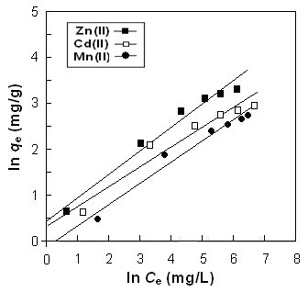
Figure 8. Freundlich isotherm plot of Zn(II), Cd(II) and Mn(II) on maize stalks

It can be observed from the correlation coefficient values (R²) in Table 2 that Freundlich isotherm model exhibited good fit to the sorption data of Zn(II) and Mn(II).

The Temkin Isotherm
This isotherm was developed by Temkin and Pyzhev [53], and it is based on the assumption that the heat of adsorption decreases linearly with the increase of coverage of adsorbent [54]. Temkin isotherm assumes that the fall in the heat of sorption is linear rather than logarithmic [55]. This model can be shown by the equation:

$q_{e }=\frac{RT}{b_{T}}lnK_{T}+\frac{RT}{b_{T}}lnC_{e}$ (9)

where, K_{T} (L/g) is Temkin adsorption potential and b_{T} (kJ/mol) is heat of sorption (Table 1). The linear plot of ln C_{e} versus q_{e} for the three metal ions for Temkin model is shown in Figure 9. From the slope and intercept of the straight line b_{T} and K_{T} can be evaluated, respectively.

Table 2: Modeled Langmuir and Freundlich isotherms parameters for zinc(II), cadmium(II) and manganese(II) adsorption on maize stalks
Metal Ion | Lagmuir Isotherm  Q₀ b R_{L} R²  (mg/g) (L/mg) (L/mg) | Freundlich Isotherm  K_{F} n R²  (L^{n}mg^{1-n}/g) | Temkin Isotherm  K_{T} b_{T} R²  (L/g) (kJ/mol)
Zn(II) | 30.30 0.017 0.268 0.932 | 1.517 2.01 0.983 | 0.47 515.1 0.944
Cd(II) | 18.05 0.023 0.213 0.998 | 1.509 2.48 0.925 | 0.64 866.3 0.994
Mn(II) | 16.61 0.009 0.410 0.989 | 0.842 2.23 0.975 | 0.64 945.6 0.957

By comparing the correlation coefficients (R²) obtained from the three isotherms plots plots (Table 1), it can be concluded that Langmuir model can be applied successfully to Cd(II) and Mn(II) and Freundlich model can be applied to Zn(II) and Mn(II), while Temkin isotherm model appears to be favorable for fitness to the experimental data of Cd(II).

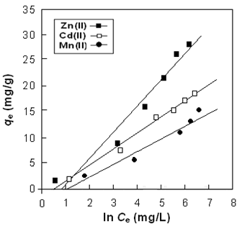
Figure 9. Temkin isotherm plot of Zn(II), Cd(II) and Mn(II) on maize stalks

Thermodynamic Parameters
The temperature dependence of the thermodynamic parameters on the adsorption of Zn(II), Cd(II) and Mn(II) on maize stalks were calculated using equations [56]:

$∆G^{o}=-RT ln K$ (10)

The Gibbs free energy change (ΔGº) is related to the entropy change (ΔHº) and enthalpy change (ΔSº) at constant temperature by the following equation:

$∆G^{o}=∆H^{o}-T∆S^{o}$ (11)

Combining the above two equations, we get:

$\ln{K=-\frac{∆H^{o}}{RT}+\frac{∆S^{o}}{R}}$ (12)

where, R is the universal gas constant (8.314 J/mol K), T is the absolute temperature (K) and K is the Langmuir equilibrium constant. ΔGº was calculated at different temperatures from equation (9). By plotting the values of ln K versus 1/T (Figure 10) using equation (11), the values of ΔHº and the ΔSº were calculated from the slope and intercept, respectively, Table 3.

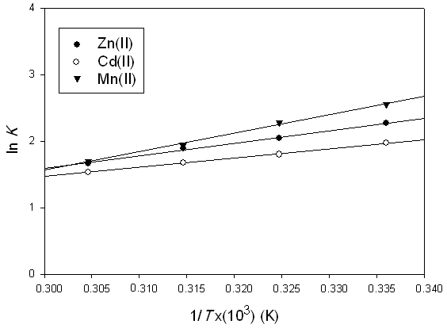
Figure 10. Plot of ln K vs. 1/T for removal of Zn(II), Cd(II) and Mn(II) by maize stalks

Table 3: Thermodynamic parameters of Zn(II), Cd(II) and Mn(II) on maize stalks at initial metal ion concentration 1000 mg/L
Metal ion | T (K) | ΔGº (KJ/mol) | ΔHº (KJ/mol) | ΔSº (J/mol K)
Zn(II) | 298 | -3.244 | -24.27 | -10.97
Zn(II) | 308 | -3.354 | -24.27 | -10.97
Zn(II) | 318 | -3.464 | -24.27 | -10.97
Zn(II) | 328 | -3.573 | -24.27 | -10.97
Cd(II) | 298 | -3.800 | -14.17 | -12.80
Cd(II) | 308 | -3.928 | -14.17 | -12.80
Cd(II) | 318 | -4.056 | -14.17 | -12.80
Cd(II) | 328 | -4.184 | -14.17 | -12.80
Mn(II) | 298 | -7.406 | -25.35 | -24.94
Mn(II) | 308 | -7.656 | -25.35 | -24.94
Mn(II) | 318 | -7.905 | -25.35 | -24.94
Mn(II) | 328 | -8.155 | -25.35 | -24.94

The negative values of Gibbs free energy change (ΔGº) indicate that the adsorption process for the three metal ion7s is feasible and spontaneous. It was observed that the values become more negative with increase in temperature. The negative values of ΔHº indicate that the adsorption of metal ions on maize stalks is exothermic. The negative values of ΔSº suggest decreased randomness at the solid/solution interface and no significant changes occur in the internal structure of the adsorbent through the adsorption of metal ions onto maize stalks [57].

Conclusion
The biosorption of Zn(II), Cd(II) and Mn(II) on maize stalks was investigated. Adsorption of the three metal ions is dependent on their initial concentrations and pH of the metal solution and the equilibrium were attained after 90 min of mixing. The results indicate that the optimum pH for maximum removal of Zn(II), Cd(II) and Mn(II) ions are 7.0, 6.0 and 5.0, respectively. The adsorption process was found to be exothermic. Langmuir adsorption model can be applied successfully with cadmium and manganese, Freundlich adsorption model fitted well with zinc and manganese, while Temkin model can be applied to cadmium. The sorption capacities were 30.03, 18.05 and 16.61 mg/g for Zn(II),Cd(II) and Mn(II) ions, respectively. Maize stalks which is an agricultural waste material can be used for industrial water treatment to eliminate low concentrations of heavy metal ions as zinc, cadmium and manganese.

References
1. Bessbousse, H., Rhlalou, T., Verchère, J.-F. and Lebrun, L. 2008. Removal of heavy metal ions from aqueous solutions by filtration with a novel complexing membrane containing poly(ethyleneimine) in a poly(vinyl alcohol) matrix. Journal of Membrane Science, 307: 249-259.
2. Esalah, J.O., Weber, M.E. and Vera, J.H. 2000. Removal of lead from aqueous solutions by precipitation with sodium di-(n-octyl) phosphinate. Separation and Purification Technology, 18: 25-36.
3. El Samrani, A.G., Lartige, B.S. and Villieras, F. 2008. Chemical coagulationof combined sewer over flow: heavy metal removal and treatment optimization. Water Research, 42: 951-960.
4. Ofir, E., Oren, Y. and Adin, A. 2007. Comparing pretreatment by iron of electro-flocculation and chemical flocculation. Desalination, 204: 87-93.
5. Lin, L.-C., Li, J.-K. and Juang, R-S. 2008. Removal of Cu(II) and Ni(II) from aqueous solutions using batch and fixed-bed ion exchange processes. Desalination, 225: 249-259.
6. Benito, Y. and Ruíz, M.L. 2002. Reverse osmosis applied to metal finishing wastewater. Desalination, 142: 229-234.
7. Cooper, C.A., Lin, Y.S. and Gonzalez, M. 2004. Separation properties of surface modified silica supported liquid membranes for divalent metal removal/recovery. Journal of Membrane Science, 229: 11-25.
8. Juang, R.-S. and Shiau, R.-C. 2000. Metal removal from aqueous solutions using chitosan-enhanced membrane filtration. Journal of Membrane Science, 165: 159-167.
9. Nasef, M.M. and Yahaya, A.H. 2009. Adsorption of some heavy metal ions from aqueous solutions on Nafion 117 membrane. Desalination, 249: 677-681.
10. Gupta, S.K., Rathore, N.S., Sonawane, J.V., Pabby, A.K., Janardan, P., Changrani, R.D. and Dey, P.K. 2007. Dispersion-free solvent extraction of U(VI) in macro amount from nitric acid solutions using hollow fiber contactor. Journal of Membrane Science, 300: 131-136.
11. Hasan, S.H., Singh, K.K., Prakash, O., Talat, M. and Ho, Y.S. 2008. Removal of Cr(VI) from aqueous solutions using agricultural waste ‘maize bran. Journal of Hazardous Materials, 152: 356-365.
12. Oliveira, W.E., Franca, A.S., Oliveira, L.S. and Rocha, S.D. 2008. Untreated coffee husks as biosorbents for the removal of heavy metals from aqueous solutions. Journal of Hazardous Materials, 152: 1073-108.
13. Gao, H., Liu, Y., Zeng, G., Xu, W., Li, T. and Xia, W. 2008. Characterization of Cr(VI) removal from aqueous solutions by a surplus agricultural waste—Rice straw. Journal of Hazardous Materials, 150: 446-452.
14. Altundogan, H.S., Bahar, N., Mujde, B. and Tumen, F. 2007. The use of sulphuric acid-carbonization products of sugar beet pulp in Cr(VI) removal. Journal of Hazardous Materials, 144: 255-264.
15. Pagnanelli, F., Mainelli, S., Vegliò, F. and Toro, L. 2003. Heavy metal removal by olive pomace: biosorbent characterisation and equilibrium modeling. Chemical Engineering Science, 58: 4709-4717.
16. Maranon, E. and Sastre, H. 1991. Heavy metal removal in packed beds using apple wastes, Bioresources Technology, 38: 39-43.
17. Ho, Y-S. and Ofomaja, A.E. 2006. Kinetic studies of copper ion adsorption on palm kernel fibre, Journal of Hazardous Materials B, 137: 1796–1802.
18. Zhu, C.-S., Wang, L.-P. and Chen, W.-b. 2009. Removal of Cu(II) from aqueous solution by agricultural by-product: Peanut hull. Journal of Hazardous Materials, 168: 739-746.
19. Meunier, N., Laroulandie, J., Blais, J.F. and Tyagi R.D. 2003. Cocoa shells for heavy metal removal from acidic solutions. Bioresources Technology, 90: 255-263.
20. Demirbas, O., Karadag, A., Alkan, M. and Dogan, M. 2008. Removal of copper ions from aqueous solutions by hazelnut shell. Journal of Hazardous Materials, 153:677–684.
21. Argun, M. E., Dursun, S., Ozdemir, C. and Karatas, M. 2007. Heavy metal adsorption by modified oak sawdust: Thermodynamics and kinetics. Journal of Hazardous Materials, 141: 77-85.
22. Fiol, N., Escudero, C. and Villaescusa, I. 2008. Chromium sorption and Cr(VI) reduction to Cr(III) by grape stalks and yohimbe bark. Bioresources Technology, 99: 5030-5036.
23. Nadeema, M., Shabbira, M., Abdullahb, M.A., Shahc, S.S. and McKayd, G. 2009. Sorption of cadmium from aqueous solution by surfactant-modified carbon adsorbents. Chemical Engineering Journal, 148: 365–370.
24. Saeed, A., Akhter, M.W. and Iqbal, M. 2005. Removal and recovery of heavy metals from aqueous solution using papaya wood as a new biosorbent. Separation and Purification Technology, 45: 25–31.
25. Runping, H., Pan, H., Zhaohui, C., Zhenhui, Z. and Mingsheng, T. 2008. Kinetics and isotherms of Neutral Red adsorption on peanut husk. Journal of Environmental Science, 20: 1035–1041.
26. Naiya, T. K., Bhattacharya, A. K. and Das, S. K. 2009. Adsorptive removal of Cd(II) ions from aqueous solutions by rice husk ash. Environmental Progress in Chemical Engineering, 28: 535-546.
27. Ozer, A. and Ozer, D. 2003. Comparative study of the biosorption of Pb(II), Ni(II) and Cr(VI) ions onto S. cerevisiae: determination of biosorption heats. Journal of Hazardous Materials, 100: 219–229.
28. Saltal, K., Sar, A. and Aydın, M. 2007. Removal of ammonium ion from aqueous solution by natural Turkish (Yıldızeli) zeolite for environmental quality. Journal of Hazardous Materials, B 141: 258–263.
29. Naiya, T.K., Chowdhury, P., Bhattacharya, A.K. and Das, S. K. 2009. Saw dust and neem bark as low-cost natural biosorbent for adsorptive removal of Zn(II) and Cd(II) ions from aqueous solutions. Chemical Engineering Journal, 148: 68-79.
30. Cieslak-Golonka, M. 1996. Toxic and mutagenic effects of chromium (VI). A review, Polyhedron, 15: 3667-3918.
31. Horsfall, M. and Spiff, A.I. 2005. Equilibrium Sorption Study of Al³⁺, Co²⁺ and Ag⁺ in Aqueous Solutions by Fluted Pumpkin (Telfairia Occidentalis HOOK f) Waste Biomass. Acta Chimica Slovinica, 52: 174–181.
32. Langmuir, I. 1916. The constitution and fundamental properties of solids and liquids. Journal of American Chemical Society, 38: 2221–2295.
33. Pehlivan, E. and Altun, T. 2008. Biosorption of chromium(VI) ion from aqueous solutions using walnut, hazelnut and almond shell. Journal of Hazardous Materials, 155: 378-384.
34. Bulut, Y., Gozubenli, N. and Aydın, H. 2007. Equilibrium and kinetics studies for adsorption of direct blue 71 from aqueous solution by wheat shells. Journal of Hazardous Materials, 144: 300–306.
35. Sun, G. and Shi, W. 1998. Sunflower stalks as adsorbents for the removal of metal ions from waste water. Industrial and Engineering Chemical Research, 37: 1324–1328.
36. Sciban, M., Klasnja, M. and Skrbic, B. 2006. Modified hardwood saw dust as adsorbent of heavy metal ions from water., Wood Science Technology, 40: 217–227.
37. Eslamzadeh, T., Nasernejad, B., Pour, B.B., Zamani, A. and Bygi. M.E. 2004. Removal of heavy metals from aqueous solution by carrot residues. Iran, Journal Science and Technology Transaction A, 28A1: 161–167.
38. Pehlivan, E., Cetin, S. and Yanik, B.H. 2005. Equilibrium studies for the sorption of zinc and copper from aqueous solutions using sugar beat pulp and fly ash. Journal of Hazardous Materials, 135: 193–199.
39. Okieiman, F.E., Okundla, E.V. and Ogbeifun, D.E. 1991. Sorption of cadmium and lead ions on modified groundnut (Arachis hypogea) husks. Journal of Chemical Technology and Biotechnology, 51: 97–103.
40. Krishnan, K.A. and Anirudhan, T.S. 2003. Removal of cadmium(II) from aqueous solutions by steamactivated sulphurised carbon prepared from sugar-cane bagasse pith: kinetics and equilibrium studies. Water SA 29: 147–156.
41. Al-Anber, Z.A. and Matouq, M.A.D. 2008. Batch adsorption of cadmium ions from aqueous solution by means of olive cake. Journal of Hazardous Materials, 151: 194–201.
42. Allen, J.S. and Brown, P.A. 2004. Isotherm analyses for single component and multicomponent metal sorption onto lignite. Journal of Chemical Technology and Biotechnology, 62: 17–24.
43. Low, K.S., Lee, C.K. and Liew, S.C. 2000. Sorption of cadmium and lead from aqueous solutions by spent grain. Process Biochemistry, 36: 59–64.
44. Singh, K.K., Rupainwar, D.C. and Hasan S.H. 2005. Low cost bio-sorbent “maize bran” for the removal of cadmium from wastewater. Journal of the Indian Chemical Society, 82: 342–346.
45. Ho, Y.S. and Wang, C.C. 2004. Pseudo-isotherms for the sorption of cadmium ion onto tree fern. Process Biochemistry, 39: 761–765.
46. Silva, R.M.P., Rodriguez, A.A., De, J.M.G.M. and Moreno, D.C. 2009. Biosorption of chromium, copper, manganese and zinc by Pseudomonas aeruginosa AT18 isolated from a site contaminated with petroleum. Bioresources Technology, 100: 1533–1538.
47. Rajic, N., Stojakovic, D., Jevtic, S., Logar, N.Z., Kovac, J. and Kaucic, V. 2009. Removal of aqueous manganese using the natural zeolitic tuff from the Vranjska Banja deposit in Serbia. Journal of Hazardous Materials, 172: 1450–1457.
48. Robinson-Lora, M.A. and Brennan, R.A. 2010. Biosorption of manganese onto chitin and associated proteins during the treatment of mine impacted water. Chemical Engineering Journal, 162:565 -572.
49. Yavuz, O., Altunkaynak, Y. and Guze, F. 2003. Removal of copper, nickel, cobalt and manganese from aqueous solution by kaolinite. Water Research, 37: 948–952.
50. Mohamed, Z.A. 2001. Removal of cadmium and manganese by a non-toxic strain of the freshwater cyanobacterium gloeothece magna. Water Research, 35: 4405–4409.
51. Freundlich, H.M.F. 1906. Over the adsorption in solution. Journal of Physical Chemistry, 57: 385–470.
52. Senturk, H.B., Ozdes, D., Gundogdu, A., Duran, C. and Soylak, M. 2009. Removal of phenol from aqueous solutions by adsorption onto organomodified Tirebolu bentonite: Equilibrium, kinetic and thermodynamic study. Journal of Hazardous Materials, 172: 353–362.
53. Temkin, M.J. and Pyzhev, V. 1940. Recent modifications to langmuir isotherms. Acta Physiochimica URRS, 12: 217–222.
54. Aharoni, C. and Ungarish, M. 1977. Kinetics of activated chemisorption. Part 2-Theoretical models. Journal of Chemical Society, Faraday Transaction, 73: 456.
55. Hosseine, M., Merten, M., Ghorbani, M. and Arshadi, M.R. 2003. Asymmetrical Schiff bases as inhibitors of mild steel corrosion in sulphuric acid media. Materials Chemistry and Physics, 78: 800–807.
56. Meena, A.K., Mishra, G.K., Rai, P.K., Rajagopal, C. and Nagar, P.N. 2005. Removal of heavy metal ions from aqueous solutions using carbon aerogel as an adsorbent. Journal of Hazardous Materials, B 122: 161-170.
57. Ugurlu, M. 2009. Adsorption of a textile dye onto activated sepiolite. Microporous and mesoporous Materials, 119: 276-283.

