
SYNTHESIS AND CHARACTERIZATION OF YAG:Ce PREPARED BY SOLID STATE REACTION METHOD

(Sintesis dan Pencirian YAG:Ce Disediakan Melalui Kaedah Tindak Balas Keadaan Pepejal)

Ahmad Saat^{1*}, Hazimah Harun², Zaini Hamzah²

¹Institute of Science,
²Faculty of Aplied Sciences,
Universiti Teknologi MARA,
40450 Shah Alam, Selangor, Malaysia.

*Corresponding author: ahmad183@salam.uitm.edu.my

Abstract
Yttrium aluminum garnet (YAG) powder doped with Cerium (Ce) was successfully synthesized by solid-state reaction method. In our work, we investigated YAG and YAG:Ce phase formation by X-ray diffraction (XRD) technique and the result showed that YAG and YAG:Ce were crystallized at 1000°C for 6 h. In all samples, small peak of Ce₂O₃ appeared at 2θ = 28.572° and 47.51°. The intensity of these peaks increased with increasing doping concentration of dopant. Field emission scanning electronic microscope (FESEM) images showed that the resultant YAG:Ce powders were basically spherical. Particle size, estimated by XRD using Scherrer’s equation, was found to be 53 - 82 nm while by FESEM image the average sizes of the grains were in the range 45 – 50 nm. All the samples have pure YAG phase and the TAG intensity decreases on increasing the doping concentration.

Keywords: YAG:Ce, X-ray diffraction, field emission scanning electronic microscope

Abstrak
Serbuk YAG dengan Cerium (Ce) telah berjaya disintesis dengan menggunakan kaedah tindak balas keadaan pepejal. Dalam kajian ini YAG dan fasa pembentukan YSG:Ce diselidik dengan menggunakan kaedah XRD, dan hasil kajian menunjukkan YAG dan YAG:Ce membentuk hablur pada suhu 1000 ºC selepas 6 jam. Dalam semua sampel puncak kecil Ce₂O₃ muncul di 2θ = 28.572° dan 47.51°. Keamatan puncak ini meningkat dengan peningkatan kepekatan dopan yang digunakan. Imej-imej mikroskop imbasan elektron pancaran medan (FESEM) menunjukkan serbuk YAG:Ce yang terhasil berbentuk sfera. Saiz zarah-zarah yang dianggarkan menggunakan persamaan Scherrer ailah 53 - 82 nm namun menggunakan imej FESEM saiz zarah-zarah berada dalam julat 45 – 50 nm. Semua sampel mengandungi fasa YAG tulen, dan keamatan TAG berkurang dengan peningkatan kepekatan dopan.

Kata kunci: YAG:Ce, pembelauan sinar –X, mikroskop imbasan elektron pancaran medan

Introduction
Recently, inorganic phosphors have been extensively investigated for the application for various types of display panels. To improve the brightness and resolution of these displays, much effort has been made to develop phosphors with controlled morphology, high efficiency and fine size particles [1]. Yttrium Aluminum Garnet (Y₃Al₅O₁₂, YAG) is a well-known inorganic compound which has excellent chemical, physical and optical properties. YAG base phosphors have been widely studied in the application of displays because of their stability at the conditions of high irradiance with an electron beams [2]. Besides, the YAG phosphors doped with various rare earth elements are useful in a variety of display applications including cathode ray tube, low voltage field emission display and backlight source [3]. Among them, cerium-doped YAG (YAG:Ce) is a comprehensively studied phosphor which is used as a yellow-emitting component for the production of white light in the liquid crystal display (LCD) backlighting and the illumination light sources. YAG is used as the host materials of full-color phosphors by changing of the doping material. Previous study, more researchers conducted wet-chemical process, i.e. the sol-gel process [1, 4-7] co-doping/substitution [8] solvo-thermal method [9] and combustion method [10, 11] have been reported. Although YAG particles synthesized by chemical methods have some advantages, i.e. high purity, homogeneous composition and fine grain size. In this work, we reported preparation of spherical and fine size particles of Ce doped YAG by solid state reaction.

Experimental
Synthesis of YAG:Ce by solid-state reaction method
The powder samples were prepared by solid-state reaction. The starting materials Yttrium Aluminum Garnet, Y₃Al₅O₁₂ with grade 99.99% and rare earth element Cerium Oxide, Ce₂O₃ 99.99% were weighted separately at various percentage (wt%) on analytical balance. Both sources were mixed together by grinding in an agate mortar. 5 ml of acetone was added into the samples to obtain homogeneous mixtures. Samples, in covered crucibles were transferred into a furnace for crystallization at 1000°C for 6 hours. The temperature was slowly reduces to room temperature by switching off the furnace. Finally, the cooled samples were pounded into a fine powder by using an agate mortar.

Characterization
The products were characterized by using powder X-ray diffraction (XRD) machine a XRD Xpert Pro with graphite monochromator and Cu Kα radiation (λ = 0.1540598 nm) in the scanning range of 2θ between 10° and 80°, with a rate of 0.04° per second. The average crystallite sizes, D were estimated from the broadening of the XRD peaks according to Scherrer’s equation [5]:

(1)
where λ is the XRD wavelength that is 0.1540598 nm, β is the corrected half-width of the strongest diffraction peak and θ is the diffraction angle. Morphologies of the samples were examined using Zeiss Gemini FESEM scanning electron microscope. The instrument is fully automated and the SmartSEM software is operated via a graphical user interface that can be used intuitively.

Results and Discussion
X-ray diffraction
Figure 1 shows the graph of XRD pattern with various high amount of Ce₂O₃. In all the samples, small peaks of Ce₂O₃ appeared at 2θ = 28.572° and 47.51°. The spectra show that the intensity of peaks increased with increasing doping concentration of dopant. Although, pure YAG phase in samples and observed the peak intensity decreases on increasing the doping concentration. At high doping concentrations, activation of Ce₂O₃ did not completely occur in the matrix of the YAG host material. So, the samples with low Ce₂O₃ concentrations have crystallites with bigger sizes than that with high concentrations. Figure 2 shows the graph of XRD pattern with various small amount of Ce₂O₃. The diffraction peaks of samples spectra are indexed as Ce₂O₃ phase and no impurity peaks are detected. From XRD patterns the average size of particles, calculation by Scherrer’s equation were between 53 - 82 nm. The YAG:Ce particle size estimated by FESEM photograph as between 45 - 50 nm and it is different in size by Scherrer’s equation since Scherrer’s equation calculated form XRD patterns while FESEM photographs calculated form selected area in sample. The sizes of particles are consistent with the results estimated by the XRD patterns and FESEM image. In general, similar morphological characteristics were observed in these powders in term of agglomerated and basically spherical in shape.

Figure 1: XRD patterns of YAG:Ce particles prepared with different high doping concentrations of Ce₂O₃

Figure 2:XRD patterns of YAG:Ce particles prepared with different low doping concentrations of Ce₂O₃

Morphology and size of YAG:Ce
FESEM micrograph given in Figure 3 shows the morphology of the YAG:Ce product synthesized at a sintering temperature 1000ºC with Ce₂O₃ concentration of 5%. The average size and shape of the particles measured from FESEM photographs were estimated to be between 45 – 50 nm and spherical, respectively. In this study, we expected the doping concentrations of Ce₂O₃ below 5% were good used as phosphors materials. It is because the lower doping of Ce₂O₃ does not disturb the crystalline structure of samples compared to higher doping of Ce₂O₃. The luminescence efficiency of phosphors depends on the morphology of the powder particles such as grain size, shape, crystallinity, defects, grain boundary and so on. The grains are monocrystalline, which must be considered a very good property of the phosphor powder.

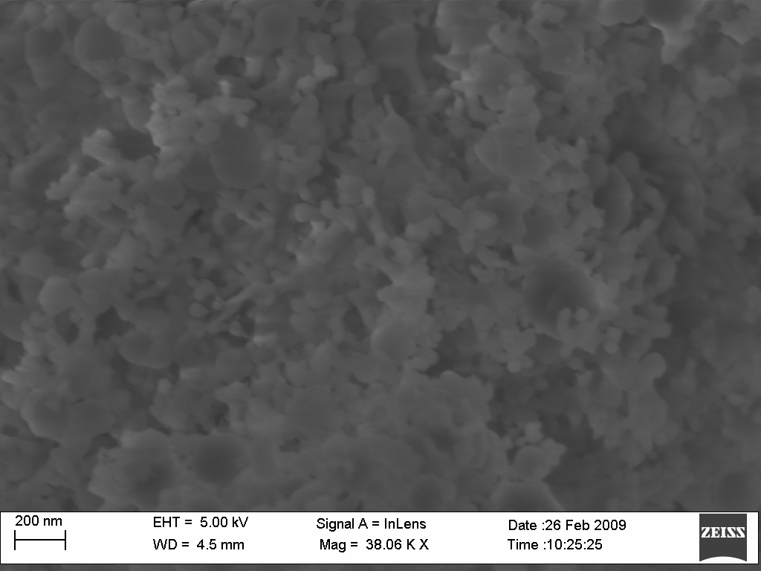
Figure 3. FESEM image of YAG:Ce sample annealed at 1000ºC for 6h with Ce₂O₃ concentration of 5%

Conclusion
We have synthesized YAG:Ce by solid-stae reaction. Through this method, the YAG:Ce particle size estimated by FESEM photographs as between 45 – 50 nm, whole from XRD patterns were obtained average size of particle, calculation by Scherrer’s equation, between 53-82 nm. Increasing the doping materials could affect the YAG phase as shown by the decreases in peak intensities. In further study, we would concentrate on photoluminescence study for better understanding in analysis.

Acknowledgement
The authors gratefully acknowledge the financial supports for this project from E-science Fund (03-01-01-SF0084) for the Ministry of Science, Technology and Innovation (MOSTI), Malaysia.

References
- H. M. H. Fadlalla, C. C. Tang, E. M. Elssfah, J. Zhang, E. Ammar, J. Lin, X. X. Ding, (2008). “Synthesis and characterization of photoluminescent cerium-doped yttrium aluminum garnet,”. Materials Research Bulletin. 43. 3457-3462.
- Y. C. Kang, I. Wuled Lenggoro, S. B. Pak, K. Okuyama, (2000). “YAG:Ce phosphor particles prepared by ultrasonic spray pyrolysis,”. Materials Research Bulletin. 35. 789-798.
- Mikrajuddin Abdullah, Kikuo Okuyama, I. Wuled Lenggoro, Syuichi Taya, (2005). “ A polymer solution process for synthesis of (Y, Gd)₃Al₅O₁₂:Ce phosphor particles,”. Journal of Non-Crystalline Solids. 351. 697-704.
- H. M. H. Fadlalla, C. C. Tang, S. Y. Wei, X. X. Ding, (2008). “Preparation and properties of nanocrystalline powder in (Y_{1-x} Ce_{x})₃Al₅O₁₂ system,”. Journal of Luminescence. 128. 1655-1659.
- Kiranmala Devi, Rekha Coudhary, A. K. Satsangi, Ravi Kumar Gupta, (2008). “Sol-gel synthesis and characterization of nanocrystalline yttrium aluminum garnet nanopowder,”. Defense Science Journal. Vol. 58, no. 4, pp.545-549.
- Zhang Na, Wang Dajian, Li Lan, Meng Yanshuang, Zhang Xiaosong, Ming Nan, (2006). “YAG:Ce phosphors for WLED via nano-psedoboehmite sol-gel route,”. Journal of Rare Earths. 24. 294-297.
- J. Y. Choe, D. Ravichandran. S. M. Blomquist, K. W. Kirchner, E. W. Forsythe, D. C. Morton, (2001). “Catholuminescence study of novel sol-gel derived Y_{3-x}Al₅O₁₂:Tb_{x} phosphors,”. Journal of Luminescence. 93. 119-128.
- Heesun Yang, Dong-Kyoon Lee, Yong-Seong Kim, (2009). “Spectral variations of nano-sized Y₃Al₅O₁₂:Ce phosphors via codoping/substitution and their white LED characteristics,”. Material Chemistry and Physics. 114. 665-669.
- Xia Li, (2009). “ Fabrication of transparent Yttrium Aluminum Garnet Ceramic,”. Journal of Physics: Conference Series. 152.
- Sukumar Roy, Liwu Wang, Wolfgang Sugmund, Fritz Aldinger, (1999). “Synthesis of YAG phase by a citrate-nitrate combustion technique,”. Material Letters. 39. 138-141.
- Zhiping Yang, Xu Li, Yong Yang, Xingmin Li, (2007). “The influence of different conditions on tha luminescent properties of YAG:Ce phosphor formed by combustion,”. Journal of Luminescence. 122-123. 707-709.

